NodeFileSystem

Screenshots

1. Endpoint : /createFile

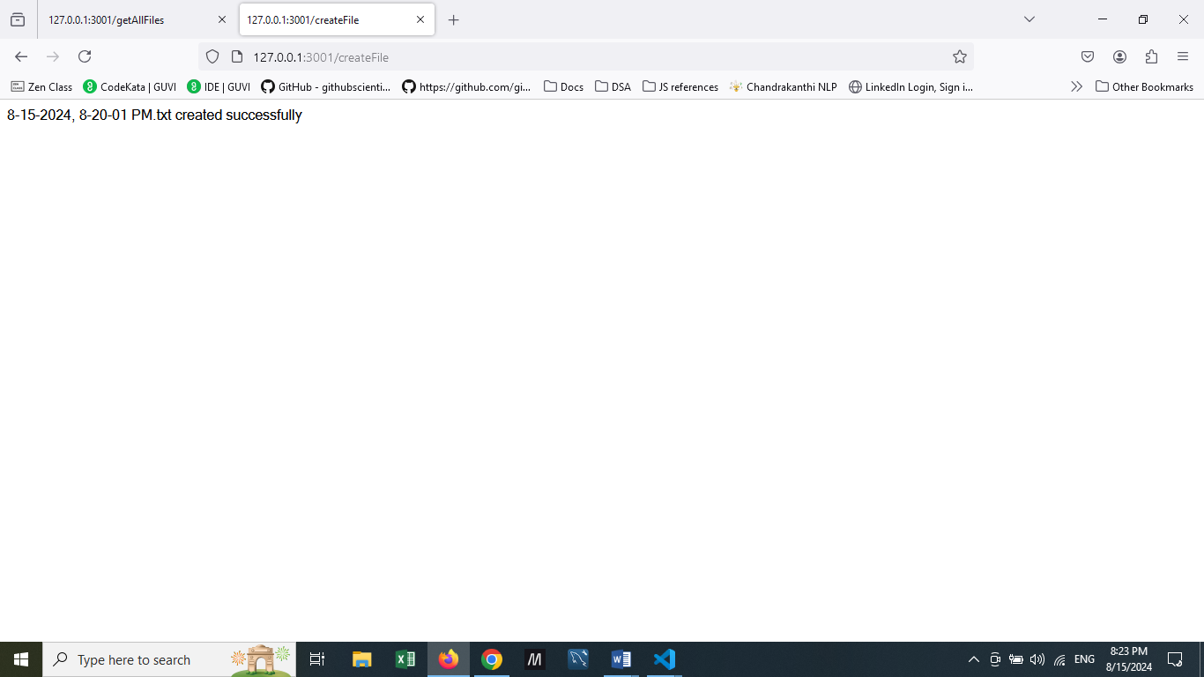

1. Created files in the folder

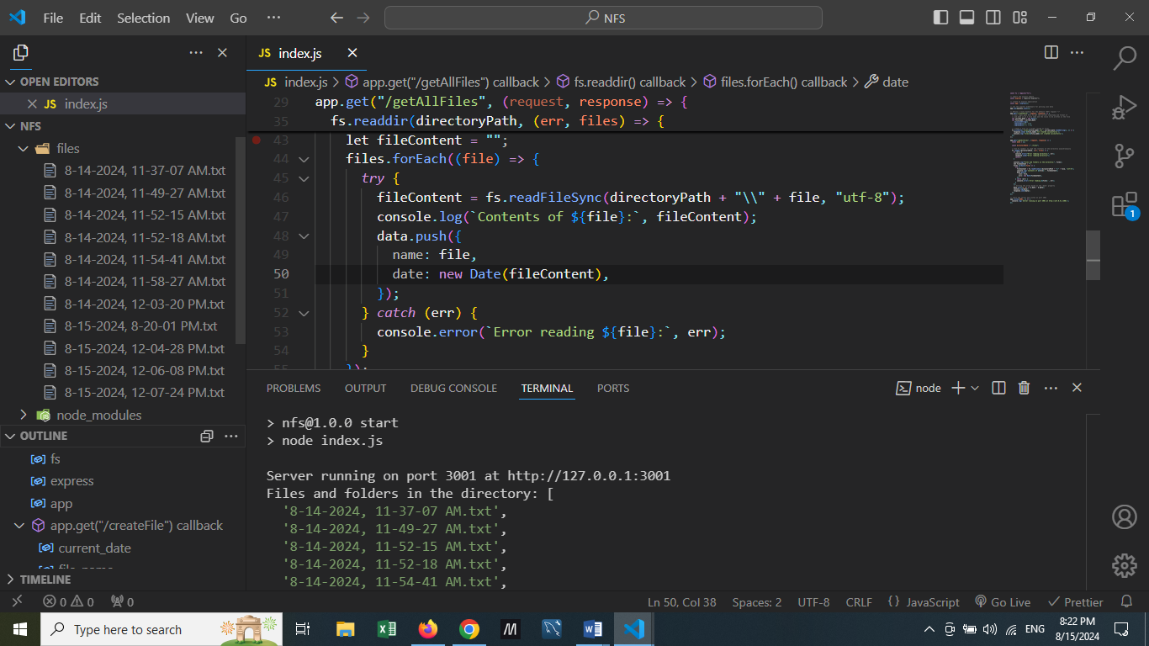

1. Retrieving files using /getAllFiles endpoint

