PES UNIVERSITY
DEPARTMENT OF COMPUTER SCIENCE AND ENGINEERING
ACADEMIC YEAR 2025-2026 | FIFTH SEMESTER B.TECH
SOFTWARE ARCHITECTURE AND DESIGN (SAD Specification)
PROJECT: CAREERBRIDGE
Online Internship & Placement Preparation Portal
SUBMITTED BY: TEAM 4

Student Name | USN | Role Assigned | Deliverable
Dhanush Rao | PES2UG24CS153 | Team Lead & Architect | Architecture, ADRs, Component Diagram
Gunavathi M I | PES2UG24CS172 | Frontend & UI/UX Lead | Design Overview, UX Design, Sequence Diagrams
Darshan R Mali | PES2UG24CS144 | Backend & Database Architect | API Design, Data Stores, Security Architecture
Deepika K | PES2UG24CS148 | Full-Stack & QA/DevOps Lead | Test Strategy, Metrics, CI/CD Pipeline
Version: 1.0 (Draft for Review) | Date: 15-09-2026 | Status: Draft
Repository: <to be added by Team 4>

Software Architecture and Design Specification
Version: 1.0
Authors: Team 4 (CareerBridge)
Date: 15-09-2026
Status: Draft for Faculty Review

Revision History
Version | Date | Author | Change Summary
0.1 | 12-09-2026 | Team 4 | Initial draft structure and component identification
1.0 | 15-09-2026 | Team 4 | Complete SAD with component diagram, 2 sequence diagrams, API design and STRIDE threat model

Approvals
Role | Name | Department / Contact | Sign / Date
Team Lead | Dhanush Rao | PES2UG24CS153 (CSE)
Course Coordinator | Software Engineering Faculty | Dept of CSE, PES University

1. Introduction

1.1 Purpose
This Software Architecture and Design (SAD) document specifies the architecture, component structure, design patterns, API contracts, and security architecture of CareerBridge, an online internship and placement preparation portal for students. It serves as the authoritative technical reference for developers, quality assurance engineers, and assessment evaluators, providing complete traceability from architectural decisions to the functional and non-functional requirements defined in the Software Requirements Specification (SRS v1.0).

1.2 Scope
This document covers the complete software architecture and detailed design of CareerBridge, including:
- Component-based layered architecture of the React single-page application
- Node.js/Express REST API and MongoDB data persistence layer
- A supporting Python (Flask) microservice for the aptitude test engine and progress analytics
- UML component diagram illustrating all system modules and their inter-dependencies
- UML sequence diagrams modeling two core application workflows
- RESTful API design for internship listings, applications, and aptitude tests
- STRIDE-based threat modeling and security architecture
- Technology stack rationale and architectural decision records
Out of scope: third-party job-portal internals, browser rendering engine internals, and campus placement-cell administrative workflows outside the portal.

1.3 Audience
- Developers: Reference for implementing and extending CareerBridge components
- QA Engineers: Basis for deriving integration and system test cases from architectural contracts
- Security Auditors: STRIDE threat model and security control documentation
- Course Evaluators: Assessment of architectural design quality and IEEE 42010 compliance
- Maintenance Engineers: Component dependency map for impact analysis during future modifications

1.4 Definitions
Term | Definition
SAD | Software Architecture and Design Specification
SRS | Software Requirements Specification
STP | Software Test Plan
SPA | Single Page Application
JWT | JSON Web Token (used for stateless session authentication)
STRIDE | Spoofing, Tampering, Repudiation, Information Disclosure, Denial of Service, Elevation of Privilege
ADR | Architecture Decision Record
API | Application Programming Interface
CI/CD | Continuous Integration / Continuous Deployment
RTM | Requirements Traceability Matrix
TLS | Transport Layer Security
ATS | Applicant Tracking System (resume/application screening)

2. Document Overview

2.1 How to Use This Document
This document is organized into three primary sections:
- Section 3 (Architecture): Provides the high-level system decomposition, component relationships, technology stack decisions, and security architecture. Start here for understanding the overall system structure.
- Section 4 (Design): Contains detailed design specifications including sequence diagrams for core workflows, API contracts, error handling strategies, and UX design principles. Reference this section for implementation-level guidance.
- Section 5 (Appendices): Contains the glossary, normative references, and tooling documentation.
All UML diagrams conform to UML 2.5 notation standards. Architecture decisions follow the Architecture Decision Record (ADR) format where applicable.

2.2 Related Documents
Document | Version | Notes
Software Requirements Specification (SRS) | 1.0 | Maintained by Team 4
Software Test Plan (STP) | 1.0 | Companion document to this SAD
Requirements Traceability Matrix (RTM) | 1.0 | Included in SRS
Database Schema (DDL/Schema definition) | 1.0 | database/schema.js (Mongoose)
CI/CD Workflow Definition | 1.0 | .github/workflows/ci.yml

3. Architecture

3.1 Goals and Constraints
Architectural Goals:
- Modularity: Independent development and testing of each functional module (Listings, Applications, Aptitude Tests, Analytics)
- Accessibility: A responsive interface usable by students on both desktop and mobile devices
- Security: Defense-in-depth strategy with JWT authentication, input sanitization, and encrypted transport
- Performance: Internship search and filtering results returned within 2 seconds under normal load
- Maintainability: Clear component boundaries between the React frontend, Node/Express API, and the Python analytics microservice
- Availability: Target 99.5% uptime during placement season with graceful degradation of non-critical features
Architectural Constraints:
- Must operate as a client-side SPA served independently of the backend API (decoupled frontend/backend)
- Must integrate a MongoDB document store using the Mongoose ODM
- The aptitude-test scoring and analytics engine must be implemented in Python to leverage pandas/scikit-learn, and exposed to the Node backend as an internal microservice
- Must pass automated CI/CD validation (build, test, lint) on every push and pull request via GitHub Actions
- Technology stack must align with the course-approved options: Python / JavaScript (MERN Stack)

3.2 Stakeholders and Concerns
Stakeholder | Primary Concerns
Team Lead (Dhanush) | System reliability, architecture coherence, deployment simplicity, team coordination
Frontend Developer (Gunavathi) | UI responsiveness, component reusability, accessibility, visual consistency
Backend Developer (Darshan) | Data integrity, schema design, API correctness, query performance
QA/DevOps Lead (Deepika) | Test coverage, CI/CD pipeline reliability, build reproducibility, defect tracking
Course Evaluators | IEEE compliance, documentation quality, functional completeness, collaboration evidence
End Users (Students) | Ease of discovering internships, fair aptitude assessment, visibility into readiness and progress
Placement Cell / Recruiters | Accurate applicant data, reliable listing management, exportable reports

3.3 Component (UML) Diagram
The following UML Component Diagram illustrates the high-level decomposition of CareerBridge into its constituent modules, their provided/required interfaces, and inter-component dependencies:
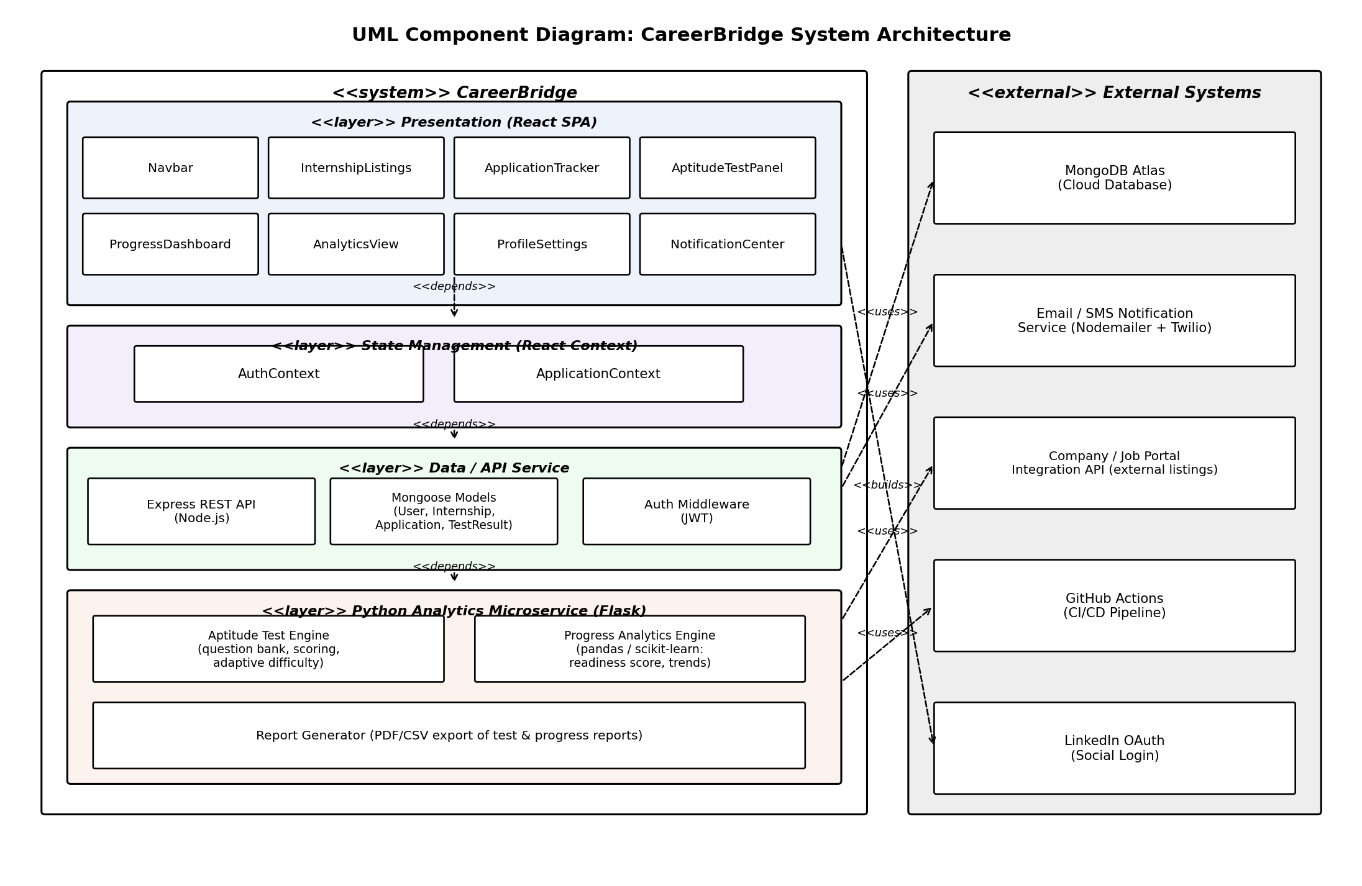
Figure 3.1: UML Component Diagram – CareerBridge System Architecture
The system is decomposed into the following primary components:
- Presentation Layer: Navbar, InternshipListings, ApplicationTracker, AptitudeTestPanel, ProgressDashboard, AnalyticsView, ProfileSettings, NotificationCenter
- State Management Layer: AuthContext, ApplicationContext
- Data / API Service Layer: Express REST API, Mongoose Models, JWT Auth Middleware
- Python Analytics Microservice: Aptitude Test Engine, Progress Analytics Engine, Report Generator
- External Systems: MongoDB Atlas, Email/SMS Notification Service, Company/Job Portal Integration API, GitHub Actions CI/CD, LinkedIn OAuth

3.4 Component Descriptions
Component | Module Path | Responsibility | Dependencies
App Shell | src/App.jsx | Root application container; manages routing and global layout | AuthContext, Navbar
Navbar | src/components/layout/Navbar.jsx | Top navigation with profile display and notification bell | AuthContext
InternshipListings | src/components/listings/InternshipListings.jsx | Searchable, filterable list of internship postings | ApplicationContext
ApplicationTracker | src/components/applications/ApplicationTracker.jsx | Displays status of a student's submitted applications | ApplicationContext
AptitudeTestPanel | src/components/tests/AptitudeTestPanel.jsx | Timed aptitude test UI: question rendering, timer, submission | ApplicationContext
ProgressDashboard | src/components/dashboard/ProgressDashboard.jsx | Readiness score, test history and trend charts | ApplicationContext
AnalyticsView | src/components/analytics/AnalyticsView.jsx | Aggregate analytics: strengths/weaknesses by topic | ApplicationContext
ProfileSettings | src/components/settings/ProfileSettings.jsx | Resume upload, skills, and preference configuration | AuthContext
NotificationCenter | src/components/notifications/NotificationCenter.jsx | In-app and email/SMS notification preferences and history | AuthContext
AuthContext | src/context/AuthContext.jsx | React Context managing authentication state and JWT session | Express API
ApplicationContext | src/context/ApplicationContext.jsx | React Context managing internships, applications, and test data | Express API, AuthContext
Express REST API | server/routes/*.js | Node.js API gateway exposing REST endpoints, request validation | Mongoose Models, JWT Middleware
Mongoose Models | server/models/*.js | Schema definitions for User, Internship, Application, TestResult | MongoDB Atlas
Aptitude Test Engine | analytics_service/test_engine.py | Question bank management, scoring, adaptive difficulty (Flask) | MongoDB Atlas (via API)
Progress Analytics Engine | analytics_service/analytics.py | Readiness score and trend computation using pandas | Aptitude Test Engine
Report Generator | analytics_service/reports.py | Exports PDF/CSV test and progress reports | Progress Analytics Engine

3.5 Chosen Architecture Pattern and Rationale
Selected Pattern: Layered Component Architecture with a Polyglot Analytics Microservice
Rationale:
Criterion | Layered + Microservice (Chosen) | Full Microservices | Monolithic MVC
Separation of Concerns | Strong (component + service boundary) | Very Strong (full isolation) | Moderate
Development Complexity | Low-Medium | High (orchestration overhead) | Low
Team Parallelism | High (4 independent modules) | Very High | Low (merge conflicts)
Deployment Simplicity | Medium (2 services) | Low (many services) | High
Fit for Python analytics needs | Excellent (dedicated Flask service) | Excellent but overkill | Poor (JS-only)
Academic Evaluation Fit | Good (npm run dev + flask run) | Poor (needs orchestration) | Good
Decision: A layered component architecture was chosen for the React frontend and Node/Express backend because it provides strong separation of concerns while keeping deployment simple. A single focused Python (Flask) microservice was introduced specifically for the aptitude test engine and progress analytics, since these features benefit from Python's data-science ecosystem (pandas, scikit-learn) that is not natively available in the Node.js runtime. A full microservices split was rejected as unnecessary complexity for the project scope; a pure monolithic JavaScript stack was rejected because it would have made the analytics workloads harder to implement and maintain.

3.6 Technology Stack and Data Stores
Layer | Technology | Version | Justification
UI Framework | React | 18.x | Component-based SPA with a mature ecosystem and hooks-based state management
Build Toolchain | Vite | 5.x | Fast dev server and optimized production bundling
State Management | React Context API | Built-in | Sufficient for project scope; avoids external dependency overhead
Backend API | Node.js + Express | 20.x / 4.x | Lightweight REST API layer, large middleware ecosystem
Database | MongoDB (Atlas) | 7.x | Flexible document schema suited to varied internship/application data
ODM | Mongoose | 8.x | Schema validation and query building for MongoDB
Analytics Microservice | Python + Flask | 3.x / 3.0 | Exposes aptitude scoring and analytics via internal REST endpoints
Data Analysis | pandas, scikit-learn | Latest | Readiness scoring, trend analysis, and adaptive difficulty logic
Authentication | JSON Web Tokens (JWT) | — | Stateless session management across frontend and API
Unit Testing | Jest (JS) / PyTest (Python) | Latest | Test coverage for both the Node API and Python microservice
CI/CD | GitHub Actions | Latest | Automated build, lint, and test pipeline on push/PR
Transport Security | TLS 1.2+ | — | Enforced for all client-server and inter-service communication

Data Store Architecture (MongoDB Collections):
- users – student profile, credentials (hashed), resume metadata
- internships – postings sourced internally or via integration API
- applications – links a user to an internship with status (applied, shortlisted, rejected, offered)
- testResults – aptitude test attempts, scores, per-topic breakdown
- progressSnapshots – periodic readiness-score snapshots computed by the analytics engine

3.7 Risks and Mitigations
Risk ID | Risk Description | Probability | Impact | Mitigation Strategy
RISK-01 | MongoDB Atlas free-tier connection limits reached during peak usage | Medium | Medium | Connection pooling in Mongoose; upgrade tier before placement season
RISK-02 | Python analytics microservice becomes a single point of failure | Low | High | API gracefully degrades: cached last-known readiness score shown if service is unreachable
RISK-03 | Aptitude test question bank duplication across attempts reduces validity | Medium | Medium | Randomized question selection with per-student attempt history exclusion
RISK-04 | Inconsistent internship data from external integration API | Medium | Low | Schema validation and sanitization layer before persistence
RISK-05 | CI/CD pipeline failure blocking Pull Request merges | Low | Medium | Separate build/test jobs with independent failure isolation
RISK-06 | Resume/file upload used to inject malicious content | Low | High | File-type whitelisting, size limits, and virus-scan hook before storage

3.8 Traceability to Requirements
The following table traces architectural components to representative functional requirements defined in SRS v1.0:
Requirement ID | Requirement Description | Architectural Component(s)
CB-F-001 | Student registration and login | AuthContext, Express API, Mongoose (users)
CB-F-002 | Browse and filter internship listings | InternshipListings, Express API
CB-F-003 | Apply to an internship | ApplicationTracker, ApplicationContext, Express API
CB-F-004 | Attempt a timed aptitude test | AptitudeTestPanel, Aptitude Test Engine (Flask)
CB-F-005 | Adaptive difficulty based on performance | Aptitude Test Engine
CB-F-006 | View readiness score and progress trends | ProgressDashboard, Progress Analytics Engine
CB-F-007 | Export progress/test report | Report Generator
CB-F-008 | Receive email/SMS notifications on application status change | NotificationCenter, Notification Service

3.9 Security Architecture
Threat Modeling (STRIDE Analysis):
STRIDE Category | Threat Description | Countermeasure | Component
Spoofing | Unauthorized user impersonating a legitimate student | JWT-based session tokens with password hashing (bcrypt) | AuthContext, Express API
Tampering | Malicious modification of application or test-score data in transit | TLS enforced on all API calls; server-side input validation | Express API
Repudiation | Student denying they submitted a particular test attempt | Immutable testResults log with timestamp and user ID | Aptitude Test Engine
Information Disclosure | Unauthorized access to another student's resume or application data | Ownership checks on every query; field-level access control | Express API, Mongoose
Denial of Service | Excessive test-submission requests overwhelming the analytics service | Rate limiting on submission endpoints; request queueing | Express API, Aptitude Test Engine
Elevation of Privilege | Student attempting to access placement-cell admin functions | Role-based access control enforced server-side, not just hidden in UI | AuthContext, Express API

Security Controls Summary:
- Authentication: JWT-based session management with bcrypt password hashing
- Authorization: Ownership and role checks enforced in Express middleware, not only client-side
- Input Sanitization: Server-side validation plus React JSX auto-escaping on the client
- Transport Security: TLS 1.2+ enforced on all client-server and service-to-service communication
- File Upload Safety: Type/size restrictions and scanning on resume uploads
- Dependency Security: Automated npm audit and pip-audit in the CI/CD pipeline

4. Design

4.1 Design Overview
CareerBridge is designed as a modular, component-based single-page application with a companion analytics microservice, following separation of concerns at every layer:
- Presentation Layer: React functional components with hooks-based lifecycle management, each module (Listings, Applications, Tests, Dashboard) independently encapsulated
- State Management Layer: Two React Context providers (AuthContext and ApplicationContext) serve as centralized state containers
- Data Access Layer: The Express REST API routes all CRUD operations to MongoDB via Mongoose, and delegates aptitude-test scoring and analytics to the Python Flask microservice over an internal HTTP call
This layered design enables each team member to develop and test their assigned components independently, with well-defined interfaces at layer boundaries.

4.2 UML Sequence Diagrams

4.2.1 Sequence Diagram 1: Student Registration & Internship Application Workflow
This sequence diagram models the end-to-end flow from student registration through browsing and applying to an internship listing:
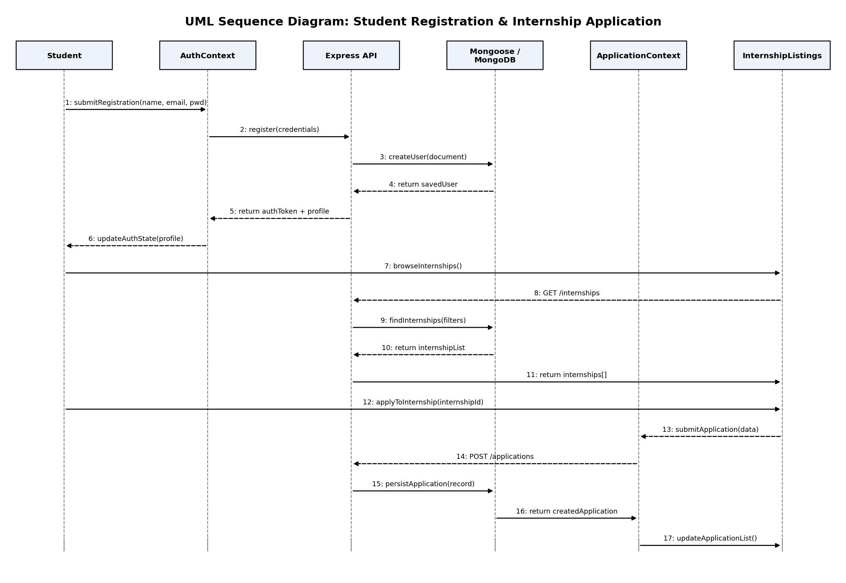
Figure 4.1: UML Sequence Diagram – Registration and Internship Application
Flow Description:
- Student submits registration details; AuthContext dispatches the request to the Express API
- Express API creates the user document in MongoDB and returns an auth token and profile
- AuthContext updates client-side auth state; the student browses internship listings
- InternshipListings requests data from the API, which queries MongoDB and returns matching internships
- Student applies to a chosen internship; ApplicationContext submits the application
- The API persists the application record and the application list is refreshed on screen

4.2.2 Sequence Diagram 2: Aptitude Test Attempt & Progress Analytics Workflow
This sequence diagram models a student attempting an aptitude test and reviewing computed progress analytics:
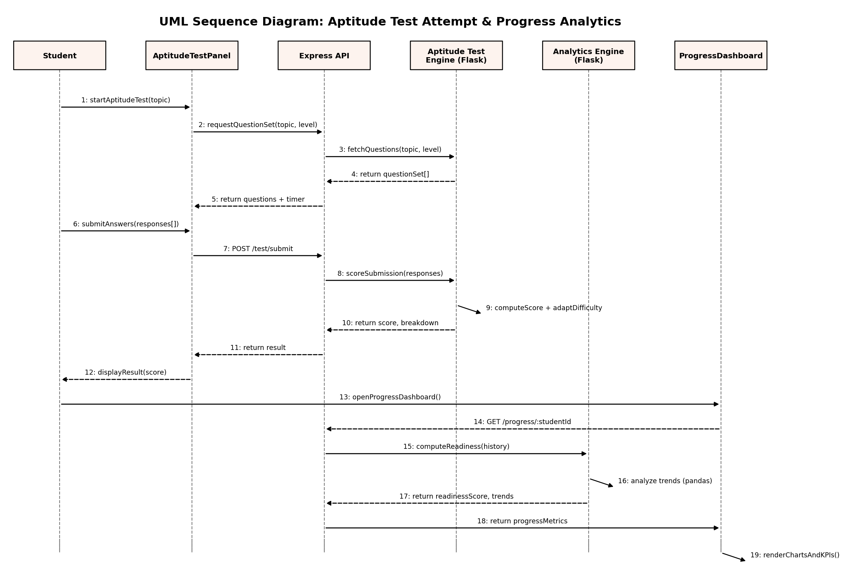
Figure 4.2: UML Sequence Diagram – Aptitude Test Attempt and Progress Analytics
Flow Description:
- Student starts an aptitude test for a chosen topic; the API requests a question set from the Aptitude Test Engine
- Student submits answers, which are scored by the Aptitude Test Engine, including adaptive difficulty adjustment for future attempts
- Student opens the Progress Dashboard; the API requests readiness computation from the Analytics Engine
- The Analytics Engine analyzes historical attempts with pandas to compute a readiness score and topic-level trends
- The dashboard renders charts and KPI cards summarizing the student's placement readiness

4.3 API Design
CareerBridge exposes a RESTful API from the Express backend; the analytics microservice exposes a small internal API consumed only by the Express layer (not the browser).

4.3.1 Internships API
Endpoint | Method | Description
/api/internships | GET | Retrieve internship listings with optional filters (location, domain, stipend)
/api/internships | POST | Create a new internship listing (placement-cell role only)
/api/internships/:id | GET | Retrieve a single internship's details
/api/applications | POST | Submit a new application to an internship
/api/applications/:studentId | GET | Retrieve a student's application history and statuses
Request Schema (POST /api/applications):
{
"internshipId": "ObjectId (required)",
"studentId": "ObjectId (required)",
"resumeUrl": "string (required)",
"coverNote": "string (optional, max 1000 chars)"
}

Error Responses:
- 401 Unauthorized – Missing or invalid authentication token
- 403 Forbidden – Student attempting to reapply after rejection lockout period
- 422 Unprocessable Entity – Validation failure (missing required fields, invalid enum value)

4.3.2 Aptitude Test API (internal, via Express → Flask)
Endpoint | Method | Description
/api/test/questions | GET | Fetch a question set for a given topic and difficulty level
/api/test/submit | POST | Submit responses for scoring; returns score and per-topic breakdown
/api/progress/:studentId | GET | Retrieve computed readiness score and trend data
/api/reports/:studentId | GET | Generate and download a PDF/CSV progress report
Response Schema (200 OK, POST /api/test/submit):
{
"score": "integer",
"totalQuestions": "integer",
"breakdown": "{ topic: string -> correctCount: integer }",
"nextDifficultyLevel": "string (enum: easy | medium | hard)"
}

4.4 Error Handling, Logging and Monitoring
Error Handling Strategy:
- All API calls are wrapped in try-catch blocks with standardized error response parsing
- If the Python analytics microservice is unreachable, the API falls back to the last cached readiness score with a user-visible notice
- Form validation errors are displayed inline with field-level error messages
- Unrecoverable client errors are caught by a React Error Boundary that renders a graceful fallback UI
Logging and Monitoring:
- Application status changes and test submissions are logged with timestamp, user ID, and action type
- No sensitive information (passwords, tokens) is written to any log
- CI/CD pipeline provides automated build health monitoring on every push
- API response time and error-rate metrics are captured via console/server logs for local monitoring

4.5 UX Design
Design Principles:
- Clarity: Application statuses and test results are shown with clear, color-coded indicators
- Progressive Disclosure: Advanced filters and settings are tucked into secondary panels to keep the primary flow simple
- Accessibility: Readable font sizes, sufficient color contrast, and keyboard-navigable forms
- Responsive Layout: Usable from mobile browsers (360px) up through desktop widescreen layouts
Visual Design System:
- Color Palette: Clean light theme with an accent color for calls-to-action and status badges
- Typography: System font stack for readability across platforms
- Spacing: 8px grid system for consistent padding, margins, and component sizing

4.6 Open Issues and Next Steps
Issue | Status | Next Step
Resume parsing to auto-fill profile fields | Not started | Evaluate a resume-parsing library or lightweight NLP model
Real-time notifications (WebSocket push) | Deferred | Evaluate Socket.IO for live application-status updates
Recruiter-facing dashboard for shortlisting | Not started | Design a separate role-gated view for placement-cell staff
Mobile app wrapper | Not started | Evaluate a PWA wrapper around the existing React SPA

5. Appendices

5.1 Glossary
Term | Definition
Internship Listing | A posting describing an internship opportunity, including role, domain, stipend, and eligibility
Aptitude Test | A timed, topic-based assessment used to gauge a student's placement readiness
Readiness Score | A computed metric summarizing a student's aggregate preparedness across topics and attempts
Adaptive Difficulty | Adjustment of subsequent question difficulty based on a student's prior performance
ATS | Applicant Tracking System style status pipeline (applied → shortlisted → offered/rejected)

5.2 References
Reference | Description
IEEE 42010:2011 | Systems and Software Engineering – Architecture Description
OWASP Top 10 (2021) | Open Web Application Security Project – Top 10 Web Application Security Risks
React Documentation | Official React 18 documentation (react.dev)
Express.js Documentation | Official Express.js framework documentation (expressjs.com)
MongoDB / Mongoose Documentation | Official MongoDB and Mongoose ODM documentation
Flask Documentation | Official Flask microframework documentation (flask.palletsprojects.com)

5.3 Tools
Tool | Purpose
Visual Studio Code | Primary development IDE
Git / GitHub | Version control and team collaboration
GitHub Actions | CI/CD pipeline automation
Postman | API testing for Express and Flask endpoints
Jest / PyTest | Unit testing frameworks for JS and Python code
Python (Matplotlib) | UML diagram generation for documentation

