InvestFlow Digital Customer Experience Redesign
  - Deepika Kola | Portfolio case study | November 2026
InvestFlow is an independently developed simulated portfolio project. It uses demo investment data and role placeholders. No financial institution sponsored the work. The project involved no customer research, live trading, production release, or measured customer impact.

Executive summary
A retail investing customer needs to answer three questions before taking action: what is available now, what changed over time, and what am I about to confirm? InvestFlow makes those decisions easier to evaluate by separating balances, synchronizing performance periods, and clearing old order confirmations after edits.
I connected the delivery plan in Wrike to the requirements, prototype and browser evidence. I used AI assistance for drafting, configuration, implementation and test execution. The strongest example is order review. The first version could show a previous confirmation beside a newly edited order. The updated version clears that confirmation and requires a new review.
Backlog scope | Estimated effort | Review gates | Schedule links
47 delivery tasks | 143 story points | 7 native milestones | 12 finish-to-start dependencies

Evidence at a glance
Evidence | What it demonstrates
Requirements and traceability | Ten pain points linked to requirements, story IDs, screens, tests, and results.
Prototype and retest | Five original failures reproduced and retested. 23 of 23 checks passed in Chromium and 23 of 23 passed in Firefox.
Delivery governance | Six sprint groups, the schedule reconciliation, and a readiness decision that separates prototype evidence from release acceptance.

Outcome and boundary
The revised prototype is ready for a portfolio walkthrough. Release acceptance remains open because accessibility, customer validation, and live Wrike reconciliation are incomplete.
01 CUSTOMER CONTEXT

Journey hypotheses and decisions
Three personas guided the test design. They represent plausible behavior for this exercise. Their needs have yet to be validated with participants.
Persona | Decision they need to make | Risk if the design is unclear
New investor | Distinguish invested assets, cash and total balance. | They may confuse portfolio value with money available to use.
Self-directed investor | Find a company, save it, then return to the same result. | An unclear saved state or lost focus can break the research flow.
Active investor | Verify the cost and current terms before confirming. | An old confirmation can appear to validate new inputs.

Journey | Baseline friction or hypothesis | Updated design
Overview | Total reconciled but the screen had no as-of date. | A fixed demo timestamp sits alongside the total and cash breakdown.
Portfolio | The period changed the numbers without a corresponding trend. | The label, amount, plot and table update from the same sample series.
Research and Watchlist | Saving rebuilt the result and sent focus to the page body. | Saving updates the same control. Removing an item moves focus to the next useful control.
Order review | After edits, the previous confirmation remained on screen. | Editing the security or quantity invalidates confirmation immediately.

How to validate the hypotheses
Ask participants to identify available cash, explain a selected return period, find a saved ticker, and revise an order. Record task completion, interpretation accuracy and help needed separately. The browser tests establish behavior under defined inputs. They do not establish customer preference or comprehension.
02 BUSINESS ANALYSIS

Requirements traceability
Each row links a customer concern to a business requirement, backlog story, screen and test. The workbook carries the full criteria and both browser results.
Customer concern | Requirement and story | Screen | Executed evidence
Balance freshness | BR01 / IF-010, IF-012, IF-013 | Overview | B02. Snapshot and totals verified.
Trend integrity | BR03 / IF-016, IF-017 | Portfolio | B03, B04. Values and chart move together.
Research continuity | BR04, BR05 / IF-024 to IF-026, IF-030 | Research / Watchlist | B05 to B07, B11. Search and save verified.
Confirmation accuracy | BR06 / IF-033, IF-035, IF-036 | Order review | B08 to B10, A08. Edits and errors verified.
Keyboard and mobile access | BR02, BR07 / IF-011, IF-026, IF-040, IF-041 | Across views | A01 to A07, A09, M01, M02. Scoped checks passed.

Functional and quality requirements
Functional criteria define what changes, such as the estimate and confirmation when quantity changes. Quality criteria define how it must behave, such as a visible focus outline, an announced selection state and a layout that fits a narrow viewport. The browser register records both the expected and observed behavior.

Prioritization
Prioritize by consequence, reach and evidence. An inconsistent confirmation can misstate the review result, and focus loss blocks keyboard continuity. Comparison, notes and cost basis add value but are separate scope decisions. Preserve those backlog items and assess them before assigning effort or dates.
03 UX SOLUTION

Balances and performance
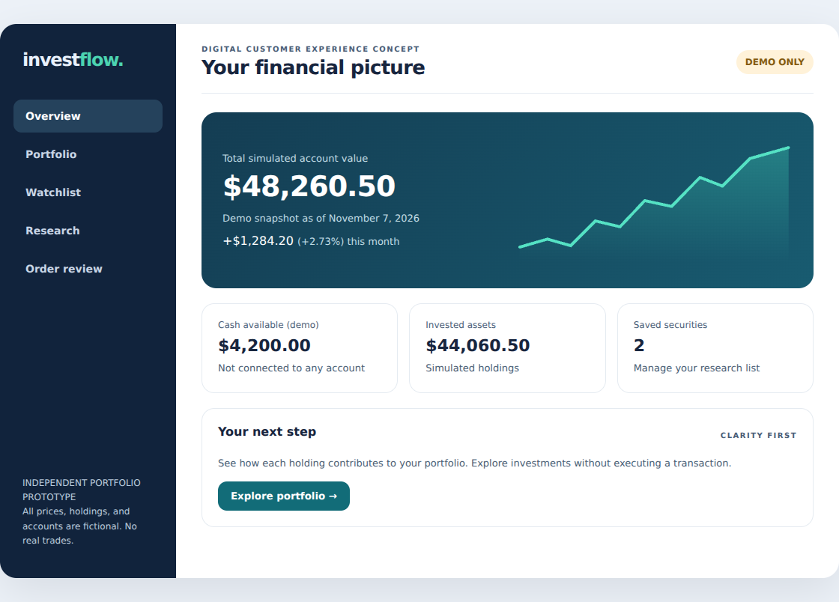
Figure 1. Updated Overview showing the dated demo snapshot and the balance components.
The account summary places cash and invested assets beside the total. The as-of date clarifies freshness without implying a live price feed.
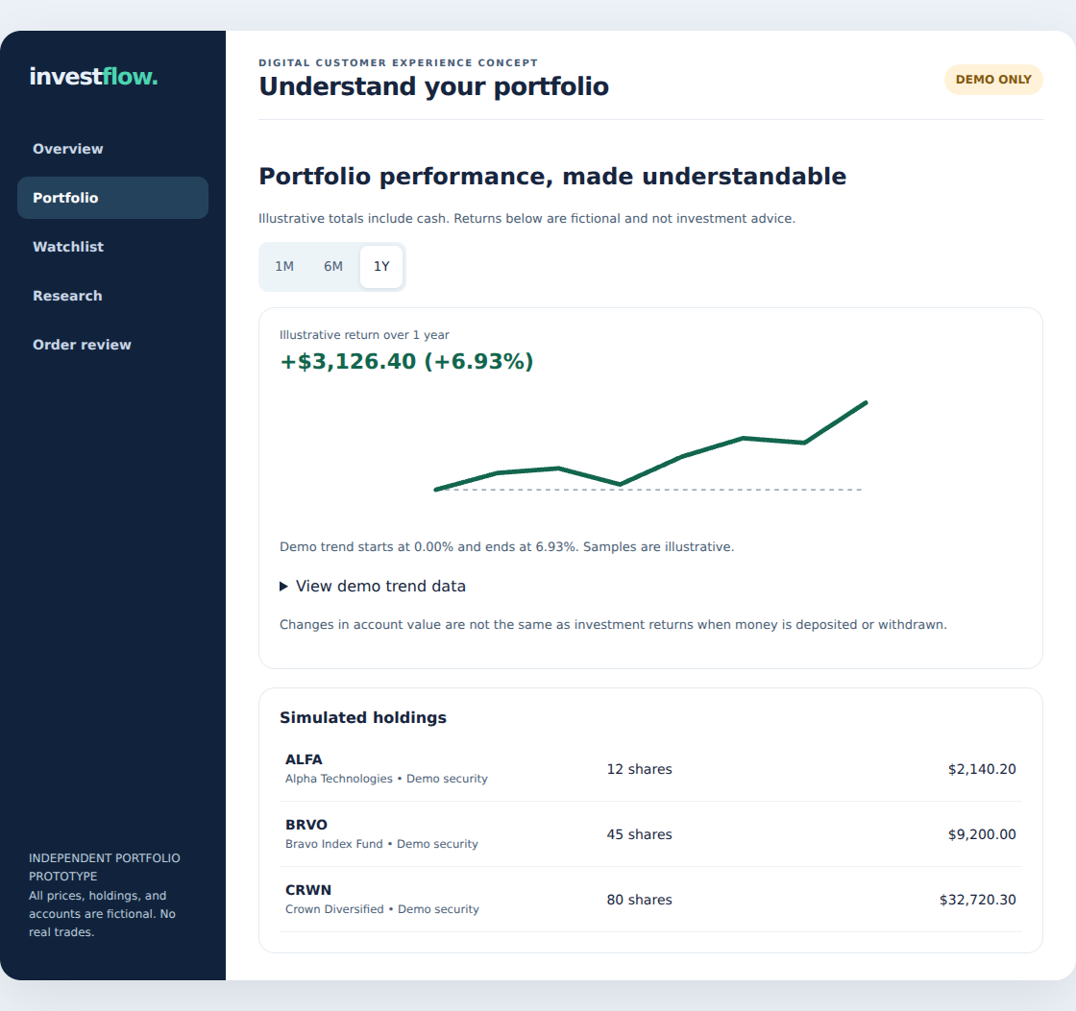
Figure 2. Updated Portfolio with the 1-year return, matching trend and access to the data table.
One period record drives the return label, amount, chart and alternative table. The data table gives users a direct way to verify the displayed samples.
04 UX SOLUTION

Research and order review
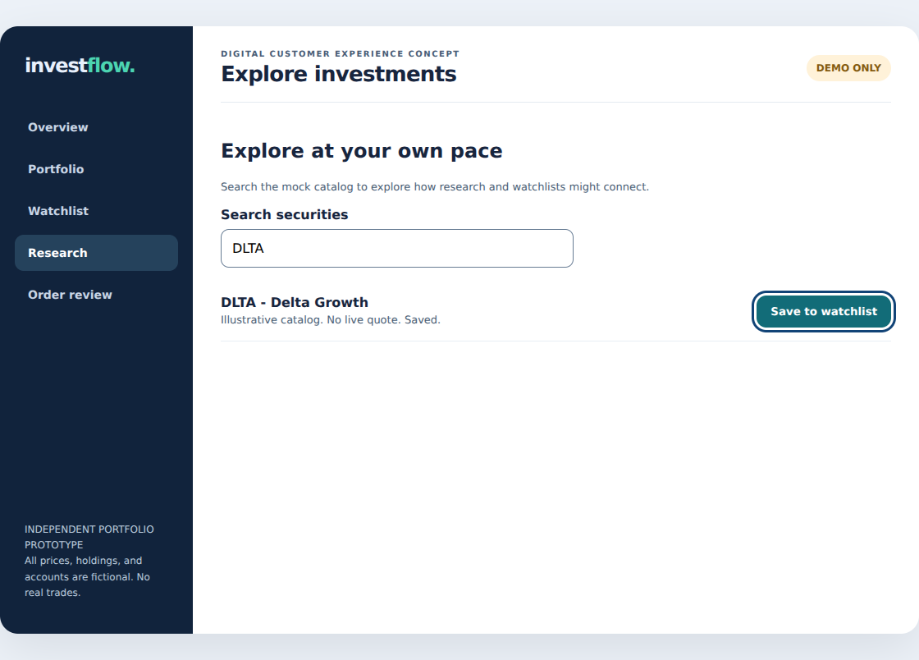
Figure 3. Keyboard focus remains on the DLTA control after a save. The row reports its saved state.
Saving updates the existing button. When a user removes an item, focus moves to the next item or the discovery action. The watchlist lasts for the current page session, as disclosed in the interface.
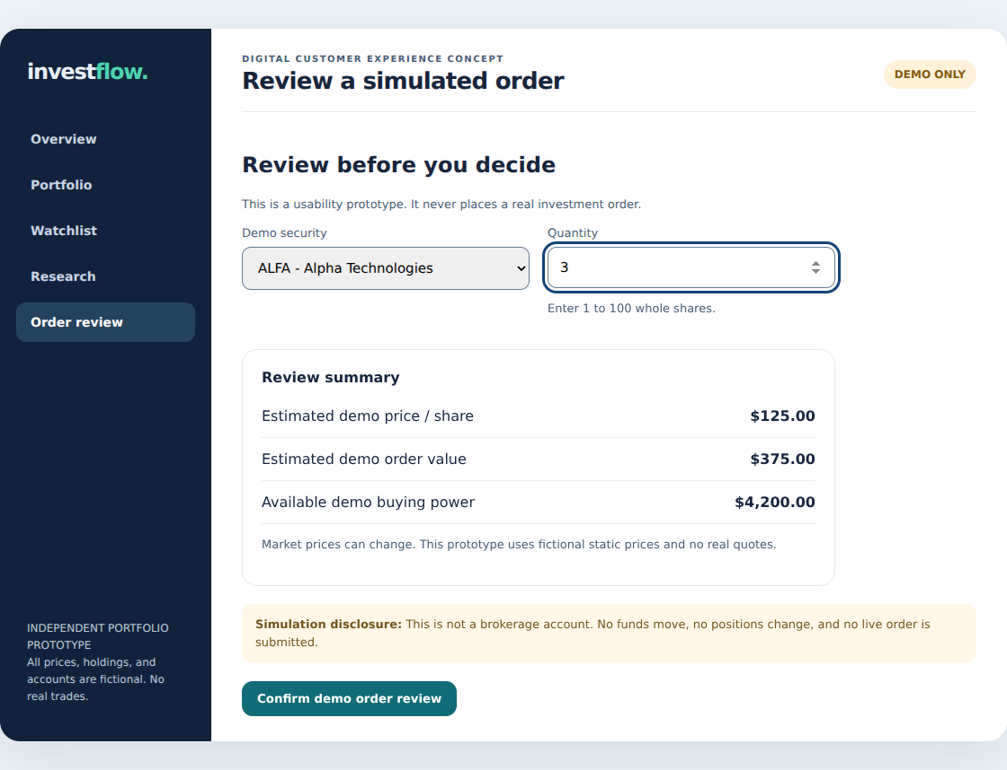
Figure 4. After editing ALFA from two to three shares, the estimate changes to $375 and the old confirmation clears.
The order uses integer cents for the estimate. It rejects invalid quantities and orders above demo buying power. These decisions reduce ambiguity at the point of review and leave a clear test for every input change.
05 AGILE DELIVERY

Sprint plan and release gates
The delivery plan has one discovery sprint and five delivery sprints. Story points express planned relative effort. The archived export places all 47 original delivery tasks in Backlog.
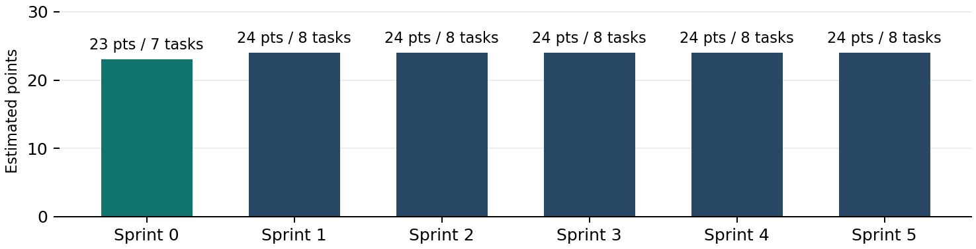
Figure 5. Estimated scope by sprint from the archived Wrike export.
Milestone gate | Task | Planned date
Discovery readiness | IF-006 | Nov 27, 2026
Navigation review | IF-015 | Dec 11, 2026
Portfolio review | IF-023 | Dec 25, 2026
Watchlist review | IF-031 | Jan 8, 2027
Order review | IF-039 | Jan 22, 2027
Release decision | IF-046 | Feb 5, 2027
Portfolio closure | IF-047 | Feb 5, 2027

Workflow and sprint review
Backlog, Ready for Sprint, In Progress, Review / UAT, Done (Accepted), and Blocked form the delivery workflow. In a planned review, demonstrate acceptance criteria against the test record and record what was accepted, deferred or sent back. The ceremonies are planning artifacts. No team sessions or sprint acceptance are recorded.
06 WRIKE EVIDENCE

Schedule and governance
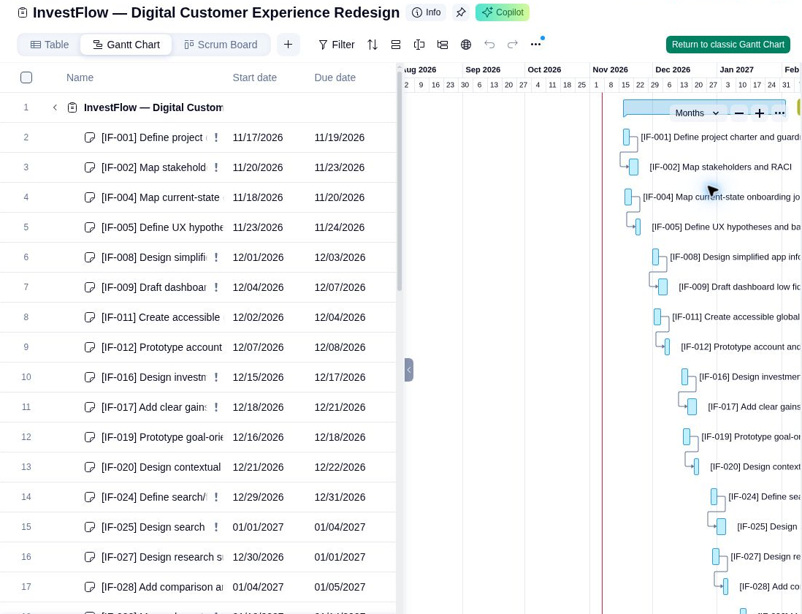
Figure 6. Archived Wrike Gantt capture with dependency links. Cropped to show the schedule without the onboarding pop-up.
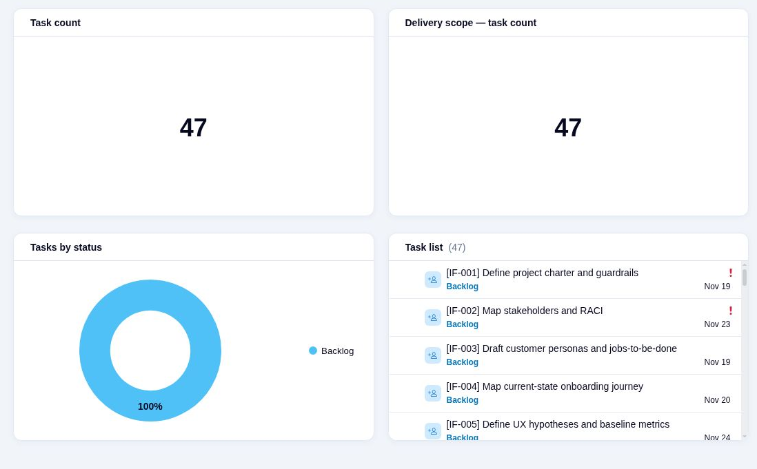
Figure 7. Archived dashboard showing the 47 original delivery tasks before governance subitems were added.
The last verified export reconciles 12 finish-to-start dependencies and 12 changes to imported task dates. Five risks and five issues appear as separate governance subitems. Current live statuses and updated defect records still require Wrike access.
07 VALIDATION

Baseline failures and verified retest
Original failure | Fix | Retest
B02 Missing snapshot date | Add visible, fixed demo as-of date. | Pass in both
B04 Missing period trend | Bind the SVG, endpoint and data table to the period. | Pass in both
B10 Stale order confirmation | Clear confirmation when ticker or quantity changes. | Pass in both
A03 Selected state only visual | Expose current view and pressed period programmatically. | Pass in both
A04 Focus loss after save | Update the saved button in place. | Pass in both

Test conditions and findings
23 of 23 checks passed in Chromium and 23 of 23 passed in Firefox. The suite covers order boundaries and errors, keyboard-only use, explicit labels, holdings reconciliation, search, watchlists, and 320 px and 390 px viewports. Chromium used touch emulation. Firefox used narrow desktop viewports.
Axe reported zero violations among selected rules across all five views in each engine. The Overview gradient remained an incomplete automated item. A separate computed check sampled the two foregrounds against the lighter gradient endpoint and returned 7.58:1 and 5.27:1.

Coverage limits
Screen-reader testing, physical mobile devices, Safari and customer sessions remain unexecuted. The contrast sample and automated scans cover the tested states. They do not establish WCAG conformance.
08 READINESS

Decisions and next steps
Workstream | Evidence and decision
Wrike configuration | Archived evidence confirms scope, sprint groups, epics, points and scheduling. Current live state could not be checked because the session required sign-in.
Prototype development | The five baseline defects were corrected. The public demo is ready for a portfolio walkthrough.
Executed testing | Both browser runs passed the defined checks. The report separates automated findings and manual follow-up.
Simulated Agile activities | Sprint plans, review agenda, risk tracking and milestone criteria describe the intended delivery process.
Unexecuted work | Screen reader and physical-device testing, customer validation, holiday capacity review, release sign-off and live Wrike defect updates remain open.

Trade-offs and follow-up
The chart uses deterministic samples so reviewers can reproduce period changes. The watchlist is session-only so the demo needs no storage or accounts. Research comparison, cost basis and loading or cancellation scenarios stay in the register as separate scope items.
Before a production acceptance decision, validate interpretation with participants, run assistive-technology and physical-device checks, and assign owners to the remaining scope. In Wrike, attach the retest evidence to the existing stories and review the calendar before approving dates.

Lesson learned
A passing happy path can conceal a defect in the next action. Testing an edit after confirmation and a save followed by another keyboard action exposed problems that a one-click test would miss.

