**Applied Data Science 1**

**Student Name: Deepika Mokkapati**

**Student ID: 22075704**

**Github Link:**

# **Exploratory Data Analysis (EDA) on World Bank data**

This study examined the energy landscape of four prominent countries, namely India, United Kingdom, United States, and Australia. The emphasis was placed on evaluating the generation of energy obtained from coal and oil as natural resources. The purpose of this comparison research was to identify significant details about the energy dynamics and resource utilisation techniques used by these major global participants.

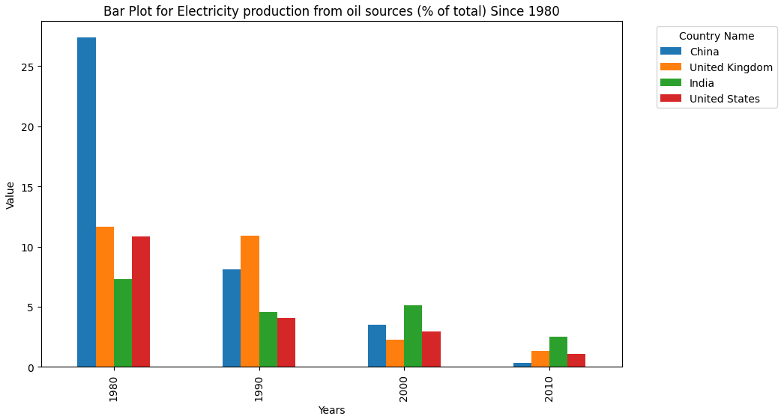

The above bar graph represents the progression of the proportions of power generation derived from oil in China, United Kingdom, India, and the United States from 1980 till 2020. Although China has generally been at the forefront in this regard, there has been a noticeable decrease from 2010 to 2020. The significant decrease seen in all nations indicates a deliberate change in strategy, maybe due to an increasing need for imported oil. This shift exemplifies a worldwide movement towards expanding the variety of energy sources, indicating a concerted push to decrease reliance on oil for producing power and bolster energy stability.

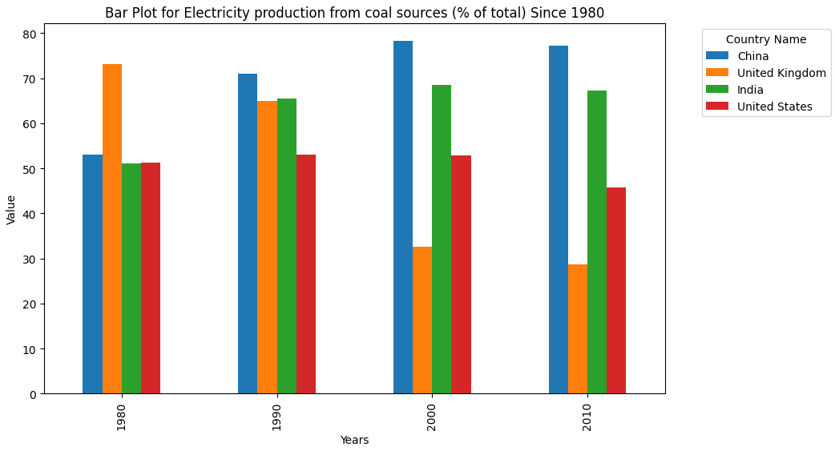

The following bar graph represents the percentage of energy generation sourced from coal. China, the United Kingdom, and India continued to heavily rely on coal for energy generation, whilst the United States significantly decreased its dependence on coal. This variation highlights the different approaches that countries are taking to shift towards cleaner energy options. The United States, in particular, is showing a strong dedication to reducing the use of coal in its electricity production. This commitment may be motivated by environmental concerns and a desire to adopt more sustainable energy sources.

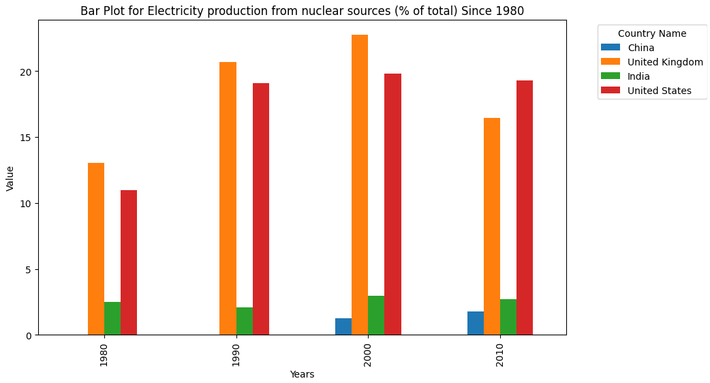

This bar graph represents the percentage of electricity produced from nuclear sources, highlighting the United Kingdom and the United States as the primary suppliers. India and China have a low dependence on nuclear energy for generating power. This discrepancy highlights the differences in the adoption of nuclear energy, which may be driven by various governmental objectives and resource distributions across the countries.

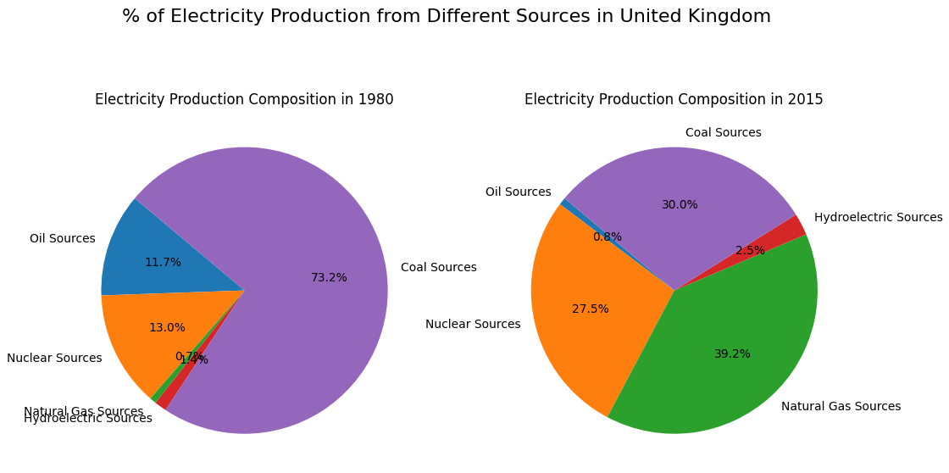

The pie chart demonstrates a significant shift in the electrical production of the United Kingdom. In 1980, coal was the predominant energy source, accounting for a significant 73.2% portion. In 2015, there was a significant decline in this dependency, dropping to 30%, which indicates a significant change. Significantly, natural gas became a crucial participant, accounting for 39.2% of the power composition in 2015, which is a notable difference from its small 0.7% contribution in 1980. The increase in natural gas use corresponds to the growing demand for greener energy sources. Simultaneously, nuclear sources had a twofold increase in their influence, rising from 13% in 1980 to 27.5% in 2015. This highlights the UK's strategic commitment to expanding its energy portfolio and decreasing dependence on conventional fossil fuels.

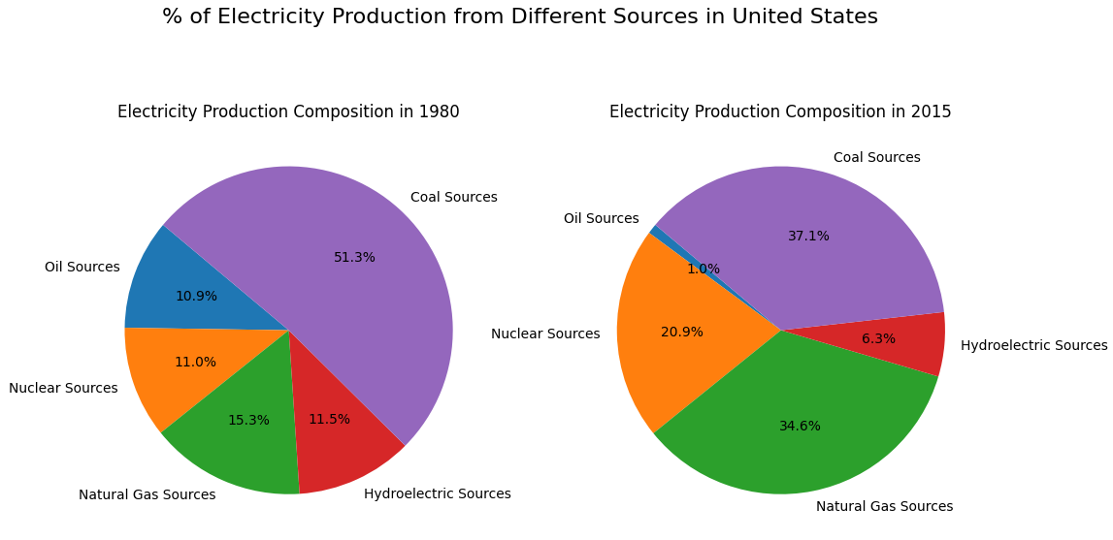

The pie chart demonstrates a substantial change in the electrical generation landscape of the United States between 1980 and 2015. During the 1980s, coal was the predominant source, accounting for 51.3% of the total. However, by 2015, this dependency had decreased to 37.1%. Significantly, natural gas saw a significant increase, reaching the second-highest position with a share of 34.6% in 2015, compared to a meagre 15.3% in 1980. This transition is in line with the growing demand for greener energy sources and the widespread accessibility of natural gas. Concurrently, nuclear sources had an almost twofold increase in their contribution, escalating from 11% in 1980 to 20.9% in 2015. This demonstrates the United States' dedication to broadening its energy portfolio and diminishing its dependence on coal.

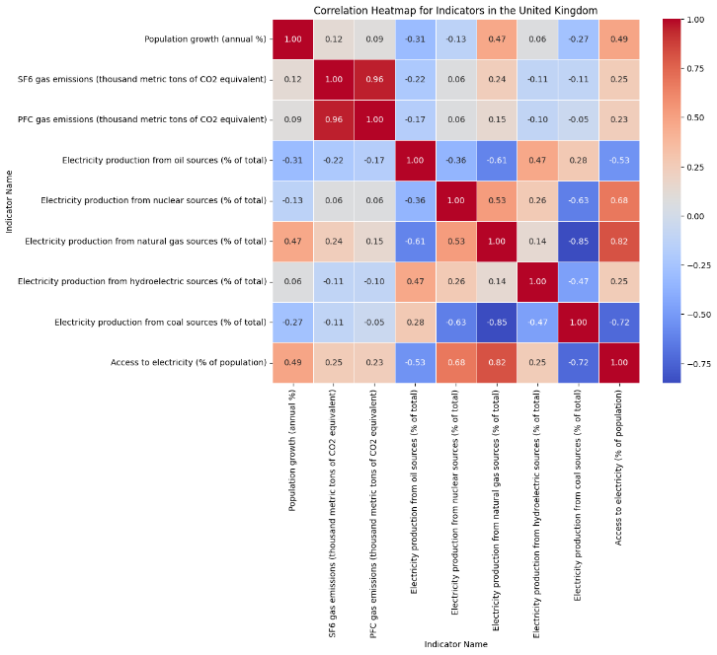

Curiously, the correlation matrix, which looks at multiple indicators for the United Kingdom's generation of electricity, shows some interesting insights. Access to electricity (% of population) and population growth (annual %) have a strong correlation, as seen in the heatmap. This shows that areas where power is more readily available could have a matching rise in population. Indicators like "Electricity production from nuclear sources (% of total)" and "Electricity production from natural gas sources (% of total)" also show a strong correlation with "Access to electricity (% of population). The increased use of nuclear power and natural gas as power generation sources is consistent with making energy more accessible. The complex processes of power generation and accessibility in the United Kingdom may be better understood with the help of these connections.