**Lab Report**

Title: Site Suitability for Solid waste management

Notice: Dr. Bryan Runck

Author: Deepika Mallika Tamilselvan

Date: 29/09/2022

**Project Repository:** *https://github.com/Deepikamt/GIS_5571*

**Google Drive Link:**

**Time Spent:** 10 days

**Abstract**

In India, the amount of Municipal Solid Waste (MSW) is expected to increase significantly in near future. In general, MSW is disposed of in low-lying, open, and uncontrolled managed areas without taking any precautions or operational controls. The management of MSW in India has surfaced or continued to be a severe problem because of environmental and aesthetic concerns and the enormous quantities generated every day. Multi-criteria analysis has been done for solid waste disposal site selection in this study. When remotely sensed data are combined with other landscape variables organized within a GIS environment, provides an excellent framework for data capture, storage, synthesis, measurement, and analysis. For assessing a site as a possible location for solid waste disposal, several environmental and political factors and legislation should be considered. The Geographical Information System (GIS) can provide an opportunity to integrate various thematic layers and other relevant data or other associated features, which will help in the selection of suitable disposal sites. The present study is carried out with the objective of identifying a suitable site for the disposal of MSW generated in Thanjavur using a Geographic Information System (GIS) and Analytical Hierarchy Process (AHP).

**Problem Statement**

Municipal Solid Waste Management (MSWM) is one of the major environmental problems of Indian megacities. In India, it is interesting to note that currently 1 out of 3 persons are living in urban areas and it is projected that as much as 50% of India’s population will live in cities in the next 10 years. In spite of heavy expenditure by civic bodies, MSWM continues to remain one of the most neglected areas of urban development in India. The MSWM is one of the country's main functions of all Urban Local Bodies (ULBs). All ULBs are required to meticulously plan, implement and monitor all systems of urban service delivery especially that of MSW. With limited financial resources, technical capacities, and land availability, urban local bodies are constantly striving to meet this challenge. MSWM provides guidance to urban local bodies on planning, designing, implementing, and monitoring municipal solid waste management systems. Issues of environmental and financial sustainability of these systems are a critical consideration.

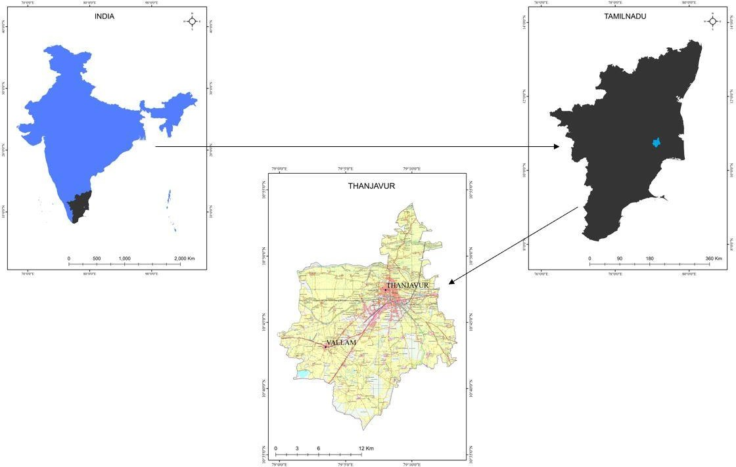

KEY MAP

*Figure: Key map*

Table 1 Required data

|  |  |  |  |  |  |
| --- | --- | --- | --- | --- | --- |
| **#** | **Requirement** | **Defined As** | **(Spatial) Data** | **Dataset** | **Preparation** |
| 1 | Lithology data | Type of rock present in an outcrop or subsurface rock | Vector | Geological Survey of India | Yes |
| 2 | Soil data | Type of soil available | Vector | National bureau of soil survey | Yes |
| 3 | Land use and Landcover data | How the land has been used | Raster | Landsat | Yes |
| 4 | Geomorphology data | Classification of landforms | Raster | Landsat | Yes |
| 5 | Lineament | Fissure or crack on earth’s surface | Line | Landsat | Yes |
| 6 | Road | Road network | Road geometry | Survey of India | Yes |

Table 2 Input data

|  |  |  |  |
| --- | --- | --- | --- |
| **#** | **Title** | **Purpose in Analysis** | **Link to Source** |
| 1 | Road | Raw input dataset for routing analysis | https://surveyofindia.gov.in/pages/downloads |
| 2 | Landsat data | Will be used to create LULC, Geomorphology, and Lithology | Landsat 8 |
| 3 | NBSS | Raw data to create a soil map | https://nbsslup.icar.gov.in/ |
| 4 | GSI | Raw data to create a Lithology map | https://www.gsi.gov.in/webcenter/portal/OCBIS |

**Methods**

Criteria to be considered for Municipal solid waste disposal site selection are identified and broadly grouped into exclusionary and non-exclusionary criteria. These criteria are defined using the standards given in Municipal Solid Waste (Management and Handling) Rules 2000 and include landfill area required, proximity to lakes and rivers, proximity to highways, distance to population centers, slope, etc. The non-exclusionary criteria are further categorized into four categories viz., Lithology, soil, geomorphology, land use/land cover.

EXCLUSIONARY CRITERIA:

The Board has formulated locational guidelines for the selection of engineered sanitary landfill sites. The minimum distance of the proposed landfill site from habitation, water bodies, Air Ports, etc., shall be as follows.

* No landfill should be constructed within 200mts of any lake or pond.(Land cover)
* No landfill within 100mts of navigable rivers or streams. (Streams)
* No landfill within 200mts of any state or national highway. (Toposheets)
* A landfill site must be at least 1000mts from a notified habitat area.(Toposheets)
* No landfill should be constructed within 2000mts of an airport.(Toposheets)
* A landfill should not be located in potentially unstable zones such as landslide-prone areas, fault zone, etc. (This can be identified through a Geomorphology map)
* A landfill not should be near a coastal regulation zone. (Since my study area is far away from the ocean or sea I can exclude this parameter)

NON-EXCLUSIONARY CRITERIA:

Exclusionary Criteria were prepared from different data. The Suitable sites were obtained by integrating all the thematic layers by assigning weightage to each parameter of individual thematic maps using Analytical Hierarchical process (AHP) methods. delineation of thematic layers such as lithology, soil, geomorphology, Landuse / land cover, and lineament map was prepared with aid of ArcGIS Pro.

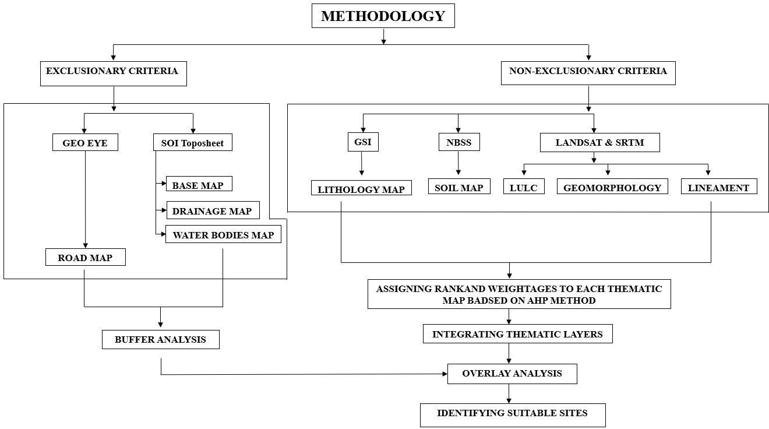

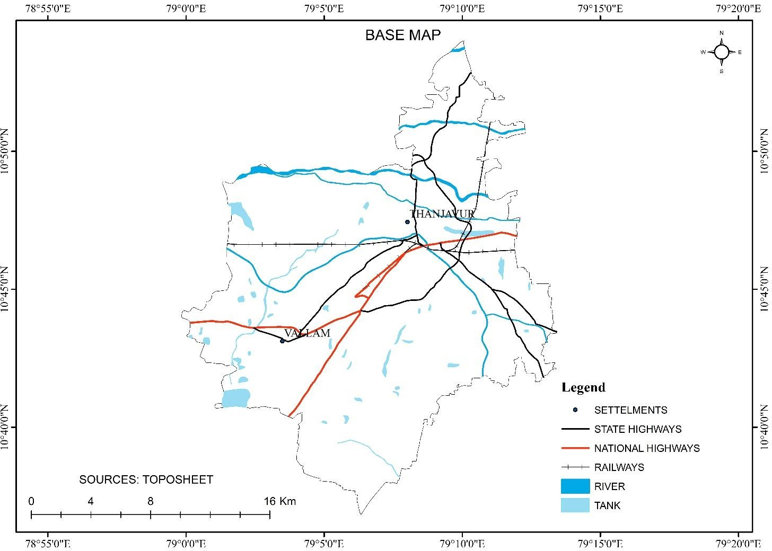

*Figure: Base map*

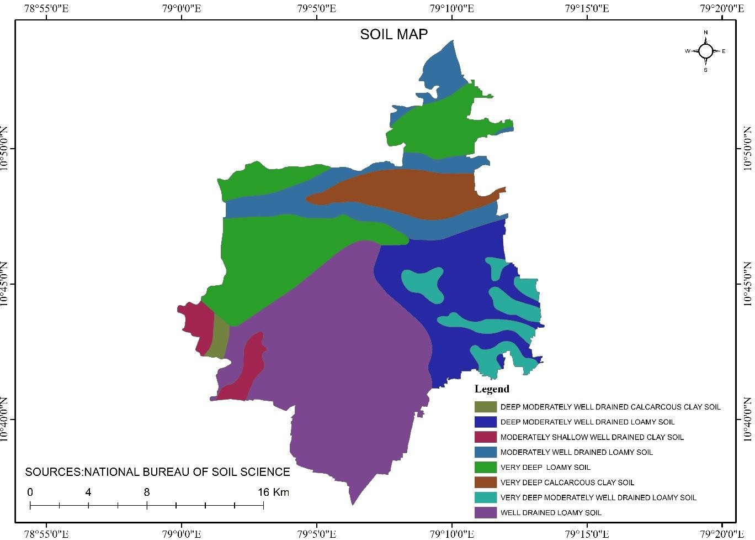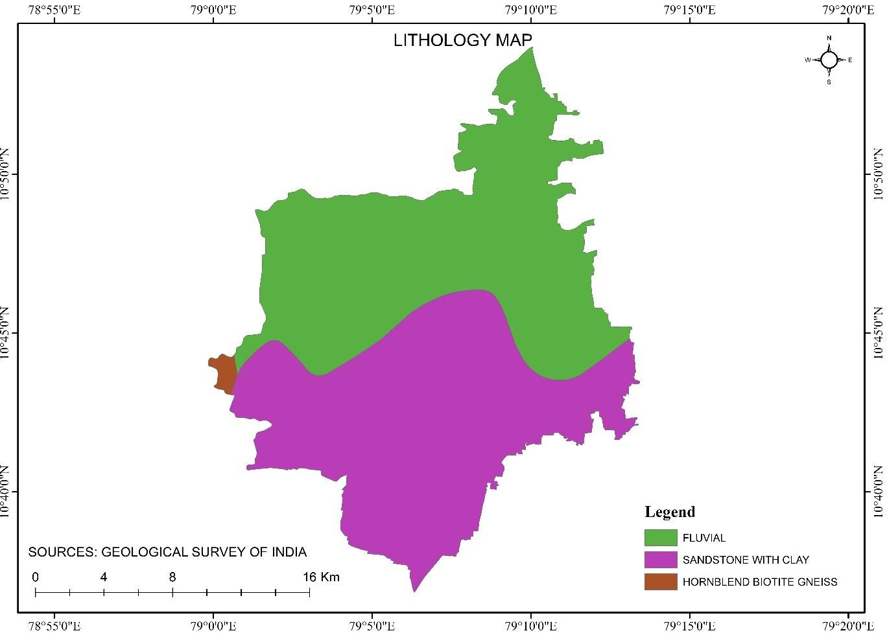

*Figure: Lithology map*

*Figure: Soil map*

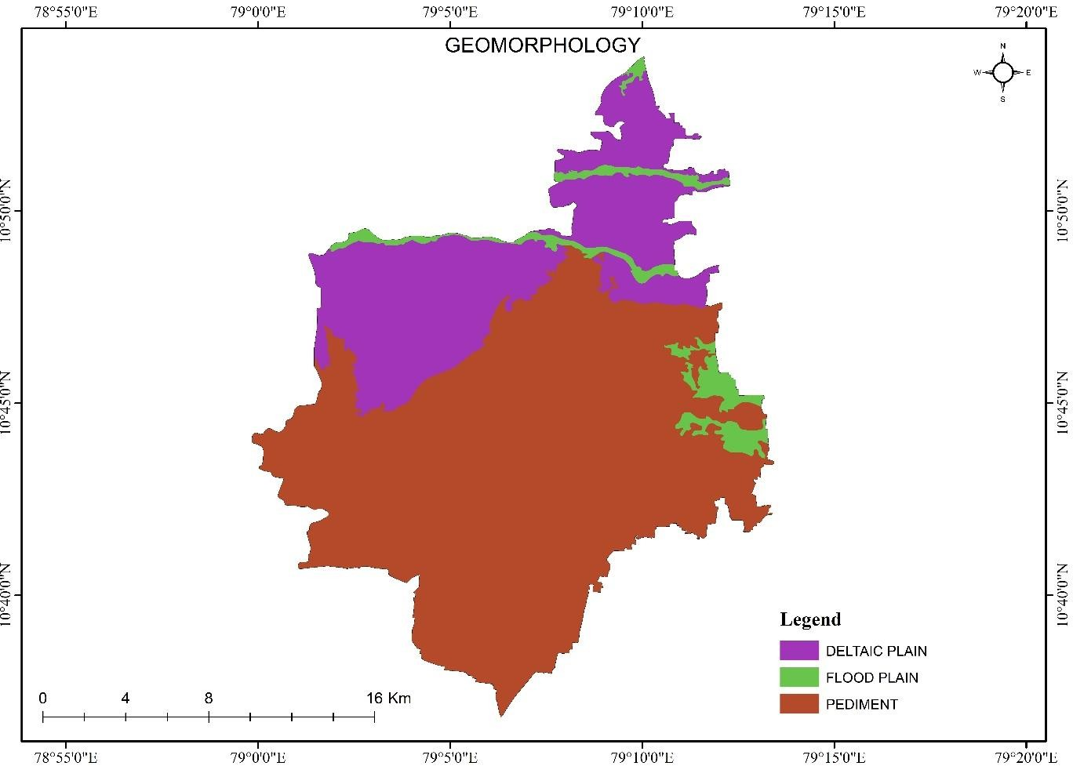

*Figure: Geomorphology map*

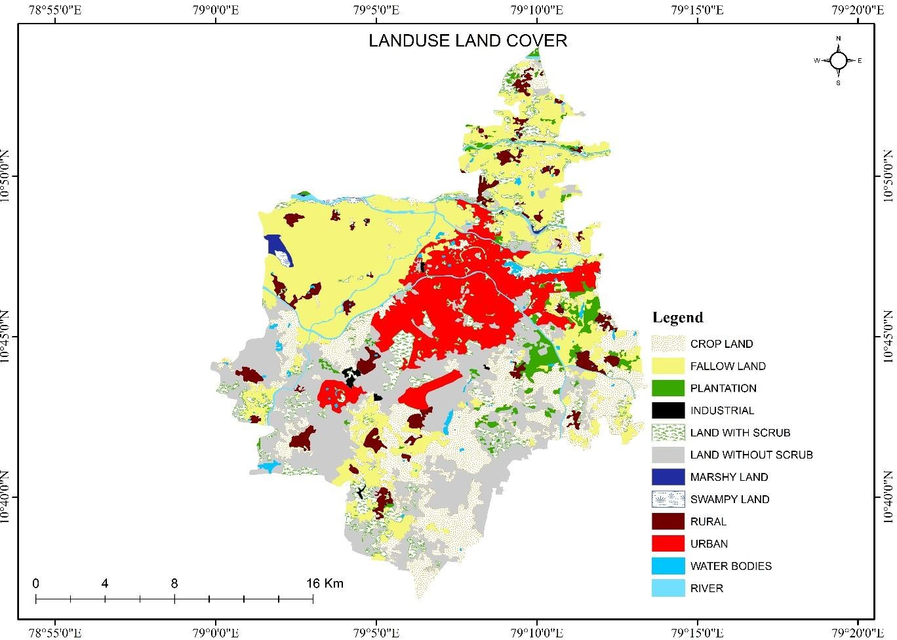

*Figure: Landuse and Land cover map*

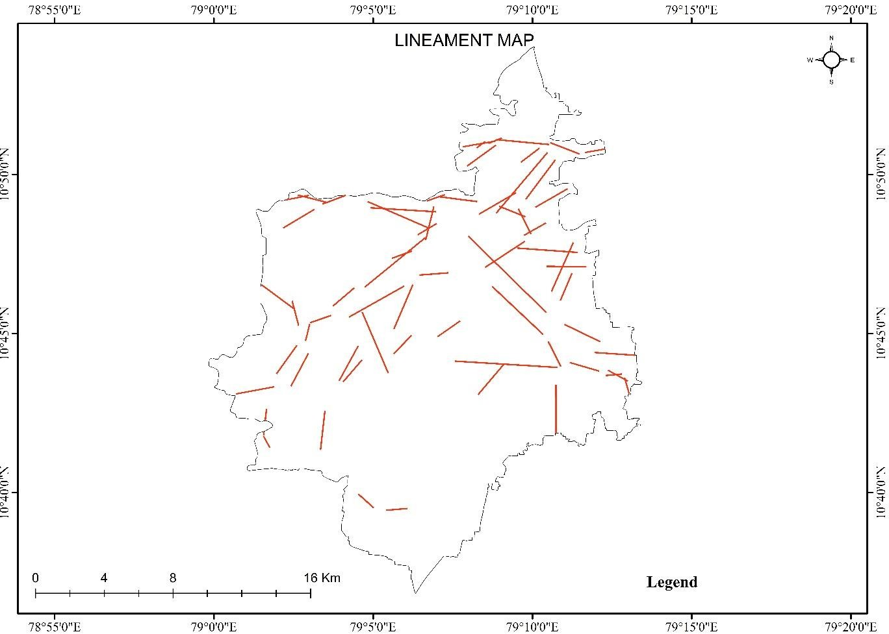

*Figure: Lineament map*

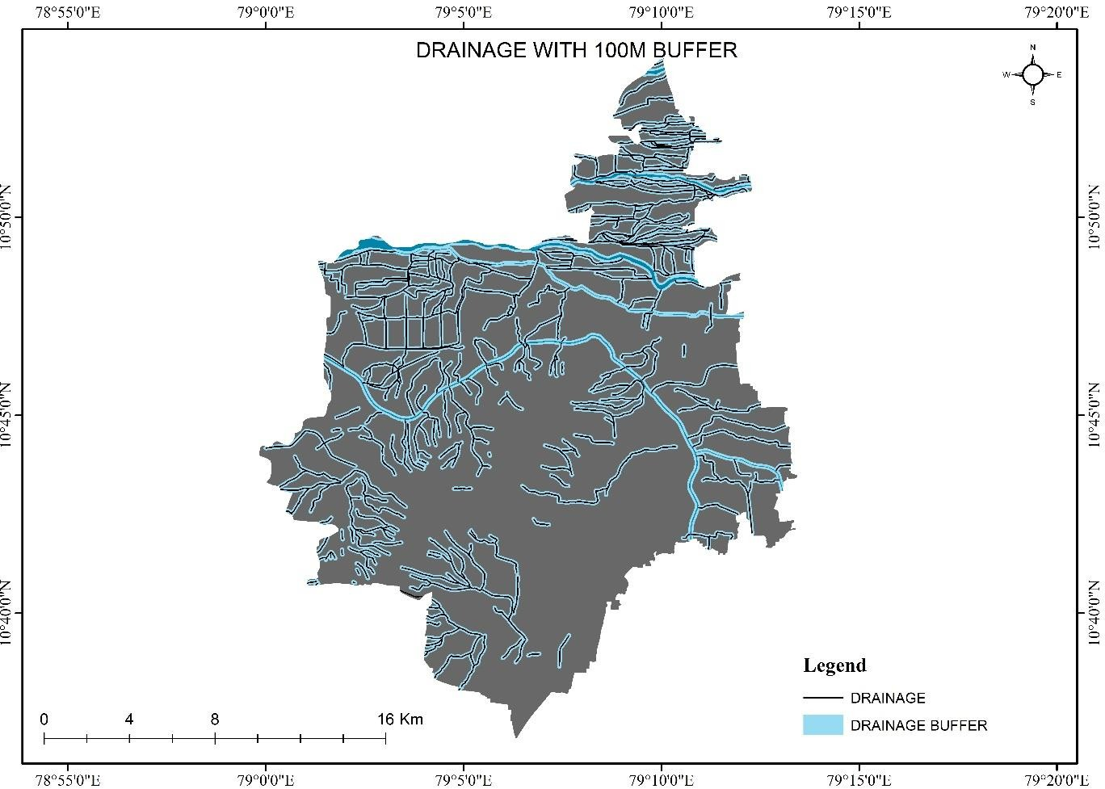

*Figure: Drainage buffer map (1000m)*

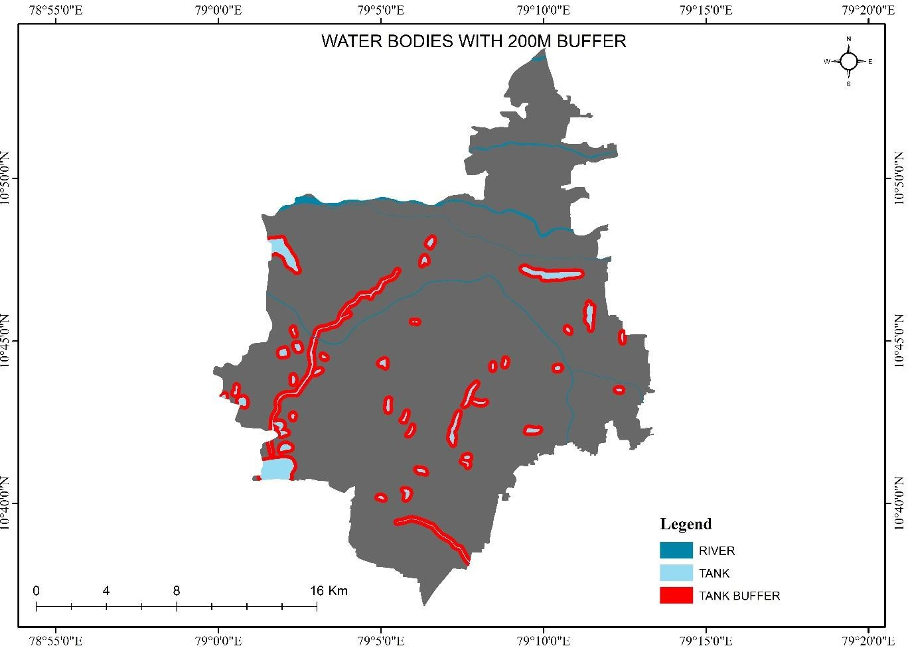

*Figure: Waterbodies buffer map (200m)*

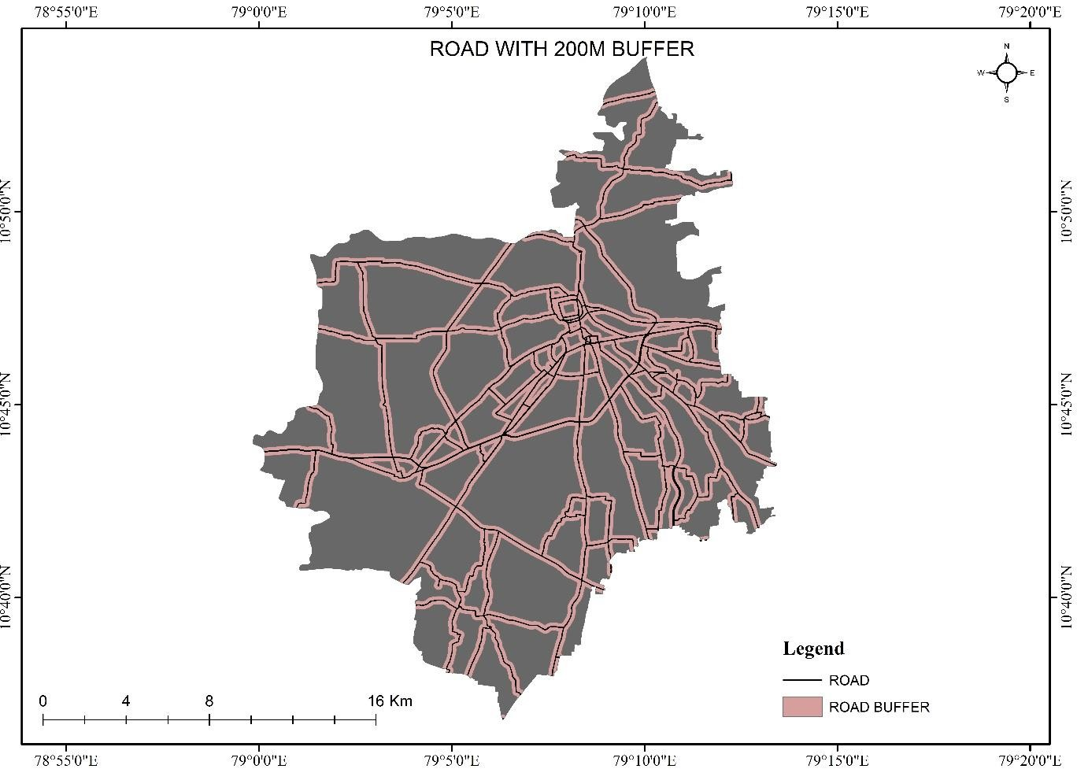

*Figure: Road buffer map (200m)*

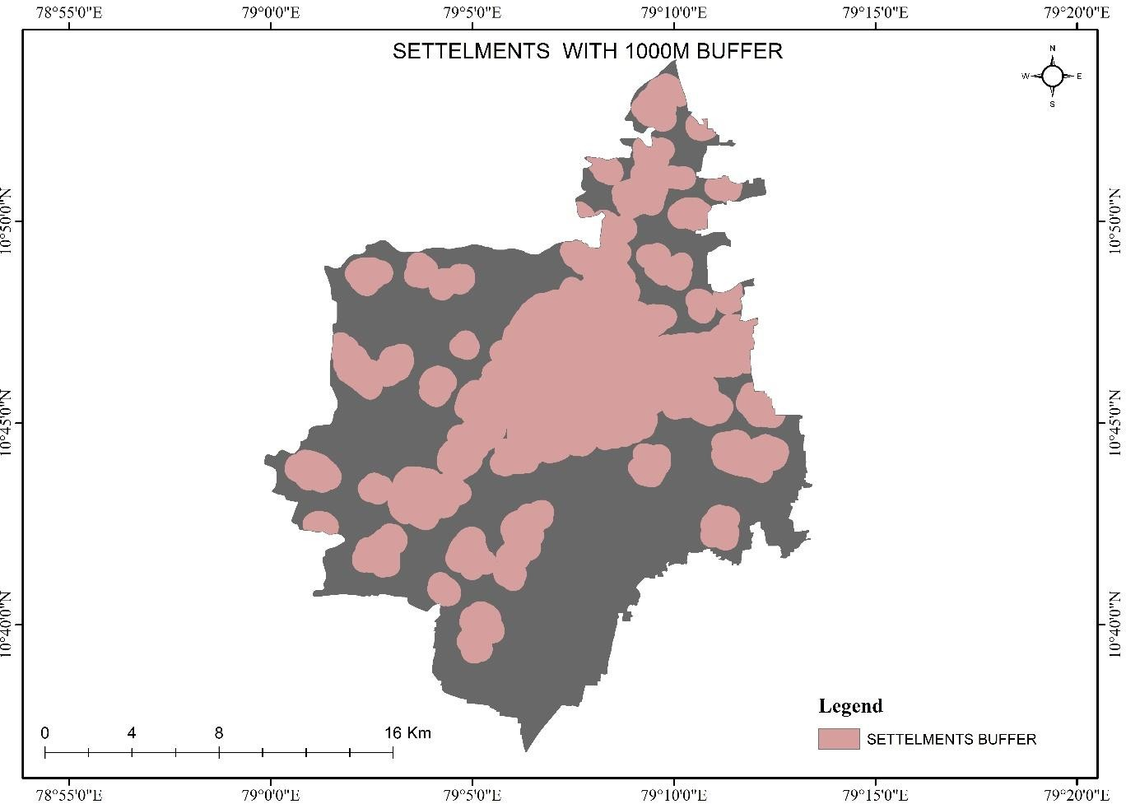

*Figure: Settlements buffer map (1000m)*

**Overlay through AHP**

The AHP method breaks down the complex multi-criteria decision problem into a hierarchy based on a pair-wise comparison of the importance of different criteria and sub-criteria (Saaty 2005). The following table shows the general method top assigning values. The normalization process reduces the subjectivity associated with the assigned weights of the thematic maps and their features. Furthermore, as the weights are assigned based on different experts’ opinions, the normalized weights of the thematic layers and those of their features are also examined for consistency of the features (Saaty1980).

The resultant can be used to compare and rank the alternatives, and hence assist the decision maker in making a choice. AHP is a systematic method for comparing a list of objectives or alternatives. The comparison matrix generated by the author’s expertise using Saaty’s scale is shown below.

|  |  |  |
| --- | --- | --- |
| **Intensity of importance** | **Definition** | **Explanation** |
| **1** | Equal importance | **Two elements contribute equally to the objective** |
| **3** | Moderate importance | **Experience and judgment slightly favor one element over another** |
| **5** | Strong Importance | **Experience and judgment strongly favor one element over another** |
| **7** | Very strong importance | **One element is favored very strongly over another, its dominance is demonstrated in practice** |
| **9** | Extreme importance | **The evidence favoring one element over another is of the highest possible order of affirmation** |
| **2,4,6,8 can be used to express intermediate values** | | |

**Assigned weight for each thematic layer**

|  |  |
| --- | --- |
| **THEMATIC LAYERS** | **WEIGHTAGE** |
| **LU/LC** | **8** |
| **SOIL** | **6** |
| **GEOMORPHOLOGY** | **6** |
| **LITHOLOGY** | **5** |

A pair-wise comparison matrix as shown below. The sums of each column and the then division of each column by the corresponding sum are computed to obtain the normalized weights.

|  |  |  |  |  |
| --- | --- | --- | --- | --- |
|  | **LULC** | **GEOMORPHOLOGY** | **SOIL** | **LITHOLULU** |
| **LULC** | 1 | 5 | 3 | 3 |
| **GEOMORPHOLOGY** | 0.2 | 1 | 2 | 2 |
| **SOIL** | 0.33333 | 0.5 | 1 | 2 |
| **LITHOLOGY** | 0.33333 | 0.5 | 0.5 | 1 |
| **SUM** | 1.86667 | 7 | 6.5 | 8 |

**PAIR-WISE COMPARISON MATRIX**

|  |  |  |  |  |  |
| --- | --- | --- | --- | --- | --- |
|  |  |  |  |  | **Criteria Weights** |
| **LULC** | 0.535 | 0.714 | 0.461 | 0.375 | 0.5216 |
| **GEOMORPHOLOGY** | 0.107 | 0.142 | 0.307 | 0.25 | 0.2019 |
| **SOIL** | 0.178 | 0.071 | 0.153 | 0.25 | 0.1634 |
| **LITHOLOGY** | 0.178 | 0.071 | 0.076 | 0.125 | 0.1129 |

**STANDARDIZED MATRIX**

|  |  |  |  |  |  |  |
| --- | --- | --- | --- | --- | --- | --- |
| **Criteria Weights** | **0.5216** | **0.2019** | **0.1634** | **0.1129** | **Weighted sum value** |  |
| **LULC** | 0.5216 | 1.0096 | 0.4903 | 0.3389 | 2.3605 | 4.5253 |
| **Geomorphology** | 0.1043 | 0.2019 | 0.3269 | 0.2259 | 0.8591 | 4.2547 |
| **Soil** | 0.1738 | 0.1009 | 0.1634 | 0.2259 | 0.6642 | 4.0637 |
| **Lithology** | 0.1738 | 0.1009 | 0.0817 | 0.1129 | 0.4695 | 4.1560 |
| **CI & CR WORKSHEET** | | | | | **λmax;** 4.2499 | |

|  |  |
| --- | --- |
| **CI** (Consistency Index) | 0.08332 |
| **RI** (Random Index) | 0.9 |
| **CR** (consistency ratio) | 0.09258 |

**Saaty’s RI values for matrices are given by the following table**

|  |  |  |  |  |  |  |  |  |  |  |
| --- | --- | --- | --- | --- | --- | --- | --- | --- | --- | --- |
| **Size of Matrix** | 1 | 2 | 3 | 4 | 5 | 6 | 7 | 8 | 9 | 10 |
| **Random Index (RI)** | 0 | 0 | 0.58 | 0.90 | 1.12 | 1.24 | 1.32 | 1.41 | 1.45 | 1.49 |

**Results**

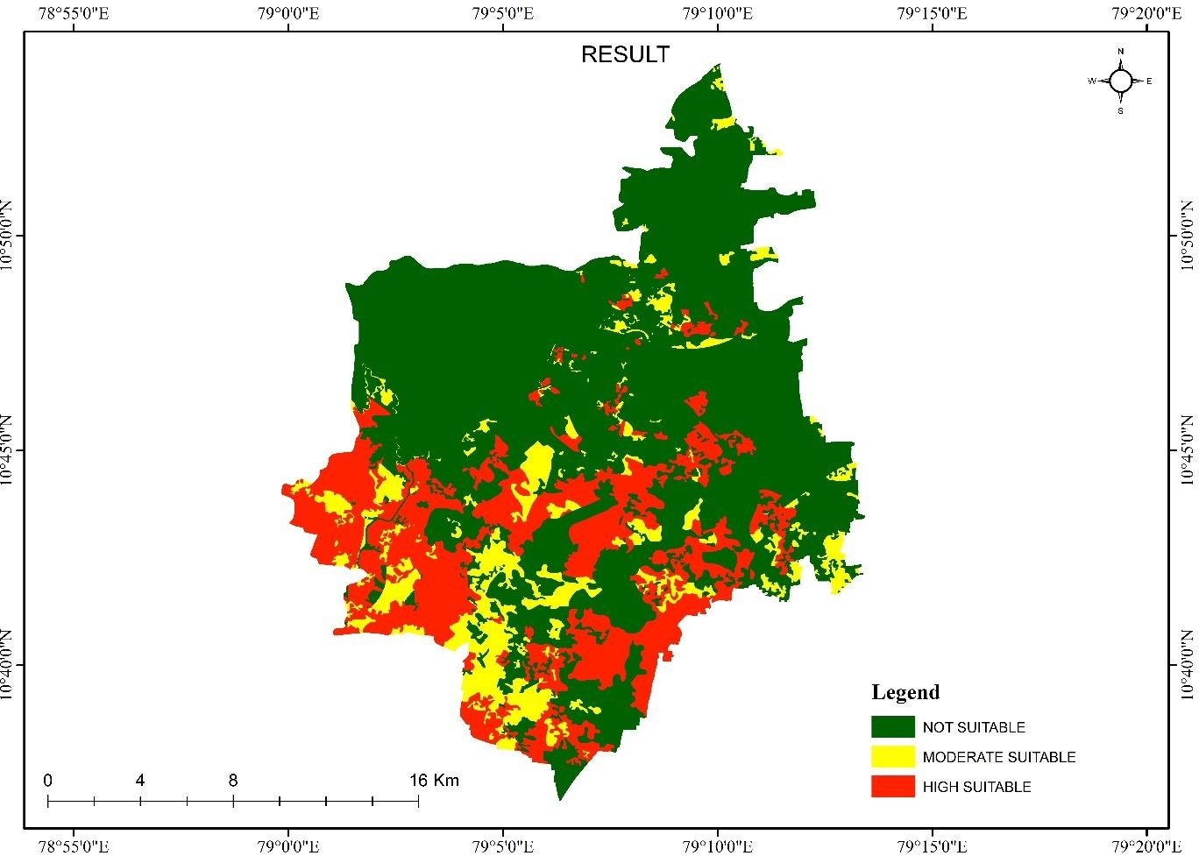

*Figure: Overlay output*

**Removing all exclusion zones**

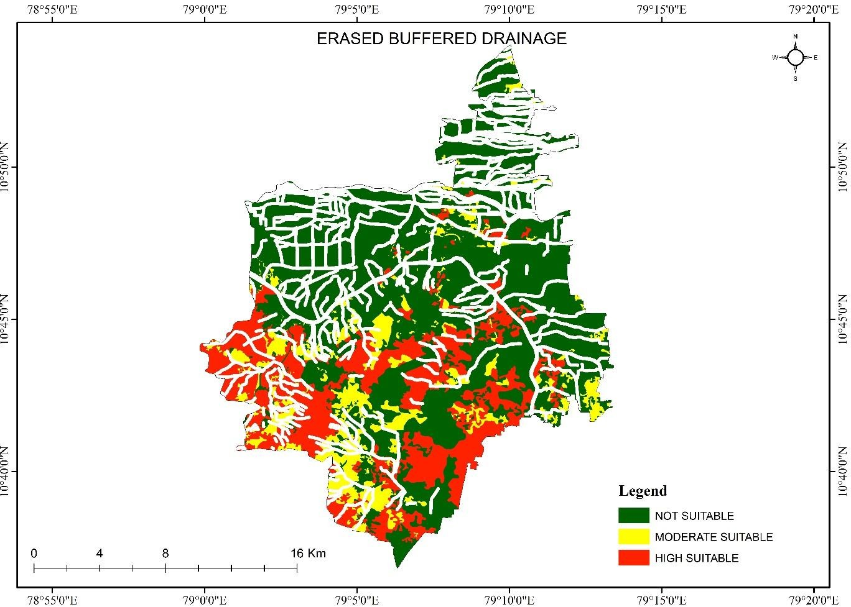

*Figure: Erased Drainage buffer*

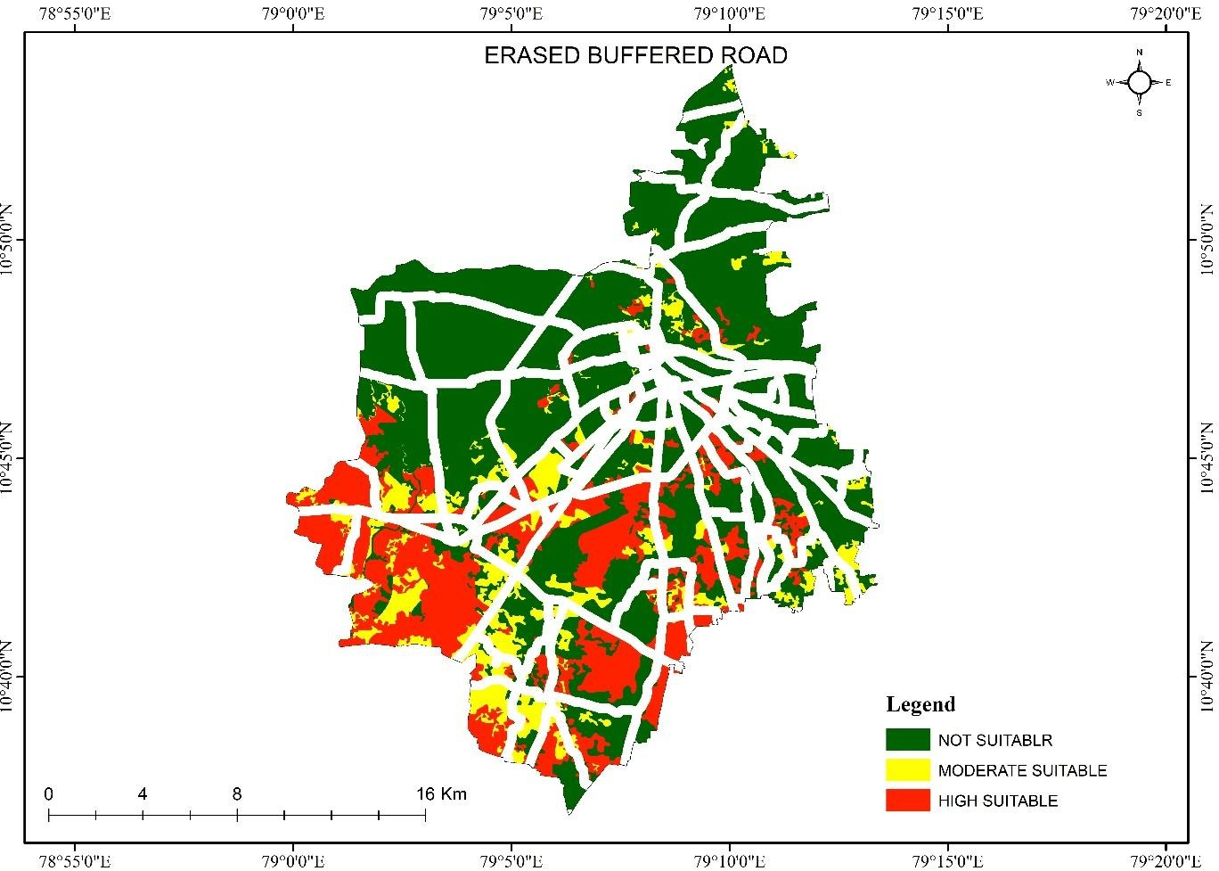

*Figure: Erased Road buffer*

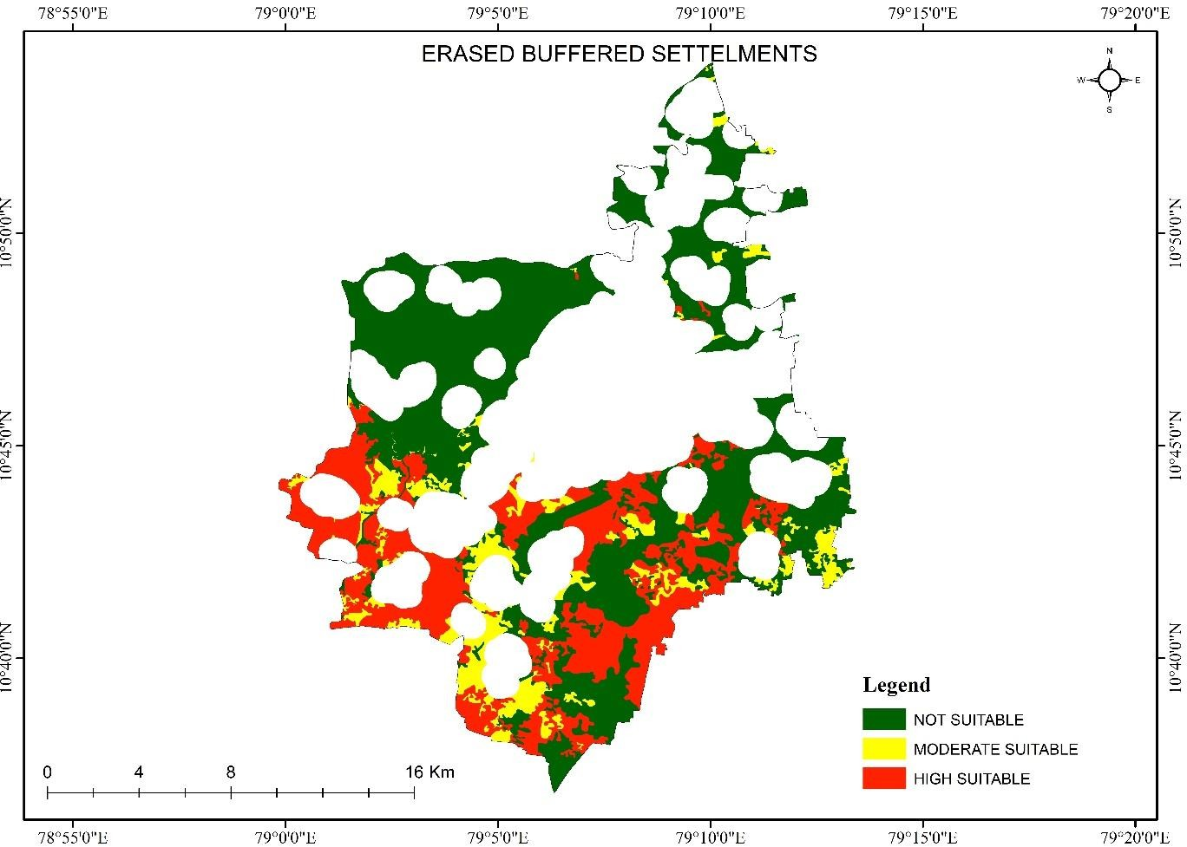

*Figure: Erased Settlements buffer*

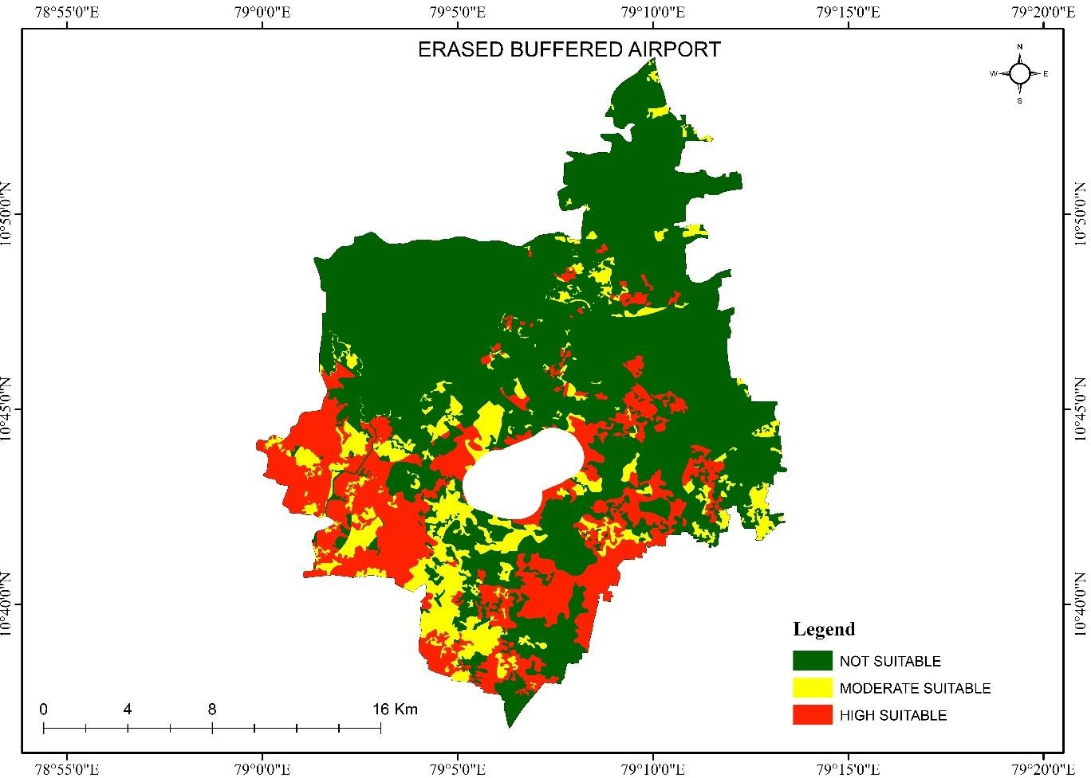

*Figure: Erased Airport buffer*

**SITE SUITABILITY MAP**

After erasing all the Exclusionary layers from the AHP result, final site suitability map has been prepared. Of the many sites identified, sites selected for solid waste dumping based on attribute evaluation. This study will reveal which area in my study area will be highly suitable for solid waste dumping. In addition, which area needs to have more concentration? Solid waste management is an important part of sustainable development. Good solid waste practices can help to reduce greenhouse gas emissions. It can help to reduce pollution and protect the environment. While improper solid waste management can lead to environmental contamination and health risks.

The site suitability map is shown below,

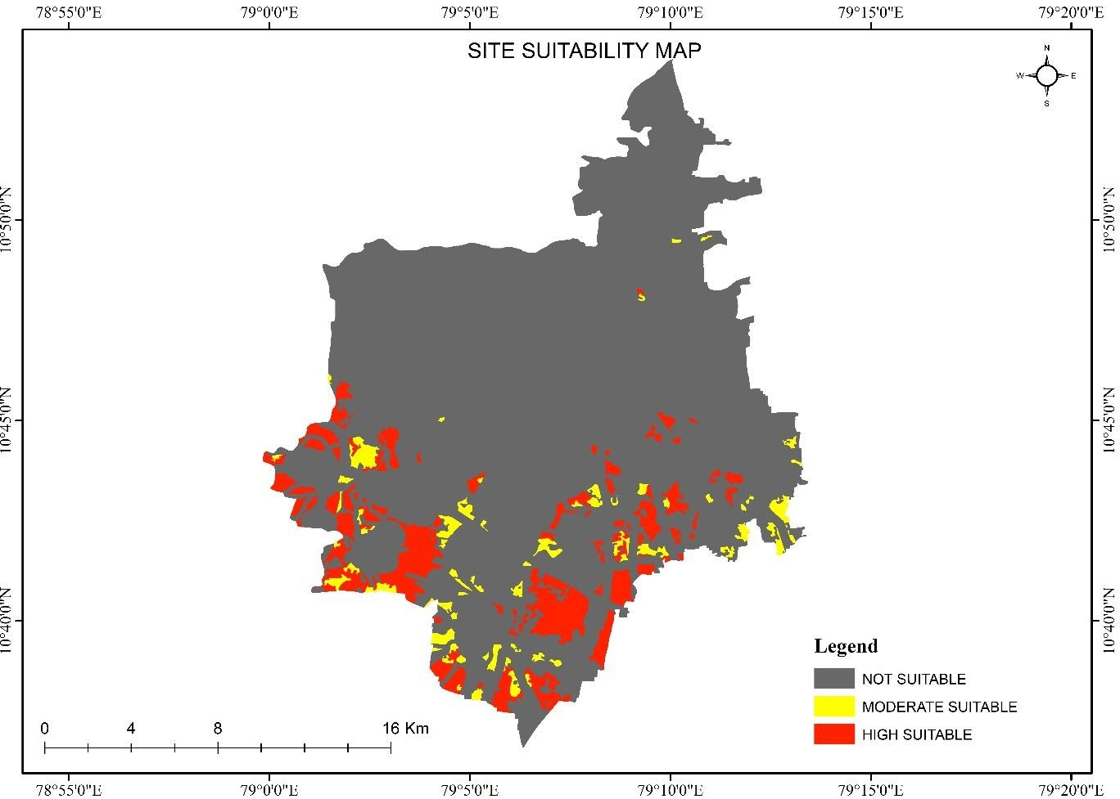

*Figure: Site Suitability map*

**Results Verification**

The results of the solid waste management site suitability study have shown that the proposed site is suitable for the development of a solid waste management facility. This methodology incorporates a large number of environmental and economic factors which are essential to identify the sites which have no or minimal adverse impact on the environment. In fact, many other parameters are required to make this study in a broad manner, but I am going to take the most important parameters. Based on the analysis, it was determined that the proposed site meets all the necessary requirements for the development of a solid waste management facility. The site is located in an area that is easily accessible by waste collection vehicles, and the geology and topography of the site are suitable for the construction of waste management infrastructure. Overall, the results of the study indicate that the proposed site is a suitable location for the development of a solid waste management facility. It is recommended that the project proceed as planned, with appropriate measures put in place to mitigate any potential negative impacts.

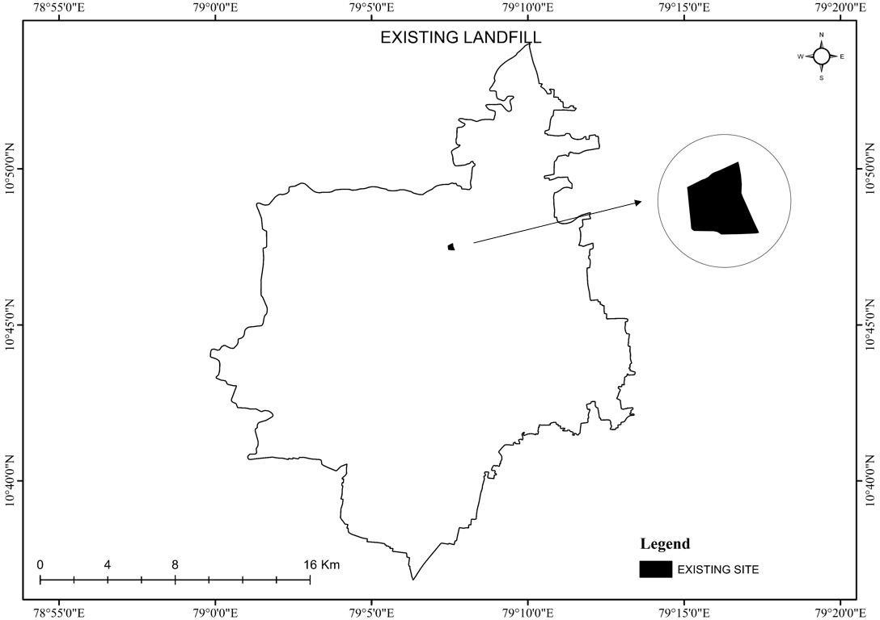

*Figure: Already existing landfill map*

|  |  |  |  |
| --- | --- | --- | --- |
| S. No | Zone | Area (Sq.km) | Area (Acres) |
| 1 | HIGH SUITABLE | 35.667 | 8813.577 |
| 2 | MODERATE SUITABLE | 11.379 | 2811.847 |
| 3 | NOT SUITABLE | 346.229 | 85572.355 |

The results reveal that the area falls into three classes ranging from not suitable to highly suitable. The result shows (Fig 6.5) that 35.667 km² area is highly suitable, 11.379 km² area is moderately suitable for dumping & 346.299 km² area is unsuitable.

Moderately rate suitable region the indicative of the least favorable region for dumping waste, while highly high suitable indicates the most favorable region. The study illustrates the importance of GIS technology in the presdaydays. GIS technology, as an information tool, has helped in the acquisition of recent land use information studies aimed at solving environmental problems.

**Discussion and Conclusion**

It is apparent that the already existing solid waste landfill is not located in an appropriate place that should be moved to somewhere place for the betterment of the people as well as the government. Solid waste management (SWM) has so far been the most ignored and least studied area in environmental sanitation. However, it is a vital, ongoing and large public service system, which needs to be efficiently provided to the community to maintain aesthetic and public health standards. Municipal agencies will have to plan and execute the system in keeping with the increase in population. Through this project, I believe that I will be able to gain more knowledge on how site suitability has been created.



**References**

* + 1. Nishanth., Prakash, M.N., Vijith, H., (2010). Suitable site determination for urban solid waste disposal using GIS and Remote sensing techniques in Kottayam Municipality, India. International Journal of Geomatics and Geosciences Volume 1, No 2, pp 197-210.
    2. Babalola, A., Busu, I. (2011): Selection of landfill sites for solid waste treatment in Damaturu town-using GIS techniques. - J Environ Prot 2(1):1-10, DOI: 10.4236/jep.2011.21001
    3. Eiselt, H. A., Marianov, V. (2015): Location modelling for municipal solid waste facilities. - Comput Oper Res 62(1): 305–315.
    4. Alanbari, M. A., Al-Ansari, N., Jasim, H. K. (2014): GIS and multicriteria decision analysis for Landfill site selection in Al-Hashemiyah Qadaa. - Natural Science 6: 282–304, <http://dx.doi.org/10.4236/ns.2014.65032>.
    5. A Support Manual for Municipal Solid Wastes (Management and Handling) Rules, 2000, Central Pollution Control Board (CPCB), Ministry of Environment and Forests, New Delhi.4.
    6. Jilani T**,** 2002. State of Solid Waste Management in Khulna City. Unpublished Undergraduate thesis, Environmental Science Discipline, Khulna University Khulna, pp. 2585.

**Self-score**

|  |  |  |  |
| --- | --- | --- | --- |
| **Category** | **Description** | **Points Possible** | **Score** |
| **Structural Elements** | All elements of a lab report are included **(2 points each)**:  Title, Notice: Dr. Bryan Runck, Author, Project Repository, Date, Abstract, Problem Statement, Input Data w/ tables, Methods w/ Data, Flow Diagrams, Results, Results Verification, Discussion and Conclusion, References in common format, Self-score | 28 | 28 |
| **Clarity of Content** | Each element above is executed at a professional level so that someone can understand the goal, data, methods, results, and their validity and implications in a 5 minute reading at a cursory-level, and in a 30 minute meeting at a deep level **(12 points)**. There is a clear connection from data to results to discussion and conclusion **(12 points)**. | 24 | 23 |
| **Reproducibility** | Results are completely reproducible by someone with basic GIS training. There is no ambiguity in data flow or rationale for data operations. Every step is documented and justified. | 28 | 28 |
| **Verification** | Results are correct in that they have been verified in comparison to some standard. The standard is clearly stated **(10 points)**, the method of comparison is clearly stated **(5 points)**, and the result of verification is clearly stated **(5 points)**. | 20 | 18 |
|  |  | 100 | 97 |