Assignment

**1. Create a blog or website using Blogspot and WordPress. Customize the theme design and post new article with 500 words.**

[**https://denmashgroups.blogspot.com/2023/10/demkash-incinerator.html?m=1**](https://denmashgroups.blogspot.com/2023/10/demkash-incinerator.html?m=1)

**2. Create a New Facebook Business Page and post one social media poster for your brand.**

[**https://www.facebook.com/profile.php?id=61552238751440&mibextid=ZbWKwL**](https://www.facebook.com/profile.php?id=61552238751440&mibextid=ZbWKwL)

**3. Create and design a social media advertisement poster using canva.**

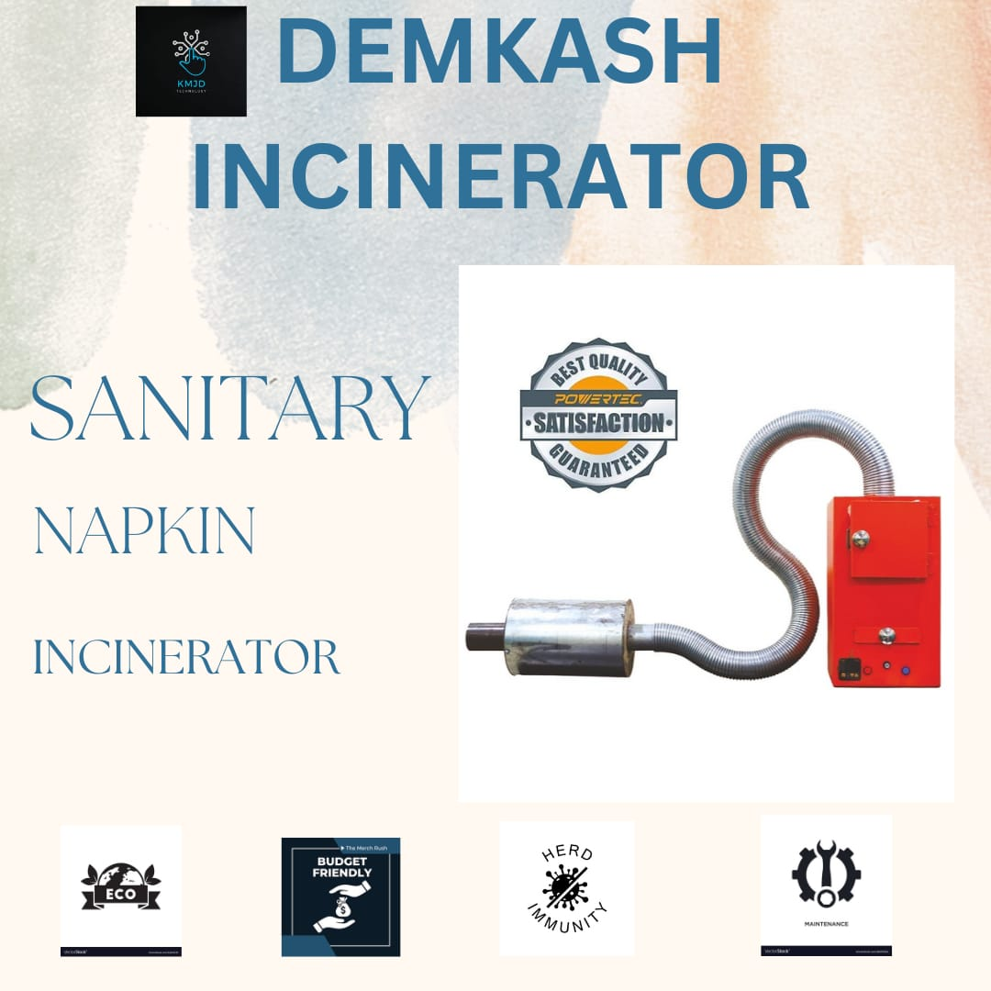

[**https://m.facebook.com/story.php?story_fbid=pfbid0N3ZK2VkLZndgw5LJzV9en1z4Cky2b3CeHFNDs3N5xYZZP6QkxE6zfD9JTEZrJ72ml&id=61552238751440&mibextid=Nif5oz**](https://m.facebook.com/story.php?story_fbid=pfbid0N3ZK2VkLZndgw5LJzV9en1z4Cky2b3CeHFNDs3N5xYZZP6QkxE6zfD9JTEZrJ72ml&id=61552238751440&mibextid=Nif5oz)

**4. Create email newsletter design using MailChimp or canva tool.**

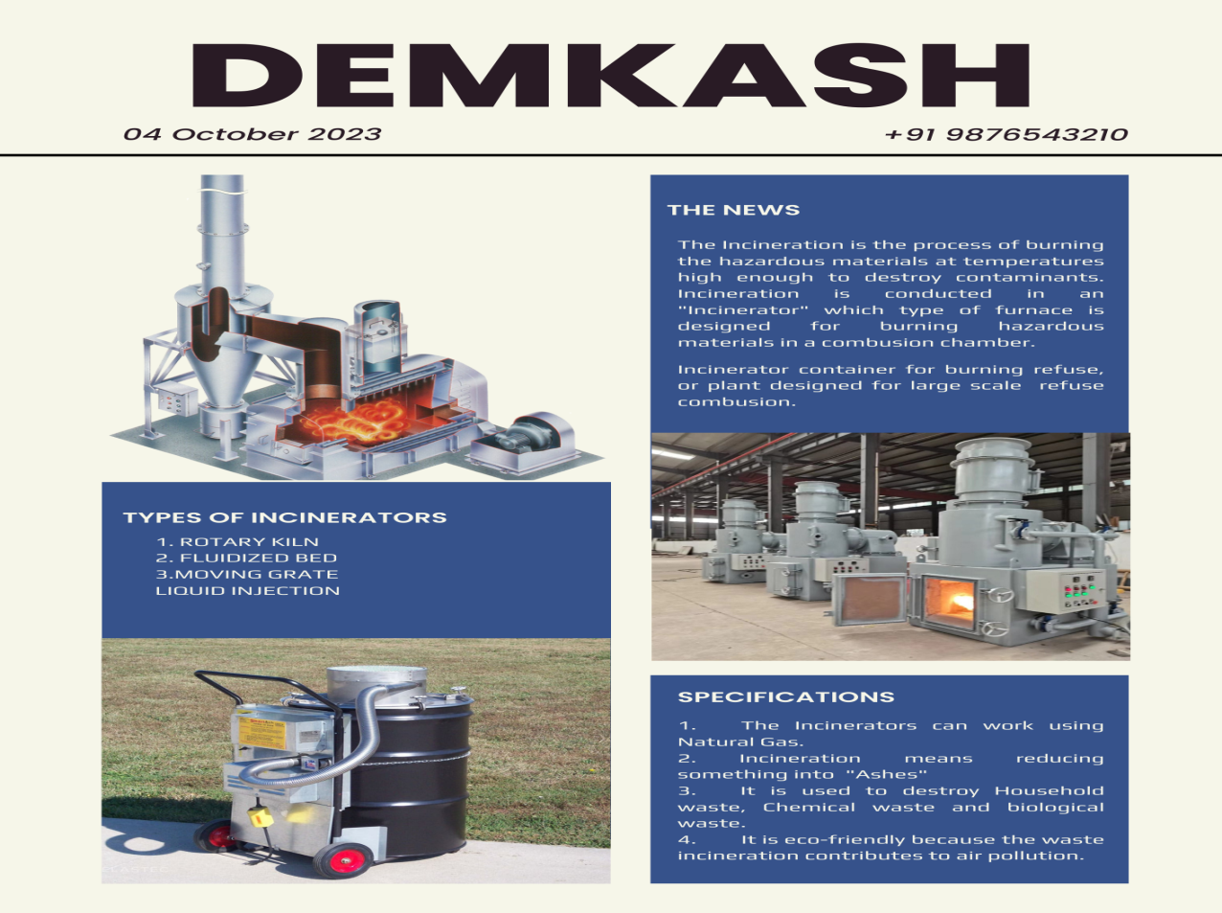

[**https://m.facebook.com/story.php?story_fbid=pfbid0RGk8b719df7yTR52Md9kZUfckMkiiciE8MGxTX5gZsVo9Kk9iE8NTi1rtXzrZ25Xl&id=61552238751440&mibextid=Nif5oz**](https://m.facebook.com/story.php?story_fbid=pfbid0RGk8b719df7yTR52Md9kZUfckMkiiciE8MGxTX5gZsVo9Kk9iE8NTi1rtXzrZ25Xl&id=61552238751440&mibextid=Nif5oz)