Show database

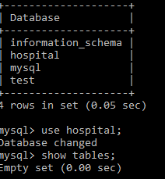

Creating a table doctor and its description

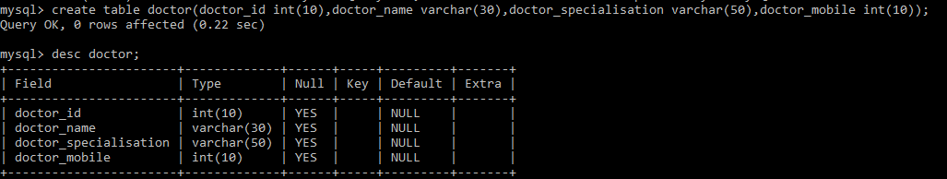

Alter Table with modify and change

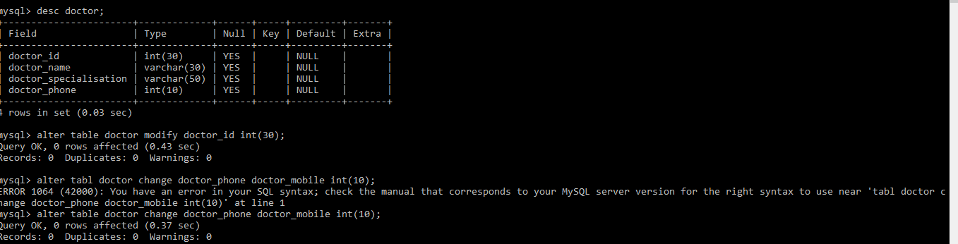

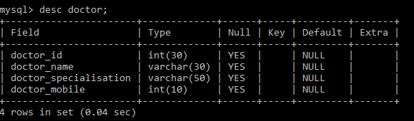

Alter table – Add new columns

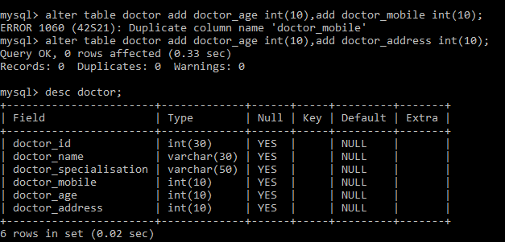

Alter – Drop few columns

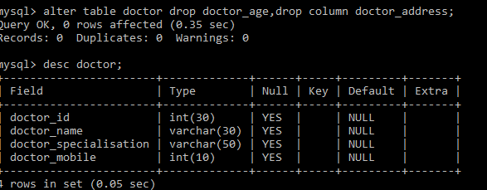

Insert

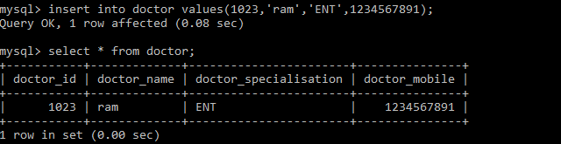

Insert

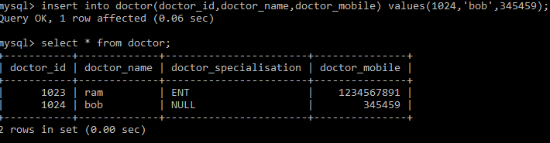

Update

