Deepika P Mavinakatti
2611006900019

CRYPTO ASSIGNMENT
LAB 2 :
Importance of Cryptography
Cryptography is one of the most important tools for protecting information on the internet. To understand its role, I carried out an experiment using Wireshark in Kali Linux. In this experiment, I captured dummy login credentials being sent over both HTTP and HTTPS, and the results showed a clear difference in how each protocol handles sensitive data.
When I logged in through HTTP, Wireshark displayed the username and password directly in the packet details. The credentials were visible in plain text, meaning anyone monitoring the network could easily read them. This shows that HTTP does not provide any security for confidential information, and it leaves users vulnerable to attacks such as eavesdropping or credential theft.

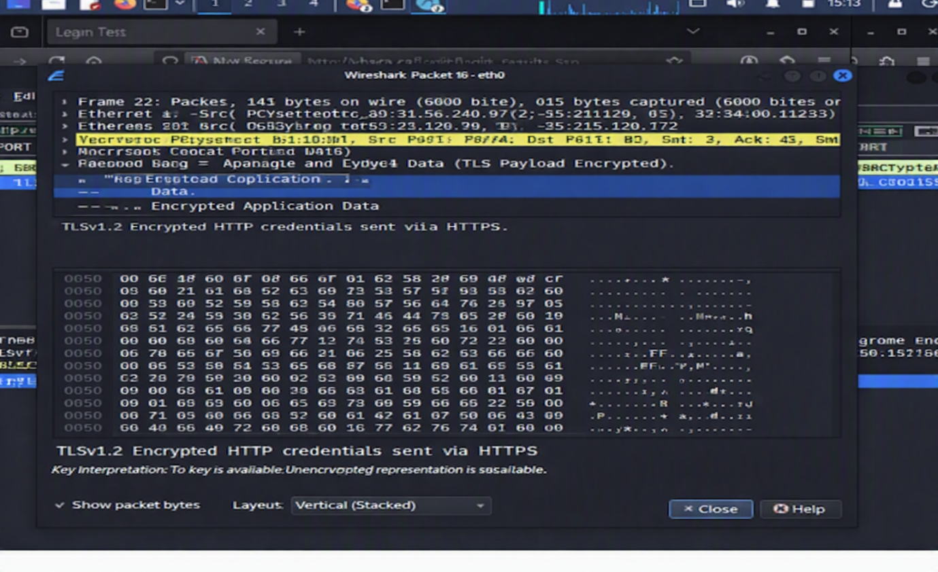
HTTP Traffic Analysis Observations

However, when I repeated the same process using HTTPS, the outcome was very different. Wireshark still captured the packets, but instead of showing the credentials, the data appeared as encrypted blobs. The packets contained TLS handshake messages and encrypted application data, which means the login details were scrambled by cryptography. Only the intended server, with the correct keys, could decrypt and read the information. For anyone intercepting the traffic, the credentials were completely hidden.
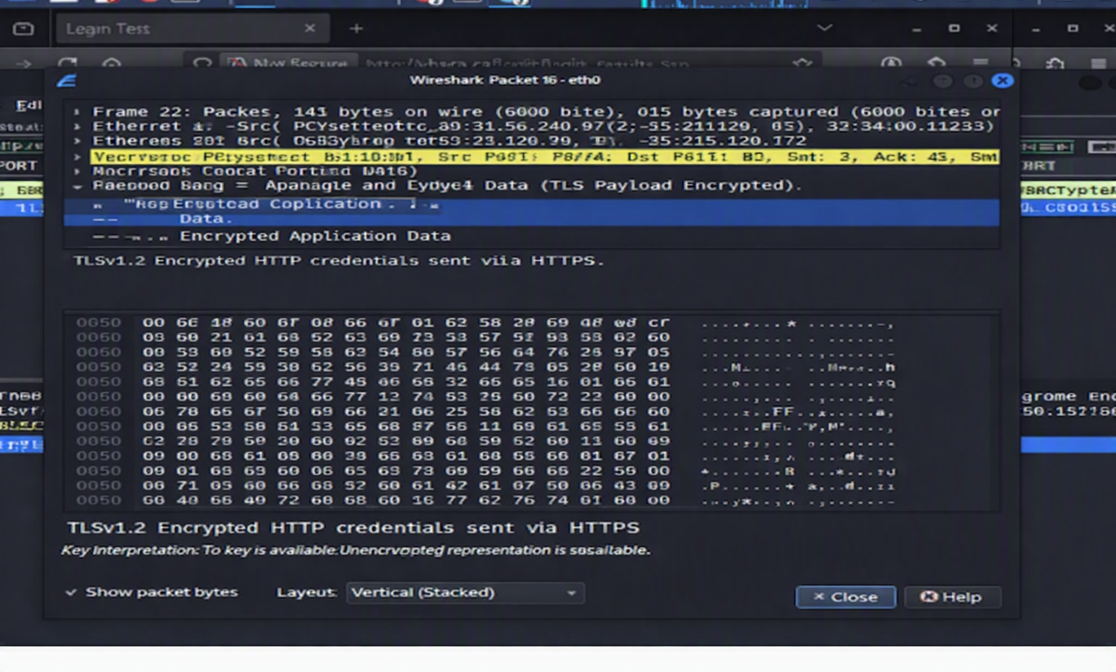
HTTPS Traffic Analysis Observations

By comparing the two,
it becomes clear that HTTP exposes sensitive data openly, while HTTPS secures it through encryption. Encryption ensures that even if someone captures the traffic, they cannot understand or misuse the information. This protects against man-in-the-middle attacks and keeps communication private and trustworthy.
Without encryption, personal data such as login credentials, financial details, or private messages would be at risk. With cryptography, users can be confident that their information is safe during transmission, making secure communication possible in today’s digital world.

Role of Encryption
- Encryption converts readable data into ciphertext using cryptographic keys.
- In HTTPS, TLS (Transport Layer Security) ensures:
Confidentiality — data cannot be read by unauthorized parties.
Integrity — data cannot be altered during transit.
Authentication — verifies the server’s identity via digital certificates.
- This mechanism protects sensitive information such as login credentials, banking details, and personal data from interception.

