Gowtham Patel C
261100690007

Part A: Authentication Log

Exercise 1: To print

Write sed commands to:

Print the first log entry.
: sed -n '1p' auth.log

Print the fifth log entry.
: sed -n '5p' auth.log

Print entries from lines 2 to 6.
: sed -n '2,6p' auth.log

Print the last entry.
: sed -n '$p' auth.log

Print every second log entry starting from line 1.
: sed -n '1~2p' auth.log

Print all entries containing Failed password.
: sed -n '/Failed password/p' auth.log

Print all successful login entries containing Accepted password.
: sed -n '/Accepted password/p' auth.log

Print entries from the first failed login to the authentication failure.
: sed -n '/Failed password/, /authentication failure/p' auth.log

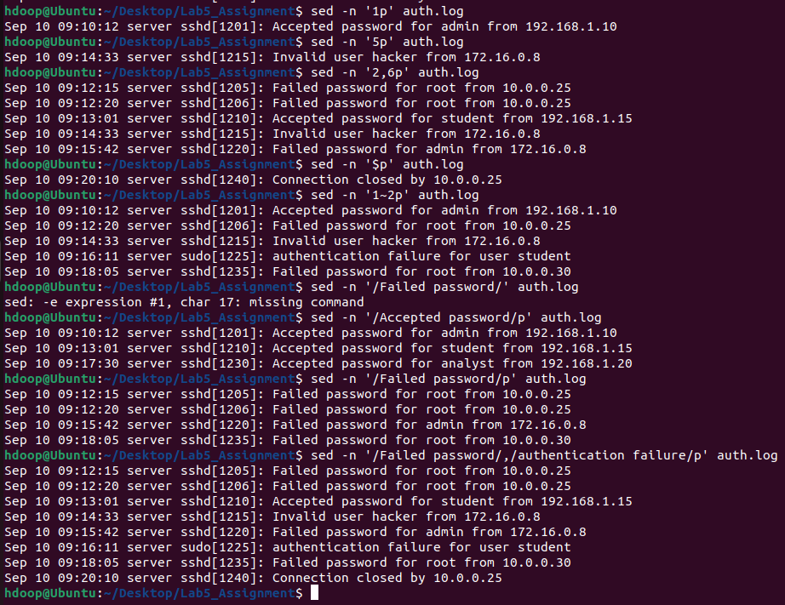

Exercise 2: Filtering Security Events

Write commands to:

Display failed login attempts.
: sed -n '/Failed password/p' auth.log

Display successful login attempts.
: sed -n '/Accepted password/p' auth.log

Display entries associated with the root account.
: sed -n '/root/p' auth.log

Display entries containing Invalid user.
: sed -n '/Invalid user/p' auth.log

Display all events related to IP address 172.16.0.8.
: sed -n '/172\.16\.0\.8/p' auth.log

Display all events that do not contain Accepted password.
: sed -n '/Accepted password/!p' auth.log

Display all events except those generated by sudo.
: sed -n '/sudo/!p' auth.log

Display only the entries that contain either Failed password or Invalid user using multiple -e commands.
: sed -n -e '/Failed password/p' -e ‘/Invalid user/p’ auth.log

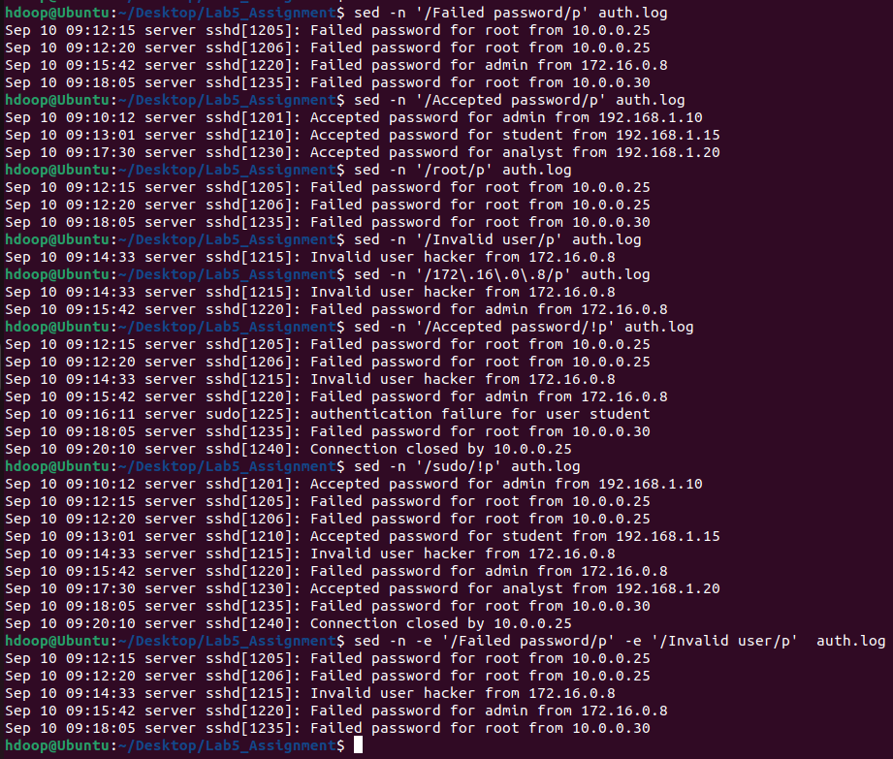

Exercise 3: Removing Irrelevant Entries

Without modifying the original file, display the log after:

Deleting successful login entries.
: sed '/Accepted password/d' auth.log

Deleting entries containing Connection closed.
: sed '/Connection closed/d' auth.log

Deleting the first three entries.
: sed '1,3d' auth.log
Deleting entries from lines 4 to 7.
: sed '4,7d' auth.log

Deleting all entries associated with 192.168.1.15.
: sed '/192\.168\.1\.15/d' auth.log

Deleting every second entry starting from the first line.
: sed '1~2d' auth.log

Deleting all events that do not contain Failed password.
: sed '/Failed password/!d' auth.log

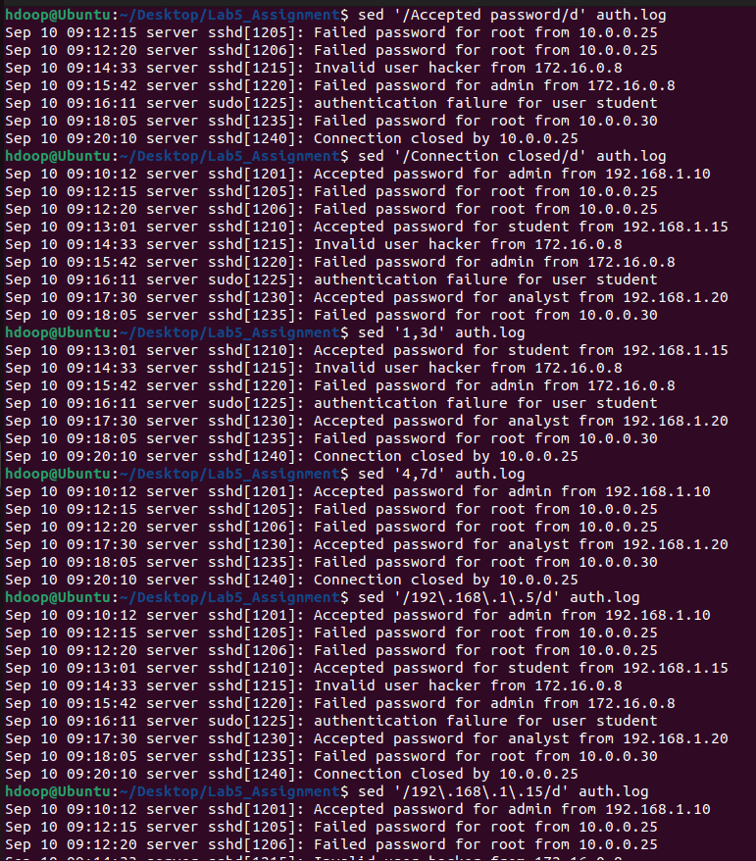
Exercise 4: Classifying Security Events

Replace Accepted password with [SUCCESSFUL LOGIN].
: sed 's/Accepted password/[SUCCESSFUL LOGIN]/g' auth.log

Replace Failed password with [FAILED LOGIN].
: sed 's/Failed password/[FAILED LOGIN]/g' auth.log

Replace Invalid user with [INVALID USER].
: sed 's/Invalid user/[INVALID USER]/g' auth.log

Replace authentication failure with [AUTHENTICATION FAILURE].
: sed 's/authentication failure/[AUTHENTICATION FAILURE]/g' auth.log

Replace root with PRIVILEGED_USER.
: sed 's/\broot\b/PRIVILEGED_USER/g' auth.log

Replace every occurrence of server with authentication-server.
: sed 's/server/authentication-server/g' auth.log

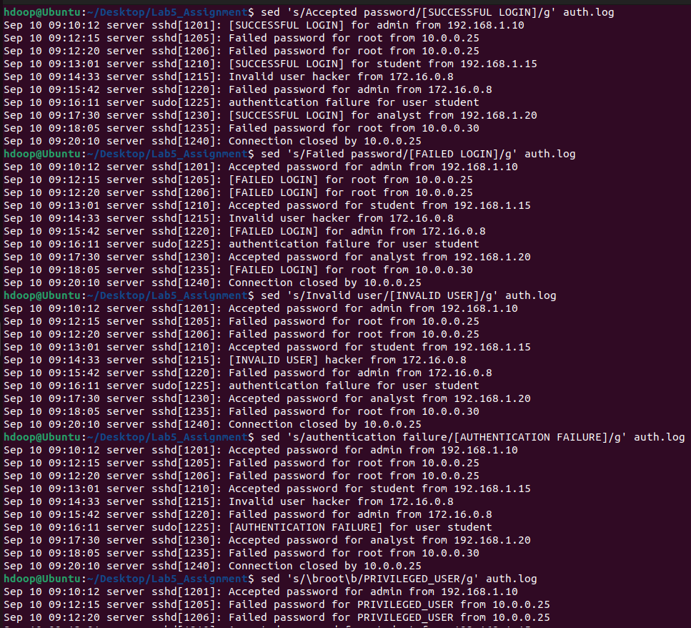
Exercise 5: Masking Sensitive Information

Use sed to anonymise the log before sharing it.

Replace IP address 10.0.0.25 with X.X.X.X.
: sed 's/10\.0\.0\.25/X.X.X.X/g' auth.log

Replace 172.16.0.8 with SUSPICIOUS_IP.
: sed 's/172\.16\.0\.8/SUSPICIOUS_IP/g' auth.log

Replace username admin with USER_A.
: sed 's/\badmin\b/USER_A/g' auth.log

Replace username student with USER_B.
: sed 's/\bstudent\b/USER_B/g' auth.log

Replace all digits with X.
: sed 's/[0-9]/X/g' auth.log

Replace periods in IP addresses with hyphens.
: sed 's/\([0-9]*\)\.\([0-9]*\)\.\([0-9]*\)\.\([0-9]*\)/\1-\2-\3-\4/g' auth.log

Replace all IP addresses in the sample file with [REDACTED_IP].
: sed 's/[0-9]\{1,3\}\.[0-9]\{1,3\}\.[0-9]\{1,3\}\.[0-9]\{1,3\}/[REDACTED_IP]/g' auth.log

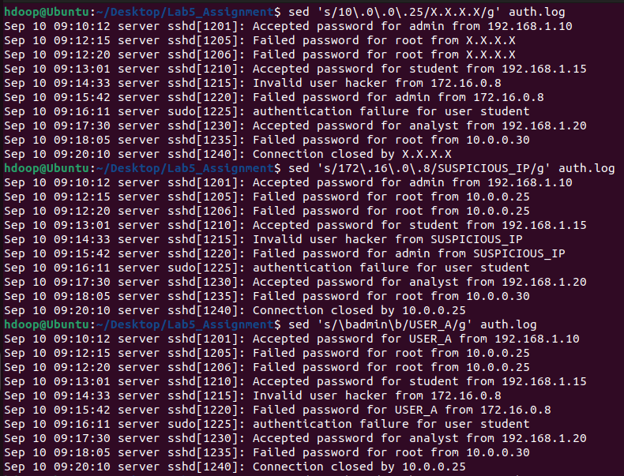
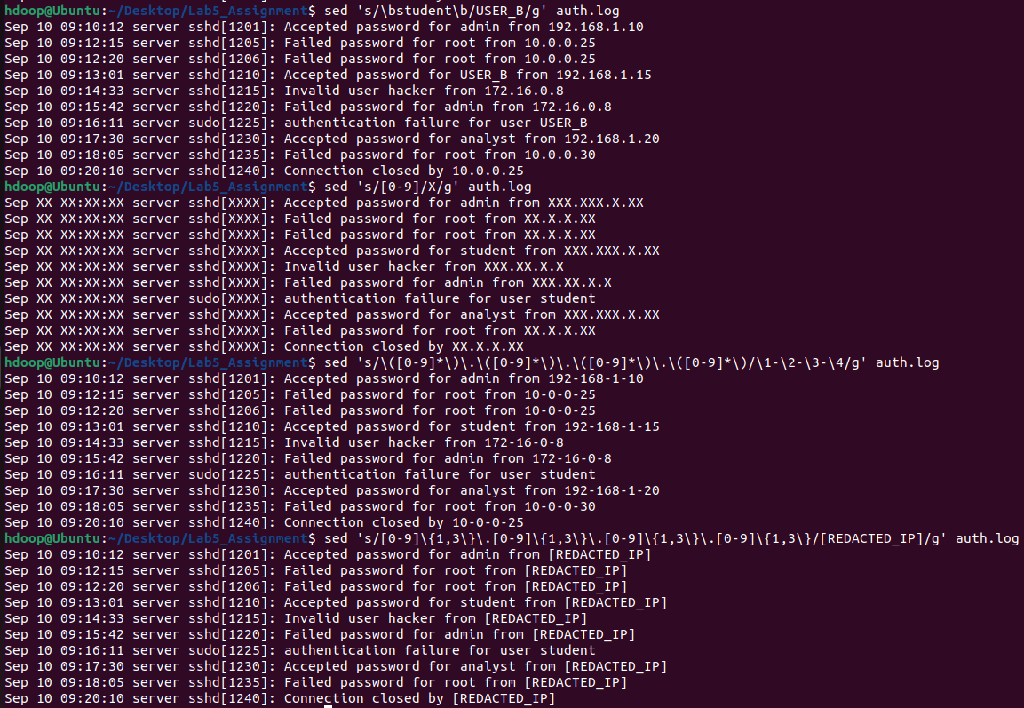

Part B: Web-Server Log

Use access.log to solve the below questions

Write sed commands to:

Print all requests that returned status code 200.
: sed -n '/200/p' access.log

Print all requests that returned status code 401.
: sed -n '/401/p' access.log

Print all requests that returned status code 403.
: sed -n '/403/p' access.log

Print all requests to /admin/login.
: sed -n '/\/admin\/login/p' access.log

Print all POST requests.
: sed -n '/^POST /p' access.log

Print requests containing ../.
: sed -n '/\.\.\//p' access.log

Print requests containing <script>.
: sed -n '/<script>/p' access.log

Print requests containing OR.
: sed -n '/\bOR\b/p' access.log

Print all requests except successful requests.
: sed -n '/200/!p' access.log

Print all requests from 10.0.0.25.
: sed -n '/10\.0\.0\.25/p' access.log

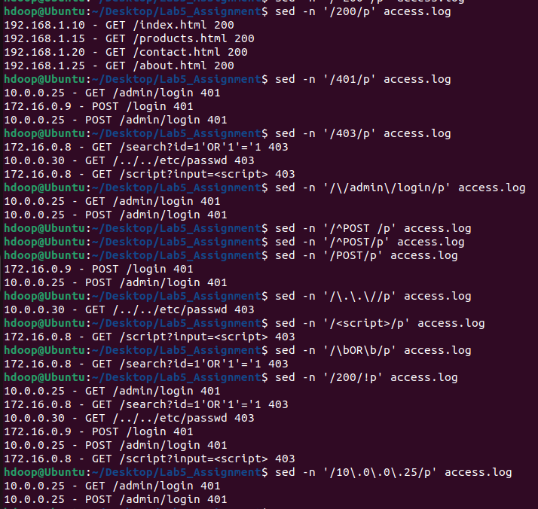

Exercise 7: Labelling Suspicious Web Requests

Use substitution to label the events:

Replace status code 200 with [ALLOWED].
: sed 's/200/[ALLOWED]/g' access.log

Replace status code 401 with [UNAUTHORIZED].
: sed 's/ 401 / [UNAUTHORIZED] /g' access.log

Replace status code 403 with [BLOCKED].
: sed 's/ 403 / [BLOCKED] /g' access.log

Replace /admin/login with /RESTRICTED_RESOURCE.
: sed 's/\/admin\/login/\/RESTRICTED_RESOURCE/g' access.log

Replace GET with READ_REQUEST.
: sed 's/GET/READ_REQUEST/' access.log

Replace POST with SUBMIT_REQUEST.
: sed 's/POST/SUBMIT_REQUEST/' access.log

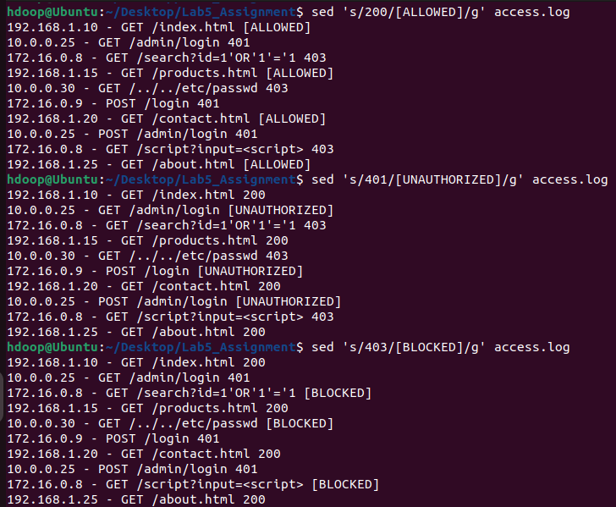

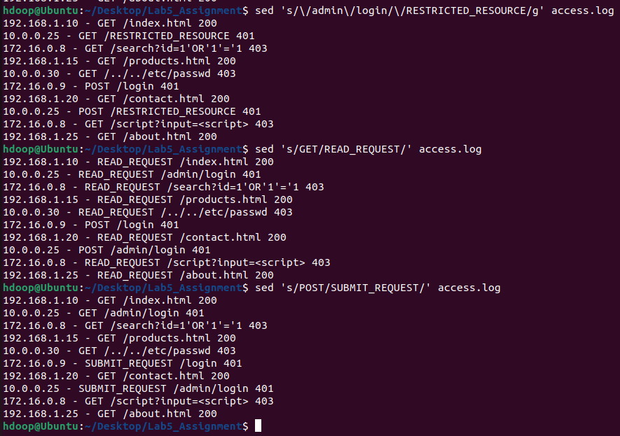

Exercise 8: Grouping Security Operations

Use { } to perform multiple commands.

For entries containing status code 401
Replace 401 with [UNAUTHORIZED].
Print the modified line.
: sed '/ 401 /{s/ 401 /[UNAUTHORIZED]/; p;}' access.log

For entries containing status code 403:
Replace 403 with [BLOCKED].
Replace the source IP address with [REDACTED_IP].
Print the modified entry.
: sed '/ 403 /{s/ 403 /[BLOCKED]/; s/[0-9]\{1,3\}\.[0-9]\{1,3\}\.[0-9]\{1,3\}\.[0-9]\{1,3\}/[REDACTED_IP]/; p;}' access.log

For requests to /admin/login:
Replace the URL with /PROTECTED_PAGE.
Replace the source IP with [REDACTED_IP].
Print the result.
: sed '/\/admin\/login/{s/\/admin\/login/\/PROTECTED_PAGE/; s/[0-9]\{1,3\}\.[0-9]\{1,3\}\.[0-9]\{1,3\}\.[0-9]\{1,3\}/[REDACTED_IP]/; p;}' access.log

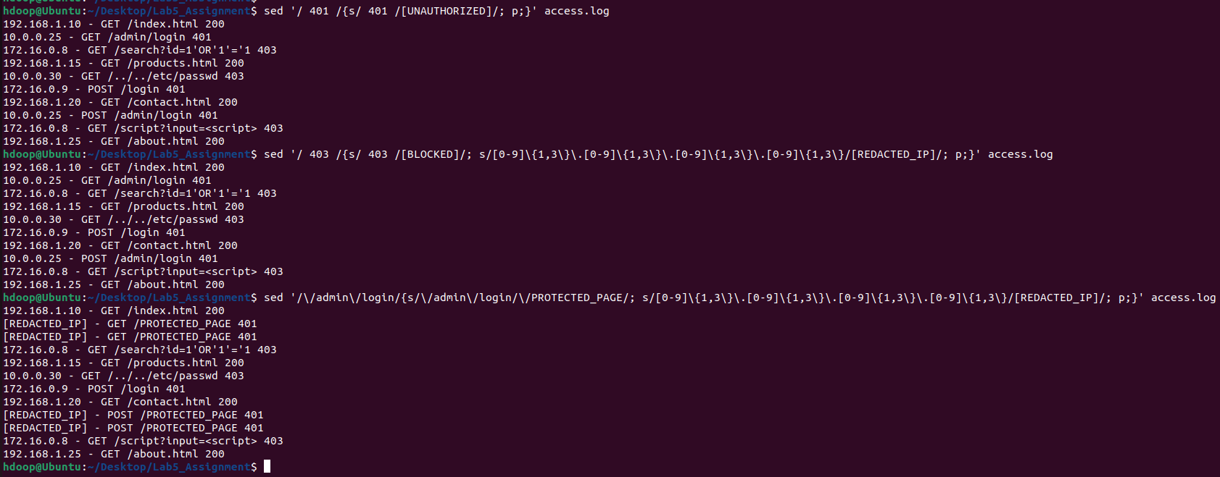

Exercise 9: Adding Incident Labels

Insert the following heading before the first line of auth.log:
SECURITY AUTHENTICATION LOG
: sed '1i\SECURITY AUTHENTICATION LOG' auth.log

Append the following message after the final entry:
END OF SECURITY LOG
: sed '$a\END OF SECURITY LOG' auth.log

Insert [WARNING] before every failed login.
: sed '/Failed password/s/^/[WARNING] /' auth.log

Append Review this event after every invalid-user entry.
: sed '/Invalid user/s/$/ - Review this event/' auth.log

Insert [SUSPICIOUS WEB REQUEST] before every 403 entry.
: sed '/403/s/^/[SUSPICIOUS WEB REQUEST] /' access.log

Append [REQUIRES INVESTIGATION] after every 401 entry.
: sed '/401/s/$/ [REQUIRES INVESTIGATION]/' access.log

Replace all entries containing Connection closed with:
[CONNECTION TERMINATED]
: sed '/Connection closed/c\[CONNECTION TERMINATED]' auth.log

Replace all successful web requests with:
[NORMAL WEB REQUEST]
: sed '/200/c\[NORMAL WEB REQUEST]' access.log

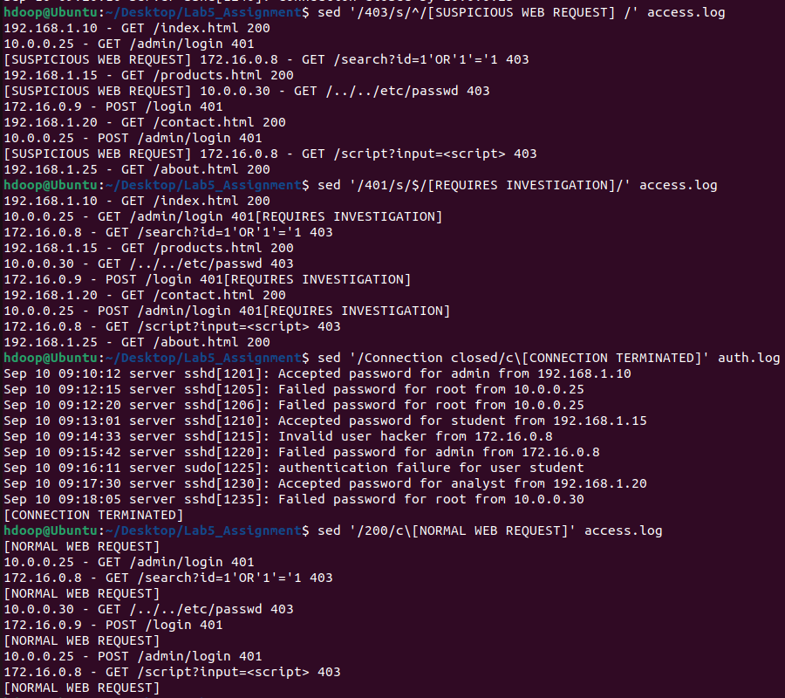
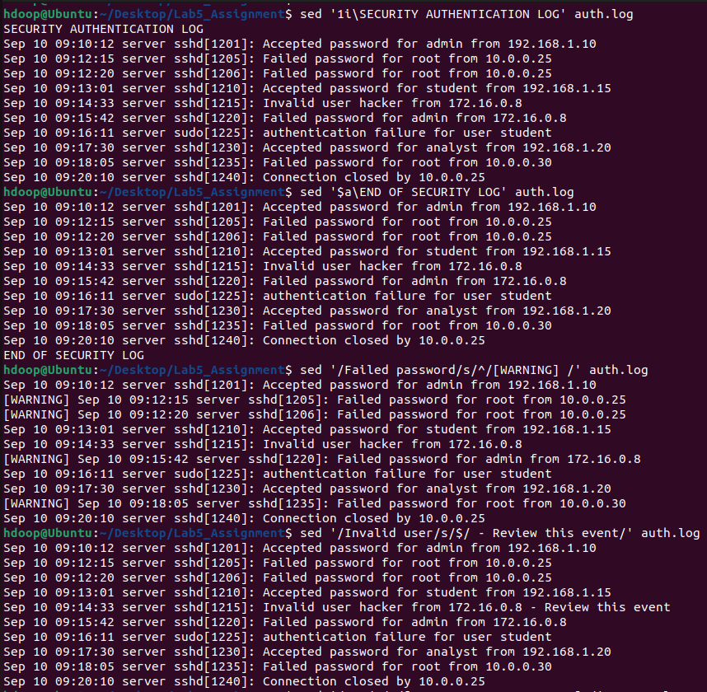
Exercise 10: Separating Log Entries with G

Use G to:

Add a blank line after every authentication event.
: sed 'G' auth.log

Add a blank line after every failed login.
: sed '/Failed password/G' auth.log

Add a blank line after every blocked web request.
: sed '/403/G' access.log

Add a blank line after every second entry starting with the first entry.
: sed '1~2G' auth.log

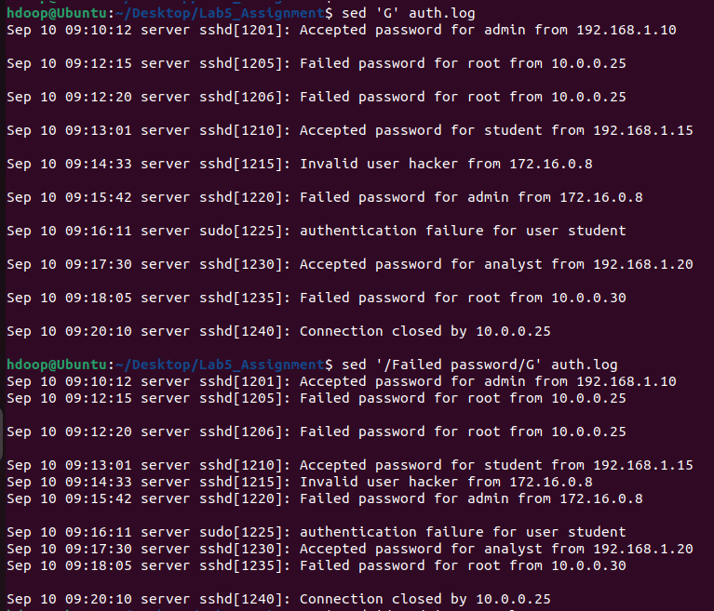

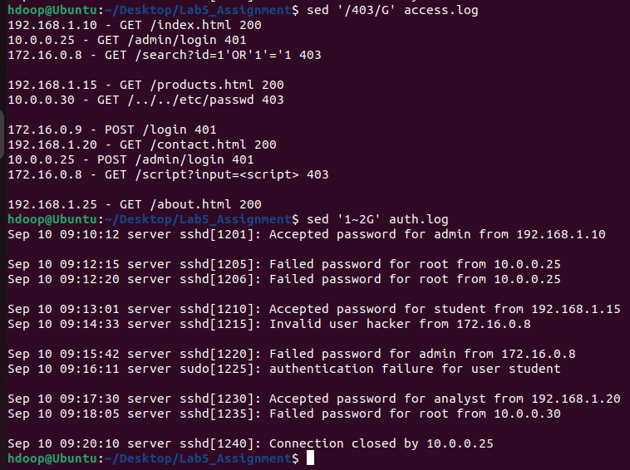

Write failed logins to failed_logins.txt.
: sed -n '/Failed password/w failed_logins.txt' auth.log

Write successful logins to successful_logins.txt.
: sed -n '/Accepted password/w successful_logins.txt' auth.log

Write invalid-user events to invalid_users.txt.
: sed -n '/Invalid user/w invalid_users.txt' auth.log

Write 401 web events to unauthorized_requests.txt.
: sed -n '/401/w unauthorized_requests.txt' access.log

Write 403 web events to blocked_requests.txt.
: sed -n '/403/w blocked_requests.txt' access.log

Write all events related to 172.16.0.8 to suspicious_ip.txt.
: sed -n '/172\.16\.0\.8/w suspicious_ip.txt' auth.log
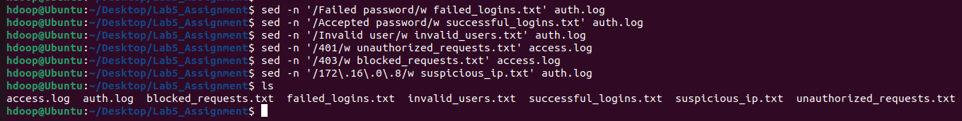

Label successful and failed logins.

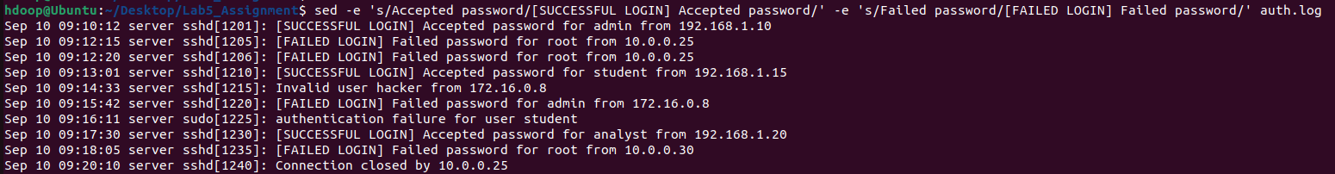
Label 401 and 403 web requests.

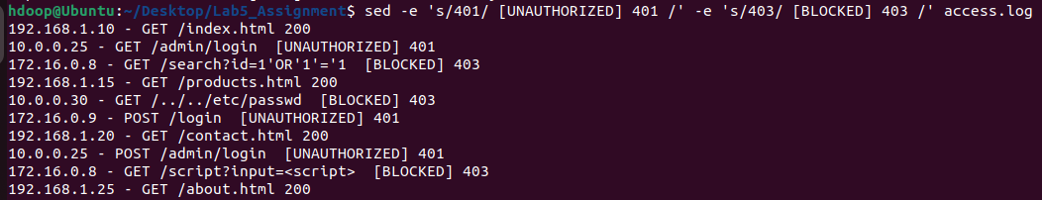
Delete successful logins and print failed logins.

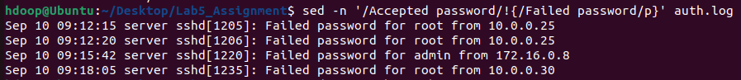
Replace root with [PRIVILEGED_USER] and mask all IP addresses.

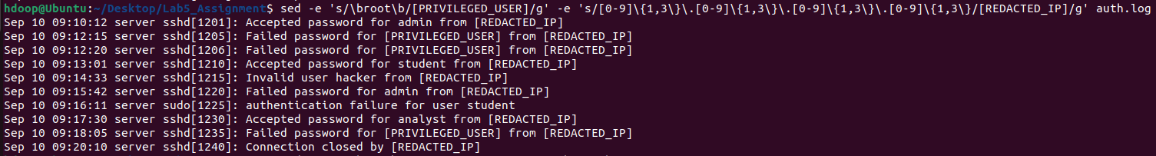
Replace GET and POST with READ_REQUEST and SUBMIT_REQUEST.

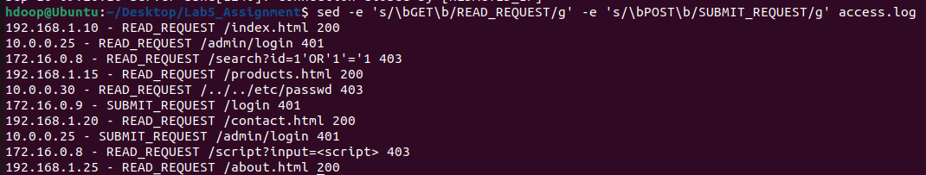

Create security_report.sed containing commands to:

Insert SECURITY INCIDENT REPORT before the first line.
Replace Failed password with [FAILED LOGIN].
Replace Invalid user with [INVALID USER ATTEMPT].
Replace Accepted password with [SUCCESSFUL LOGIN].
Replace all sample IP addresses with [REDACTED_IP].
Append END OF INCIDENT REPORT after the last line.

Execute it using:

sed -f security_report.sed auth.log

Save the output:

sed -f security_report.sed auth.log > incident_report.txt

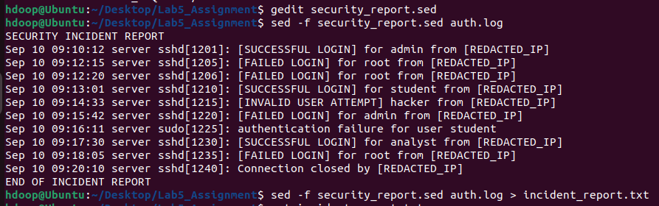

Exercise 14: Modifying a Security Configuration File

Create security.conf:

PermitRootLogin yes
PasswordAuthentication yes
MaxAuthTries 6
FirewallStatus disabled
LogLevel INFO
GuestLogin enabled

First make a backup:

cp security.conf security.conf.backup

Use sed -i to:

Change PermitRootLogin yes to PermitRootLogin no.
Change MaxAuthTries 6 to MaxAuthTries 3.
Change FirewallStatus disabled to FirewallStatus enabled.
Change LogLevel INFO to LogLevel VERBOSE.
Change GuestLogin enabled to GuestLogin disabled.

Use the safer backup form:

sed -i.bak 'sed-command' security.conf

This exercise demonstrates configuration editing only; it does not configure the actual system.

Write a Bash script named security_log_analyser.sh.

The script should:

Accept a log filename as a command-line argument.
Check whether the argument is provided.
Check whether the file exists.
Extract failed login attempts.
Extract invalid-user attempts.
Replace sensitive IP addresses with [REDACTED_IP].
Add the heading SECURITY ALERT REPORT.
Add [ALERT] before suspicious entries.
Append END OF REPORT.
Save the result in security_alert_report.txt.
Display the generated report.

: cp security.conf security.conf.backup

sed -i.bak 's/PermitRootLogin yes/PermitRootLogin no/' security.conf
sed -i.bak 's/MaxAuthTries 6/MaxAuthTries 3/' security.conf
sed -i.bak 's/FirewallStatus disabled/FirewallStatus enabled/' security.conf
sed -i.bak 's/LogLevel INFO/LogLevel VERBOSE/' security.conf
sed -i.bak 's/GuestLogin enabled/GuestLogin disabled/' security.conf

Bash Script:

#!/bin/bash

# Accept a log filename as a command-line argument and check availability
if [ -z "$1" ]; then
echo "Error: No log filename provided."
echo "Usage: $0 <log_filename>"
exit 1
fi

LOG_FILE="$1"

# Check whether the file exists
if [ ! -f "$LOG_FILE" ]; then
echo "Error: File '$LOG_FILE' does not exist."
exit 1
fi

OUTPUT_FILE="security_alert_report.txt"

sed -e '1i\SECURITY ALERT REPORT' \
-e '/Failed password/s/^/[ALERT] /' \
-e '/Invalid user/s/^/[ALERT] /' \
-e 's/[0-9]\{1,3\}\.[0-9]\{1,3\}\.[0-9]\{1,3\}\.[0-9]\{1,3\}/[REDACTED_IP]/g' \
-e '$a\END OF REPORT' \
"$LOG_FILE" > "$OUTPUT_FILE"

echo "Report generated successfully: $OUTPUT_FILE"
echo "----------------------------------------"

# Display the generated report
cat "$OUTPUT_FILE"

