Deepika P M
261100690019

Exercise 1 – Identify Your Linux Filesystem

Explore the storage configuration of your Linux system.

Determine:

1. The storage devices available.
2. The partitions available on each device.
3. The filesystem type used by each partition.
4. The device/partition on which `/` is located.
5. The filesystem type used for `/`.
6. The total, used, and available storage space.

:
Storage devices available: The primary storage device is /dev/sda (a 40G disk). There is also a read-only optical drive /dev/sr0 (51M) attached.

Partitions available: The sda disk is divided into three partitions: sda1 (1M), sda2 (513M), and sda3 (39.5G).

Filesystem types:
sda2 uses vfat (FAT32).
sda3 uses ext4.
sr0 uses iso9660.

Partition for / (root): The root directory is located on /dev/sda3

Filesystem type for /: The root partition is formatted using the ext4 filesystem

Total, used, and available storage space (for /):
Total Size: 39G
Used: 21G (56% utilization)
Available: 17G

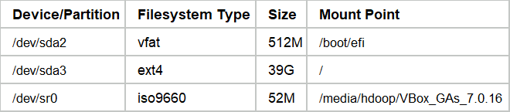

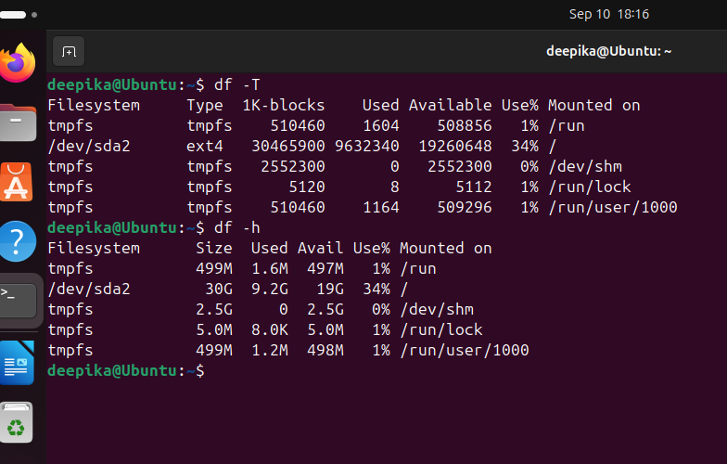

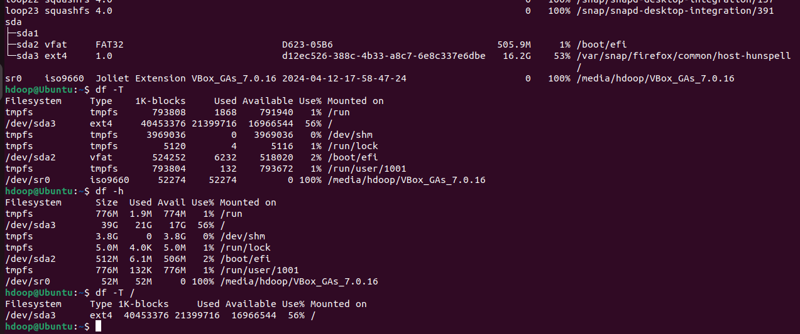

Exercise 2 – Disk → Partition → Filesystem → Mount Point

Using the information obtained in Exercise 1, draw the storage organization of your own Linux system.
For example:

Disk
|
+-- Partition
|
+-- Filesystem
|
+-- Mount Point

Do not copy the example values. Use the actual values observed on your machine.
Explain in 2–3 sentences the relationship between these four components.

:
Disk (/dev/sda)
|
+-- Partition (/dev/sda2)
| |
| +-- Filesystem (vfat)
| |
| +-- Mount Point (/boot/efi)
|
+-- Partition (/dev/sda3)
|
+-- Filesystem (ext4)
|
+-- Mount Point (/)

A physical disk is divided into logical, isolated sections called partitions to manage different storage needs. Each partition is then formatted with a specific filesystem that dictates exactly how data is structured, indexed, and retrieved. Finally, the OS makes that structured data accessible by attaching it to a specific directory in the system's root hierarchy, known as a mount point.
Exercise 3 – Explore the Root Filesystem

Start from your current location.

1. Determine your current working directory. : pwd
2. Navigate to the root directory. : cd /
3. Display the contents of the root directory. : ls
4. Identify all directories directly available under `/`. : ls -d /*
5. Determine whether hidden entries are present. : ls -la /

:
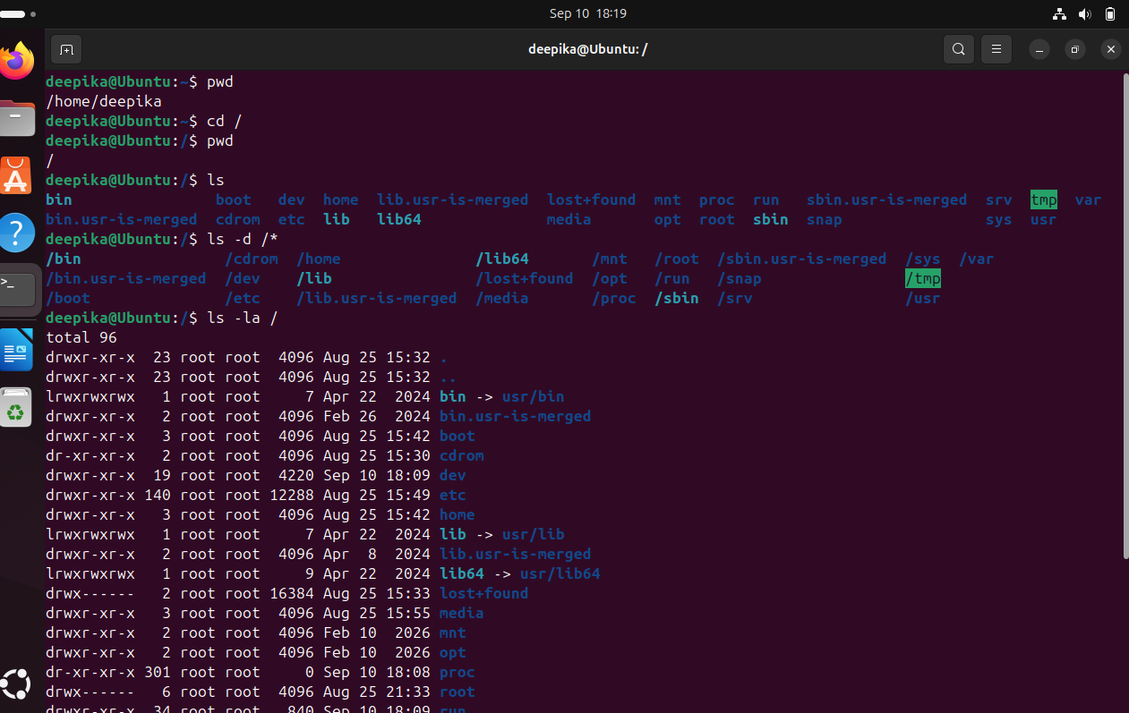

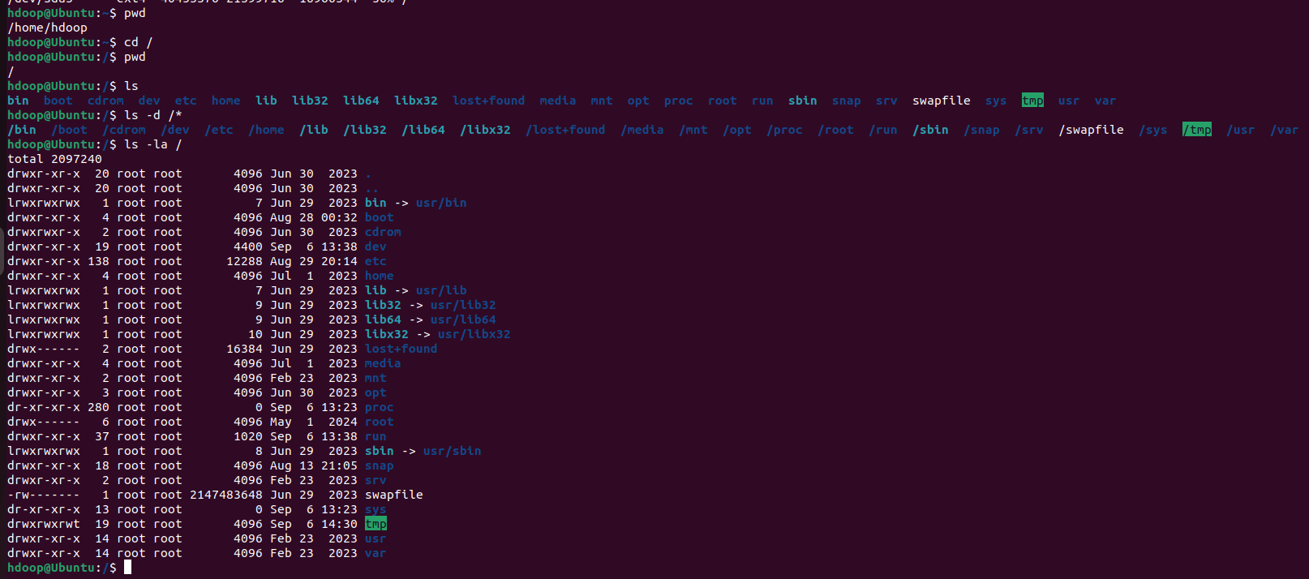

Exercise 4 – Linux Filesystem Hierarchy Investigation

Investigate the following locations:

/home
/root
/etc
/var
/var/log
/tmp
/usr
/boot
/dev
/proc

For each location:
1. Examine its contents.
2. Identify at least three entries, where available.
3. Determine the likely purpose of the directory.

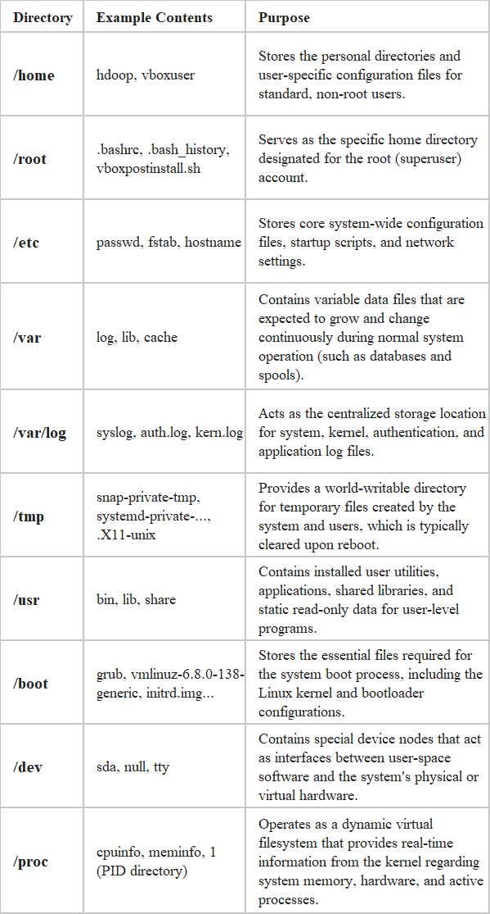
Exercise 5 – Find Your Home Directory

Without assuming its location:
1. Determine your username. : whoami
2. Determine your home directory. : echo $HOME
3. Navigate to your home directory. : cd "$HOME"
4. Display its absolute path. : pwd
5. List its normal contents. : ls
6. List all contents, including hidden files. : ls -la

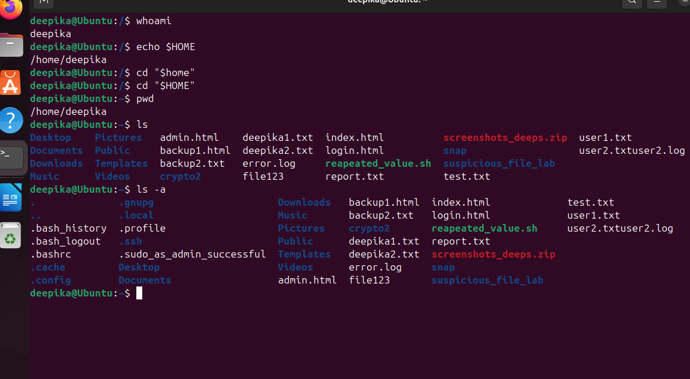

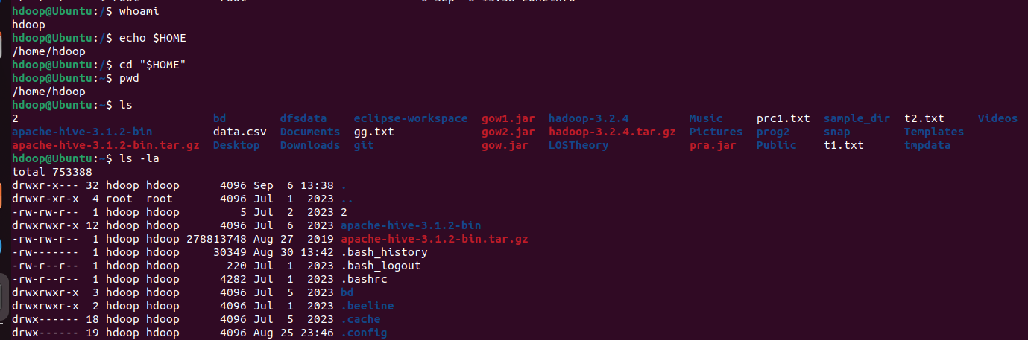

Exercise 6 – Hidden Files Investigation

Examine your home directory.
Compare:

ls
ls -a

Identify at least 2 hidden files/directories.
Answer:

1. How does Linux identify a hidden file?
: Linux identifies a file or directory as hidden if its name begins with a period or "dot" (e.g., .bashrc).

2. Why does a normal `ls` not display these files?
: The ls command is programmed by default to filter out any files starting with a dot. This is done to declutter the terminal output, as hidden files are usually configuration files, history logs, or cache directories that standard users don't need to see during routine file browsing.

3. What do `.` and `..` mean?
- : . (single dot) represents the current working directory you are in.
- .. (double dot) represents the parent directory (one level up in the hierarchy).

4. Can a hidden file still be accessed if its name is known?
: Yes. Hidden files are not inherently restricted or locked; they are only visually hidden from default listings. If you know the name (or use ls -a to find it), you can read, edit, or execute them just like any normal file (e.g., cat .bash_history).

5. From a cybersecurity perspective, why should hidden files not automatically be considered safe or malicious?
: They should not be automatically considered safe because attackers frequently use the dot-prefix to hide malware, backdoors, or staging folders from casual administrators who only run basic ls commands. Conversely, they should not automatically be considered malicious because almost all legitimate Linux applications and user environments rely extensively on hidden files to store essential configurations and local settings (like .ssh/authorized_keys or .profile). Their safety must be determined by their contents, permissions, and location, not just their hidden status.

: Identified Hidden Files/Directories:
- .bash_history (Hidden file)
- .cache (Hidden directory)
- .config (Hidden directory)
- .ssh (Hidden directory)

Exercise 7 – Build a Small Filesystem Hierarchy
Explore: mkdir
Hint: you can create this hierarchy in a single command
cyber_lab/
|
+-- evidence/
| +-- network/
| +-- system/
|
+-- logs/
|
+-- scripts/
|
+-- reports/
```

Create the following files:

cyber_lab/evidence/network/traffic.txt
cyber_lab/evidence/system/processes.txt
cyber_lab/logs/security.log
cyber_lab/scripts/check.sh
cyber_lab/reports/investigation.txt

Use appropriate Linux commands to create the structure.
Verify that the required hierarchy has been created successfully.
Hint: tree
Explore options

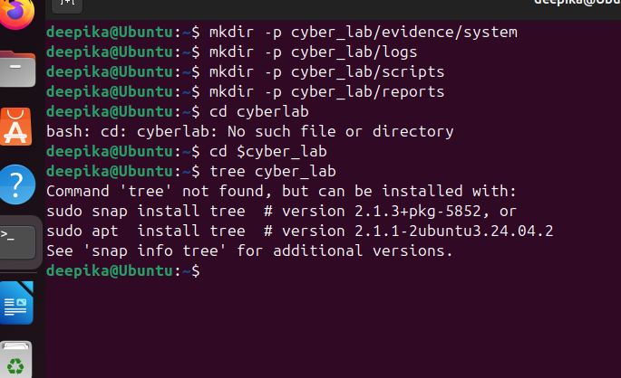

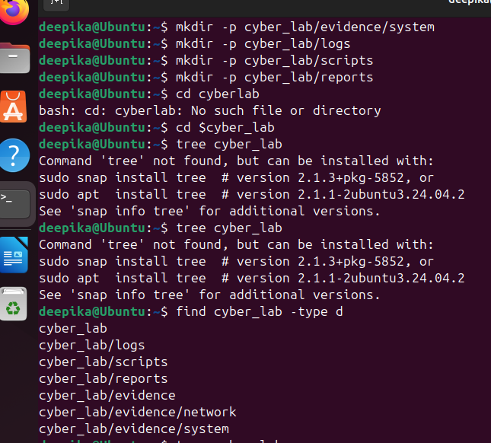

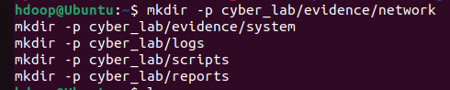

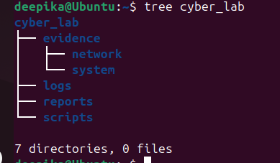

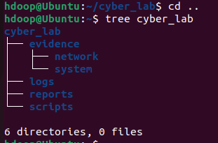

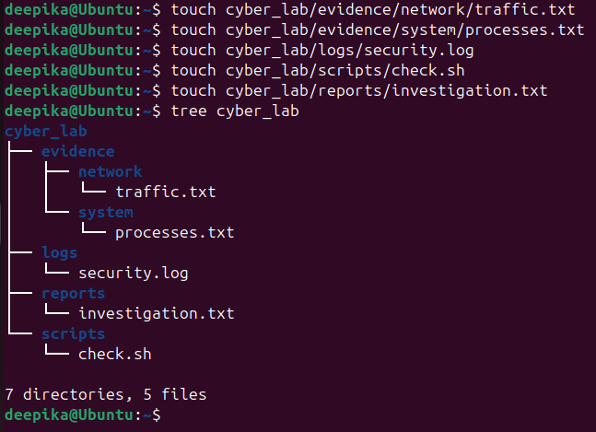
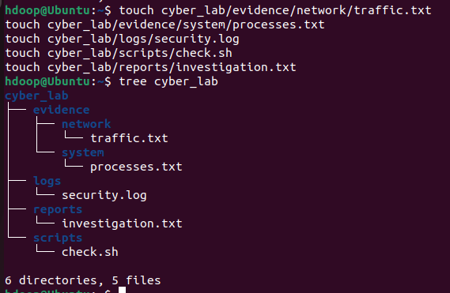

Exercise 8 – Absolute and Relative Paths

Assume your current directory is:

~/cyber_lab

Perform the following:

1. Navigate to `evidence/network` using a relative path. : cd evidence/network
2. Navigate to `/etc` using an absolute path. : cd /etc
3. Return to your home directory using the shortest possible command. : cd
4. Navigate to `cyber_lab/reports`. : cd ~/cyber_lab/reports
5. Move one directory upward. : cd ..
6. Display the current directory after every operation.

* What is an absolute path?
: An absolute path is a file or directory's full and exact location starting from the very top of the filesystem hierarchy—the root directory (/). It always begins with a / and remains valid no matter what your current working directory is (e.g., /home/hdoop/cyber_lab/reports).

* What is a relative path?
: A relative path is a file or directory's location defined in relation to your current working directory. It does not start with a /. For example, if you are inside cyber_lab, typing cd reports uses a relative path to move into the subdirectory.

* What is the difference between `/` and `~`?
- / represents the root directory, which is the absolute top-level directory of the entire Linux filesystem. Every single file and folder on the system sits somewhere under /.
- ~ (tilde) is a shell shortcut representing the current user's home directory. For your account, ~ is automatically translated by the system to /home/hdoop.

Exercise 9 – Identify File Types

Investigate the following:
/etc/passwd
/etc
/bin/bash
/dev/null
/proc

Also investigate the files created in Exercise 7.

file <filename>
ls -l <filename>

Classify each object.

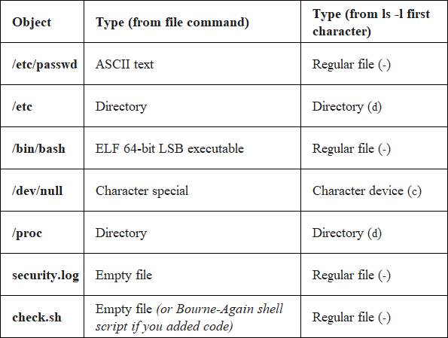

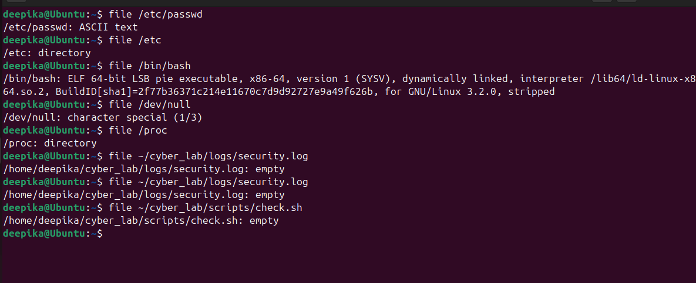

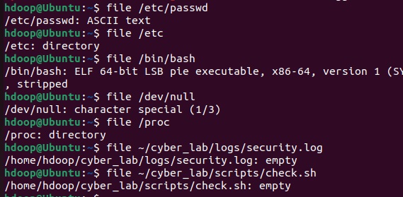

Exercise 10 – Examine File Metadata

Use:
~/cyber_lab/reports/investigation.txt

Add a small amount of text to the file.

Examine it using:
ls -l
stat investigation.txt

Identify:

Filename: investigation.txt
- File size: 32 (bytes)
- File type: regular file
- Owner: hdoop (Uid: 1001)
- Group: hdoop (Gid: 1001)
- Inode number: 1721682
- Access time: 2026-09-06 16:28:50.299921140 +0530
- Modification time: 2026-09-06 16:28:35.115921396 +0530
- Change time: 2026-09-06 16:28:35.115921396 +0530

1. What is metadata?
: Metadata is "data about data." In a Linux filesystem, it refers to the system attributes that describe a file—such as its size, permissions, owner, physical location on the disk (inode), and timestamps—rather than the actual text or data stored inside the file.

2. Is metadata the same as file content?
: No. File content is the actual data you put into the file (in this case, the text "Filesystem investigation report"). Metadata is the administrative information the operating system uses to manage and track that file.

3. Which timestamp changes when file contents are modified?
: The Modification time (Modify/mtime) changes whenever the actual contents of the file are altered. (Note: The Change time (Change/ctime) will also update concurrently, because altering the contents usually changes the file's size, which is a change to its metadata).

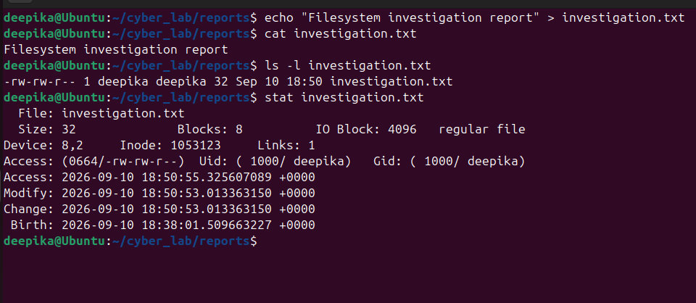

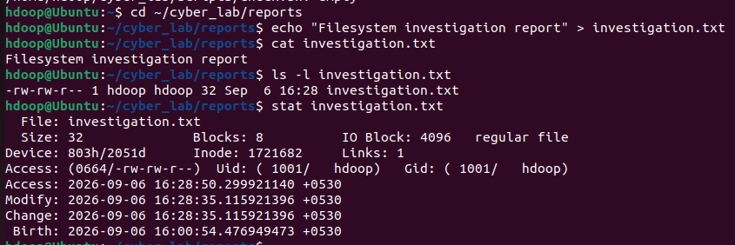
Exercise 11 – Explore `/etc`

Investigate:
/etc

Locate:
passwd
group
hostname
hosts

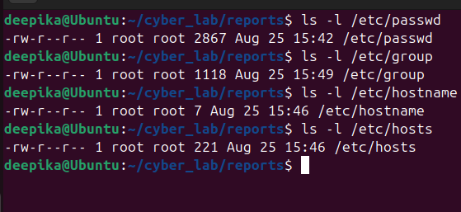

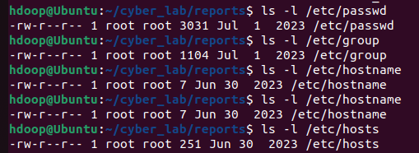
Note: Without modifying any system files, examine their contents where permitted.

Answer:

1. What kind of information is primarily stored under `/etc`?
: The /etc directory primarily stores core, system-wide configuration files, startup scripts, and administrative settings. It does not contain executable programs, but rather the text files that dictate how the system and its applications behave.

2. What information does `/etc/passwd` contain?
: It contains a list of all user accounts on the Linux system. Each line represents a single user (e.g., hdoop:x:1001:1001:,,,:/home/hdoop:/bin/bash) and includes their username, an 'x' indicating their password is encrypted elsewhere, their User ID (UID), Group ID (GID), user information/comments, home directory path, and default login shell.

3. What information does `/etc/hostname` contain?
: It contains the simple string representing the system's network name. Based on your output, your machine's hostname is exactly Ubuntu.

4. Why is `/etc` security-sensitive?
: Because it contains the blueprints for how the system operates. If a malicious actor or unauthorized user can modify files in /etc, they could easily create fake root accounts in /etc/passwd, alter network routing in /etc/hosts, disable security controls, or manipulate startup scripts to establish persistent malware. Therefore, almost all files in /etc require root privileges to modify.

Exercise 12 – Explore Linux Log Storage

Investigate:
/var/log
: ls -la /var/log

Identify:
* Available log files : find /var/log -maxdepth 1 -type f -print
* Available log directories : find /var/log -maxdepth 1 -type d -print
* Recently modified entries : ls -lt /var/log
* Entries you can read : find /var/log -type f -readable -print
* Entries you cannot read as a normal user : find /var/log -type f ! -readable -print

Answer:

1. Why does Linux maintain logs?
: Linux maintains logs to create a continuous, historical record of system events, application behavior, and user activity. This allows administrators to monitor system health, troubleshoot hardware or software failures, audit security policies, and ensure services are running correctly.

2. Why are logs useful during incident investigation?
: Logs provide the critical audit trail necessary to reconstruct an incident. They allow investigators to establish a timeline of events, identify compromised accounts, trace an attacker's steps (such as finding failed SSH login attempts or malicious web requests), and determine the scope and impact of a breach.

3. Why might access to some logs be restricted?
: Logs frequently contain sensitive information, such as IP addresses, user command histories, authentication tokens, or internal system configurations. Restricting access (typically limiting it to the root user or the adm group) prevents standard users from spying on others and makes it harder for unauthorized users or attackers to read sensitive data or easily cover their tracks by altering the logs.

Exercise 13 – Investigate `/tmp`

Explore `/tmp` without modifying files belonging to other users.
ls -la /tmp

Determine:
1. Whether files/directories currently exist.
: find /tmp -maxdepth 1 -type d -print , find /tmp -maxdepth 1 -type f -print

2. Whether hidden files exist.
: ls -la /tmp

3. Who owns some of the entries.
: ls -la /tmp

4. Which entries were modified recently.
: ls -lt /tmp

Why can temporary directories be relevant during a cybersecurity investigation?
: The /tmp directory is world-writable, meaning any user or process on the system can create, edit, and execute files there without needing root or elevated privileges. This makes it a prime, low-friction staging ground for attackers. During an intrusion, threat actors frequently use /tmp to drop exploit scripts, download malware payloads, run cryptominers, or temporarily aggregate and compress sensitive data before exfiltrating it off the network. Because of this, investigators often check /tmp to uncover malicious artifacts, leftover scripts, or tools the attacker failed to clean up.

Exercise 14 – Explore the `/proc` Filesystem

Investigate:
/proc

Examine:
cat /proc/cpuinfo
cat /proc/meminfo

Then identify your current shell PID:
echo $$ : 4147

Check whether a corresponding directory exists under `/proc`.

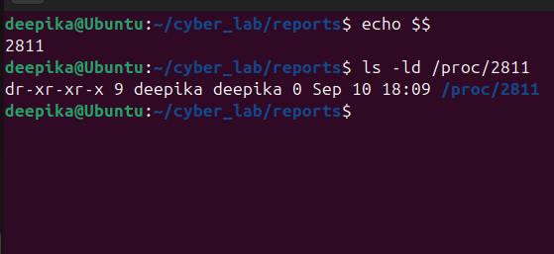

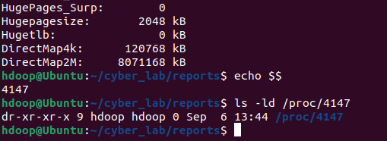
Answer:

1. What information does `/proc/cpuinfo` provide?
: /proc/cpuinfo provides detailed hardware specifications about the system's processor(s). According to your output, it shows you have a GenuineIntel processor (11th Gen Intel(R) Core(TM) i7-1165G7 @ 2.80GHz) with 3 active cores, a clock speed of ~2803 MHz, and a 12288 KB cache size. It also lists supported CPU flags and known hardware bugs (like spectre_v1).

2. What information does `/proc/meminfo` provide?
: /proc/meminfo provides a real-time, comprehensive breakdown of system memory utilization. Your output shows the total physical RAM (MemTotal: ~7.9 GB), free RAM (MemFree: ~3.9 GB), available RAM (MemAvailable: ~6.1 GB), and swap space usage (SwapTotal: ~2 GB, all of which is free). It also details how memory is allocated for caching, buffers, and system structures.

3. Why do directories with numbers appear inside `/proc`?
: The numbered directories (like 1, 17, and your current shell 4147) represent the Process IDs (PIDs) of every actively running process on the system. Each directory contains live status, memory mapping, and execution details for that specific process.
4. Is `/proc` an ordinary disk directory?
: No, /proc is not an ordinary disk directory. It is a pseudo-filesystem (procfs) that resides completely in RAM. It acts as an interface directly to the kernel, providing a window into the internal state of the operating system.

5. Why could `/proc` be useful during security investigation?
: Since /proc displays live system state, it is invaluable for incident response and forensics. Investigators can examine running processes in real-time to uncover hidden malware that has deleted itself from the disk but is still running in memory. It allows for the extraction of process command-line arguments, environment variables, active network connections, and open file handles associated with suspicious PIDs.

Exercise 15 – Explore `/dev`

/dev

Examine:

ls -l /dev/null
ls -l /dev/zero

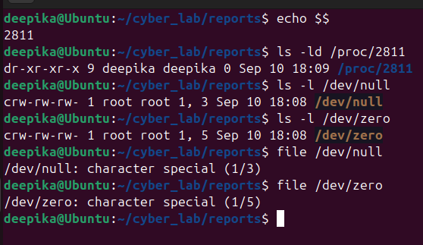

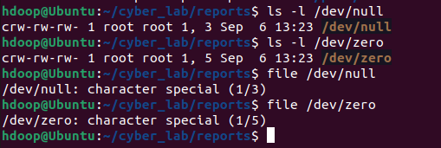

1. What does `/dev` represent?
: /dev contains special device files (or device nodes). It acts as the interface between user-space applications and the system's hardware or virtual kernel drivers.

2. Are the entries ordinary user files?
: No, they are not ordinary text or binary files that store data on a hard drive. As shown by the c at the beginning of the ls -l output, they are special device nodes that act as communication channels to the kernel.

3. Determine the file type of `/dev/null`.
: According to the file command output and the leading c in the ls output, /dev/null is a character special file (also known as a character device).

4. Why does Linux expose devices through the filesystem?
: This follows the core Unix design philosophy that "everything is a file." By exposing hardware and virtual devices as files in /dev, Linux allows standard programs and commands (like echo, cat, or dd) to interact with hardware natively using standard read/write operations, without requiring specialized, device-specific APIs or software.
Exercise 16 – Filesystem Space Investigation

Determine:
1. Total filesystem capacity.
2. Used space.
3. Available space.
4. Percentage of filesystem utilization.
5. Space occupied by your home directory.
6. Space occupied by the `cyber_lab` directory.

Use appropriate combinations of:
df
df -h
du
du -h
du -sh

Answer:
Explain the difference between `df` and `du`.
- df (disk free) reports the total amount of free and used disk space at the macro filesystem level (like /dev/sda3). It gets this information instantly by reading the filesystem's metadata (superblock indices).
- du (disk usage) calculates the actual physical space occupied by specific directories and files. It does this recursively, meaning it has to open and read the size of every single file inside the target folder (like ~/cyber_lab) to calculate a total sum.

Exercise 17 – Cybersecurity Investigation Scenario

Assume that you are investigating a Linux machine after suspicious activity has been reported.
You are initially asked to examine only the filesystem.

Identify which of the following locations you would investigate and explain **why**:

/home
ls -la /home
find /home -type f -mtime -7 -ls

Why: This directory holds individual user profiles, documents, and personal configurations. Attackers often compromise standard user accounts first before attempting privilege escalation.

Expected Information: By running find /home -type f -mtime -7 -ls, you are actively searching for files modified within the last 7 days. You would expect to find unauthorized SSH keys (.ssh/authorized_keys), modified shell profiles (.bashrc or .profile) used for persistence, or suspicious commands executed by the user in .bash_history.

/etc
ls -la /etc
cat /etc/passwd
cat /etc/hostname
cat /etc/hosts

Why: This is the core configuration hub of the Linux system. System-wide settings, network routing, and authentication parameters are stored here.

Expected Information: By examining passwd, you look for newly created, unauthorized user accounts or accounts unexpectedly granted root (0:0) privileges. Checking hosts can reveal malicious DNS redirects. You would also look for tampered service configurations (like altered sshd_config or malicious cron tasks).

/var/log
ls -lt /var/log
find /var/log -type f -readable -print

Why: This is the primary repository for system event data. It provides the historical timeline necessary to reconstruct an attack.

Expected Information: Sorting logs by time (ls -lt) allows you to correlate system events with the reported time of the suspicious activity. You would look for repeated failed logins (brute-force attacks), unauthorized successful sudo executions, application crashes indicating exploitation, or gaps in the logs that suggest an attacker attempted to clear their tracks.

/tmp
ls -lt /var/log
find /var/log -type f -readable -print

Why: The temporary directory is world-writable. Any process or user, regardless of privilege level, can write files here, making it the most common staging ground for initial payloads.

Expected Information: You would look for leftover exploit scripts, downloaded malware binaries, dropped rootkits, or compressed .tar.gz archives of sensitive data that an attacker has staged for exfiltration.

/proc
ps aux
ls /proc
cat /proc/cpuinfo
cat /proc/meminfo

Why: This is a dynamic, in-memory virtual filesystem that interfaces directly with the kernel. It holds real-time data about active system state and running processes.

Expected Information: Using ps aux alongside /proc directory inspection helps identify malicious processes currently executing in memory. You might find hidden processes, fileless malware holding open network ports, or anomalies in resource consumption (using cpuinfo or meminfo to spot cryptominers).

/dev
ls -la /dev
ls -l /dev/null
ls -l /dev/zero

Why: This directory contains device nodes representing hardware.

Expected Information: While less common for initial staging, advanced attackers might create rogue device files to bypass normal filesystem monitoring, install keyloggers attached to input devices (/dev/input), or use /dev/null or /dev/zero to quietly discard output from malicious scripts running in the background.

/root
sudo ls -la /root

Why: This is the administrative superuser's home directory. Any unauthorized activity here confirms a total system compromise (privilege escalation to root).

Expected Information: Running sudo ls -la /root allows you to hunt for the same artifacts as in /home, but with much higher severity. You would look for attacker toolkits left behind, malicious root .bash_history commands, or backdoor SSH keys planted to guarantee persistent administrative access.

