Deepika P M
261100690019

Part A — Basic grep
Exercise 1 — Search File Contents
Using payload.sh:
Find the line containing wget. Find the line containing nc.
Find the line containing chmod.
Search for WGET ignoring case. Display the line numbers containing /tmp. the number of lines containing /tmp.
Display only the matched word wget.
Search for nc as a whole word.
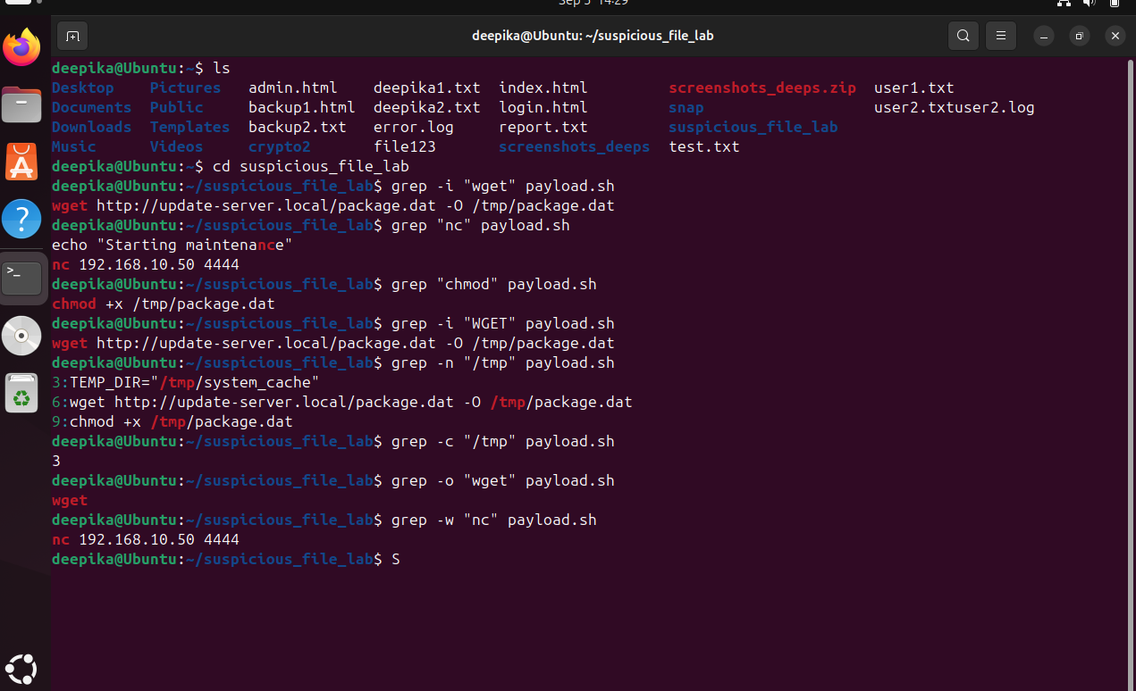

Exercise 2 — Compare Files
Search for wget in: payload.sh update.sh
cleanup.sh Answer:
Which file contains wget? Which files do not contain wget? Repeat the search for /tmp.
Which files contain /tmp?
Use grep with multiple filenames

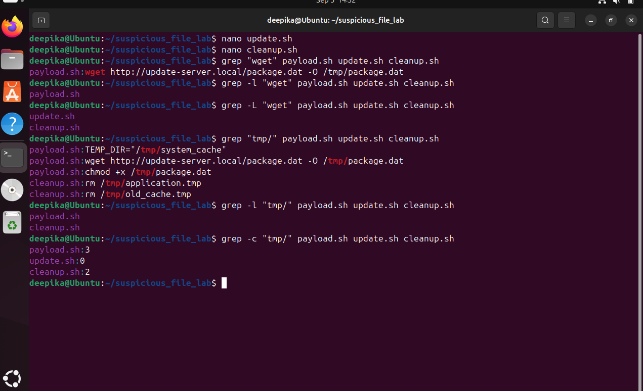

Exercise 3 — Inverse Search
Using system.log:
Display all lines that do not contain INFO.
Display all lines that do not contain ERROR.
Display all lines except those containing WARNING.
Count the number of non-INFO entries

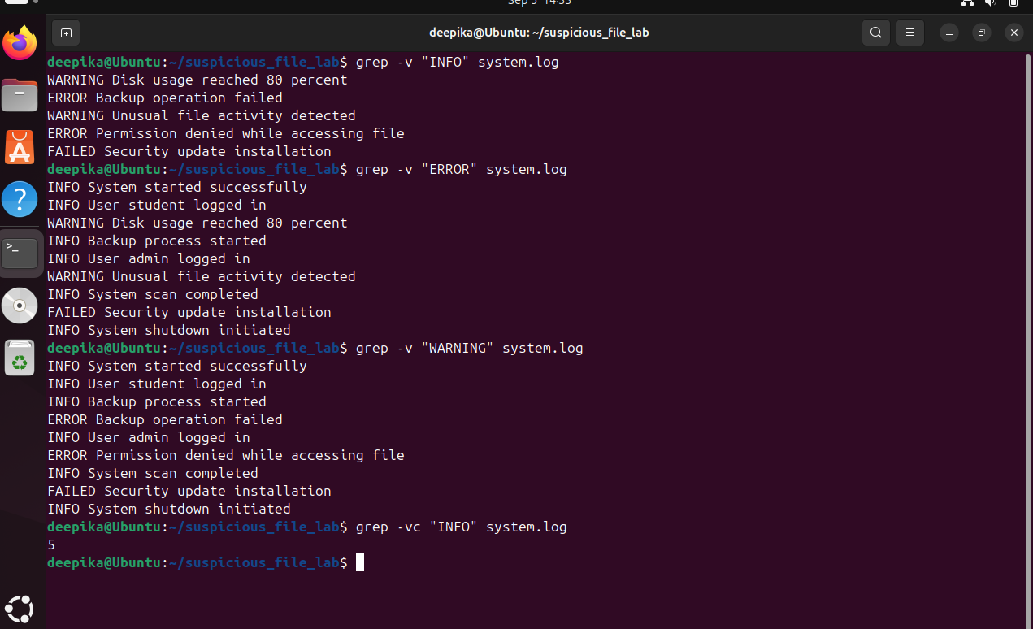

Part B — Security Log Analysis Exercise 4 — Analyze
system.log
Find all ERROR entries:
Find all WARNING entries:
Find the FAILED entry:
Count the number of ERROR entries:
Display line numbers containing WARNING:
Search for error irrespective of case:
Determine whether the word Malware occurs without displaying output:

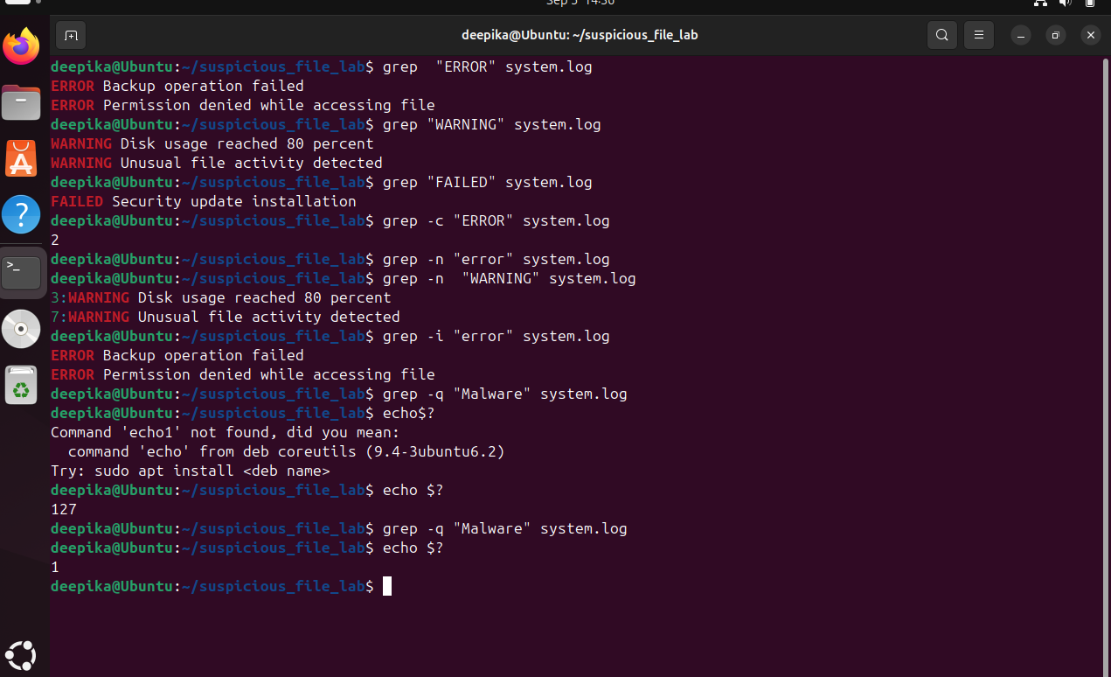

Exercise 5 — Context Investigation
An ERROR event has been detected in system.log.
Display two lines after each ERROR. Display two lines before each ERROR.
Display one line before and one line after each ERROR. Display two lines around FAILED.
Why can examining events before and after an error be useful during incident investigation?

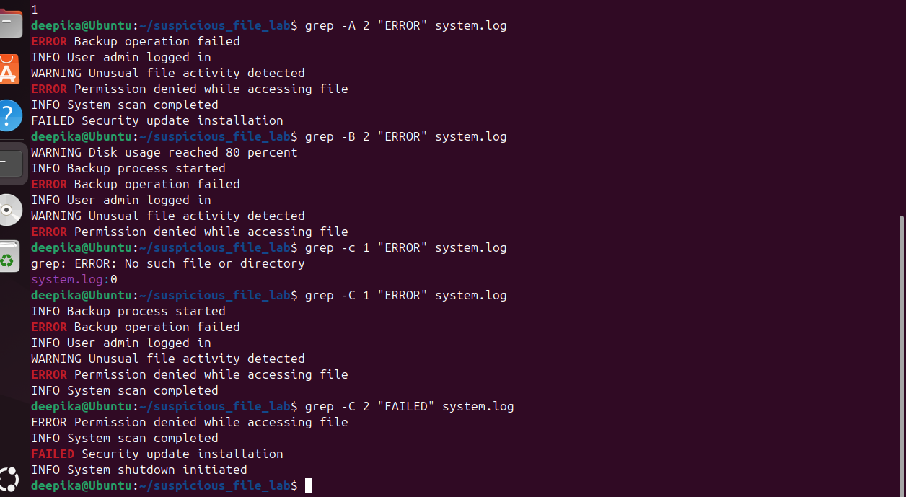

Examining the events before and after an error helps identify what caused the error and what happened after it. It gives a better understanding of the sequence of events during an incident.

Part C — egrep / grep -E
Exercise 6 — Search Multiple Security Events
Using system.log, write a single command to find lines containing:
ERROR WARNING FAILED

grep -E “ERROR|WARNING|FAILED” system.log

Exercise 7 — Multiple Suspicious Commands
Using payload.sh, search for any of:

wget curl nc chmod using a single extended regular expression.
Answer:
Which patterns were found? wget, nc, chmod Which
pattern was not found? curl
How many lines contain at least one of these patterns?

grep -E “wget|curl|nc|chmod” payload.sh

Exercise 8 — Search Multiple Files Which files contain at least one selected command?
Display only the filenames containing matches. Display matching lines with line numbers.
Count the matching lines in each file.
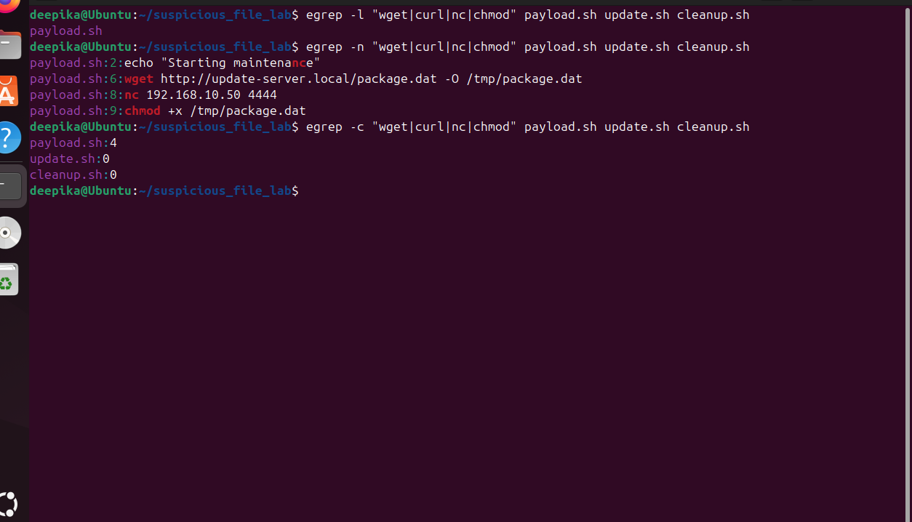

Part D — patterns.txt
Your dataset already contains patterns.txt.
Exercise 9 — Pattern File Investigation
Use patterns.txt to:
Search payload.sh.
Search system.log.
Search config.conf.
Search all .sh files.
Display only filenames containing at least one pattern from patterns.txt.
Display matching lines without printing filenames. Which files contain indicators listed in patterns.txt
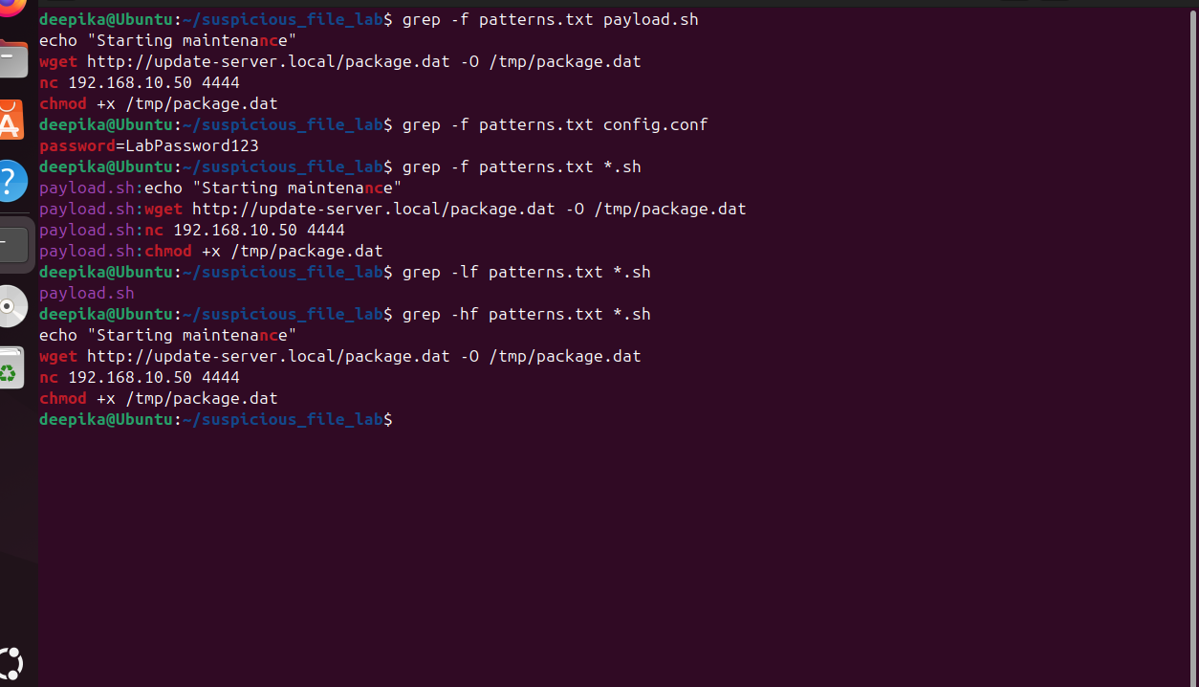

Part E — Regex Using filelist.txt
Exercise 10 — Beginning and End of Line
Using filelist.txt: Find filenames beginning with malware.
Find filenames beginning with script.
Find filenames ending in .sh. Find filenames ending in .py.
Find filenames ending in .log.
Find filenames beginning with p and ending in .sh

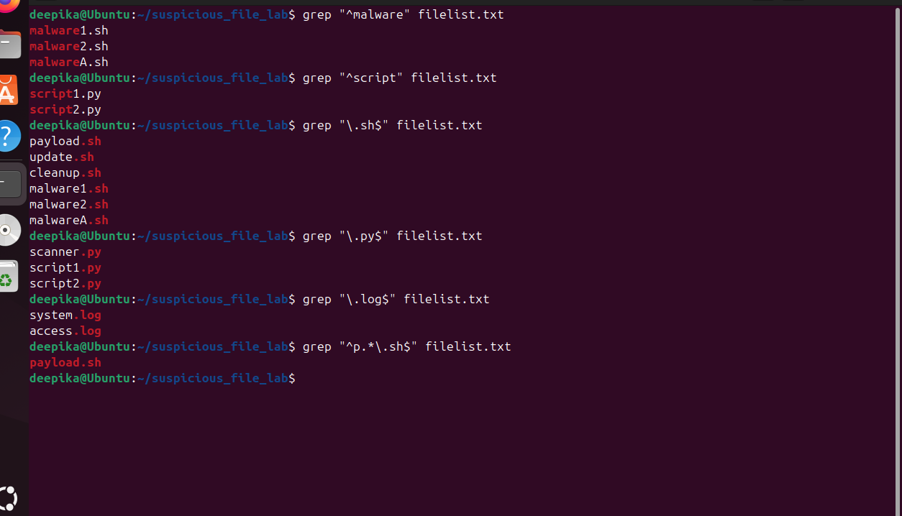

Exercise 11 — Character Classes
Using filelist.txt:
Find malware1.sh and malware2.sh using one pattern.
Find filenames containing a digit.
Find filenames containing digits 1 or 2.
Find filenames beginning with m or p.
Find filenames beginning with s or u.

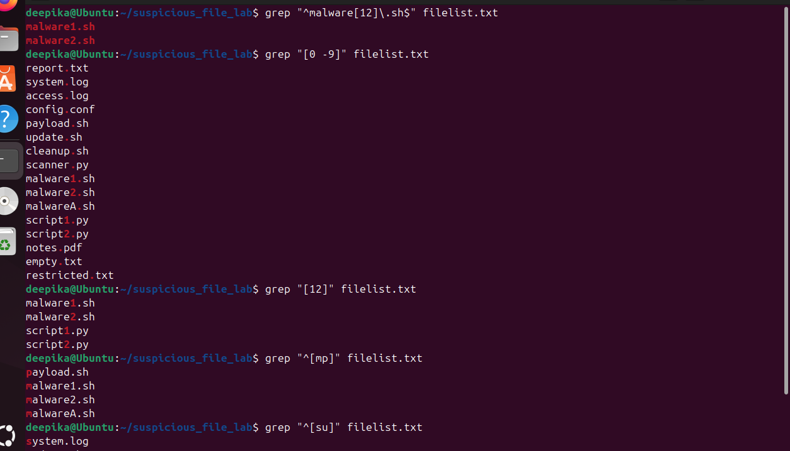

Exercise 12 — Negated Character Classes
Using filelist.txt:
Find filenames that do not begin with m. Find filenames that do not begin with m or p.
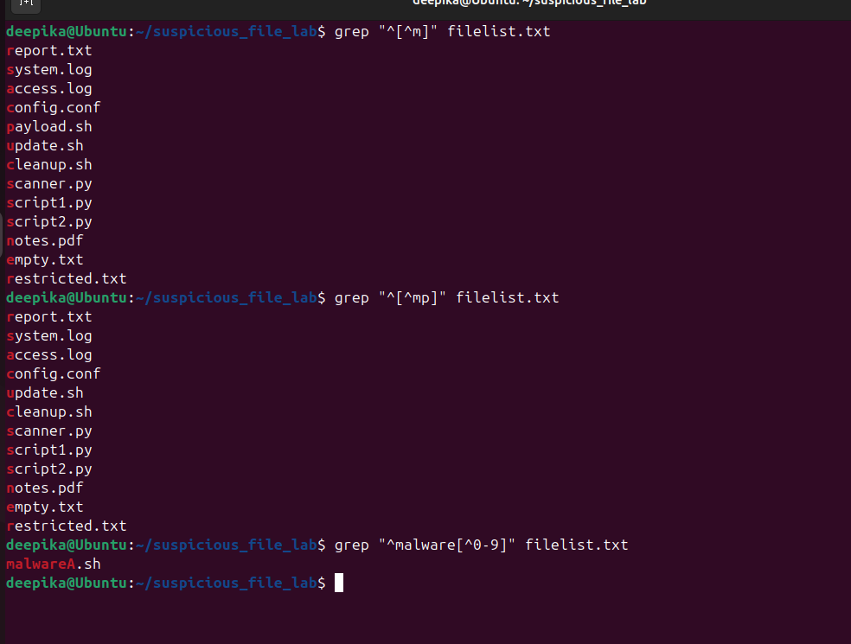

Exercise 13 —
Write a shell script that accepts a filename and determines whether it exists. Test with:
payload.sh report.txt
unknown.sh
Write a script that accepts a path and determines whether it is:
a regular file, a directory, or neither.
Test with: payload.sh system.log
quarantine backup
Unknown 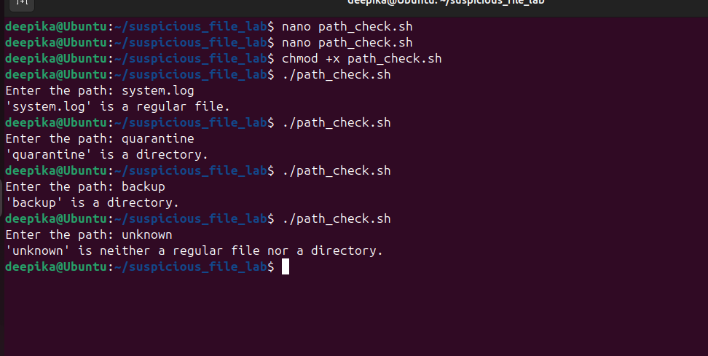

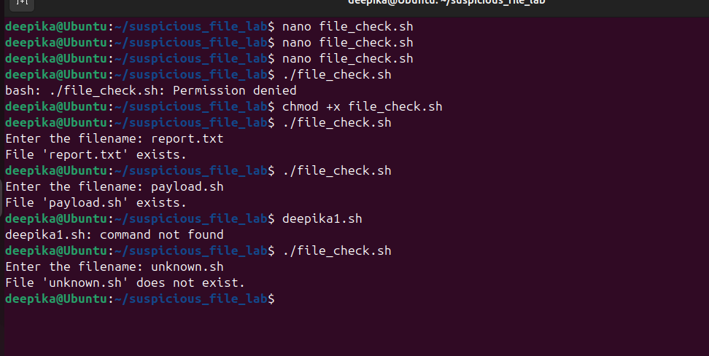
Exercise 15
Write a script that reports whether a selected file is: readable,
writable, executable. Test with: payload.sh update.sh report.txt config.conf
Expected style of output: File: payload.sh Readable : Yes Writable : Yes Executable : Yes
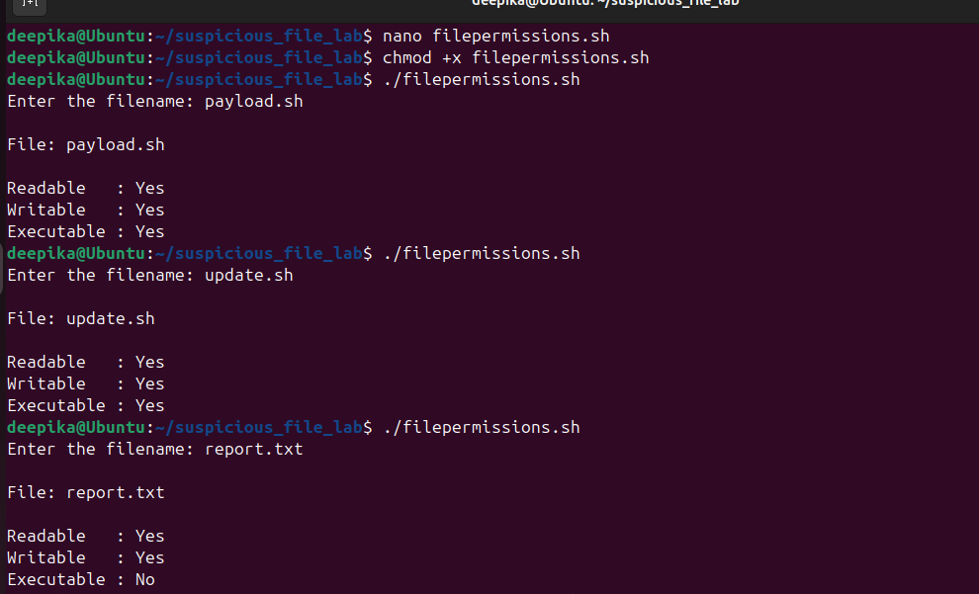

Exercise 16 —
Compare:
payload.sh empty.txt
Write a script that determines whether each file contains data.
Display: File contains data or:
File is empty

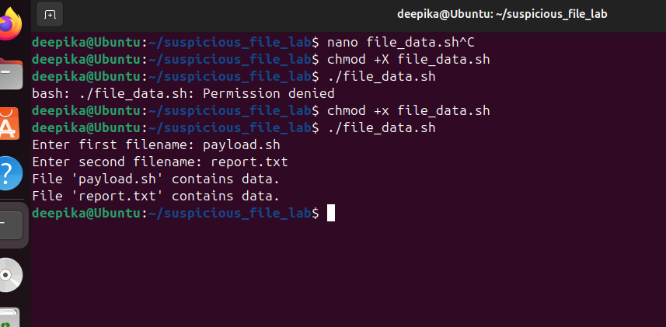

Part G
Exercise 17 — File Validation Using [ ] Write a script that accepts a filename and checks:
Does it exist?
Is it a regular file? Is it readable?
Is it non-empty?
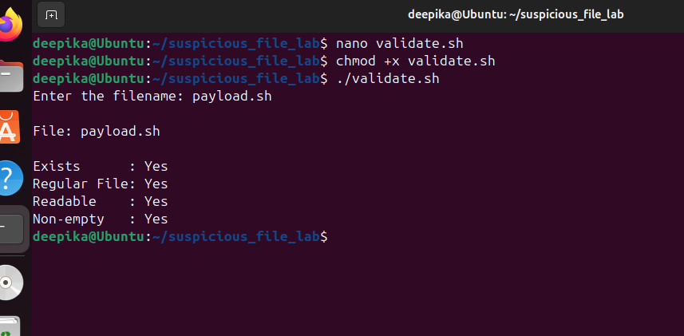

Exercise 18 — [ ] + grep Write a script with the following logic: Does file exist?
↓
Is it a regular file?
↓
Is it readable?
↓

Is it non-empty?
↓
Search for "wget"
If wget is detected, display:
Selected indicator detected – investigate further Otherwise:
Selected indicator not detected Test using both: payload.sh
update.sh
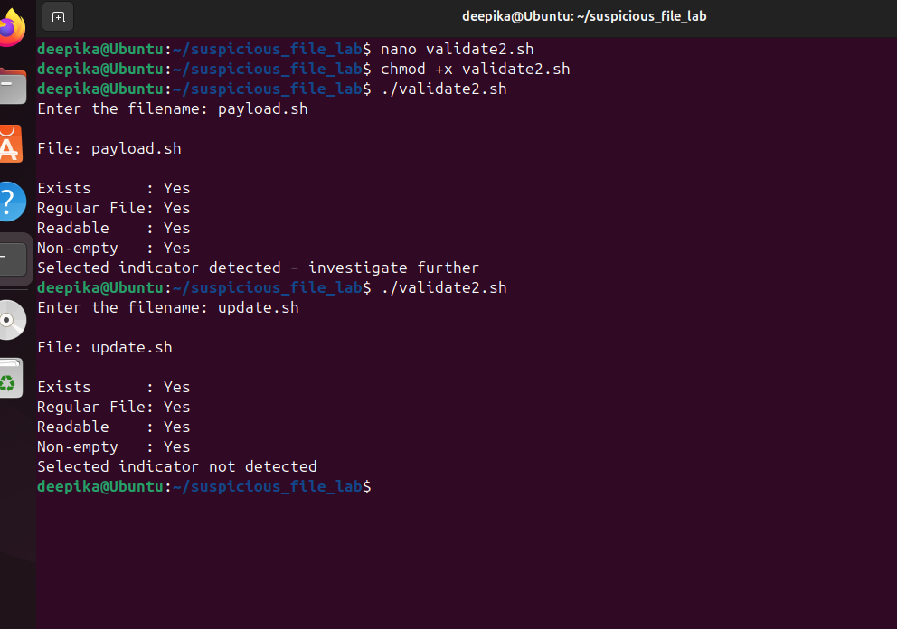

Part H
Exercise 19 — Repeat File Tests Using [[ ]]
Repeat Exercise 17 using:

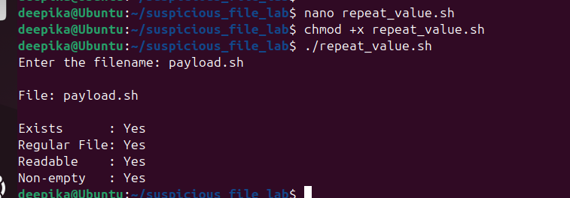

Exercise 20 — Regex Using [[ ]]
Write a shell script that accepts a filename and checks whether the filename ends with .sh. Use:
[[ "$filename" =~ regex ]] Display:
Shell script identified for inspection or:
File does not have a .sh extensio Test:
payload.sh scanner.py report.txt
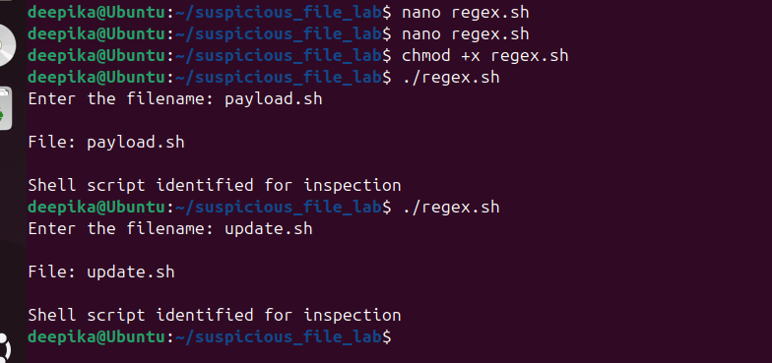

Exercise 21 — Multiple Extensions Using [[ ]]
Extend the previous script to identify:
.sh
.py .pl files. Test:
payload.sh scanner.py report.txt config.conf
Do not classify these as malicious. Display: Script file – inspect if required

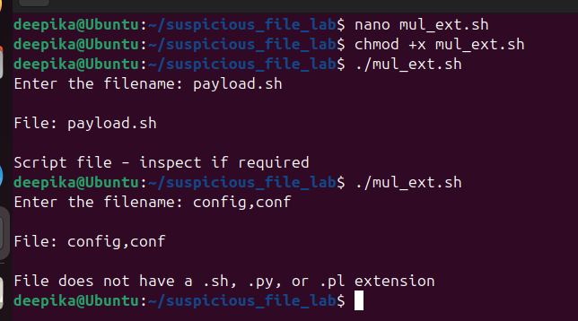

Part I — grep + File Operators + Constructs
Exercise 22 — Executable File Content Analysis
Write a script that: Accepts a filename.
Checks whether it exists.
Checks whether it is a regular file.
Checks whether it is executable.
If executable, searches for wget Test with:
payload.sh update.sh report.txt

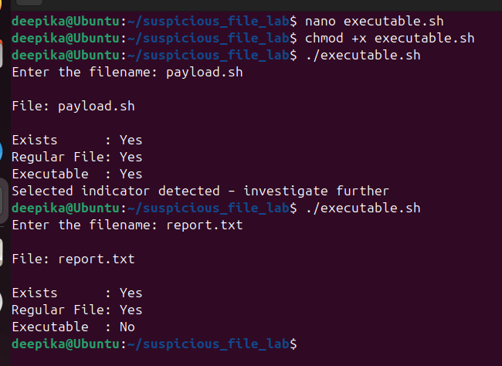

Exercise 23 — egrep + File Operators
Write a script that performs content analysis only when the selected file is: a regular file,
readable, non-empty.
If the checks succeed, use egrep/grep -E to search for: wget|curl|nc|chmod Display:
One or more selected indicators detected if a match occurs.
Otherwise:
Selected indicators not detected

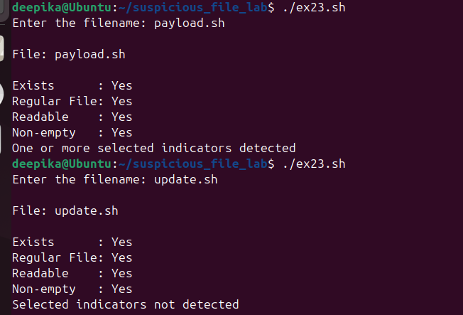

Part J — Configuration File
Investigation Exercise 24 — Sensitive Information Search
Use config.conf. First verify that it:
exists, is a regular file, is readable, is non-empty.
Then use egrep to search for:
password|username Display the matching lines.
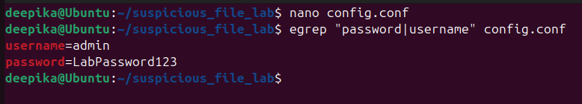

Configuration files need extra protection because they can contain usernames and passwords. If someone gets the file, they could use those details to access the system.

Part K
Exercise 25 — Suspicious File Triage
Write a Bash program called
file_check.sh
The program should ask the user to enter a filename. It should:
Determine whether the path exists. Determine whether it is a regular file. Determine whether it is a directory.
If it is a regular file, determine whether it is readable. Determine whether it is writable.
Determine whether it is executable. Determine whether it is empty/non-empty.
If readable and non-empty, use grep to search for wget. Use egrep/grep -E to search for wget|curl|nc|chmod.
Use $? to determine whether a selected search succeeded.
Use [[ ]] with regex to determine whether the filename ends in .sh. Display a summary of the findings.

Example:
Enter filename: payload.sh
----- FILE INVESTIGATION -----
Exists : Yes
Regular File : Yes
Directory : No
Readable : Yes
Writable : Yes
Executable : Yes
Non-empty : Yes
Shell Script : Yes

