Deepika P M
261100690019
1. 400 (r--)
Read permission on file and directory
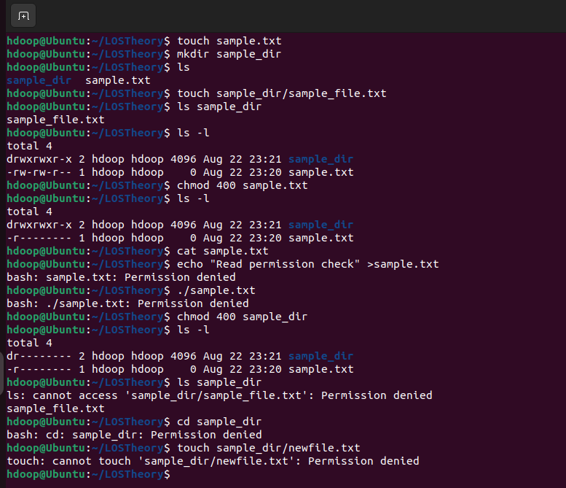

2. 200 (-w-)
Write permission on a file and directory

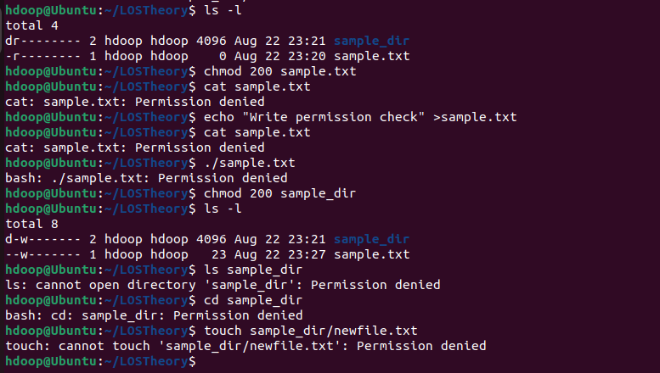

3. 100 (--x)
Execute permission on a file and directory

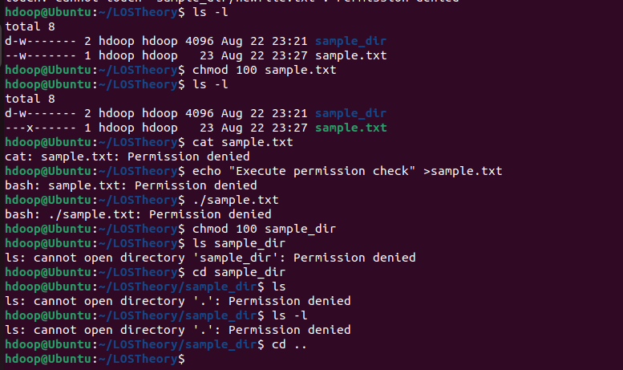

4. 500 (r-x)

Read execute permission on a file and directory

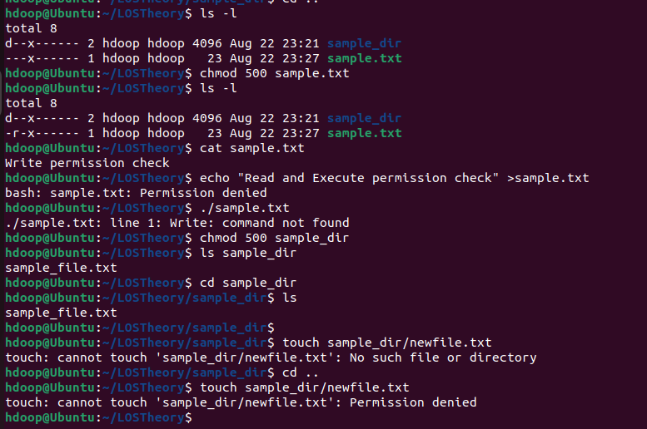

5. 600 (rw-)

Read, write and execute permissions on file and directory

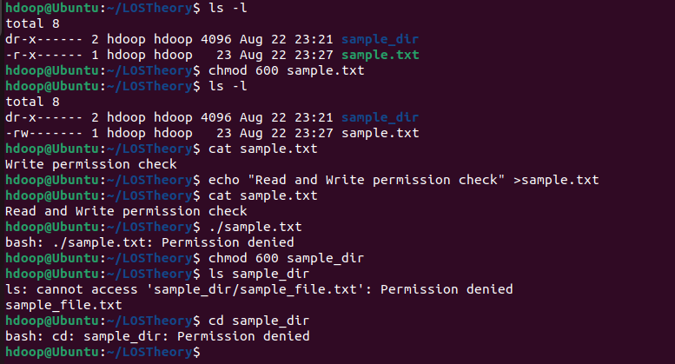

6. 700 (rwx)—
Read, write and execute permessions on file and directory

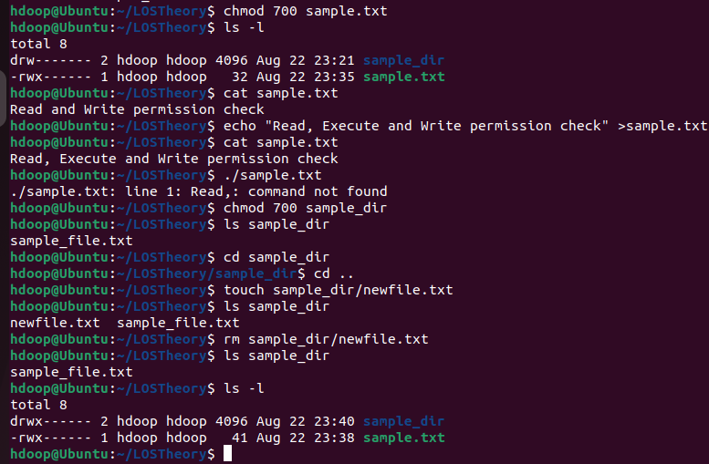

Permission Testing and Observation
Permission | Regular File - Test | Observation | Directory - Test | Observation
400 (r--) | cat sample.txt  nano sample.txt | File can be read but cannot be modified. | ls sample_dir  cd sample_dir | Directory cannot be listed or entered.
200 (-w-) | cat sample.txt  echo "hi" > sample.txt | File cannot be read but can be overwritten. | ls sample_dir  cd sample_dir  touch sample_dir/new.txt | Directory cannot be accessed, so a new file cannot be created.
100 (--x) | cat sample.txt  ./sample.txt | File cannot be read. Execution is possible when the file is an executable program or script. | ls sample_dir  cd sample_dir | Directory cannot be listed, but it can be entered.
500 (r-x) | cat sample.txt  nano sample.txt | File can be read and executed but cannot be modified. | ls sample_dir  cd sample_dir | Directory can be listed and entered, but files cannot be created or deleted.
600 (rw-) | cat sample.txt  nano sample.txt | File can be read and modified. | ls sample_dir  cd sample_dir  touch sample_dir/new.txt | Directory cannot be accessed because execute permission is not given.
700 (rwx) | cat sample.txt  nano sample.txt  ./sample.txt | File has read, write and execute permissions. | ls sample_dir  cd sample_dir  touch sample_dir/new.txt  rm sample_dir/inner.txt | Directory has full control. Contents can be listed, entered, created and deleted.

1.What does read (r) permission allow you to do with a regular file?
Read (r) on a regular file It means I can open the file and see what’s written inside. I can read the text but I cannot change anything.

2. What does read (r) permission allow you to do with a directory?
It lets me see the list of files and folders inside that directory. Basically, I can run ls and check the names.

3.What does write (w) permission mean for a regular file?
This allows me to change the contents of the file. I can edit, add new lines, or overwrite what’s already there.

4.What does write (w) permission mean for a directory?
It means I can create new files, delete files, or rename files inside that directory. I’m changing the entries of the directory itself.
5.What does execute (x) permission mean for a regular file?
If the file is a program or a script, this permission lets me run it. Without x, even if it’s a script, I can’t execute it.

6.Why is execute (x) permission important for accessing a directory?
This is important because it lets me enter the directory using cd and access files inside if I know their names. Without x, I can’t move into the directory.
7.Which permission combination allows the owner to fully access a regular file?
The combination rwx (700) gives the owner complete control — they can read, write, and execute the file.
8.Which permission combination allows the owner to fully access a directory?
Again, rwx (700) gives full control — the owner can list files, enter the directory, create new files, and delete existing ones.
9.Based on your observations, explain why the same r, w, and x permissions behave differently for a regular file and a directory.
The difference is because files deal with content, while directories deal with entries. For a file, read means reading the text inside, but for a directory, read means listing the names. Write on a file changes its content, but write on a directory changes the entries (like adding or removing files). Execute on a file runs it, while execute on a directory lets me enter and move through it. That’s why the same permissions feel different depending on whether it’s a file or a directory.

