LINUX ASSIGNMENT
1. What If There Were No Operating System?
Without an operating system, a computer is almost unusable beyond basic hardware checks. An OS like Linux provides essential features such as multitasking, file management, and hardware abstraction, making modern computing possible.
Problems Without an Operating System
A computer without an OS relies only on firmware (BIOS/UEFI) and a bootloader. This leads to several issues:
- No multitasking: You cannot run multiple applications simultaneously.
- No file management: Files cannot be stored, organized, or retrieved easily.
- No user interface: Only a basic text-based BIOS screen is available.
- No hardware abstraction: Users must directly program hardware registers, which is complex.
- No security: No authentication, permissions, or protection from unauthorized access.
How Linux OS Solves These Problems
Linux provides robust solutions through its core features:
- Multitasking Linux uses process scheduling to run multiple applications at once. For example, you can browse the web while listening to music.
- File Management Linux organizes data into a hierarchical file system (/home, /etc, /var). Commands like ls, cp, and rm make file handling intuitive.
- Hardware Abstraction Linux uses device drivers to manage peripherals (printers, USB devices, graphics cards). Users don’t need to write low-level code to interact with hardware.
- Security Linux enforces user permissions, root access control, and supports encryption, protecting data from unauthorized use.

Demonstrating OS Features in Linux
Feature 1 — Process Management
Linux is a multi-tasking operating system. It allows multiple programs to run at the same time and manages CPU time between them using scheduling algorithms. This ensures fair distribution of resources and smooth performance.
commands ---˃˃
Ps → lists currently running processes.
Top → shows real-time CPU usage and process scheduling.
Feature 2 : File management
Linux provides a hierarchical file system that abstracts physical storage into files and directories. This makes data handling simple and organized
mkdir os_demo → creates a new directory.
cd os_demo → creates a new directory.
touch file.txt → creates a new file.
ls -l → lists files with details (permissions, size, owner).
Feature 3 : Memory management
Linux efficiently manages RAM and virtual memory. Each process runs in its own protected memory space (process isolation), preventing interference. Virtual memory allows programs to run even when physical RAM is limited, by swapping data to disk.
free -h → displays RAM usage in human-readable format
top → shows memory consumption per process.

Without Operating System vs With Operating System (Linux)

Problem | Without OS | With OS (Linux)
Running Programs | User would have to interact directly with hardware. | OS loads and executes programs.
File Management | No convenient folders or files; direct disk access would be required. | Linux provides files, directories, file systems, and permissions.
Memory Management | Programs would have to manage RAM themselves. | OS allocates and manages memory between programs.
CPU Management | Programs would compete directly for CPU resources. | OS scheduler manages and allocates CPU time to processes.
Hardware Access | Programs would have to directly control hardware devices. | OS provides device drivers and system calls for hardware access.
Security | No centralized user and permission management. | Linux provides users, groups, ownership, and file permissions.
Networking | Applications would need to directly handle network hardware. | Linux provides networking protocols, interfaces, and network management.
Multitasking | Running multiple programs safely would be difficult and impractical. | OS manages multiple processes and enables multitasking.

2. Linux Distributions for a Cybersecurity Laboratory

Linux Distribution | Cybersecurity Role | Key Tools / Features | Recommended For
Kali Linux | Penetration Testing | Nmap, Metasploit, Wireshark,  Burp Suite, Aircrack-ng | Ethical hackers, penetration testers, security students
Parrot Security OS | Security Research & Ethical Hacking | Metasploit, Nmap, Burp Suite, Wireshark, privacy tools | Security researchers, penetration testers, developers
REMnux | Digital Forensics & Malware Analysis | Malware analysis, reverse engineering, network analysis tools | Malware analysts, digital forensic investigators
Tails | Privacy & Anonymity | Tor, privacy-focused applications, encrypted storage | Privacy-focused users, researchers, journalists
Security Onion | Security Monitoring & SOC | Network security monitoring, intrusion detection, log analysis | SOC analysts, blue teams, security monitoring teams
Ubuntu | General Cybersecurity Lab & Learning | Networking tools, security utilities, package management | Beginners, students, developers, general-purpose labs
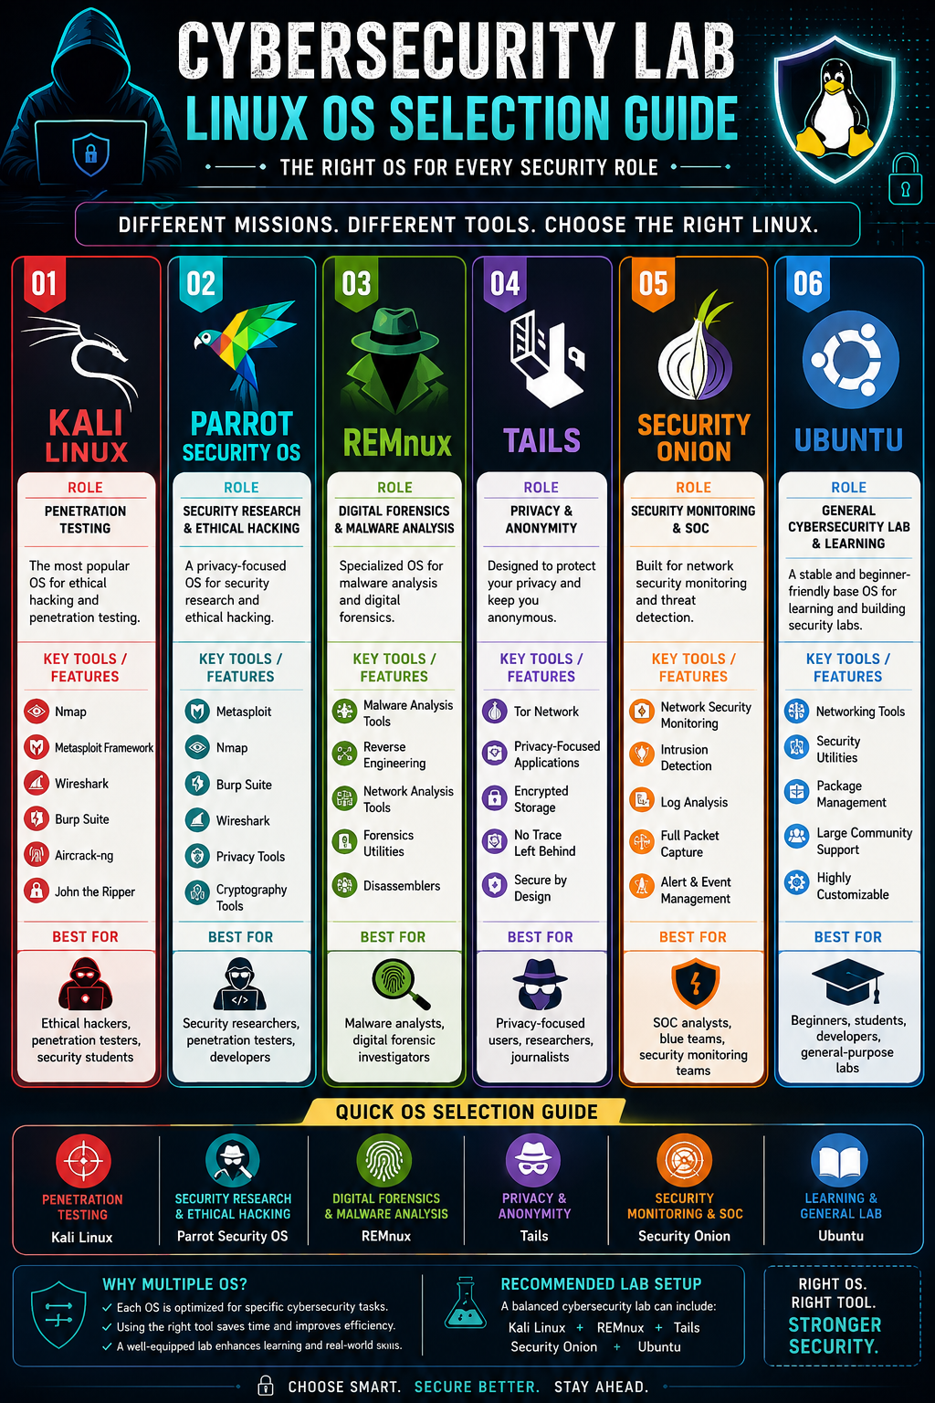
3. Exit Status ($?) in Linux
In Linux, every command returns an exit status code that indicates whether it succeeded or failed.
CommandExit Status Meaning

Command | Exit Status | Result / Meaning
cd Desktop | 0 | Success – changed directory
ls | 0 | Success – listed files
pwd | 0 | Success – printed working directory
cat exitstatus.txt | 1 | Error – file not found
tools | 127 | Error – command not found
sleep 15 | 130 | Terminated by signal
mkdir linux_file | 0 | Success – directory created
mkdir linux_file (second time) | 1 | Error – directory already exists
touch deep1.sh | 0 | Success – file created
./deep1.sh | 126 | Error – permission denied
Key point: Exit status 0 indicates success. Non-zero values indicate an error or another condition.
What can a script learn from an exit status?
A script learns from an exit status whether the last command it ran was successful or failed, and sometimes why it failed.
- Success → Exit status 0 means the command worked correctly.
- Failure → Non-zero values indicate errors (like file not found, permission denied, or no match).
- Decision making → Scripts use exit codes to decide what to do next — continue, retry, log, or stop.

