Deepika P M
261100690019

Part A — Ownership Investigation (10 Minutes)
Create a directory named ownership_lab.
Inside it, create:
incident_report.txt
network.log
credentials.txt
- mkdir ownership_lab
- cd ownership_lab
- touch incident_report.txt network.log credentials.txt
Display the detailed information for these files.
For each file, identify:
Owner
Group
Owner permissions
Group permissions
Others permissions
Determine the UID and GID of the current user.
Compare the UID/GID information with the ownership displayed for the newly created files.

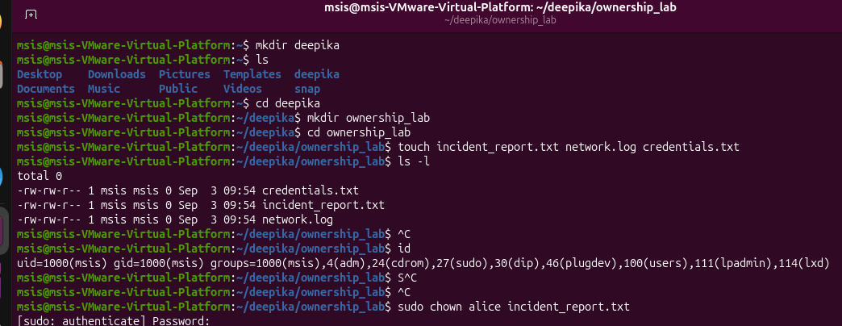

Explain the difference between file ownership and file permissions.

File Ownership: Assigns identity and primary control. Every file belongs to a specific User (the owner) and a specific Group. The owner has special privileges, such as the ability to change permissions or transfer group ownership (within limits).
File Permissions: Dictates access rights—specifically Read (r), Write (w), and Execute (x)—and applies them across three distinct categories: the User owner, the Group owner, and Everyone Else

Part B — chown: Changing Ownership
Change the owner of incident_report.txt to alice.
- sudo chown alice incident_report.txt

Change the owner of network.log to bob.
Change the owner of credentials.txt to charlie.

- sudo chown alice incident_report.txt
- sudo chown bob network.log
- sudo chown charlie credentials.txt

Verify each change.
- ls -l incident_report.txt network.log credentials.txt

Try changing the owner of a file to another user without using sudo. Record the result.

- chown bob incident_report.txt

Explain why an ordinary user is generally not permitted to transfer file ownership to another user.
Using a single command, configure:
incident_report.txt
Owner : alice
Group : security
- sudo chown alice:security incident_report.txt

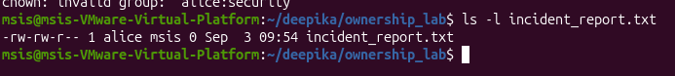
Verify the resulting ownership.

- ls -l incident_report.txt

Part C — chgrp: Changing Group Ownership
Change the group ownership of network.log to developers.
Change the group ownership of credentials.txt to security.
- sudo groupadd developers
- sudo chgrp developers network.log
- sudo chgrp security credentials.txt
Verify the changes.
-ls -l network.log credentials.txt

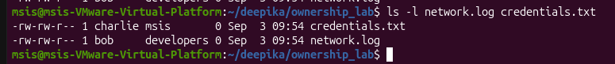
Display the group memberships of alice, bob, and charlie.
groups alice bob charlie

Log in as alice and create a file named alice_report.txt.
- sudo -u alice touch alice_report.txt

Attempt to change the group of alice_report.txt to security.
- sudo -u alice touch alice_report.txt
Result for security: chgrp: changing group of 'alice_report.txt': Operation not permitted (fails because alice is not a member of the security group).

Attempt to change its group to developers.
- sudo -u alice chgrp security alice_report.txt
Result for developers: Succeeds silently or with zero exit code (because alice is a member of the developers group).

Compare the results.
Explain how a user's group membership affects their ability to change the group ownership of a file they own.

A user can only change a file's group ownership to a group of which they are currently a member. Even if a user owns a file, they cannot arbitrarily assign it to any group on the system unless they possess administrative privileges (like sudo/root). This restriction prevents regular users from circumventing system group permissions or assigning files to groups they have no legitimate association with.

Part D — Ownership + Permission Investigation

Configure:

-rw-r----- alice security incident_report.txt
Identify what operations are available to:
alice
charlie
bob

- sudo chmod 640 incident_report.txt

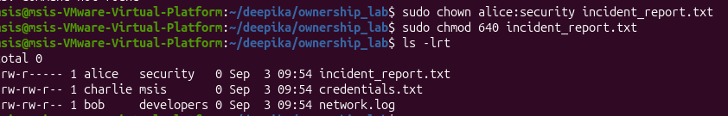

A user who belongs to neither security nor the file owner
Operations available to a user who belongs to neither security nor the file owner: No access (---). They cannot read, modify, or execute the file.
charlie belongs to security. Test whether Charlie can:
Read incident_report.txt
- sudo -u charlie cat incident_report.txt
Modify incident_report.txt
- sudo -u charlie echo "unauthorized update" >> incident_report.txt
Delete incident_report.txt
- sudo -u charlie rm incident_report.txt

Record the result of each operation.

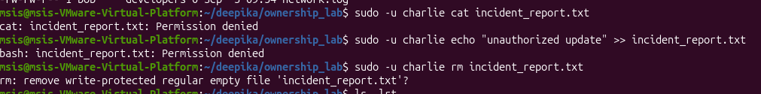

Change the permissions to:
-rw-rw----

- sudo chmod 660 incident_report.txt

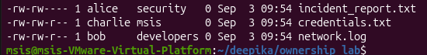

Repeat the test as charlie.

Explain why Charlie's access changed even though the owner and group of the file did not change.
Charlie's group membership did not change, but the permission bits for the group category were updated from r-- (read-only) to rw- (read and write). Because Charlie belongs to the security group, he inherited the newly added write capability.

Remove bob from the security group.

- sudo gpasswd -d bob security

Without changing the file's ownership or permissions, test Bob's access again.
- sudo -u bob cat incident_report.txt

Explain why Bob's effective permissions changed.

Bob's effective permissions changed because Linux evaluates file access using a strict hierarchy consisting of three categories: User (owner), Group, and Others.

