Deepika P M
261100690019

LOS LAB ASSIGNMENT – DAY 1
Part A — User and System Investigation
1. Determine the username of the account you are currently using.
- whoami

2. Display your UID, primary GID, and supplementary groups.
id -u
id -g
id -G
3. Display all users currently logged in to the system.
- users or who

4. Determine what activities the currently logged-in users are performing.
- w
5. Examine /etc/passwd and identify the following information for your current account:
Username
UID
GID
Home directory
Login shell
- grep "^$USER:" /etc/passwd

6. Determine how many user-account entries are present in /etc/passwd.
- wc -l /etc/passwd
7. Display only the username and UID fields from /etc/passwd.
- cut -d: -f1,3 /etc/passwd

8. Find all accounts whose UID is 0. Explain the security significance of UID 0.

- awk -F: '$3 == 0 {print $1}' /etc/passwd

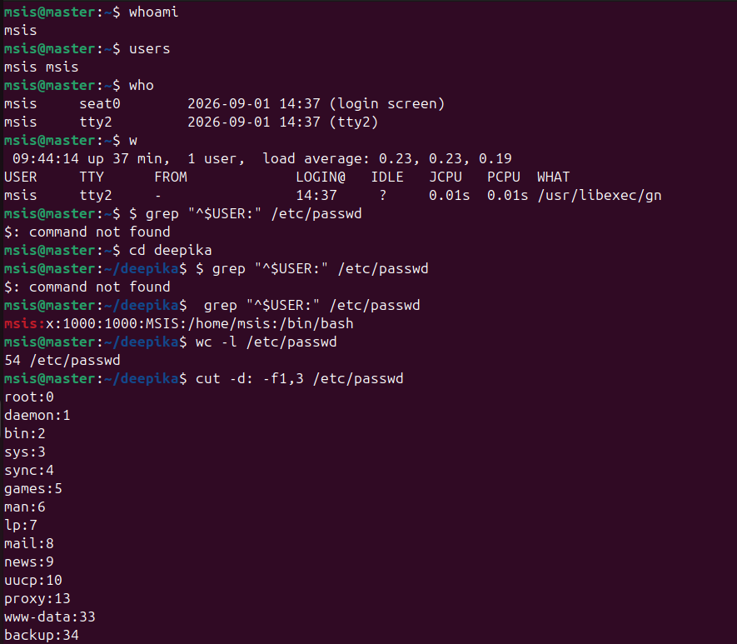

9. Compare /etc/passwd and /etc/shadow. Why are password hashes stored in /etc/shadow instead of /etc/passwd?

Comparison Table

Feature | /etc/passwd | /etc/shadow
Read Permission | Readable by everyone (644) | Readable only by root/shadow (600 or 640)
Primary Purpose | Contains general account information | Contains secure authentication details
Password Data | Shows a placeholder x | Stores the actual encrypted password hash
Aging Policies | None | Stores expiration, warning, and lockout dates

Part B — Creating and Verifying Users
1. Create the following users and ensure that a home directory is created for each:

alice, bob, charlie

sudo useradd -m alice
sudo useradd -m bob
sudo useradd -m charlie
2. Verify that all three accounts have been added to /etc/passwd.
grep -E '^(alice|bob|charlie):' /etc/passwd
3. Determine the UID assigned to each newly created user.
awk -F: '/^(alice|bob|charlie):/ {print $1 " UID is " $3}' /etc/passwd

4. Determine the home directory and default shell assigned to alice.
grep "^alice:" /etc/passwd | cut -d: -f6,7

5. Inspect /home and verify that the required home directories were created.

ls -la /home

6. Set passwords for all three accounts.
sudo passwd alice
sudo passwd bob
sudo passwd charlie

7. Switch from your current account to alice using a login shell. Verify the change using an appropriate command, and then return to your original account.
su – bob
(Enter password)
whoami
pwd
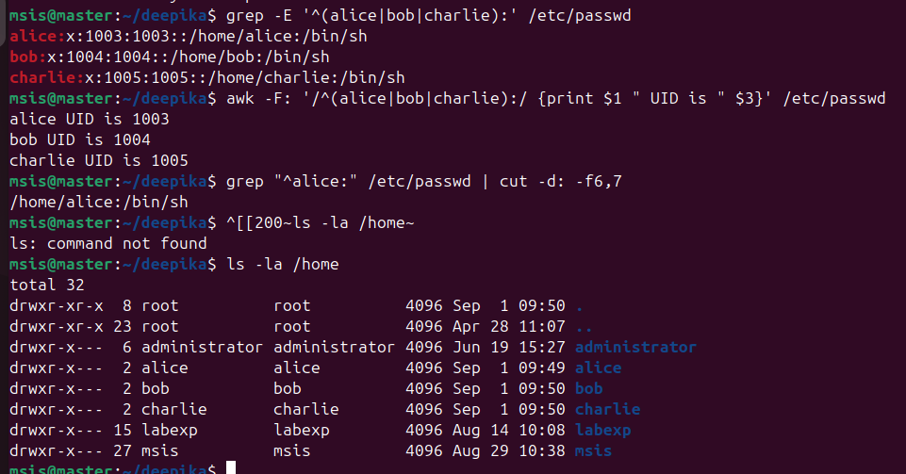
exit

Part C — Group Management and Access Control
1. Create two groups:

security and developers
sudo groupadd security
sudo groupadd developers
Add alice and charlie to the security group.
sudo usermod -aG security alice
sudo usermod -aG security charlie
2. Add bob to the developers group.
sudo usermod -aG developers bob
3. Without switching accounts, verify the group membership of all three users.
groups alice bob charlie
groups alice bob charlie
4. Display the entries corresponding to security and developers from /etc/group.
grep -E '^(security|developers):' /etc/group

5. Add bob to the security group without removing him from the developers group.
sudo usermod -aG security bob

6. Verify that bob now belongs to both groups.
groups bob

