Table of Contents
ABSTRACT 2
CHAPTER 1 –INTRODUCTION 3
1.1 Objectives 5
1.2 System Specifications 5
CHAPTER 2 – LITERATURE REVIEW 7
EXISTING SYSTEM: 10
PROPOSED SYSTEM: 12
CHAPTER 3 OVERALL DESCRIPTION OF THE PROPOSED SYSTEM 14
3.1 Module Description 14
CHAPTER 4 – DESIGN 18
4.1UML Diagrams: 19
4.1.1Usecase Diagrams: 19
4.1.2 Sequence Diagram: 21
4.1.3 Collaborate Diagram: 24
4.1.4 System Architecture Diagram: 25
4.1.5 Table Design 26
4.1.6. Work Flow Diagram 27
4.1.7. Data Flow Diagram 28
4.1.8. ER Diagram 31
4.1.9. Class Diagram 31
4.1.10. Activity Diagram 32
CHAPTER 5 - OUTPUT SCREENSHOTS 33
CHAPTER 6 – IMPLEMENTATION DETAILS 34
CHAPTER 7- SYSTEM STUDY 40
CHAPTER 8-TECHNICAL FEASIBILITY 41
CHAPTER 9-SYSTEM TESTING 44
CHAPTER 10– CONCLUSIONS 49
CHAPTER 11- REFERENCES 50

Bus Pass Management System Using Android Applications

ABSTRACT
The project entitled “Online Bus Pass Registration / Renewal” is developed using android. Mobile app provide the solution for student bus pass, route pass , route infomation for bus pass. Bus pass registration is useful for students and all passengers to get the bus pass ID, who is facing problems with the current manual work of bus pass registration and renewal. His/her renewal or registration can be done through mobile app. In the manual system the user has to go on particular date and time if they fail then the renewal cannot be done. This online bus pass registration application will help candidates to save their time and renewal bus pass without standing in a line for hours near counters. Initially uses need to register with the application by submitting their details through online. The administrator will verify the candidate details and if they are satisfied they will approve bus pass. The candidate can login with their username and password and renewal is performed

CHAPTER 1 –INTRODUCTION
The rapidly aging population causes long waiting times for taking bus pass. Diagnosing record of real-time data of each who are all using bus passes, Bus pass automation would be beneficial for government to implement proper and better rates for passes and also it would be useful for people who forget to renew their bus passes. Giving exact change for tickets to a large crowd is also a tedious process for conductors in the buses. In this paper, we propose a facility to take bus passes using android mobile application. This system also provides a facility to remind when the bus pass is about to expire. The app is also used to take print out of the pass, so that it can be shown to the College Admin who are unfamiliar with android phones. The system is also provided with digital wallet where the user can load money as a whole and use it in each buses the user travels.
As technology starts growing we need to update ourselves to current trends and our upcoming generations looking forward for necessary services in one touch. The current system of applying or renewing for bus pass is a tedious process. It takes for bus passes it involves a long queue in Depo and it is a time consuming process [1]. This increases increase in time delay for passengers and it hurts more for employees due to time delay in peak hours. Bus Pass can be used to apply/renew the bus pass through smart phone, which helps all generation people. This system provides connection between government server, where data is managed and android app. This helps in reminding user about bus pass expiry. In addition, providing a user tracking facility, this helps to determine how efficiently users use their bus passes and helps in planning new rates for bus passes.
Today’s world switching to technical world and every system of the technical world are based on digitalized system. For digitalization and rapid process online system is required. Now a day’s bus pass generation is done by manually. Todo rapid work and reduce manual work this online bus pass system is useful. This system allows getting online information about roots and it also gives current location facility.For the verification, security and proper authentication it use the Aadhaar card Number. These systems use the hadoop for analysis and processing the huge amount of data. In future we can link smart card for the online payment.
This Application is mainly aims to give an effective facility of online bus pass system. It also uses database to store information about passenger. Bus pass generation as well as renewal system is provided. It is very useful as it reduces paper work, time consuming and makes process in simple and faster way. In this paper, we propose a facility to take bus tickets and bus passes using android mobile application.. Students or Customers can easily Apply and renew their existing pass by extending their validity of time when pass expires. This system is intended to develop an application to do functions like accessing information for authentication and offer pass to particular person. So, users don’t need to stand in queue for long time.
By using the advanced technologies it is much easier to bring the entire bus pass generation to online. It is very easy and also efficient when compare to the old bus pass generation method. Old method is took very long time and have to maintain lot of details in physical form. It is very hard to transfer that much of data in physical form , so it take lot of man power to get the job done. This process is highly time consuming and more complex. Even though it is very difficult and time consuming it has lot of drawbacks. The first and main disadvantage is it does not provide any security options. This is mainly useful for school and college students and old age peoples. The aim is develop this system for government. So that it can used by many peoples. These pass are auto renewed or it can renewed in the online application. Renewed can be downloaded from the website. College Admin can verify or check the bus pass by just scanning it from their android phone. If the pass is valid the it will provide all the route and basic information about the passenger. If the pass is not valid for duplicate it will prompt as not valid. So it is easy to prevent fraudulent activities by using this application.

Objectives
Bus Pass Management System aim is to provide the information about the services or manage the bus pass cards and application for each services of user bus pass ID and it also view and update by the admin of Bus pass management system

System Specifications
Hardware Requirements:-
- PROCESSOR : Intel i3
- RAM : 4 GB RAM
- HARD DISK DRIVE : 500 GB
- MONITOR : 17” LCD/LED
- KEYBOARD : Multimedia Keyboard 108 Keys
- MOUSE : Logitech Optical Mouse

Software Requirements: -
Software Requirements: -
Front End: HTML5, CSS3, Bootstrap
Back End: PHP 8.1, MYSQL
Control End: Angular Java Script

Android Tools:
IDE: Android Studio
Android Emulator
xampp-win64-8.1

CHAPTER 2 – LITERATURE REVIEW
1 . Bus Pass Time Estimation based on Efficient Data :
Statistical description and prediction of bus arrival times is relevant for public transport users since it allows more timewise efficient journeys. This work is focused on characterizing the real behavior of buses based on past arrival estimation data. The main goal is to estimate real bus pass times by optimally collecting data from an intercity bus arrival time estimation system which is limited in petition handling capacity. This requires to model the server behavior prior to the design of the data collection system. In addition, it also requires the design of an algorithm to estimate the bus real passing time considering that only the provided estimated time of arrival is available. This information can be useful for designing alternative online arrival time estimators based on supervised learning which could potentially improve the estimator efficiency.
2. Smart Buspass System Using Android :
The main aim of this paper, to introduce the online based app for applying and renewals of bus pass in the government bus. Those who wish to take a bus pass in the government bus and also renewal of their bus pass within the specific period of time which is easy by using this app.. Once the payment is done and verified by the admin the pass is generated and sent to the students or users mail. Then the user can have the softcopy of the pass and he/she can download it and make it as hardcopy and use it. The user can also renew the bus pass by login into the website. A notification has been sent to the users registered e-mailif the pass is about to expire, so he /she can aware of it and renew it.

3. Digital Bus Pass for Local Buses :
In this system, the online bus pass generation system is a cross platform, it is supported in kind of devices .So one can apply the bus pass from anywhere easily without any difficulties. As like all other systems it provides the same functionalities with one additional functionality. The additional function is tracking, which is for women safety. This system ensures women safety by keep tracking of women pass users and also the pass, whenever the pass is scanned or used by women user a message is sent to the guardian of the women through system with location. Tracking can also be done using this incase of pass lost or theft.
This is one of the great way to provide security. The conductor who scans the QR code using the scanning app should login into the website to ensure confidentiality, whenever the pass is scanned the information are get stored in the database of the system. The conductor uses the recommended android app for the QR code scanning and whenever the pass is used or scanned a notification is sent through message for the card user and for guardian of women users.
Title1: Online Bus pass Generation System using Web Application Author: S.Famitha, G.Priyanka, M.Vasanthi Our project is created to provide timesaving, comfortable and safe services for students. Due to the drawbacks that are present in the existing system, we got the idea of doing this project of generating the bus pass through online which can help students in a better way.
In the existing system student had to do each and every process manually, but our project helps student to make their work faster and easy. Students can buy the bus pass through the internet. This system is also used to the save the students time. The students can pay to buy bus pass through Credit Card and Net banking.
Title2: Development of an Effective Online Bus Pass Generation System for Transportation Service in Karnataka State Author: Parashuram Baraki, Sandhya Kulkarni, Spurthi Kulkarni, Arpita Goggi, Keertipriya I. This project was created to provide "safe, reliable, timesaving, efficient, comfortable and affordable" services for people is seen as having accomplished this objective, although the cost for providing this service has been substantial. It is heavily subsidized by the government and is reportedly in the red, like most of India's state run road transport undertakings. Because of the drawbacks that are present in the existing system, we got this idea that would help people in a better way. As per the previous system people had to do each and every process manually, but this system helps people to make the work a bit faster. [1] Customer can buy the bus ticket over the Internet, 24 hours a day throughout the week, this solves the issue of bus ticket being misplaced or stolen. In addition, the online system lets the customers check the availability of the bus ticket before they buy bus ticket. Furthermore, customers no need to pay cash to buy bus ticket because they can pay the bus ticket by using Credit Card. Hence, there is a need of reformation of the system with more advantages and flexibility. The Bus Scheduling and Booking System eliminate most of the limitations of the existing software.
Title3: Online Bus Pass System Author: S. Pradhiba, D. SathiyaPriya, P. Vasantha Kumari and R. Rajkumar This project is created to provide “safe, reliable, saving, efficient and affordable” services for user. This idea would help the user in a better way. As per the previous system the user had to do each and every process manually, but this system helps user to make the work bit faster. The user can then take print out of this bus pass from their mail id and use them. The bus pass will be differ for different types of users. In this bus pass, all the required details such as candidate name, address, date of birth, mail id, name of the school(government/private), validity period, amount paid (free for government school students) and photo copy of the candidate are provided. Instead of school details, working organization details will be provided in employees bus pass. The renewal process can be done either monthly or yearly as per user wish. Based on that renewal period amount will be deducted.
Title4: Online Facility of Ticket Booking and Generating Bus pass Using QR Code Author: Aakansha Gupta, Beenash Iram, Bharti Samrit, Monika Dhage, Prof. Nazish Khan This online Bus Pass and Ticket Generation System is a web application which is beneficial for the regular passenger of Nagpur city who are facing problems because of the record or register facility in the bus depots. Because of the increased growth in technology, peoples are changing them with improved technology and contributing in the digital world. This system is developed to facilitate to provide efficient, inexpensive, well grounded, well planned and comfortable usage of this application for Nagpur city commuters. The heavy rush in the bus depots causes lengthy waiting time for the registration of the bus pass and also to get them. This application offers the facility to get bus tickets and bus pass with the help of an android mobile application. In addition to this, this project gives a provision by which the passenger is able to book their ticket through online procedure. This application will also send a notification in user’s email ID about the expiration period of bus pass. This application maintains a bond between users and admin.

EXISTING SYSTEM:
In the existing system bus pass registration and renewal process are carried out manually. The person has to visit the counter and have to submit the details and then they have to wait for approval. For each and every process there is time limit specifiedif the person fails to go on time then all the transactions will be cancelled. In this existing system was used to bus details maintain through file. And after bus information are stored to computerize. The Project Metrics has to enter all the details of project, documents, and tasks. And, also the maintenance team information and also efforts estimation. For this purpose the organization maintain the size of the document, source code and update the information about team member’s details manually. Whichis much of time consuming process and more importantly it is error prone. At present system bus pass collect from depot very rare one. User can facing lot of problems
Disadvantages
•It is time consuming
•It consumes lot of manpower to better results
•It lacks of data security
•Retrieval of data takes lot of time
•Percentage of accuracy is less
•Reports take time to produce

PROPOSED SYSTEM:
The proposed system overcomes the drawbacks in the existing system. In the proposed system user register their details through online and get their unique username and password for further processing. The bus pass will be differ for different types of users. In this bus pass, all the required details such as candidate name, address, date of birth, mail id, name of the school, validity period, amount paid (free for government school students) and photo copy of the candidate are provided. Instead of school details, working organization details will be provided in route bus pass. The renewal process canbe donemonthly as per user wish. Based on that renewal period amount will be deducted.

Advantages
- To make accuracy and efficient calculations.To provide proper information briefly
- To provide huge maintenance of records
- Flexibility of transactions can be completed in time
- Easily bus pass apply through online.
- You can find all the bus pass related information online without going to the bus station.
- This online bus pass software system will help students and passengers get bus passes online and eliminate the need of standing in queues for passes or collecting a ticket for each journey.
- The payment can be done online via credit or master card.

Disadvantages
- Verification of the passengers cannot be done online. They have to first get themselves verified by visiting before using the system.
- It requires a large database and memory.

CHAPTER 3 OVERALL DESCRIPTION OF THE PROPOSED SYSTEM

3.1 Module Description
The system is proposed to have the following modules: This app enhanced level of categories for Bus Pass App.
3.2 System Features
In the life of the software development, problem analysis provides a base for design and development phase. The problem is analyzed so that sufficient matter is provided to design a new system. Large problems are sub-divided into smaller once to make them understandable and easy for finding solutions. Same in this project all the task are sub-divided and categorized.
System Modules:
- Admin:
- Login
- Manage College Admin login
- Manage College List
- Approve bus pass
  - Update Slot
- Print Bus Pass
- Create Bus details
- User:
- Register
- Login
- Apply New bus pass
- Renewal bus pass
- My Bus Pass
- View Bus Route Details
- College Admin :
  - Login
  - Verify Student Details
- Approve Student

Module Description
- Admin:
- Login
In log in page, admin can manage all information. They can update or edit any information.
- Manage College Admin Login
Admin can Create & View and update the College Admin Login details
- Manage College List
Admin can Create & View and update the College List details

- Approve Bus Pass
Admin Can Approve the Bus Pass Details

- Update Slot
Admin can update the Slot details

- Manage Bus Details
Admin can Create & View and update the Bus details
- User:
- Register
User will register with the system using their username and password.
- Login
After the registration process users can login to their account any time using the login details.
- Apply New Bus Pass
User Can Apply The new Bus Pass Details
- Renewal Bus Pass
User can Renewal the Bus Pass Details
- My Bus Pass
User Can View The Bus Pass Details
- View Bus Route Details
User can View the Bus Route Details
- College Admin :
- College Admin Login
In log in page, admin can manage all information. They can update or edit any information
- Verify Student Details
College Admin Can Verify the All Student Details

- Approve Student Details
College Admin Can Approve The Student Details

CHAPTER 4 – DESIGN
Design is the first step in the development phase for any techniques and principles for the purpose of defining a device, a process or system in sufficient detail to permit its physical realization.
Once the software requirements have been analyzed and specified the software design involves three technical activities - design, coding, implementation and testing that are required to build and verify the software.
The design activities are of main importance in this phase, because in this activity, decisions ultimately affecting the success of the software implementation and its ease of maintenance are made. These decisions have the final bearing upon reliability and maintainability of the system. Design is the only way to accurately translate the customer’s requirements into finished software or a system.
Design is the place where quality is fostered in development. Software design is a process through which requirements are translated into a representation of software. Software design is conducted in two steps. Preliminary design is concerned with the transformation of requirements into data.

4.1UML Diagrams:
UML stands for Unified Modeling Language. UML is a language for specifying, visualizing and documenting the system. This is the step while developing any product after analysis. The goal from this is to produce a model of the entities involved in the project which later need to be built. The representation of the entities that are to be used in the product being developed need to be designed.
There are various kinds of methods in software design:

- Use case Diagram
- Sequence Diagram
- Collaboration Diagram

4.1.1Usecase Diagrams:
Use case diagrams model behavior within a system and helps the developers understand of what the user require. The stick man represents what’s called an actor. Use case diagram can be useful for getting an overall view of the system and clarifying that can do and more importantly what they can’t do.

Use case diagram consists of use cases and actors and shows the interaction between the use case and actors.
- The purpose is to show the interactions between the use case and actor.
- To represent the system requirements from user’s perspective.
- An actor could be the end-user of the system or an external system

4.1.2 Sequence Diagram:
Sequence diagram and collaboration diagram are called INTERACTION DIAGRAMS. An interaction diagram shows an interaction, consisting of set of objects and their relationship including the messages that may be dispatched among them.

A sequence diagram is an introduction that empathizes the time ordering of messages. Graphically a sequence diagram is a table that shows objects arranged along the X-axis and messages ordered in increasing time along the Y-axis.

4.1.3 Collaborate Diagram:
A collaboration diagram, also called a communication diagram or interaction diagram, is an illustration of the relationships and interactions among software objects in the Unified Modeling Language (UML).

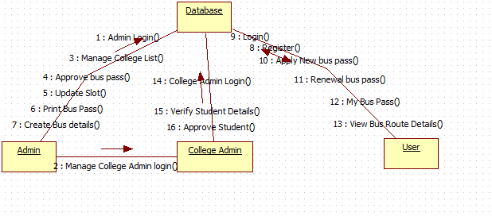

4.1.4 System Architecture Diagram:
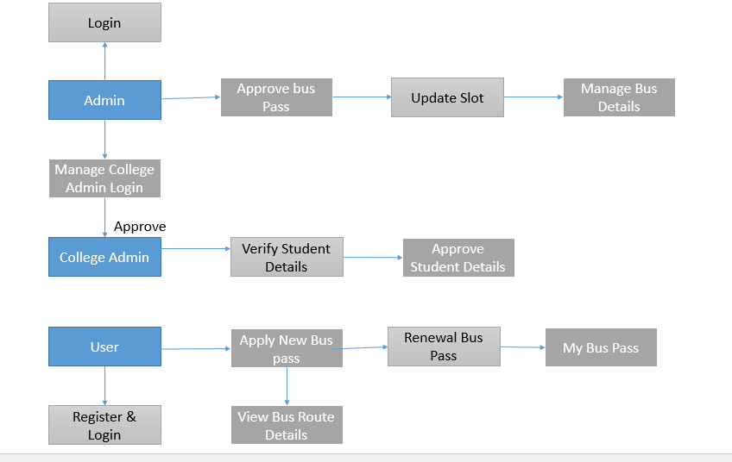

4.1.5 Table Design
User / College Admin Register & Login
User ID | Name | Email Id | Password | Mobile | Address | City | Pincode | Type
Int | Varchar | Varchar | Varchar | Varchar | Varchar | Varchar | Varchar | Varchar
100 | 100 | 100 | 100 | 100 | 100 | 100 | 100 | 100
Primary key

Bus Pass Details
User ID | Email | Pass Type | Period | Bus No | From To | Mobile | Name | Address
Int | Varchar | Varchar | Varchar | Varchar | Varchar | Varchar | Varchar | Varchar
100 | 100 | 100 | 100 | 100 | 100 | 100 | 100 | 100
Primary key

Bus Details
User ID | Bus No | From To | Route | Cost
Int | Varchar | Varchar | Varchar | Varchar
100 | 100 | 100 | 100 | 100
Primary key

Update Slot
User ID | Date | Time Around | Slot
Int | Varchar | Varchar | Varchar
100 | 100 | 100 | 100
Primary key

Admin Login
User ID | Username | Password
100 | 100 | 100
Primary key

4.1.6. Work Flow Diagram
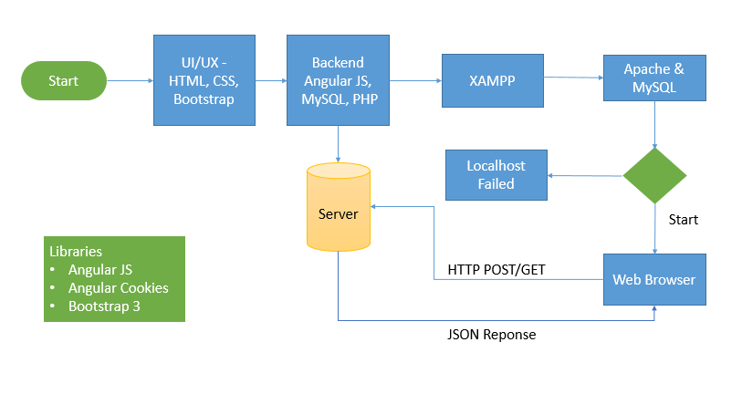

4.1.7. Data Flow Diagram
Start

User Registration

User Login

Apply New Bus Pass
Logout

View Bus Route Details
My Bus Pass
Renewal Bus Pass
Admin Start

Login

Manage College Admin Login

Manage College List
Manage Bus Details
Print Bus pass
Update Slot
Approve Buspass
College lo

sAdmin Login
Alolo AAAdmin Start

College Admin Login

Verify Student Details

Approve Student Details
Logout

4.1.8. ER Diagram
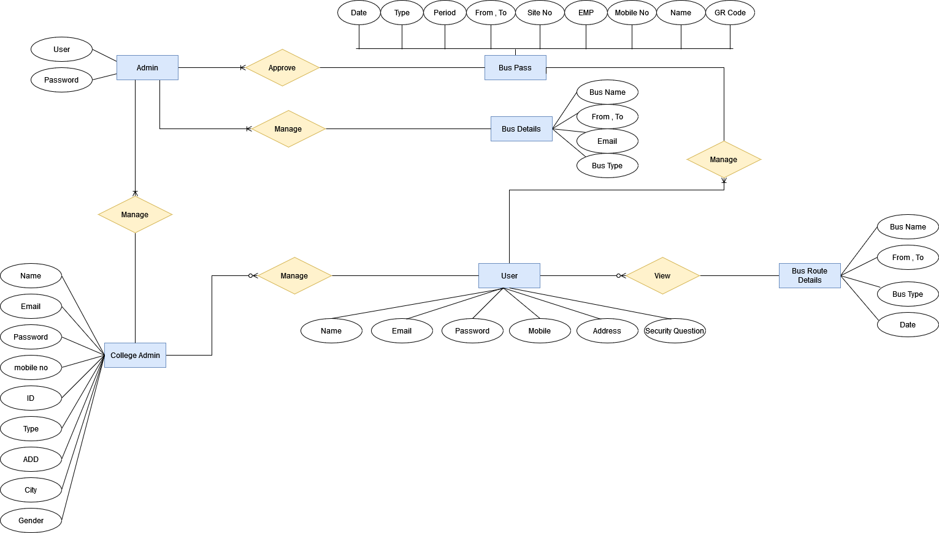

4.1.9. Class Diagram

4.1.10. Activity Diagram

CHAPTER 5 - OUTPUT SCREENSHOTS

CHAPTER 6 – IMPLEMENTATION DETAILS
6.1 Introduction to Html Framework
HyperText Markup Language, commonly referred to as HTML, is the standard markup language used to create web pages. Along with CSS, and JavaScript, HTML is a cornerstone technology used to create web pages, as well as to create user interfaces for mobile and web applications. Web browsers can read HTML files and render them into visible or audible web pages. HTML describes the structure of a website semantically along with cues for presentation, making it a markup language, rather than a programming language.
HTML elements form the building blocks of HTML pages. HTML allows images and other objects to be embedded and it can be used to create interactive forms. It provides a means to create structured documents by denoting structuralsemantics for text such as headings, paragraphs, lists, links, quotes and other items. HTML elements are delineated bytags, written using angle brackets. Tags such as <img /> and <input /> introduce content into the page directly. Others such as <p>...</p> surround and provide information about document text and may include other tags as sub-elements. Browsers do not display the HTML tags, but use them to interpret the content of the page.
HTML can embed scripts written in languages such as JavaScript which affect the behavior of HTML web pages. HTML markup can also refer the browser to Cascading Style Sheets (CSS) to define the look and layout of text and other material

6.2 Cascading Style Sheets (CSS)
CSS is a style sheet language used for describing the presentation of a document written in a markup language. Although most often used to set the visual style of web pages and user interfaces written in HTML and XHTML, the language can be applied to any XML document, including plain XML, SVG andXUL, and is applicable to rendering in speech, or on other media. Along with HTML and JavaScript, CSS is a cornerstone technology used by most websites to create visually engaging webpages, user interfaces for web applications, and user interfaces for many mobile applications.
CSS is designed primarily to enable the separation of document content from document presentation, including aspects such as the layout, colors, and fonts. This separation can improve content accessibility, provide more flexibility and control in the specification of presentation characteristics, enable multiple HTML pages to share formatting by specifying the relevant CSS in a separate .css file, and reduce complexity and repetition in the structural content, such as semantically insignificant tables that were widely used to format pages before consistent CSS rendering was available in all major browsers. CSS makes it possible to separate presentation instructions from the HTML content in a separate file or style section of the HTML file. For each matching HTML element, it provides a list of formatting instructions. For example, a CSS rule might specify that "all heading 1 elements should be bold", leaving pure semantic HTML markup that asserts "this text is a level 1 heading" without formatting code such as a<bold> tag indicating how such text should be displaye
This separation of formatting and content makes it possible to present the same markup page in different styles for different rendering methods, such as on-screen, in print, by voice (when read out by a speech-based browser orscreen reader) and on Braille-based, tactile devices. It can also be used to display the web page differently depending on the screen size or device on which it is being viewed. Although the author of a web page typically links to a CSS file within the markup file, readers can specify a different style sheet, such as a CSS file stored on their own computer, to override the one the author has specified. If the author or the reader did not link the document to a style sheet, the default style of the browser will be applied. Another advantage of CSS is that aesthetic changes to the graphic design of a document (or hundreds of documents) can be applied quickly and easily, by editing a few lines in one file, rather than by a laborious (and thus expensive) process of crawling over every document line by line, changing markup.
The CSS specification describes a priority scheme to determine which style rules apply if more than one rule matches against a particular element. In this so-called cascade, priorities (or weights) are calculated and assigned to rules, so that the results are predictable.
6.3 MYSQL Server
MySQL is an open-source relational database management system (RDBMS);[6] in July 2013, it was the world's second most widely used RDBMS, and the most widely used open-source client–server model RDBMS. It is named after co-founder Michael Widenius's daughter, My. The SQL acronym stands for Structured Query Language. The MySQL development project has made its source code available under the terms of the GNU General Public License, as well as under a variety of proprietary agreements. MySQL was owned and sponsored by a single for-profit firm, the Swedishcompany MySQL AB, now owned by Oracle Corporation. For proprietary use, several paid editions are available, and offer additional functionality.

6.4 PHP
PHP is a server-side scripting language designed for web development but also used as a general-purpose programming language. Originally created by RasmusLerdorf in 1994, the PHP reference implementation is now produced by The PHP Group. PHP originally stood for Personal Home Page, but it now stands for therecursive backronym PHP: Hypertext Preprocessor.
PHP code may be embedded into HTML code, or it can be used in combination with various web template systems, web content management system and web frameworks. PHP code is usually processed by a PHPinterpreter implemented as a module in the web server or as a Common Gateway Interface (CGI) executable. The web server combines the results of the interpreted and executed PHP code, which may be any type of data, including images, with the generated web page. PHP code may also be executed with a command-line interface(CLI) and can be used to implement standalone graphical applications.
The standard PHP interpreter, powered by the Zend Engine, is free software released under the PHP License. PHP has been widely ported and can be deployed on most web servers on almost every operating system andplatform, free of charge.
The PHP language evolved without a written formal specification or standard until 2014, leaving the canonical PHP interpreter as a de facto standard. Since 2014 work has gone on to create a formal PHP specification.

6.5 ANGULAR JAVA SCRIPT
AngularJS (commonly referred to as "Angular" or "Angular.js") is an open-source web application framework mainly maintained by Google and by a community of individuals and corporations to address many of the challenges encountered in developing single-page applications. It aims to simplify both the development and the testing of such applications by providing a framework for client-side model–view–controller (MVC) and model–view–viewmodel(MVVM) architectures, along with components commonly used in rich Internet applications.
The AngularJS framework works by first reading the HTML page, which has embedded into it additional custom tag attributes. Angular interprets those attributes as directives to bind input or output parts of the page to a model that is represented by standard JavaScript variables. The values of those JavaScript variables can be manually set within the code, or retrieved from static or dynamic JSON resources.
According to JavaScript analytics service Libscore, AngularJS is used on the websites of Wolfram Alpha, NBC,Walgreens, Intel, Sprint, ABC News, and approximately 8,400 other sites out of 1 million tested in July 2015.
AngularJS is the frontend part of the MEAN stack, consisting of MongoDB database, Express.js web application server framework, Angular.js itself, and Node.js runtime environment.

CHAPTER 7- SYSTEM STUDY

7.1 FEASIBILITY STUDY
The feasibility of the project is analyzed in this phase and business proposal is put forth with a very general plan for the project and some cost estimates. During system analysis the feasibility study of the proposed system is to be carried out. This is to ensure that the proposed system is not a burden to the company. For feasibility analysis, some understanding of the major requirements for the system is essential.
Three key considerations involved in the feasibility analysis are
- ECONOMICAL FEASIBILITY
- TECHNICAL FEASIBILITY
- SOCIAL FEASIBILITY

ECONOMICAL FEASIBILITY

This study is carried out to check the economic impact that the system will have on the organization. The amount of fund that the company can pour into the research and development of the system is limited. The expenditures must be justified. Thus the developed system as well within the budget and this was achieved because most of the technologies used are freely available. Only the customized products had to be purchased.

CHAPTER 8-TECHNICAL FEASIBILITY

This study is carried out to check the technical feasibility, that is, the technical requirements of the system. Any system developed must not have a high demand on the available technical resources. This will lead to high demands on the available technical resources. This will lead to high demands being placed on the client. The developed system must have a modest requirement, as only minimal or null changes are required for implementing this system.

SOCIAL FEASIBILITY
The aspect of study is to check the level of acceptance of the system by the user. This includes the process of training the user to use the system efficiently. The user must not feel threatened by the system, instead must accept it as a necessity. The level of acceptance by the users solely depends on the methods that are employed to educate the user about the system and to make him familiar with it. His level of confidence must be raised so that he is also able to make some constructive criticism, which is welcomed, as he is the final user of the system.

8.1Non Functional Requirements
Non-functional requirements are the quality requirements that stipulate how well software does what it has to do. These are Quality attributes of any system; these can be seen at the execution of the system and they can also be the part of the system architecture.

8.2 Accuracy:
The system will be accurate and reliable based on the design architecture. If there is any problem in the accuracy then the system will provide alternative ways to solve the problem.

8.3 Usability:
The proposed system will be simple and easy to use by the users. The users will comfort in order to communicate with the system. The user will be provided with an easy interface of the system.

8.4 Accessibility:
The system will be accessible through internet and there should be no any known problem.

  - Performance:
The system performance will be at its best when performing the functionality of the system.

  - Reliability:
The proposed system will be reliable in all circumstances and if there is any problem that will be affectively handle in the design.

  - Security:
The proposed system will be highly secured; every user will be required registration and username/password to use the system. The system will do the proper authorization and authentication of the users based on their types and their requirements. The proposed system will be designed persistently to avoid any misuse of the application.

CHAPTER 9-SYSTEM TESTING

The purpose of testing is to discover errors. Testing is the process of trying to discover every conceivable fault or weakness in a work product. It provides a way to check the functionality of components, sub-assemblies, assemblies and/or a finished product It is the process of exercising software with the intent of ensuring that the
Software system meets its requirements and user expectations and does not fail in an unacceptable manner. There are various types of test. Each test type addresses a specific testing requirement.

TYPES OF TESTS

Unit testing
Unit testing involves the design of test cases that validate that the internal program logic is functioning properly, and that program inputs produce valid outputs. All decision branches and internal code flow should be validated. It is the testing of individual software units of the application .it is done after the completion of an individual unit before integration. This is a structural testing, that relies on knowledge of its construction and is invasive. Unit tests perform basic tests at component level and test a specific business process, application, and/or system configuration. Unit tests ensure that each unique path of a business process performs accurately to the documented specifications and contains clearly defined inputs and expected results.

Integration testing
Integration tests are designed to test integrated software components to determine if they actually run as one program. Testing is event driven and is more concerned with the basic outcome of screens or fields. Integration tests demonstrate that although the components were individually satisfaction, as shown by successfully unit testing, the combination of components is correct and consistent. Integration testing is specifically aimed at exposing the problems that arise from the combination of components.

Functional test
Functional tests provide systematic demonstrations that functions tested are available as specified by the business and technical requirements, system documentation, and user manuals.
Functional testing is centered on the following items:
Valid Input : identified classes of valid input must be accepted.
Invalid Input : identified classes of invalid input must be rejected.
Functions : identified functions must be exercised.
Output : identified classes of application outputs must be exercised.
Systems/Procedures: interfacing systems or procedures must be invoked.

Organization and preparation of functional tests is focused on requirements, key functions, or special test cases. In addition, systematic coverage pertaining to identify Business process flows; data fields, predefined processes, and successive processes must be considered for testing. Before functional testing is complete, additional tests are identified and the effective value of current tests is determined.

System Test
System testing ensures that the entire integrated software system meets requirements. It tests a configuration to ensure known and predictable results. An example of system testing is the configuration oriented system integration test. System testing is based on process descriptions and flows, emphasizing pre-driven process links and integration points.

White Box Testing
White Box Testing is a testing in which in which the software tester has knowledge of the inner workings, structure and language of the software, or at least its purpose. It is purpose. It is used to test areas that cannot be reached from a black box level.

Black Box Testing
Black Box Testing is testing the software without any knowledge of the inner workings, structure or language of the module being tested. Black box tests, as most other kinds of tests, must be written from a definitive source document, such as specification or requirements document, such as specification or requirements document. It is a testing in which the software under test is treated, as a black box .you cannot “see” into it. The test provides inputs and responds to outputs without considering how the software works.

9.1 Unit Testing:

Unit testing is usually conducted as part of a combined code and unit test phase of the software lifecycle, although it is not uncommon for coding and unit testing to be conducted as two distinct phases.

Test strategy and approach
Field testing will be performed manually and functional tests will be written in detail.

Test objectives
- All field entries must work properly.
- Pages must be activated from the identified link.
- The entry screen, messages and responses must not be delayed.

Features to be tested
- Verify that the entries are of the correct format
- No duplicate entries should be allowed
- All links should take the user to the correct page

9.2 Integration Testing
Software integration testing is the incremental integration testing of two or more integrated software components on a single platform to produce failures caused by interface defects.
The task of the integration test is to check that components or software applications, e.g. components in a software system or – one step up – software applications at the company level – interact without error.
Test Results: All the test cases mentioned above passed successfully. No defects encountered.

9.3 Acceptance Testing
User Acceptance Testing is a critical phase of any project and requires significant participation by the end user. It also ensures that the system meets the functional requirements.

Test Results: All the test cases mentioned above passed successfully. No defects encountered.

CHAPTER 10– CONCLUSIONS

The Online Bus pass system is a real time project which will prove to be very much useful and handy for the public who are having issues with the current manual work of bus pass registration and renewal. User can find all the bus pass related information online without going to any private or public offices. The project allows users to register and generate bus pass to get bus pass through application/website and interact online to manage their account.

CHAPTER 11- REFERENCES

- Development of an Effective Online Bus Pass Generation System for Transportation System for Transportation Service in Karnataka State.
- Caulfield and M. O’Mahony, “An examination of the public transport information requirements of users”, IEEE Transactions on Intelligent Transportation Systems, vol. 8, no. 1, (2007).
- J. Lee, K. Hong, H. Lee, J. Lim and S. Kim, “Bus information system based on smart-phone Apps”, in Proc. of KSCI Winter Conference (2012)
- S. Chandurkar, S. Mugade, S. Sinha, M. Misal and P. Borekar, “Implementation of Real Time Bus Monitoring and Passenger Information System”, International Journal of Scientific and Research Publications, vol. 3, no. 5, (2013).
- K. G. Zografos, K. N. Androutsopoulos and V. Spitadakis, “Design and assessment of an online passenger information system for integrated multimodal trip planning”, Trans. Intell. Transport. Syst.vol. 10, (2009).
- K. Ganesh, M. Thrivikraman, J. Kuri, H. Dagale, G. Sudhakar and S.Sanyal, “Implementation of a Real Time Passenger Information System”.
- Parashuram Baraki, Sandhya Kulkarni, Spurthi Kulkarni, Arpita Goggi,Keertipriya. (Development of an Effective Online Bus Pass Generation System for Transportation Service in Karnataka State)
- N.Nandhini,S.Pavithra, E.Sangavi, K.Aravindhan (online bus pass renewal system using web application)
- Melisa Kaur A/P Narjan Singh (Study And Development Of An Online Bus Ticketing System).
- Akshay K, Abhishek Chowdhari, Keerthana D, Rajeshwari S(A Survey on online Bus-Pass Generation System using Aztec code)
- K. Ganesh, M. Thrivikraman, J. Kuri, H. Dagale, G. Sudhakar and S. Sanyal, (Implementation of a Real Time Passenger Information System)
- Wee kim li (Bus ticket reservation system) [13] Oloyede, M.O., Alaya S.M., Adewole, K.( Development of an Online Bus Ticket Reservation System for a Transportation Service in Nigeria)
- D.M.Bae, “An analysis on the efficiency of bus information systems in Bucheon city”, Journal of Korean Society of Transportation, vol. 20, (2002) [15] S.Kim,”Security scheme for Bus Information on Smart phone”

