FRONT –END DEVELOPMENT

PROJECT DOCUMENTATION-**CookBook: Your Virtual Kitchen Assistant**.

1. introduction

Cooking is not only a necessity but also a cultural art form passed down through generations. However, in today’s fast-paced world, people face several challenges in the kitchen: lack of time, minimal knowledge of cooking, dietary restrictions, and limited availability of ingredients. For many, preparing a balanced and tasty meal can be overwhelming.

The Cook Book – Kitchen Assistant aims to address these issues by leveraging artificial intelligence, natural language processing (NLP), and modern mobile technologies. It is designed as a user-friendly digital assistant that guides individuals in cooking, offering recipe suggestions, nutritional information, multilingual voice support, and community-driven features.

This project envisions a platform that not only teaches people to cook but also encourages healthy eating, reduces food waste, and preserves cultural inclusivity by supporting multiple Indian languages such as English.

2. objectives

to create a smart assistant that suggests recipes based on the ingredients users have.

provide step-by-step instructions with voice guidance for hands-free cooking.

to offer nutritional breakdowns (calories, proteins, fats, vitamins, etc.).

to promote inclusivity through multilingual support

to integrate timers and alerts for accurate cooking.

to provide kitchen hacks for storage, preservation, and waste reduction

to build a community platform where users can upload, share, and explore recipes.

3. problem Statement

The act of cooking often becomes a barrier for:

Students and working professionals with little time or experience.

Elderly people who may struggle with written instructions or complex apps.

Diet-conscious individuals who need detailed nutritional tracking.

Rural households where access to recipes in local languages is limited.

Current recipe applications mostly focus on text-based recipes or video tutorials. They lack AI-driven ingredient suggestions, voice interactivity in multiple Indian languages, and personalized diet recommendations. This project bridges that gap with an AI-powered, inclusive, and intelligent cooking assistant.

4. literature Review

Several apps and tools exist in the market:

Tasty / Yummly / AllRecipes – Recipe apps with wide collections but limited personalization.

Google Assistant / Alexa – Provide general help but lack domain-specific focus on cooking.

Diet-focused apps (MyFitnessPal, HealthifyMe) – Excellent at tracking nutrition but not integrated with actual recipe suggestions.

Gaps identified:

No platform integrates ingredient-based recipe discovery with voice assistance.

Lack of support for regional Indian languages in cooking guidance.

Limited community-driven recipe sharing for localized cultural cuisines.

This project stands apart by combining these missing elements into a holistic platform.

5. Features

The assistant will include:

1. Ingredient-based Recipe Finder – Suggest dishes with whatever ingredients are available.

2. Voice Assistant – Hands-free commands like “Next step”, “Repeat”, “How many minutes left?”.

3. Multilingual Support – Tamil, English, Hindi, with future scope for more languages.

4. Nutritional Insights – Detailed macro and micro nutrient values per serving.

5. Timers & Alerts – Automatic reminders for cooking steps.

6. Kitchen Tips – Smart hacks for food storage, preservation, and reducing waste.

7. Community Sharing – A social feature to upload, rate, and discuss recipes

6. System Architecture

The architecture will be designed with scalability and modularity in mind.

Frontend:

React (for web) or Flutter (for mobile).

Intuitive UI with minimal learning curve.

Backend:

Node.js or Django for handling logic and APIs.

Integration with third-party APIs.

Database:

MySQL for structured recipe data.

Firebase for real-time data sync and user management.

AI / NLP Layer:

OpenAI API for natural language understanding.

Dialogflow for conversational voice flows.

External APIs:

Spoonacular API for recipes and nutrition details.

IoT Extension (optional):

Smart display with voice control

Integration with weighing scale sensors for precise measurements

Compatibility with Alexa / Google Assistant.

7. Methodology

The development follows a structured methodology:

1. Requirement Analysis – Identify diverse user needs.

2. Design – System architecture, wireframes, user flow diagrams.

3. Development – Build frontend, backend, and AI integration.

4. Testing – Unit testing, usability testing, voice command validation.

5. Deployment – Launch on Android, iOS, and web platforms.

6. Iteration – Collect feedback and continuously improve. C:\Users\admin\AppData\Local\Temp\ksohtml3476\wps1.pngC:\Users\admin\AppData\Local\Temp\ksohtml3476\wps2.png

8. Use Cases

1. Student cooking with limited ingredients – “I only have rice, onion, and tomato” → Assistant suggests dishes like tomato rice or onion curry.

2. Diet-conscious person – Chooses recipes under 500 calories per serving.

3. Rural household – Learns new recipes in Tamil with step-by-step voice help.

4. Elderly person – Uses voice commands to follow a recipe without reading.

5. Family cooking – Saves left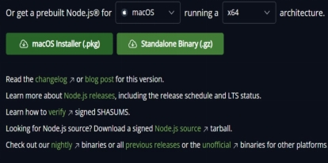

9. Future Scope

Integration with smart kitchen devices like ovens, induction cookers, and fridges.

Personalized AI diet planning for medical conditions (e.g., diabetes-friendly meals).

Expansion to regional languages beyond Tamil and Hindi.

Gamification to make cooking more engaging (rewards, challenges).

Cloud synchronization for accessing user data across devices.

10.OUTPUT

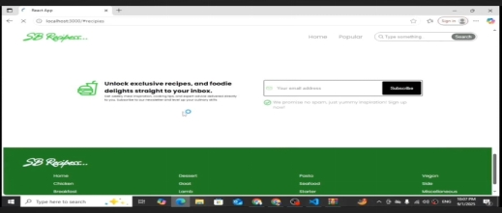

C:\Users\admin\AppData\Local\Temp\ksohtml3476\wps5.pngC:\Users\admin\AppData\Local\Temp\ksohtml3476\wps6.png

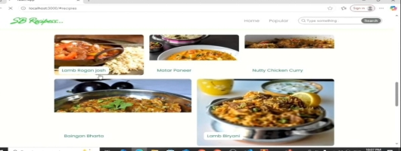

11.conclusion

The Cook Book – AI Powered Kitchen Assistant is a comprehensive solution for modern kitchens. By combining AI, NLP, and optional IoT, it transforms the way people cook, making the process more efficient, enjoyable, and inclusive.

It addresses real-world problems of time, dietary needs, and cultural accessibility, while also promoting healthy eating and reducing food wastage. With further expansion, this project has the potential to become a leading smart kitchen ecosystem.

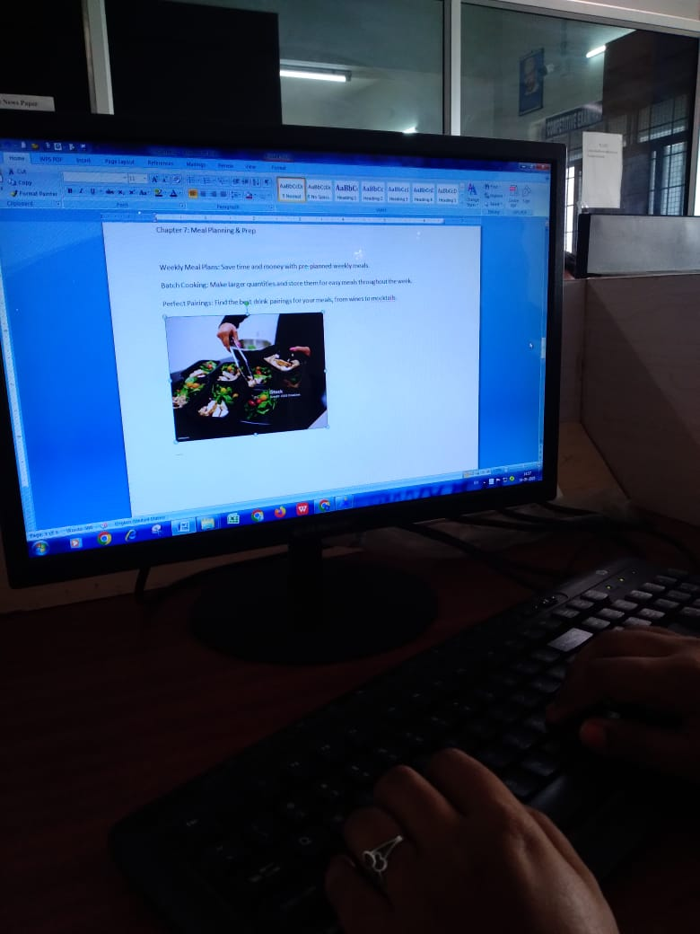

**THANK YOU!**