



**-: PREFACE :-**

* The main objective of any computer science student is to get practical knowledge as possible. Being able to have a practical knowledge by developing a project is a lifetime experience. As practical knowledge is important as theoretical knowledge we are thankful of having a project.
* Through the development of the project we had a great experience of various strategies that can be applied in development of the project. This project is the stepping stone for our career.
* We are pleased to present this project report. Proper case has been taken while organizing the report so that it is easy to comprehend. Also, various software engineering concepts have been implemented.

**-: acknowledgement :-**

We are students of BCA sem-5 Studying in the Kamani Science and Prataprai Arts College, Amreli. We are thankful to the entire person who has given their support in shaping of the system.

We thanks to all the our teacher’s for giving us guidance and Co-operation in understanding the system. We also thank them for their unconditional help in making of this project.

We have great deal of gratitude towards our Head of Department who encourage us in taking up this activity. We thank all faculties and administrative staffs of the institute.

**Thanks to all !**

**-: Index :-**

|  |  |  |
| --- | --- | --- |
| No | Title | Page No |
| 1 | **Introduction** | 6 |
| 2 | **Time-line Chart** | 7 |
| 3 | **Project Profile** | 8 |
| 4 | **Hardware Requirement** | 9 |
| 5 | **Software Requirement** | 9 |
| 6 | **Requirement Specification** | 10 |
| 7 | **Problem Definition** | 10 |
| 8 | **Project Planning & Scheduling** | 11&12 |
| 9 | **System Analysis** | 13 |
| 10 | **Project Page Structure** | 16 |
| 11 | **Data Dictionary** | 19 |
| 12 | **Data Flow Diagram** | 24 |
| 13 | **ER-Diagram** | 27 |
| 14 | **Use case Diagram** | 28 |
| 15 | **Activity Diagram** | 29 |
| 16 | **Screen shot** | 32 |
| 17 | Bibliography | 42 |

**-: Introduction :-**

**I**n this world everyone or maybe some of them owned at least one vehicle so whenever they go outside and. At that time main problem has occurred of Parking so here is the solution with our site people can reserve Parking. Slot where they go so with this many People Can park their vehicles in discipline so the traffic Problem has been also solved

Propose of this site to provide below facilities to the users.

1. People can reserve or book Park slot before

they go that perticular place.

2) User can safely parked their vehicles.

3) This site is maintained user privacy strictly.

**-: Timeline Chart :-**

**Preliminary Investigation**

**Analysis**

**Design**

**Coding**

**Testing**

**Documentation**

**-: Project Profile :-**

|  |  |
| --- | --- |
| Project name | Online Vehicle Parking System |
| Developed by | Devang Khuman  Vivek Malaviya |
| Frontend tool | PHP,HTML,CSS |
| Backend Tool | MYSQL |
| Operating system | Microsoft windows XP &Microsoft window 7 or 10 |
| Computer system | Intel i3 or higher, Ram:2 GB |
| Project Details | This site gives users to book or reserve their parking slot for their vehicle**.** |
| Completion time | 2.5 Months |
| Guide by | Mr. Ravi Joshi |
| Submitted by | Saurashtra University, Rajkot |

**-: Hardware Requirement :-**

* 256+MB of RAM
* Multimedia Keyboard, Mouse
* CPU and Monitor
* 1.0+GHz Processer
* Printer

**-: Software Requirement :-**

* Operating System :- Microsoft Windows 7 or 11
* Front-End Tool :- PHP,HTML,CSS,Javascript
* Back-End Tool :- MySQL
* Documentation Tool :- Microsoft word-2007
* Browser Specification :- Google Chrome or Edge

**-: Requirement Specification :-**

* MySQL & PHP using to maintain the all concerned data.
* Display all types of data using classified reports with combinations of multiple data base table.
* Controlling the information regarding whole network site.

**-: Problem Definition :-**

* Maintain Users Profile
* Maintain Allocated Park Slot
* Maintain Area Filter
* Maintain Users Privacy

**-: Project Plannig & Scheduling :-**

**A**fter notice the current Situation of Population of the our country or the world. and the number of vehicles which is owned by many Peoples, this create the Parking Problem at many overcrowded and Public Places. At this places where vehicle is not Parked in discipline So that create a new problem of traffic at road so it make Pollution in our environment. when some People try to park their vehicles it's very complex and time consuming.

So, we decided to make a Solution with this site and save the time of client to find Parking area. Site User need to register and than have to log in the site after that User can find that Perticular area and book the Park slot for their vehicles.

**-: Project Plannig & Scheduling :-**

**Implementation**

**Maintenance**

**Testing**

**Coding**

**System Design**

**System Analysis**

**Priliminary Investigation**

**-: System Analysis :-**

**S**ystem analysis is the process of identification of objectives and requirements, evaluation of alternative solutions and recommendation for a more feasible solution. In other words, system analysis is the step by step process of gathering, recording and interpreting facts. The main aim of analysis is to determine problem areas and to take solutions to reduce or eliminate them.

* **System analysis itself breaks into two stages:**

**1.** Preliminary analysis

**2.** Detailed analysis

During analysis, data are collected from the available Files, decision points and transactions of the systems using Various tools like **Data Flow Diagram (DFD).**

**-: Feasibilty Study :-**

**A** purpose of feasibility study is to check out the possibility of a computerized solution to the organization’s observed problem before very much money that has been spent on.

A feasibility study is carried out to select the best system that meets performance requirements, only by spending the time to evaluate to feasibility do I reduce the chances for extreme embarrassment at later stage of the system project.

For the complete feasibility study I need to concentrate on following area:

**They are of Three types:**

**1.** Technical

**2.** Operational

**3.** Economical

* **Technical :-**

**T**echnical feasibility considers whether the desired project can be completed within the framework of available technology. As our project was website designing, this was not much of a problem, as many advanced web-editing tools are available.

* **Operational:-**

**O**perational feasibility was done to assure that the product that would be developed would be used. Since a cards and gifts has to have a website of its own sooner or later, that wasn’t much of a problem.

* **Economical:-**

**O**ur Commercial Website is Economically Feasible Because. We have developed this website only for one time. Only future enhancement is required on the other hand every client can view our site any time or many time as per their requirement. So the future economical expenses are null. So we can say that this website is totally economically feasible.

**-: Project Page Structure :-**

* **Client Side:-**

**Client Side**

**Create Account**

**Login**

**Book Slot**

**View Ticket**

**Logout**

**Add Review**

**Logout**

**Delete Feedback**

**Edit Feedback**

**delete product**

**Login**

**Add product**

* **Operator Side:-**

**Operator**

**Login**

**Take Action**

**Search Vehicles**

**Add Charges,Outtime**

**Logout**

**Out Vehicles**

* **Admin Side:-**

**Manage Vehicle**

**Vehicle Entry**

**Login**

**Admin Side**

**View& Print Data**

**Delete Category**

**Delete Admin**

**Delete Operator**

**Add Operator**

**Add Admin**

**Logout**

**Add Category**

**-: Data Dictionary :-**

The data Dictionary is a set of table. MySQL uses it to maintain information about his own database.

* **Data dictionary contains the following information:**

* Name of the table of database.
* User information such as privileges.
* Name and data-type of all columns in database table.

**Database name :** vehicle-parking-db.sql

**1.clients :-**

* **T**his table is used to stores the clients info.

|  |  |  |  |
| --- | --- | --- | --- |
| Field | Type | Size | Constraint |
| c_id | int | 11 | Primary key |
| c_uname | varchar | 255 | **-** |
| c_email | varchar | 200 | **-** |
| c_pass | varchar | 255 | **-** |
| c_mobile | varchar | 12 | **-** |
| c_review | varchar | 255 | **-** |

**2.admin :-**

* **T**his table is used to store admin information.

|  |  |  |  |
| --- | --- | --- | --- |
| Field | Type | Size | Constraint |
| ID | int | 10 | Primary key |
| AdminName | varchar | 255 | - |
| UserName | Longtext | - | - |
| MobileNumber | Longtext | - | - |
| U_mobile no. | varchar | 10 | - |

**3.c_review :-**

* **T**his table is used to store c_review information.

|  |  |  |  |
| --- | --- | --- | --- |
| Field | Type | Size | Constraint |
| c_id | int | 12 | Primary key |
| c_uname | varchar | 120 | - |
| c_gmail | varchar | 200 | - |
| c_rev | varchar | 255 | - |

**4.opt :-**

* **T**his table is used to store opt information.

|  |  |  |  |
| --- | --- | --- | --- |
| Field | Type | Size | Constraint |
| o_id | int | 12 | Primary key |
| o_name | varchar | 255 | - |
| o_mobile | varchar | 255 | - |
| o_email | varchar | 200 | - |
| o_pass | varchar | 255 | - |

**5.parea :-**

* **T**his table is used to store parea details.

|  |  |  |  |
| --- | --- | --- | --- |
| Field | Type | Size | Constraint |
| a_id | int | 11 | Primary key |
| a_name | varchar | 255 | - |
| a_limit | int | 11 | - |

**6.vcategory :-**

* **T**his table is used to store vcategory details.

|  |  |  |  |
| --- | --- | --- | --- |
| Field | Type | Size | Constraint |
| ID | int | 6 | Primary key |
| VehicleCat | varchar | 12 | - |
| shortDescription | varchar | 50 | - |
| CreationDate | timestamp | - | - |

**7.vehicle_info :-**

* **T**his table is used to store vehicle_info Detais.

|  |  |  |  |
| --- | --- | --- | --- |
| Field | Type | Size | Constraint |
| ID | int | 10 | Primary key |
| ParkingNumber | varchar | 12 | - |
| VehicleCategory | varchar | 12 | - |
| VehicleCompanyName | varchar | 255 | - |
| RegistrationNumber | varchar | 255 | - |
| OwnerName | varchar | 255 | - |
| OwnerContactNumber | biginit | 12 | - |
| a_id | int | 11 | - |
| OutTime | timestamp | 15 | - |
| ParkingCharge | int | 12 | - |
| Remark | mediumtext | 255 | - |
| status | varchar | 15 | - |
| ticket | varchar | 12 | - |
| email | varchar | 200 | - |
| intime | varchar | 255 |  |
| date | varchar | 255 |  |

**8.vout :-**

* **T**his table is used to vout Detais.

|  |  |  |  |
| --- | --- | --- | --- |
| Field | Type | Size | Constraint |
| id | int | 11 | Primary key |
| v_rn | varchar | 255 | - |
| c_name | varchar | 100 | - |
| cat | varchar | 12 | - |
| p_number | varchar | 12 | - |
| v_in_time | varchar | 15 | - |
| outtime | varchar | 15 | - |
| owner | varchar | 255 | - |
| owner_contact | varchar | 12 | - |
| charge | int | 12 | - |
| status | varchar | 15 | - |
| remark | varchar | 255 | - |

**9.contactus :-**

* **T**his table is used to contactus Detais.

|  |  |  |  |
| --- | --- | --- | --- |
| Field | Type | Size | Constraint |
| ID | int | 11 | Primary key |
| name | varchar | 120 |  |
| email | varchar | 120 |  |
| subject | varchar | 255 |  |
| message | varchar | 255 |  |

**-: Data Flow Diagram :-**

The DFD gives brief idea on how the designed system is working. It also suggests to us the type of users who using this system and the process involved in the system. The DFD gives brief idea on how the designed system is working. It also suggests to us the type of users who using this system and the process involved in the system.

**Represent Entity**

**Represent a System Processing**

**Represent a Data Flow**

**Represent a data store table**

**-:Context Level Diagram :-**

**Account Created**

**New Account Created**

**Account Created**

**Create New Account**

**Admin**

**User/Operator**

**Process to Login**

**Make Login**

**Uname & Pass Match**

**Redirect to home page**

**-:1st Level Diagram :-**

**Process for Login**

**Make Login**

**Login Successfully**

**Process for Park slot**

**Book Park slot**

**vehicle_info**

**Park slot booked**

**Park slot booked**

**Add review**

**c_review**

**Ading Review**

**ReviewAdded**

**Review Added**

**User**

**Contact**

**Contact**

**Admin**

**Operator**

**ER-Diagram :-**

**Return to Login page**

**Request to Logout**

**Logout Success**

**Logout Success**

**Logout Requested**

**Logout Requested**

**Result**

**Process of Searched**

**vehicle_info**

**Result**

**Process of Searched**

**Login Successed**

**Process for Login**

**Login Successfully**

**Make Login**

**clients**

**vehicle_info**

has

**-: Usecase Diagram :-**

**Online Vehicle Parking System**

**Admin**

**Operator**

**User**

**-: Activity Diagram :-**

* **Client Side:-**

**Login**

**Check id & pass**

**Create Account**

**Review**

**Logout**

**View Ticket**

**Book Park slot**

**Contact Us**

**Valid** **Invalid**

* **Operator Side:-**

**Login**

**Check id & pass**

**Valid** **Invalid**

**Search Vehicles**

**Add Charges**

**Out Vehicles**

**Add Out time**

**Logout**

**Login**

* **Admin Side:-**

**Check id & pass**

**Login**

**Create Account**

**Add Category**

**Delete Vehicles**

**Delete Category**

**Add/Delete Operator**

**Logout**

**Add/Delete User**

**Add Vehicles**

**Valid** **Invalid**

**-: ScreenShots:-**

**Admin Login Page:-**

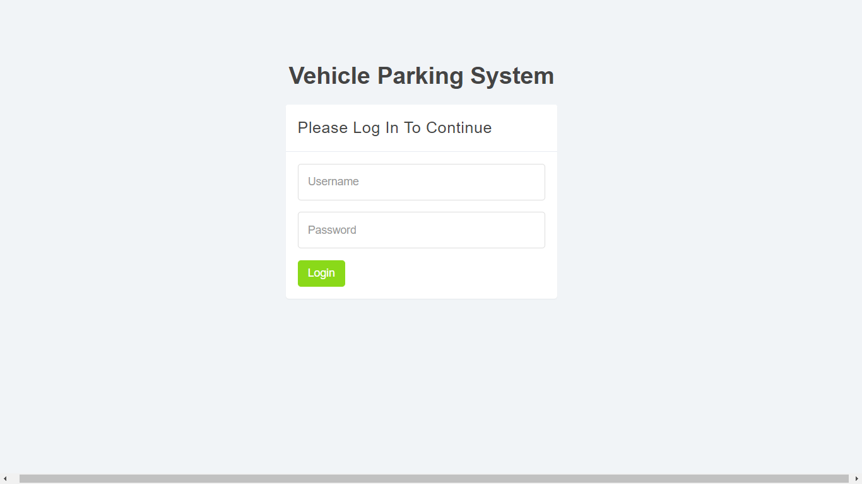

**Admin Dashboard:-**

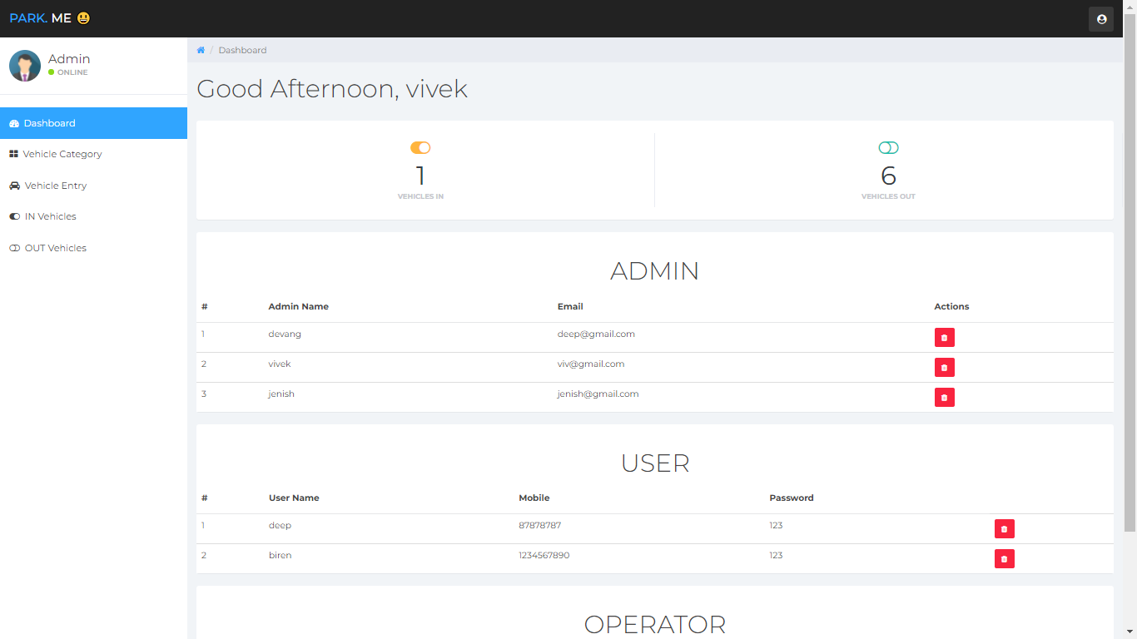

**Vehicle Category Page:-**

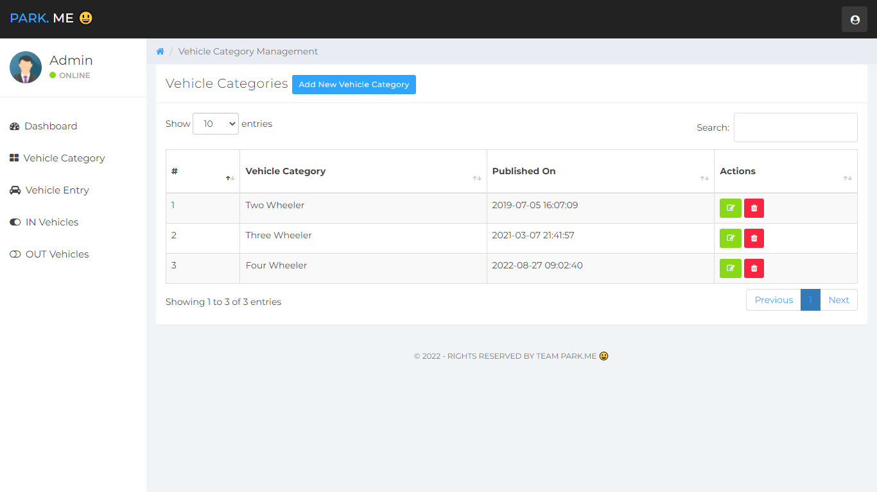**Vehicle entry Page:-**

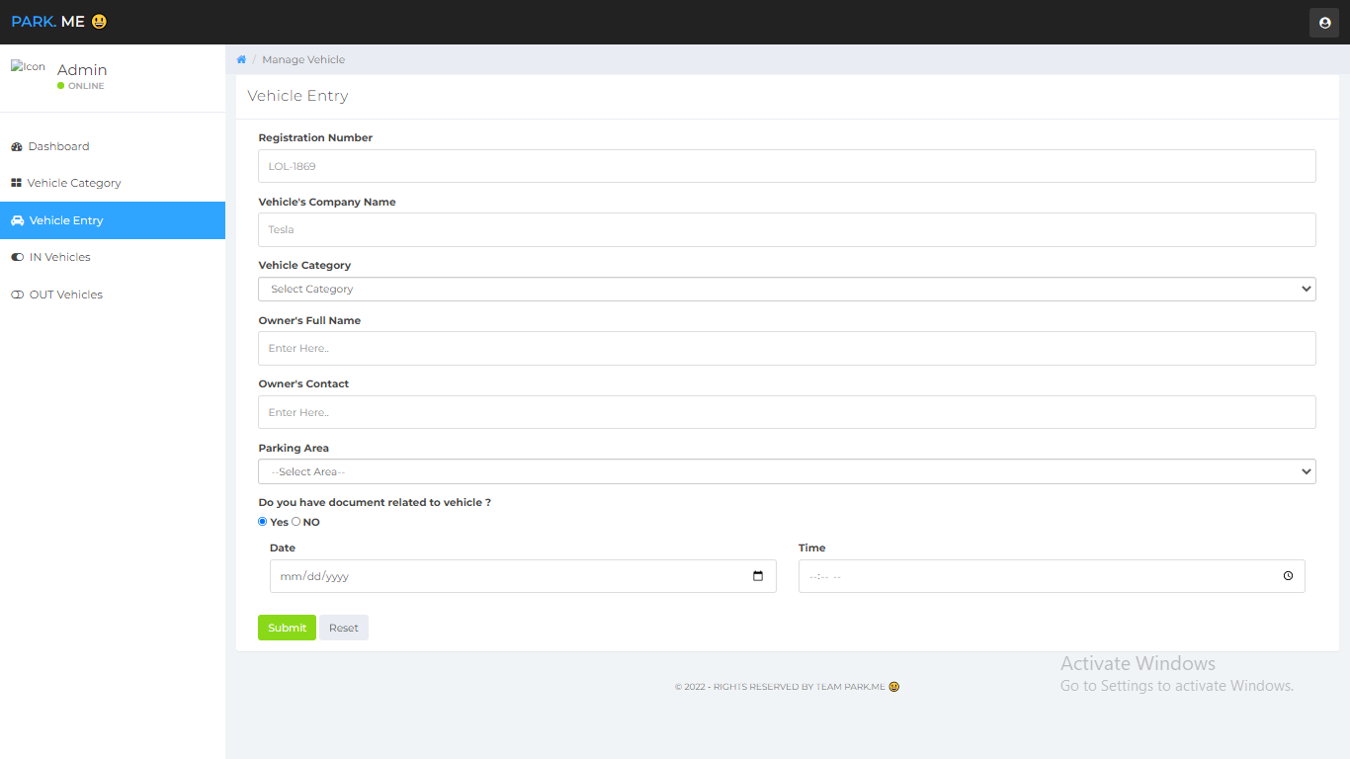

**In Vehicle Page:-**

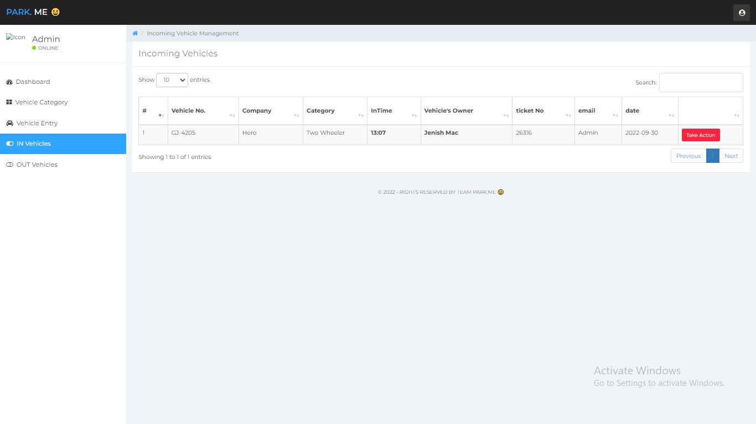

**Out Vehicle Page:-**

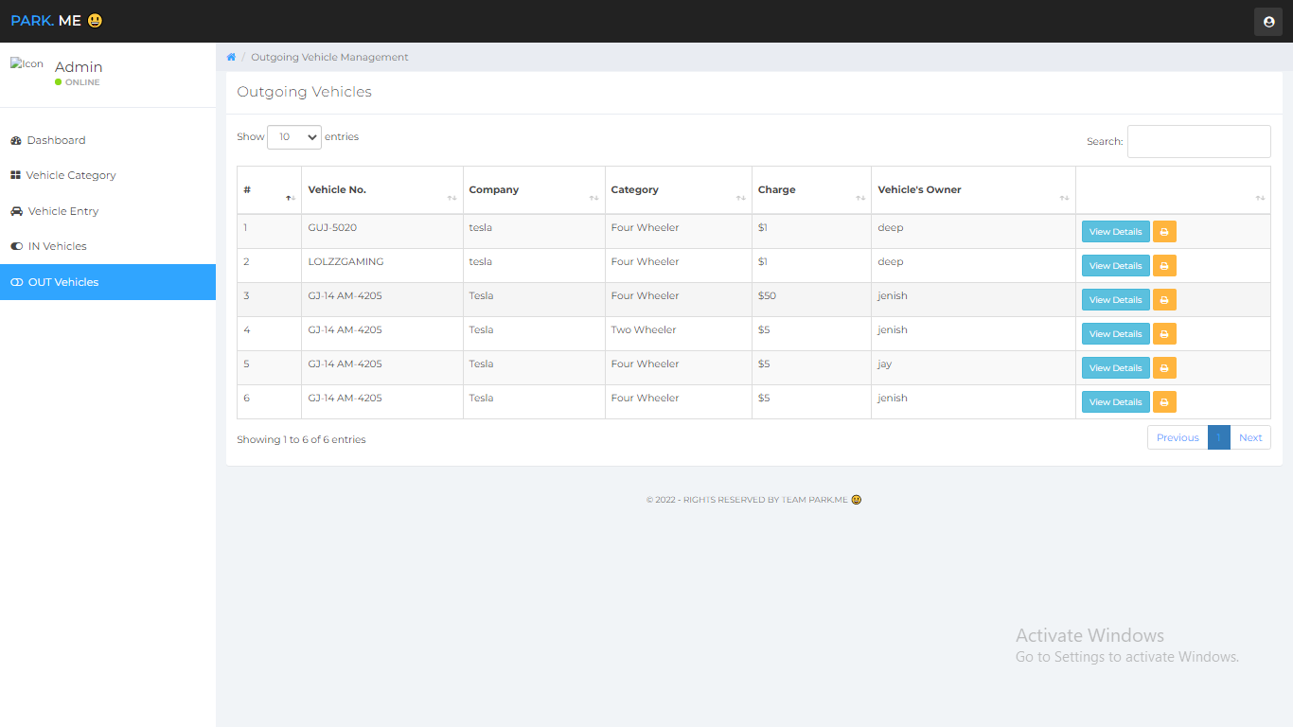

**Add Operator Page:-**

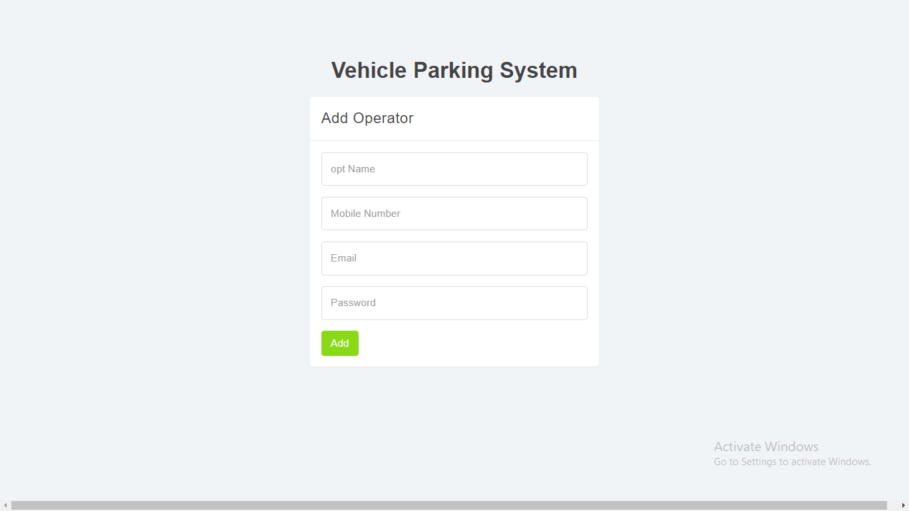

**Add Opinion Page:-**

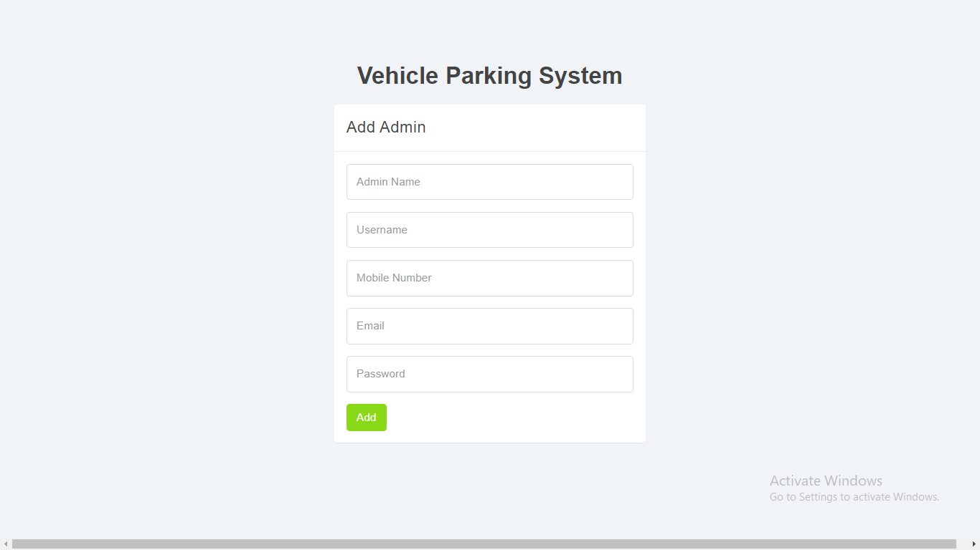

**Client Side Home Page:-**

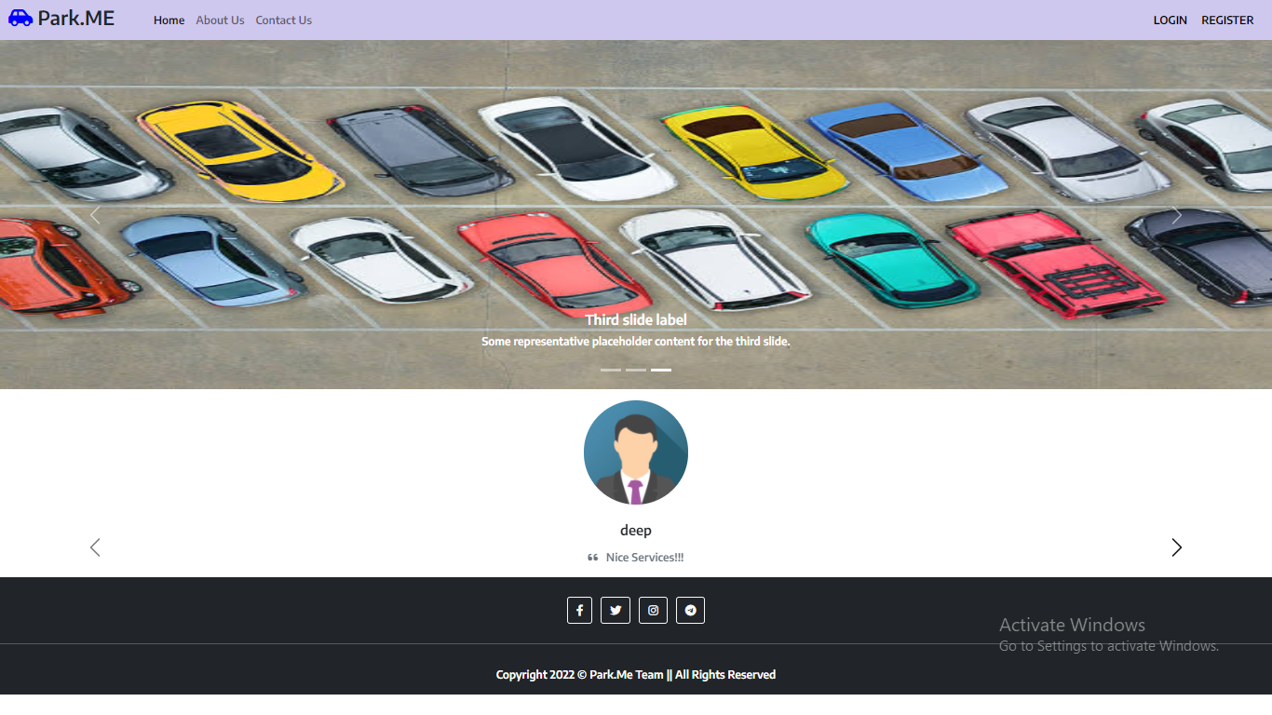

**About us Page:-**

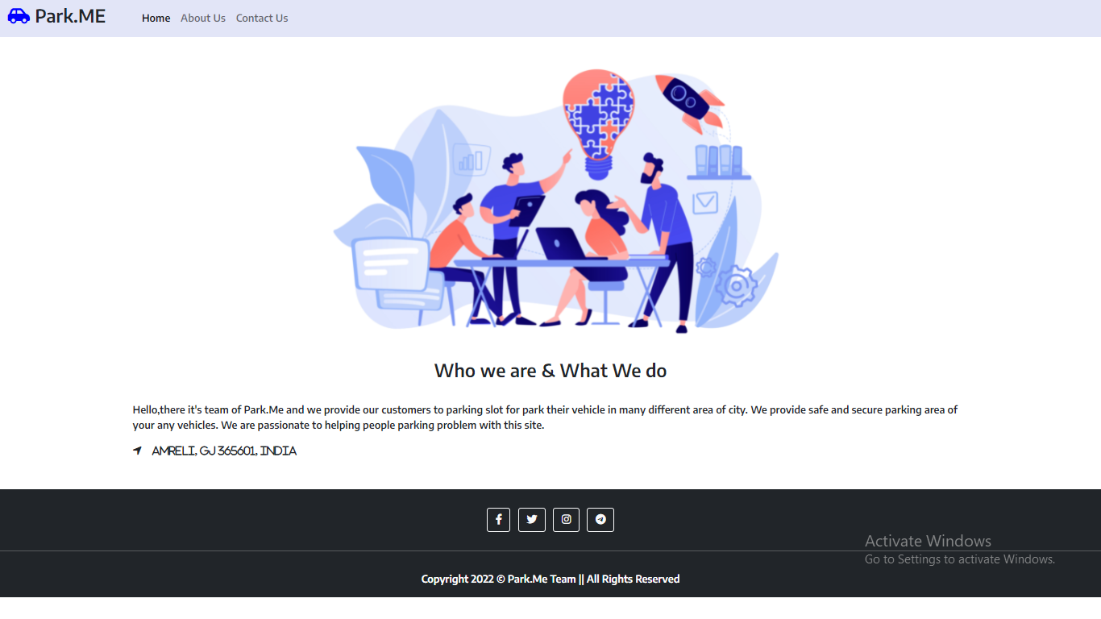

**Contact us Page:-**

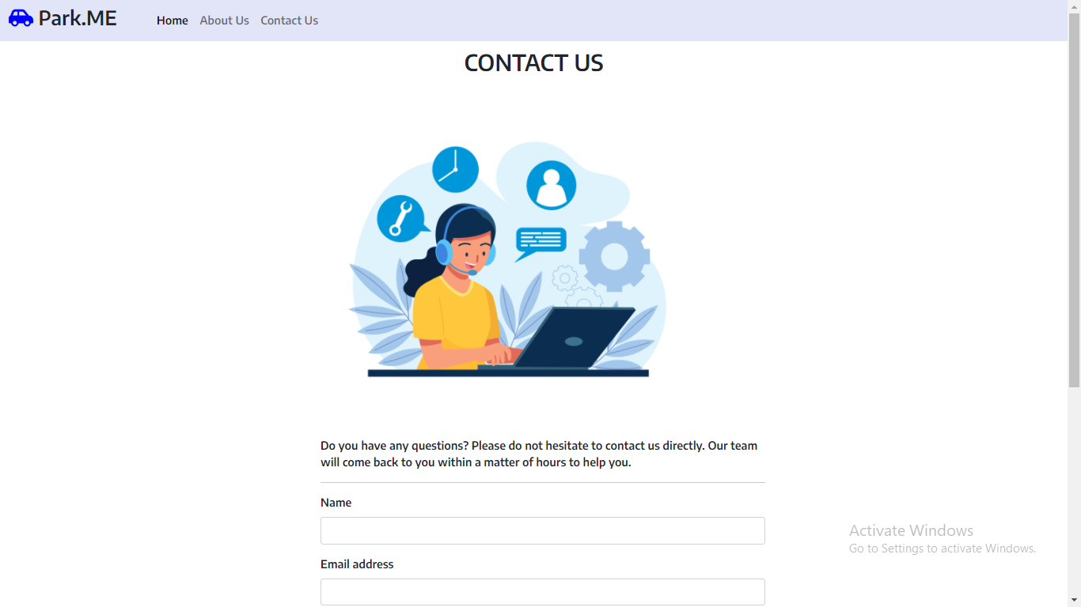

**Clients Login Page:-**

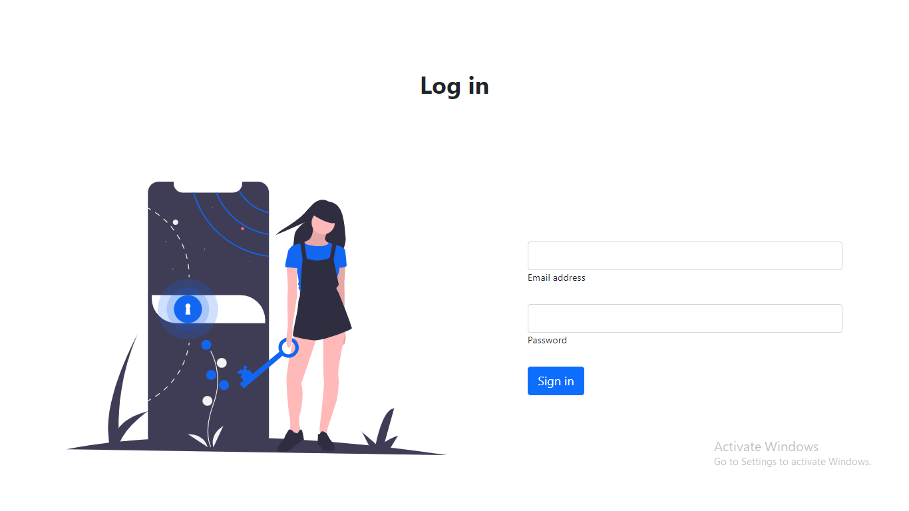

**Clients Sign up Page:-**

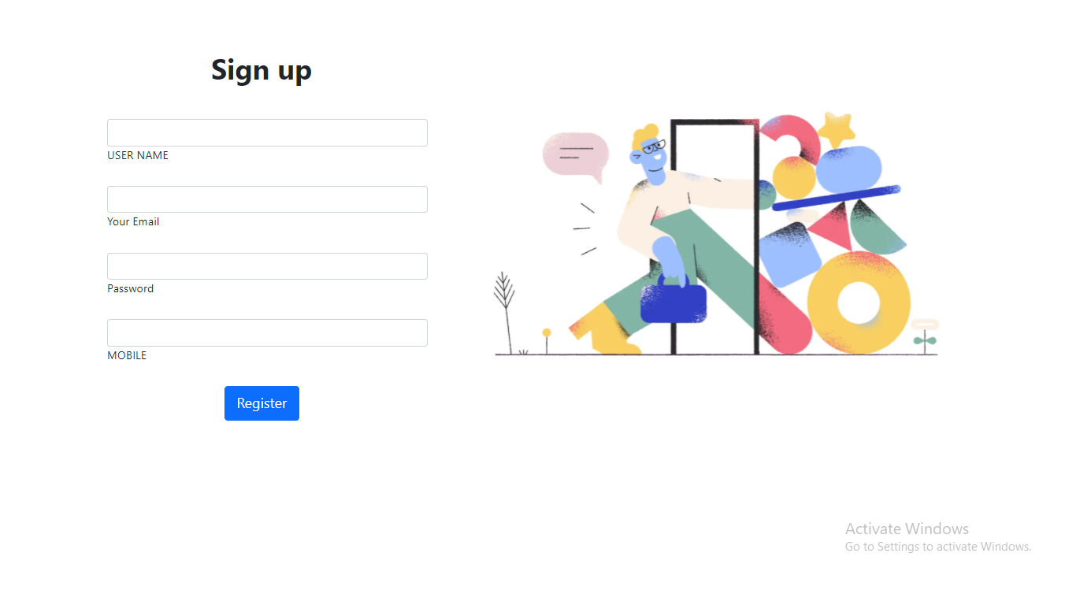

**Booking Page:-**

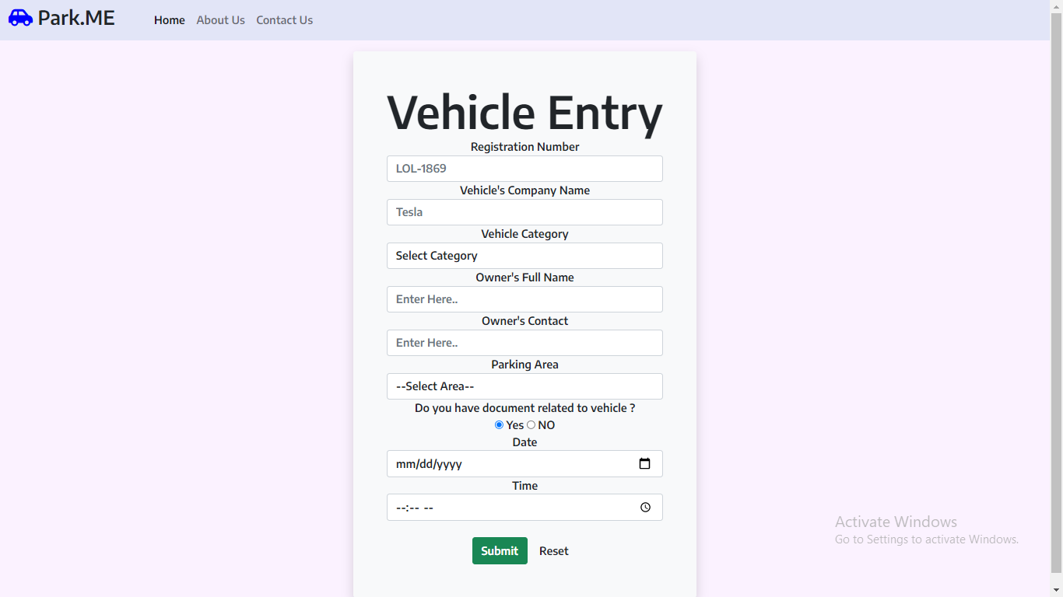

**AddReview Page:-**

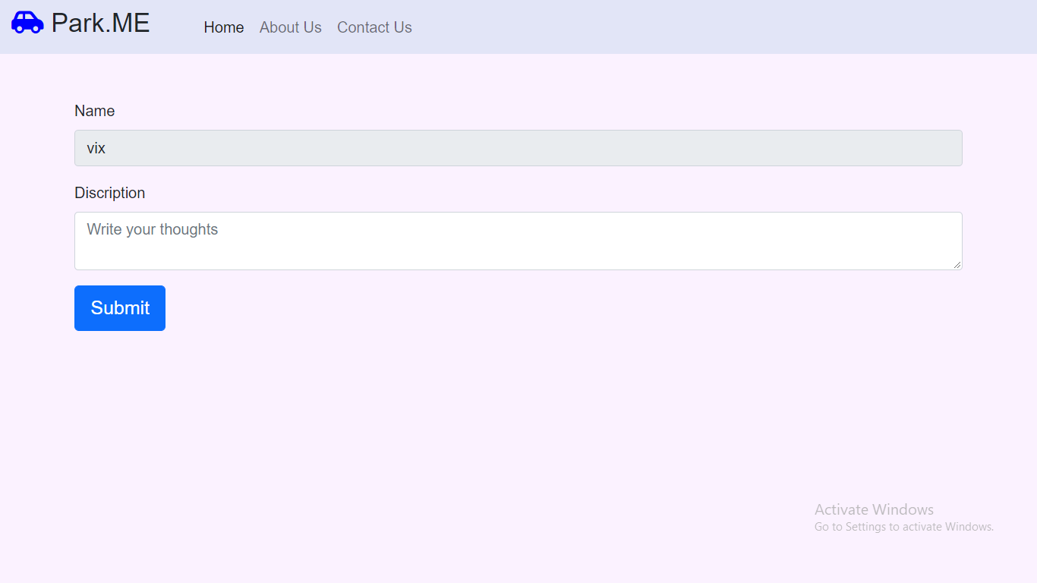

**ViewTicket Page:-**

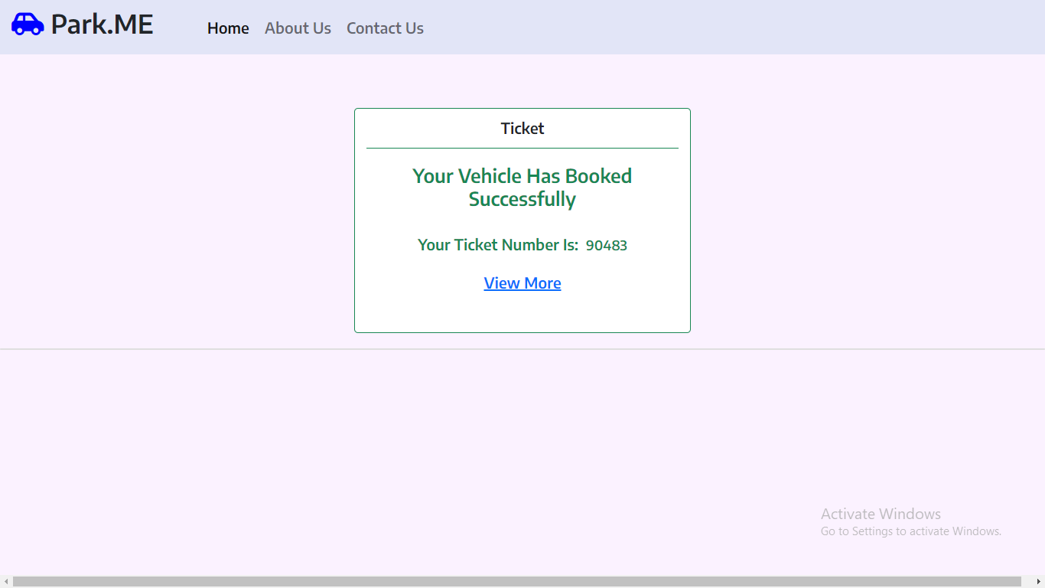

**Operator Login Page:-**

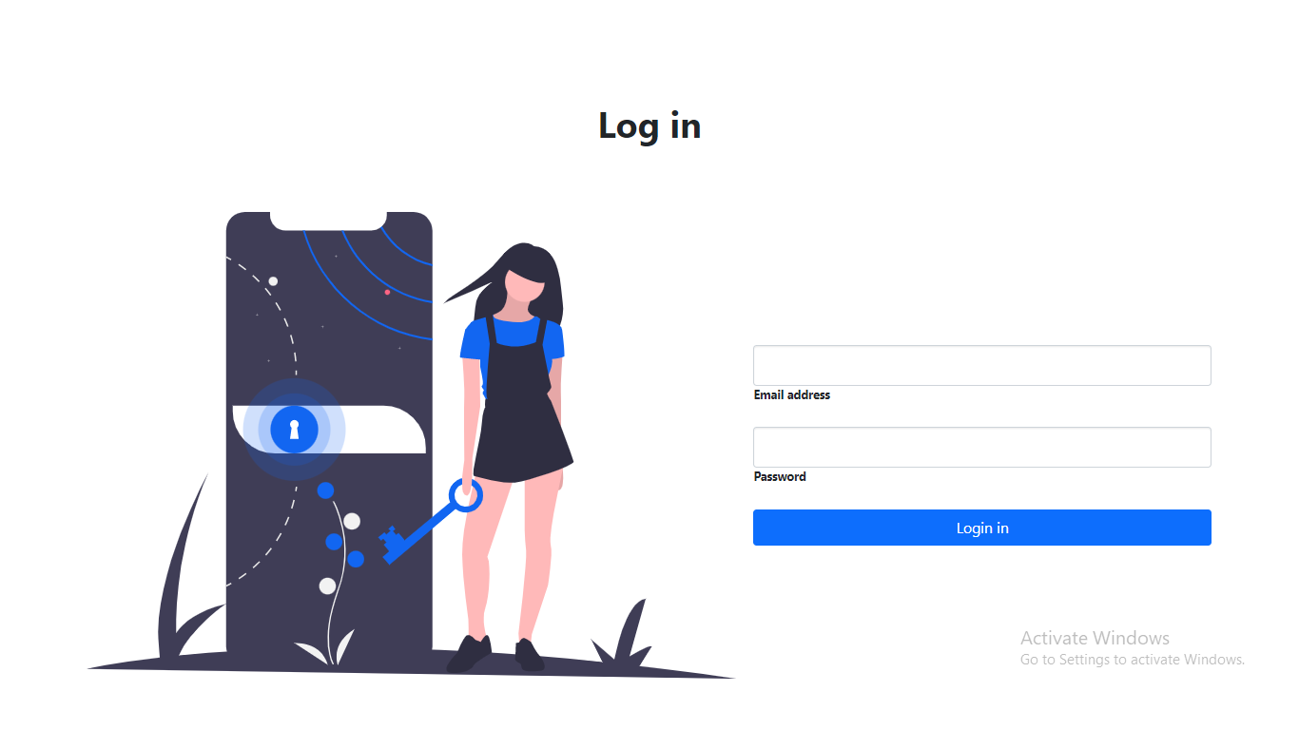

**Operator Dashboard Page:-**

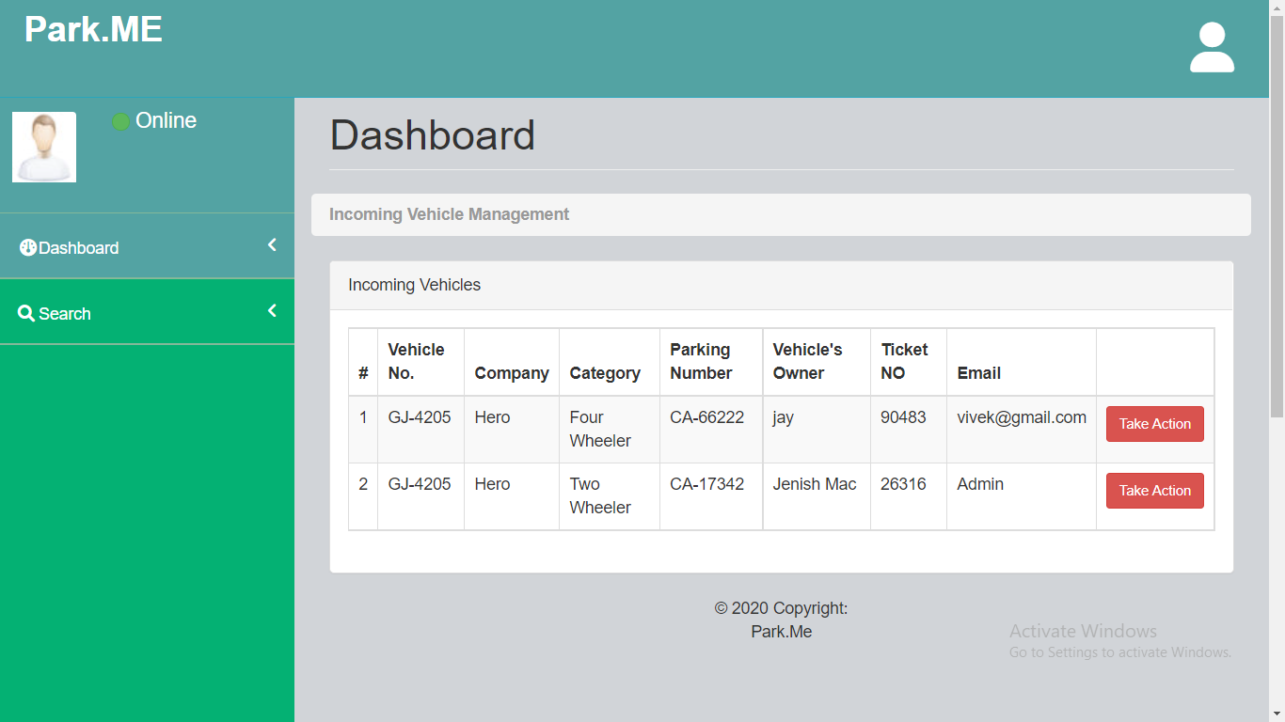

**Opt Search Vehicles Page:-**

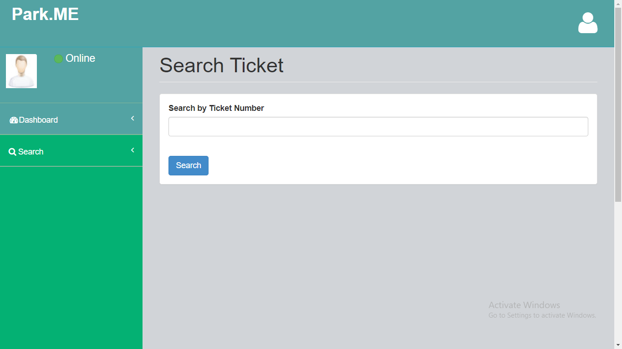

**Opt Search Vehicles Page:-**

**-: Future Scope :-**

The Future Scope of our website is to provide the more functionality and features . And the site provides feedback facility to the user.

**-: Bibliography :-**

* [**www.google.com**](http://www.google.com)
* **www.bootstrap.com**

**Thank you for check it out our project !**