EduMind

An AI-Powered Personalized Learning and Academic Assistance Platform for Students

A project report submitted in
fulfilment of the requirements for the
Design Thinking & Thinking Course

Submitted by
P. Deepesh Abinay (24KD1A1551)
K. Thanuja (24KD1A1533)
B. Hemanth (24KD1A1512)
B. Murali Sai (24KD1A1510)
Under the guidance of

MR. Sk. Althaf Rahaman, MCA, M. Tech, (Ph.D.)

Assistant Professor
Department of Computer Science & Systems Engineering


LENDI INSTITUTE OF ENGINEERING AND TECHNOLOGY
An Autonomous Institution
Approved by AICTE & Permanently Affiliated to JNTUGV, Vizianagaram Accredited by NAAC with “A” Grade and NBA
Jonnada (Village), Denkada (Mandal), Vizianagaram Dist. – 535005 Phone No. 08922-241111,241112
2021-2025

LENDI INSTITUTE OF ENGINEERING AND TECHNOLOGY

An Autonomous Institution
Approved by AICTE & Permanently Affiliated to JNTUGV, Vizianagaram Accredited by NAAC with “A” Grade and NBA
Jonnada (Village), Denkada (Mandal), Vizianagaram Dist. – 535005
Phone No. 08922-241111,241112
E-Mail: lendi_2008@yahoo.com Website: www.lendi.org

DEPARTMENT OF COMPUTER SCIENCE AND SYSTEMS ENGINEERING

BONAFIDE CERTIFICATE

This is to certify that the project entitled “EduMind: An AI-Powered Personalized Learning and Academic Assistance Platform for Students” is a Bonafide record work done by P. Deepesh Abinay (24KD1A1551), K. Thanuja(24KD1A1533), B. Hemanth (24KD1A1512), B. Murali Sai (24KD1A1551), under the supervision and guidance of SK. Althaf Rahaman , Assistant Professor in fulfilment of the requirements for the Design Thinking & Innovation course in Computer Science and Systems Engineering from Lendi Institute Of Engineering and Technology(Affiliated to JNTUGV), Jonnada, Vizianagaram for the year 2026.

Internal Guide

Mr. S.K. Althaf Rahaman, MCA, M.Tech, (Ph.D.) Assistant Professor
Department of CSSE
Head of the Department

Dr. R Rajender, M.Tech, Ph.D. Professor
Department of CSSE

External Examiner

ACKNOWLEDGEMENT

With great solemnity and sincerity, we express our deepest sense of gratitude and pay our sincere thanks to our guide Mr. S.K. Althaf Rahaman, Assistant Professor, Department of Computer Science and Systems Engineering, who evinced keen interest in our efforts and provided her valuable guidance throughout our project work.
We thank our project coordinator Mr. S. Swaroop who has made her support available in a number of ways and helped us to complete our project work in correct manner.
We thank our Dr. R. Rajender, Head of the Department of Computer Science & Systems Engineering who helped us to complete our project work in a truthful method.
We thank our gratitude to our principal Dr. V.V. Rama Reddy, for his kind attention and valuable guidance to us throughout this course in carrying out the project.
We wish to express gratitude to our Management Members who supported us in providing good lab facility.
We are thankful to All Staff Members of Department of Computer Science & Systems Engineering, for helping us directly / indirectly to complete this project work by giving valuable suggestions.
All of the above we great fully acknowledge and express our thanks to our parents who have been instrumental for the success of this project which play a vital role.

P. Deepesh Abinay (24KD1A1551)
K. Thanuja (24KD1A1533)
B. Hemanth (24KD1A1512)
B. Murali Sai (24KD1A1510)
DECLARATION

We hereby declare that the project work entitled “EduMind: An AI-Powered Personalized Learning and Academic Assistance Platform for Students” submitted to the JNTUGV is a record of an original work done by P. Deepesh Abinay (24KD1A1515), K. Thanuja (24KD1A1533), B. Hemanth (24KD1A1512), B. Murali Sai (24KD1A1510) under the esteemed guidance of Mr. S.K. Althaf Rahaman, Assistant Professor, Computer Science & Systems Engineering, Lendi Institute of Engineering & Technology. This project work is submitted in the fulfilment of the requirements for the Design Thinking & Innovation course of the degree Bachelor of Technology in Computer Science & Systems Engineering. This entire project is done with the best of our knowledge and is not submitted to any University for the award of degree.

P. Deepesh Abinay (24KD1A1551)
K. Thanuja (24KD1A1533)
B. Hemanth (24KD1A1512)
B. Murali Sai (24KD1A1510)

LENDI INSTITUTE OF ENGINEERING AND TECHNOLOGY

An Autonomous Institution
Approved by AICTE & Permanently Affiliated to JNTUGV Accredited by NAAC with “A” Grade and NBA
Jonnada ( Village ), Denkada ( Mandal ), Vizianagaram Dist – 535005
Phone No. 08922-241111,241112
E-Mail : lendi_2008@yahoo.com Website: www.lendi.org

INSTITUTE VISION

Producing globally competent and quality technocrats with human values for the holistic needs of industry and society.
INSTITUTE MISSION

- Creating an outstanding infrastructure and platform for enhancement of skills, knowledge and behavior of students towards employment and higher studies.
- Providing a healthy environment for research, development and entrepreneurship, to meet the expectations of industry and society.
- Transforming the graduates to contribute to the socio-economic development and welfare of the society through value-based education.

DEPARTMENT VISION

To be a Centre of Excellence to impart the High-Quality Education with productive Research and Consultancy in the field of Computer Science and Systems Engineering to globally competent, highly competitive Professional with Ethical and Human values to serve the society.

DEPARTMENT MISSION
- To impart high quality education with strong foundation of Computer Science and Systems Engineering principles that enables them to meet the challenges in profession/ career.
- To nurture research activities to get patens amongst faculty and students by providing necessary facilities and environment.
- To train the students into effective intrapersonal and communication skills and to develop team spirit, leadership capabilities, integrity and social responsibility with professional ethics and human values.
- To promote internships to students and consultancy works among faculty by enhancing Industry-Institute Interaction.

LENDI INSTITUTE OF ENGINEERING AND TECHNOLOGY

An Autonomous Institution
Approved by AICTE & Permanently Affiliated to JNTUGV Accredited by NAAC with “A” Grade and NBA
Jonnada ( Village ), Denkada ( Mandal ), Vizianagaram Dist – 535005
Phone No. 08922-241111,241112
E-Mail : lendi_2008@yahoo.com Website: www.lendi.org

PROGRAM OUTCOMES (POs)

PO 1 | Engineering Knowledge | Apply the knowledge of mathematics, science, engineering  fundamentals, and an engineering specialization to the solution of complex engineering problems.
PO 2 | Problem Analysis | Identify, formulate, review research literature, and analyze complex engineering problems reaching substantiated conclusions using first principles of mathematics, natural  sciences, and engineering sciences.
PO 3 | Design/Development of Solutions: | Design solutions for complex engineering problems and design system components or processes that meet the specified needs with appropriate consideration for the public health and safety, and the cultural, societal, and environmental  considerations.
PO 4 | Conduct Investigations of Complex Problems | Use research-based knowledge and research methods including design of experiments, analysis and interpretation  of data, and synthesis of the information to provide valid conclusions.
PO 5 | Modern Tool Usage | Create, select, and apply appropriate techniques, resources, and modern engineering and IT tools including prediction and modeling to complex engineering activities with an  understanding of the limitations.
PO 6 | The Engineer and Society | Apply reasoning informed by the contextual knowledge to assess societal, health, safety, legal and cultural issues and the consequent responsibilities relevant to the professional  engineering practice.
PO 7 | Environment and Sustainability | Understand the impact of the professional engineering solutions in societal and environmental contexts, and demonstrate the knowledge of, and need for sustainable  development.
PO 8 | Ethics | Apply ethical principles and commit to professional ethics and responsibilities and norms of the engineering practice.
PO 9 | Individual and Team Work | Function effectively as an individual, and as a member or leader in diverse teams, and in multidisciplinary settings.

PO 10 | Communication | Communicate effectively on complex engineering activities with the engineering community and with society at large, such as, being able to comprehend and write effective reports and design documentation, make effective presentations,  and give and receive clear instructions.
PO 11 | Project Management and Finance | Demonstrate knowledge and understanding of the engineering and management principles and apply these to one’s own work, as a member and leader in a team, to manage projects and in multidisciplinary environments.
PO 12 | Life-Long Learning | Recognize the need for, and have the preparation and ability to engage in independent and life-long learning in the Broadest context of technological change.

PROGRAM SPECIFIC OUTCOMES (PSOs)

PSO 1 | Ability to grasp the knowledge and expertise to solve all the contemporary issues.
PSO 2 | To acquire the knowledge on modern tools to solve hardware and software  solutions.
PSO 3 | Qualify in national and international competitive examinations for successful higher studies and employment.

PROGRAM EDUCATIONAL OBJECTIVES (PEOs)

PEO 1 | Graduates of Computer Science and Systems Engineering will acquire the knowledge to analyze, design and developing the new software and hardware products and acquire the skills to grasp the latest tools and techniques.
PEO 2 | Graduates of Computer Science and Systems Engineering will penetrate to interdisciplinary activities, with professional attitude and ethics, communication, to work under team and to ability to solve social issues through their Employment. Higher Studies and Research.
PEO 3 | Graduates of Computer Science and Systems Engineering will expose to learn life skills and Intrapersonal development activities to face the dynamically changing technology.

ABSTRACT
The rapid growth of digital education has provided students with access to vast learning resources, but many learners still struggle with problems such as lack of personalized guidance, ineffective study planning, inconsistent progress tracking, and difficulty in finding relevant learning materials. Most existing educational platforms provide generic content that does not adapt to individual student needs, learning speed, or career goals. This creates confusion, reduced productivity, and poor academic performance among students.
EduMind is an AI-powered personalized learning and academic assistance platform designed to solve these challenges by providing customized learning support for students. The system analyses student learning patterns, academic goals, strengths, and weaknesses to generate personalized study plans, recommend learning resources, track progress, and provide intelligent academic assistance. It also includes features such as doubt clarification, performance monitoring, career guidance, and productivity enhancement tools.
The platform aims to improve learning efficiency, reduce academic stress, and help students achieve better educational outcomes through smart recommendations and personalized learning strategies. EduMind creates a more effective, accessible, and student-centred learning environment.

LIST OF CONTENTS
Title | Page No
INTRODUCTION
1.1 Background of the problem
1.2 Importance of the project
1.3 Project Objectives
1.4 Project Scope
PROBLEM STATEMENT
LITERATURE REVIEW
DESIGN THINKING PROCESS
4.1 Empathize Phase
4.2 Define Phase
4.3 Ideate Phase
4.4 Prototype Phase
4.5 Test Phase
PROPOSED SOLUTION
SYSTEM DESIGN
6.1 Architecture Diagram
6.2 Flow Chart
6.3 Block Diagram
IMPLEMENTATION
7.1 Tools Used
7.2 Technologies Used
7.3 Deployment Process
TESTING AND RESULTS
8.1 Unit Testing
8.2 Integrating Testing
8.3 Results Analysis
IMPACT AND BENEFITS
9.1 Social Benefits
9.2 Economic Benefits
9.3 Technical Improvements
FUTURE ENHANCEMENTS
CONCLUSION
REFERENCES

LIST OF DIAGRAMS
Figure 1. EduMind System Architecture
Figure 2. Adaptive Learning Cycle
Figure 3. EduMind Frontend Visual Language
Figure 4. EduMind Dashboard Overview
Figure 5. Analyze Phase Priority and Cycle Tracker
Figure 6. Mindmap Generator Interface
Figure 7. AI Recommendations Interface

CHAPTER 1

Introduction

INTRODUCTION
The rapid growth of digital education platforms has made learning resources more accessible than ever, but access alone does not guarantee understanding. Students often move between notes, videos, search tools, and generic chat systems without receiving structured help on what to revise, what they misunderstood, or what to do next.
EduMind is proposed as an AI-powered personalized learning and academic assistance platform that organizes the study process into a guided loop. Rather than behaving as a one-time answer engine, the platform supports concept explanation, practice, mistake analysis, targeted revision, and re-learning.
The project is important because it addresses a real gap in student learning behavior. Many learners need concise explanations, repeated reinforcement, progress visibility, and timely recommendations. EduMind brings these capabilities into a single professional academic platform designed around learner support.

Project Objectives:
To provide students with a personalized AI-supported study assistant.
To organize learning into a structured cycle of Learn, Test, Analyze, Adjust, and Re-learn.
To help learners identify weak concepts and receive targeted revision support.
To create an accessible web-based academic platform with a modern, student-friendly interface.

CHAPTER 2

Literature Review

LITERATURE REVIEW
Adaptive learning research emphasizes that personalization improves student engagement, retention, and support quality when compared with static content delivery. Recent AI-assisted educational systems focus on learner modeling, targeted remediation, and context-sensitive guidance.
Existing tools such as standard note systems, fixed quiz portals, and chatbot interfaces each solve a part of the learning problem, but they often remain fragmented. Many systems explain a concept or test a student, yet they do not connect poor performance to a concrete revision pathway.
EduMind differs by combining personalized explanation, adaptive checkpoints, progress-focused dashboards, concept clustering, and revision-oriented recommendations into one study workflow. This makes the platform more suitable for continuous learning support than isolated educational utilities.

CHAPTER 3

Design Thinking Process

DESIGN THINKING PROCESS

Empathize
The project began by identifying common student pain points such as uncertainty after reading a topic once, poor revision discipline, fragmented tool usage, and difficulty identifying weak concepts.

Define
The core problem was defined as the absence of a learner-centered academic platform that can explain, evaluate, diagnose, and recommend the next study action in a single flow.

Ideate
Different approaches were considered, including a chatbot-only tutor, a planner-only product, and a quiz-only system. The final concept combined these into a single adaptive workspace.

Prototype
The prototype was implemented as a full-stack web application with an AI tutor, dashboard, mindmap generator, flashcards, adaptive quiz, and planner-style recommendation views.

Test
Testing focused on whether the workflow remained understandable and helpful across multiple study screens, and whether the visual design reinforced clarity, focus, and progress awareness.
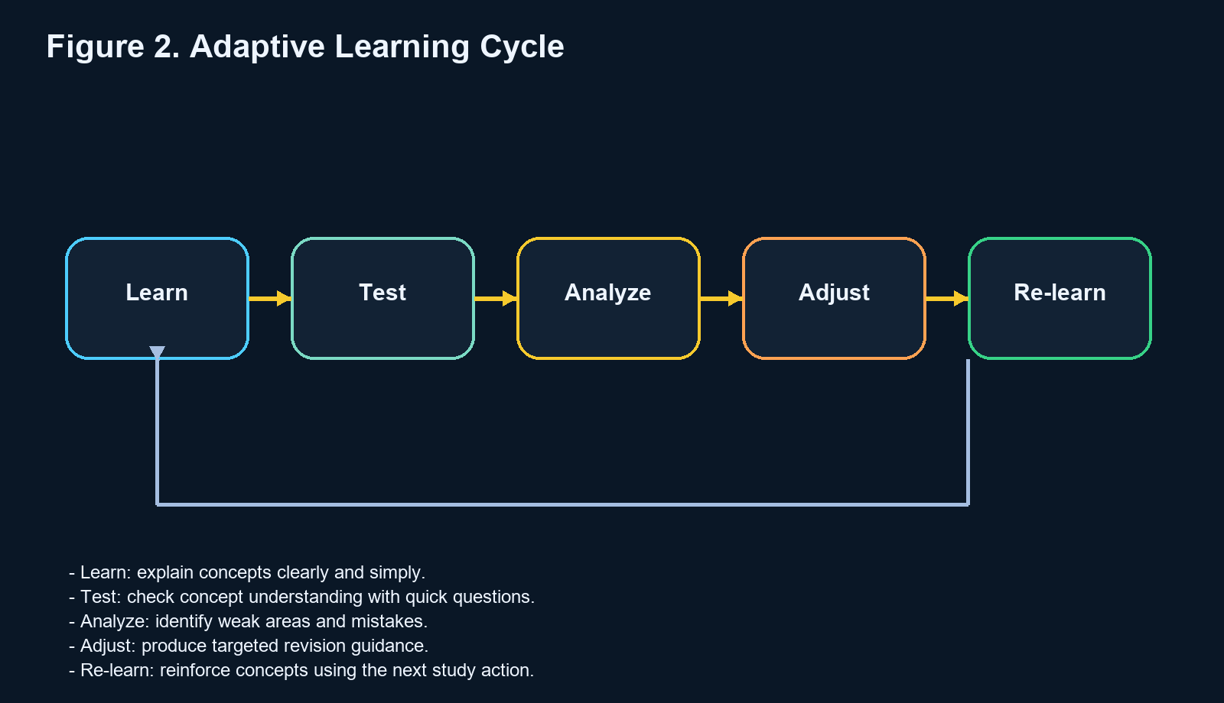
Figure 2. Adaptive learning cycle used in EduMind.

CHAPTER 4

Proposed Solution

PROPOSED SOLUTION
EduMind is a browser-based academic platform that combines AI tutoring and structured study management. The solution is designed to serve students who need more than static notes or generic answers. It helps them understand topics, validate learning, and re-enter weak concepts through actionable recovery steps.
The current solution includes a role-based study dashboard, AI tutor, adaptive quiz flow, flashcard review support, planner recommendations, and concept-map visualization. These modules work together to make the system feel like an academic workspace rather than a simple assistant window.
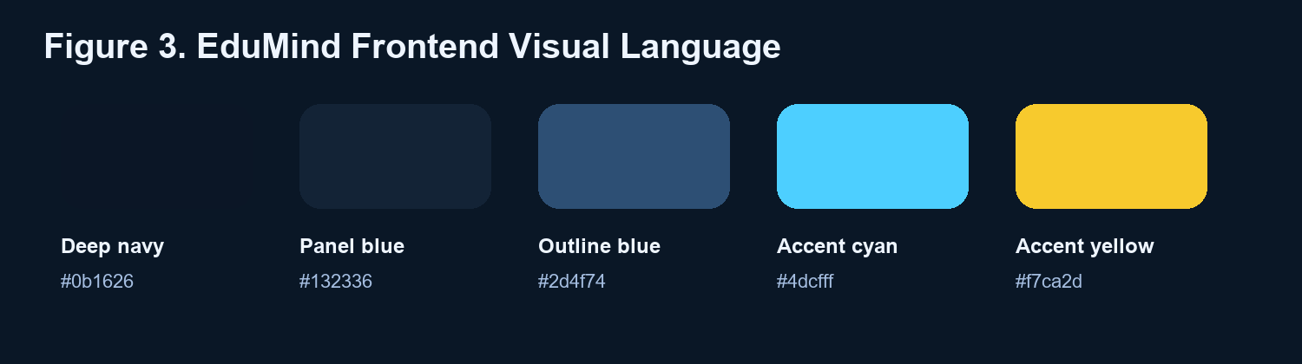
Figure 3. Frontend color styling derived from the EduMind interface.

CHAPTER 5

System Design

SYSTEM DESIGN
The EduMind system follows a client-server architecture. The frontend is developed to manage learner interaction, navigation, visual feedback, and local study continuity, while the backend handles API requests, validation, and communication with the external AI model.
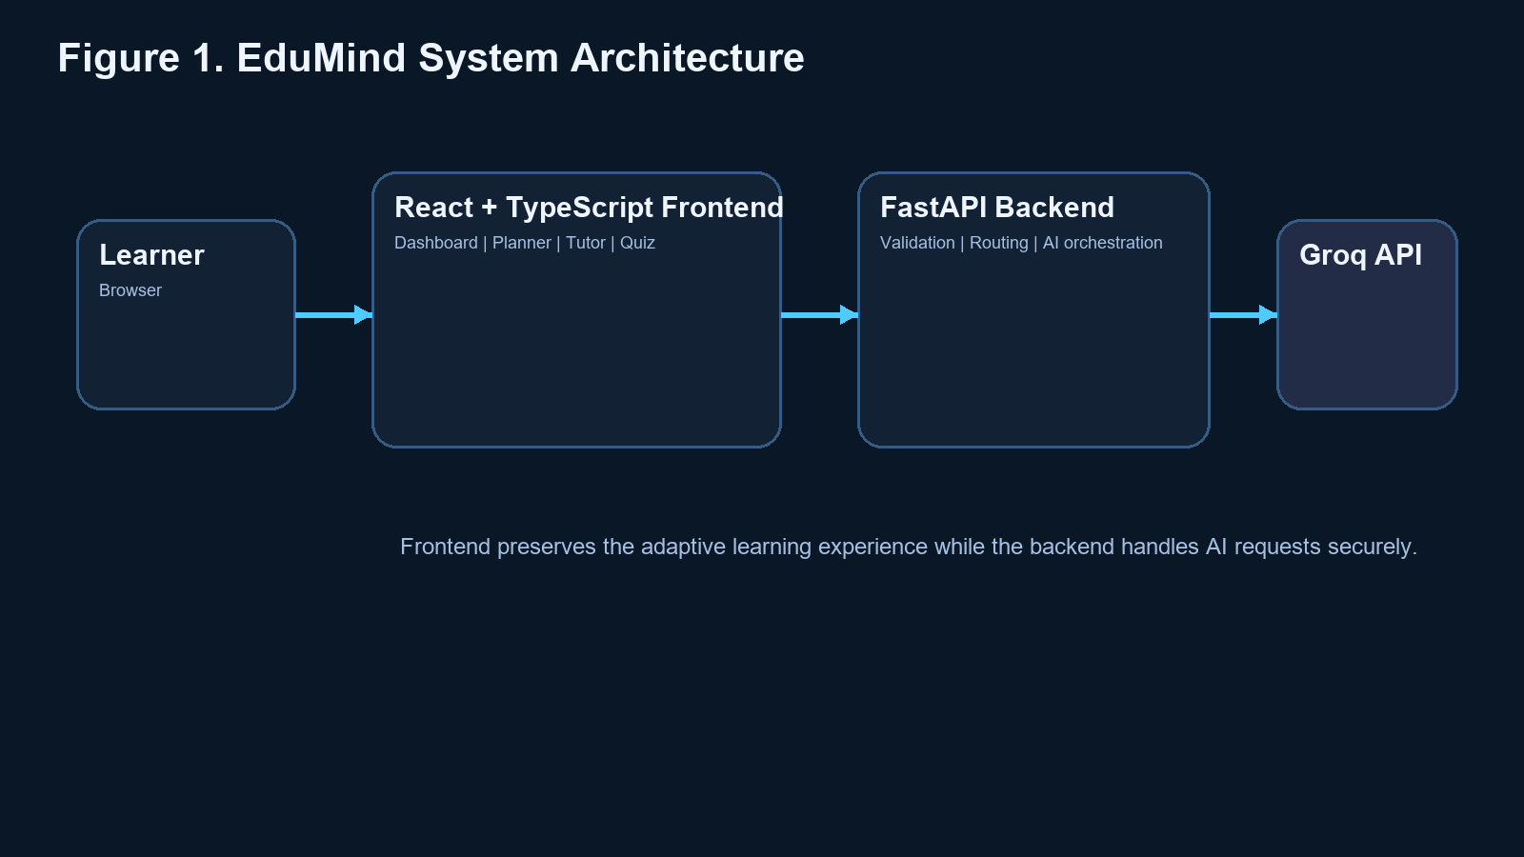
Figure 1. EduMind system architecture.
Module | Description | Role in the System
Dashboard | Displays progress cards, recovery metrics, and current study phase | Provides a learner-centric overview
AI Tutor | Explains topics and initiates guided study flow | Supports concept learning
Adaptive Quiz | Checks understanding through targeted questions | Measures concept retention
Recommendations | Suggests revision actions and priorities | Supports recovery planning
Mindmap Generator | Visualizes topic clusters and concept relations | Improves conceptual understanding
Backend API | Processes requests and AI communication | Coordinates intelligent responses

CHAPTER 6

Implementation

IMPLEMENTATION
The frontend of EduMind is built using React, TypeScript, Vite, and React Router. These technologies enable reusable UI components, maintainable state handling, and fast development workflows for an interactive educational interface.
The backend is implemented using Python and FastAPI, with request forwarding to an external Groq-compatible AI endpoint. The backend validates incoming study prompts, performs connectivity handling, and returns structured responses to the frontend.
A major implementation focus was preserving an academic yet modern user experience. The dark navy frontend theme, rounded card system, accent outlines, and cyan-to-yellow progress bars create a consistent visual identity that improves readability while preserving a professional feel.
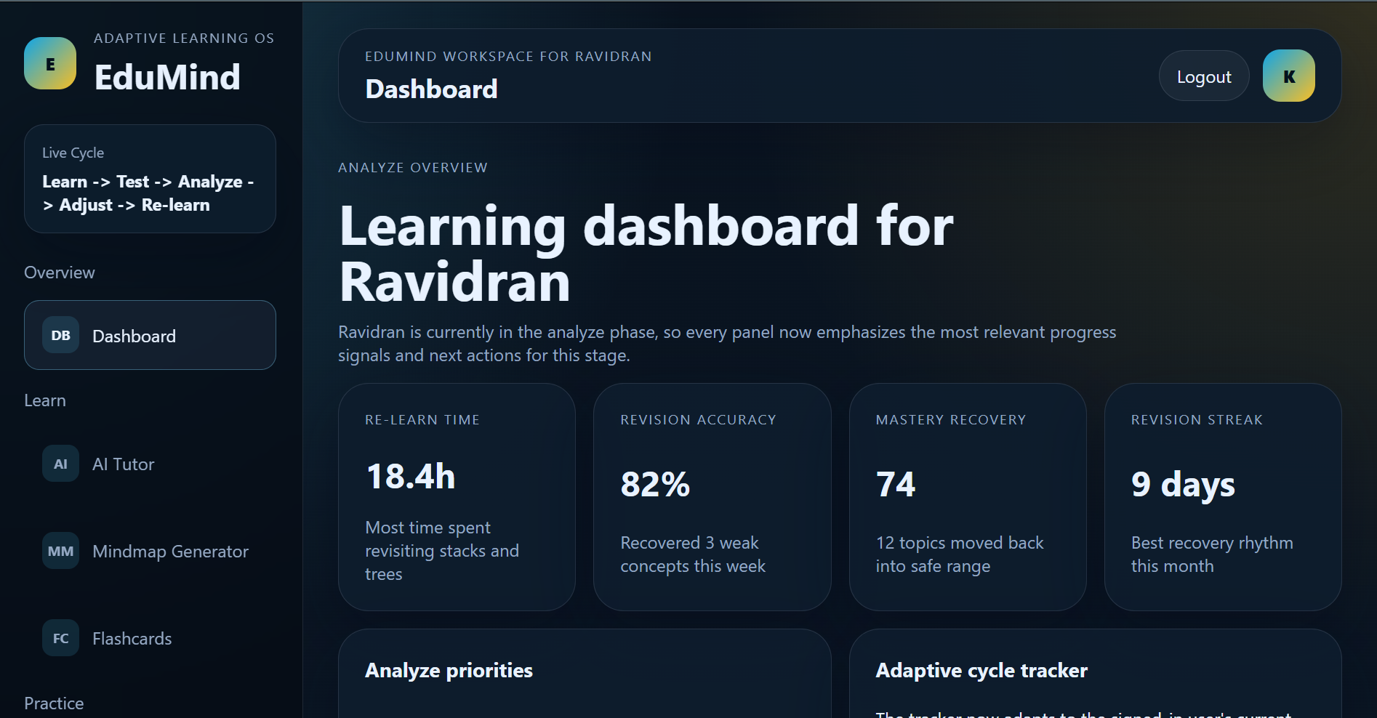
Figure 4. EduMind dashboard overview screen.
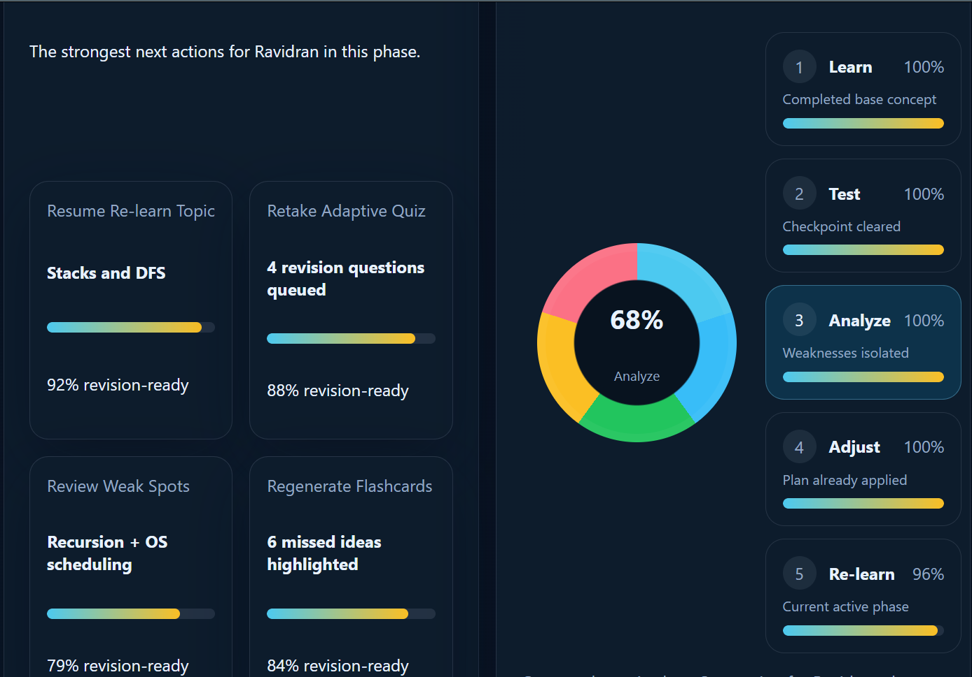
Figure 5. Analyze phase priorities and adaptive cycle tracker.

CHAPTER 7

Testing and Results

TESTING AND RESULTS
Test Case | Testing Method | Expected Result | Outcome
Login and session flow | Manual UI verification | Learner workspace should load correctly | Successful
Dashboard rendering | Component validation | Metrics and phase-specific cards should appear | Successful
Tutor workflow | End-to-end scenario test | Explanation, quiz, and revision steps should connect | Successful
Mindmap generation | Feature test using Data Structures topic | Concept nodes should render visually | Successful
Recommendation display | UI state verification | Recovery suggestions should update clearly | Successful
Backend connectivity | API route test | AI mode should respond or fail safely | Successful
The observed result is that EduMind successfully demonstrates the intended academic assistance workflow. The platform is especially strong in representing learner recovery, showing priorities, and converting concept revision into visible actions.
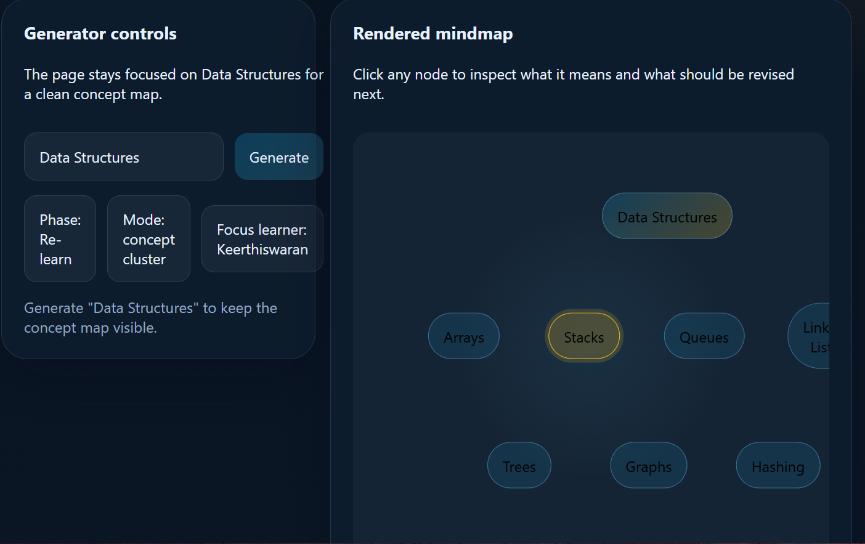
Figure 6. Mindmap generator screen showing concept-cluster rendering.
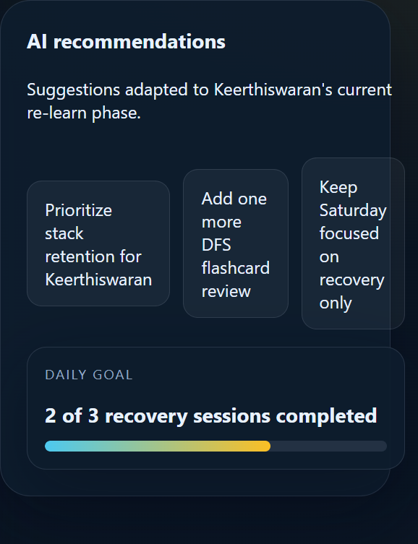
Figure 7. AI recommendations card with frontend progress styling.

CHAPTER 8

Impact and Benefits

IMPACT AND BENEFITS

Social Benefits
EduMind can reduce confusion and study stress by giving students immediate learning support and clearer next actions. This helps learners who struggle with self-organization or repeated concept failure.

Educational Benefits
The platform encourages active learning rather than passive reading. It improves concept reinforcement by linking explanations to practice, analysis, and re-learning.

Technical Benefits
The project demonstrates the practical integration of AI-assisted tutoring, full-stack development, adaptive learning workflows, and visually guided progress design.

CHAPTER 9

Future Enhancements

FUTURE ENHANCEMENTS
Integrating real user authentication and database-backed learner profiles.
Expanding support for more subjects, question types, and revision strategies.
Adding analytics dashboards for faculty insight and classroom-level monitoring.
Supporting PDF and note uploads for personalized concept extraction.
Introducing multilingual learning support and speech-based interaction.
Deploying the system for multi-user access in a hosted cloud environment.

CHAPTER 10

Conclusion

CONCLUSION
EduMind presents a professional, student-centered academic assistance platform developed using a design thinking approach. It addresses the problem of fragmented and non-adaptive study tools by combining explanation, testing, analysis, recommendation, and re-learning into one integrated environment.
The system is not merely a chatbot but a structured educational workspace. Its combination of AI capabilities, modern full-stack implementation, and carefully styled academic interface gives it strong potential for future educational deployment.

REFERENCES
[1] H. Hariyanto, F. X. D. Kristianingsih, and R. Maharani, "Artificial intelligence in adaptive education: a systematic review of techniques for personalized learning," Discover Education, 2025.
[2] L. Fadieieva, "Adaptive learning: a cluster-based literature review (2011-2022)," Educational Technology Quarterly, 2023.
[3] C. Merino-Campos, "The Impact of Artificial Intelligence on Personalized Learning in Higher Education: A Systematic Review," Trends in Higher Education, 2025.
[4] FastAPI Documentation. Available: https://fastapi.tiangolo.com/
[5] React Documentation. Available: https://react.dev/
[6] Vite Documentation. Available: https://vite.dev/guide/

