EduMind: AI-Powered Adaptive Study Assistant
Final DTI Project Report

Project Title | EduMind: AI-Powered Adaptive Study Assistant
Team Members | [Add team member names and roll numbers]
Guide / Faculty | [Add guide or faculty name]
Department / College | [Add department and college name]
Academic Year | 2025-2026

Prepared for the Design Thinking and Innovation course
Replace the bracketed placeholders with your final submission details.

2. Abstract
EduMind is an AI-powered adaptive study assistant developed to improve the way students learn, test, and revise academic concepts. Traditional e-learning systems often provide static notes or one-time answers without checking whether a learner has actually understood the topic. EduMind addresses this limitation by organizing learning into a guided cycle of explanation, assessment, analysis, adjustment, and re-learning. The system uses a React and TypeScript frontend to provide an accessible study interface, while a FastAPI backend manages request handling and AI communication. The prototype currently demonstrates topic explanation, quiz generation, answer analysis, revision planning, dashboard-based progress visibility, and supporting pages such as planner and flashcard views. The project was shaped using a design thinking approach, beginning with student pain-point identification and moving through ideation, prototyping, and feedback-driven refinement. The resulting solution is a prototype that emphasizes personalized reinforcement rather than generic content delivery. EduMind shows how AI can be applied in a practical, student-centered learning workflow and offers a strong base for future expansion into richer analytics, broader subject support, and real-time adaptive study recommendations.

3. Introduction
Education is rapidly moving toward digital and AI-supported environments, yet many learners still struggle with a familiar problem: they can access information easily, but they do not always receive the right guidance at the right time. Most conventional study tools focus on content delivery instead of concept reinforcement, error diagnosis, and structured revision.
EduMind was conceived as a response to this gap. The project focuses on making learning more adaptive by helping students move through a repeatable cycle: learn a concept, test understanding, analyze mistakes, adjust the revision plan, and re-learn the weak areas. This makes the platform suitable not only as a question-answer tool but also as a study companion that supports better academic habits.
The importance of this project lies in its human-centered focus. Many students need short explanations, immediate feedback, targeted revision prompts, and visible progress tracking. By combining these elements into one interface, EduMind aims to improve clarity, retention, and study discipline.

4. Problem Statement
Students often rely on fragmented learning resources such as notes, videos, search engines, or generic chatbots. These tools may explain a topic, but they rarely verify understanding, pinpoint misconceptions, or guide the learner into a structured revision loop. As a result, learners may believe they understand a concept when they have only read it once. The core problem addressed by this project is the lack of an integrated, adaptive study system that can explain concepts, assess comprehension, analyze mistakes, and recommend the next best revision step in a simple and engaging workflow.

5. Literature Review
Recent literature shows growing interest in adaptive and personalized learning systems. Hariyanto et al. [1] describe how AI-based adaptive education can personalize content delivery and learner support by using data-informed models and instructional adjustment. Fadieieva [2] reviews adaptive learning research between 2011 and 2022 and highlights the importance of tailoring content to learner needs, preferences, and performance patterns.
Merino-Campos [3] emphasizes that AI-supported personalized learning can improve learner engagement and flexibility in higher education, especially when systems adapt explanations and pacing to individual users. At the same time, design thinking literature from the Stanford d.school [4] shows that successful educational innovation should begin with empathy and iterative prototyping rather than technology-first decisions.
Existing study platforms provide valuable features such as digital flashcards, quiz practice, or note storage, but many of them are modular rather than truly integrated. EduMind differs by tying explanation, quiz-based checking, analysis, and revision planning into one loop. The project therefore builds on the strengths of prior adaptive learning research while keeping the implementation lightweight and directly aligned with student study behavior.
System / Approach | Strengths | Observed Limitations | How EduMind Responds
Static e-learning content | Easy access to notes and videos | No feedback on whether the student understood the topic | Adds testing and revision guidance after explanation
Generic chatbots | Flexible question answering | No built-in memory of study phase or recovery loop | Introduces a structured Learn-Test-Analyze-Adjust-Re-learn cycle
Quiz-only tools | Good for practice | Often weak in concept explanation and remediation | Connects quiz errors to targeted re-learning support

6. Design Thinking Process
The project followed the five-stage design thinking model of empathize, define, ideate, prototype, and test. This approach helped ensure that the solution stayed focused on learner needs instead of becoming only a technical demonstration.
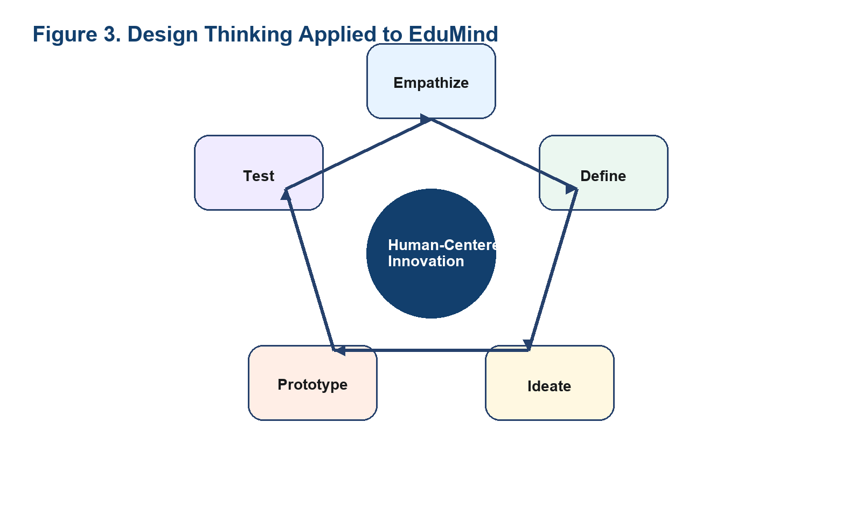
Figure 3. Design thinking stages used to shape the EduMind prototype.

1. Empathize - Understanding Users
The empathize stage focused on common difficulties faced by students during independent study: confusion after reading once, poor retention, lack of direction after making mistakes, and difficulty planning revision. Observations from everyday student behavior and the design goal of reducing repeated confusion informed the user profile.

2. Define - Problem Definition
The collected observations were synthesized into a clear challenge statement: students need a study assistant that does more than explain concepts once; it should verify understanding and recommend what to revise next. This definition narrowed the project toward adaptive support rather than general conversation.

3. Ideate - Idea Generation
During ideation, multiple options were considered, including a note summarizer, chatbot-only tutor, flashcard generator, and quiz portal. The most promising idea was a guided cycle that could combine tutoring, assessment, diagnosis, and revision support within one learning flow.

4. Prototype - Model Creation
The prototype was implemented as a web application with a React frontend and FastAPI backend. The interface includes a tutor cycle, progress-oriented dashboard, quiz page, study planner, and flashcard views to demonstrate how the learner experience can extend beyond a single prompt.

5. Test - Evaluation of Solution
Testing focused on validating whether the learner flow was understandable and complete: topic input, explanation, quiz answering, analysis generation, and revision guidance. Feedback from this stage informed refinements such as cleaner session handling, better workflow transitions, and clearer UI separation across pages.

7. Proposed Solution
EduMind is proposed as a browser-based adaptive study assistant that supports the learner from the first question to the revision stage. Instead of answering in isolation, the system is designed as a learning journey. A student begins by entering a study topic, receives a simple explanation, attempts a short quiz, and then gets feedback and a revision plan based on the mistakes made.
The current prototype demonstrates this idea through a tutor module and complementary screens such as the dashboard, planner, quiz page, flashcards, analytics-focused layout, and knowledge-view pages. Together these features communicate a broader vision: a learning system that not only teaches but also helps the learner recover weak concepts in a disciplined way.
Learner sign-in flow using demo user profiles.
Topic explanation in either guided demo mode or backend AI mode.
Quiz-based concept checking for immediate validation.
Analysis of wrong answers and generation of a revision plan.
Progress-oriented views such as dashboard, quiz map, planner, and flashcard reinforcement.
For the final submitted report, this section can be strengthened further by inserting screenshots of the login page, dashboard, tutor flow, and quiz interface once you share the latest frontend captures.

8. System Design
EduMind uses a client-server architecture in which the frontend is responsible for interaction, navigation, and local session continuity, while the backend handles API exposure, validation, and external AI communication. This separation keeps the system modular and easier to extend.
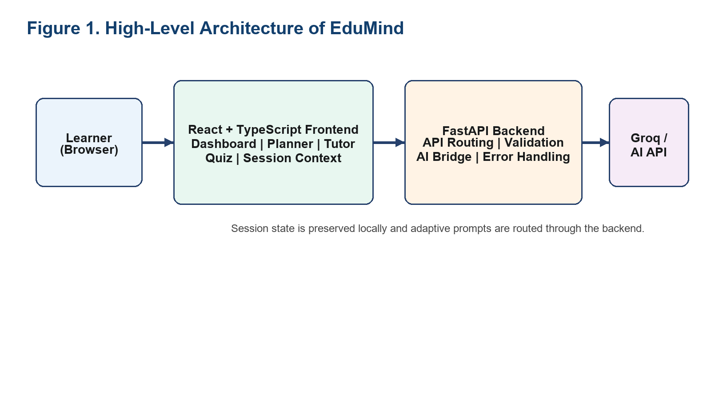
Figure 1. High-level architecture showing frontend, backend, and AI integration.
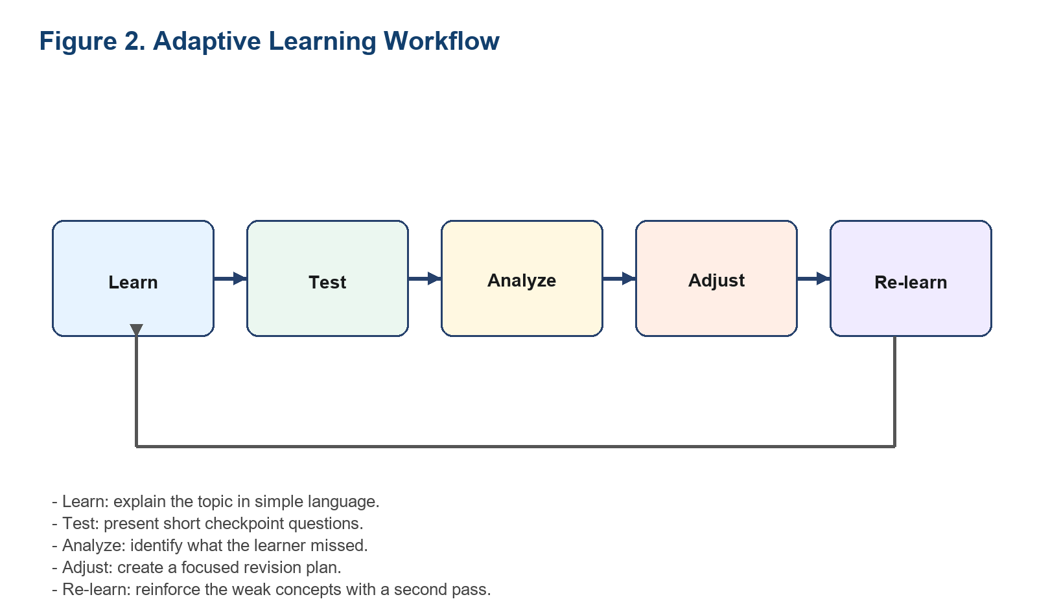
Figure 2. Adaptive learning workflow implemented by the tutor cycle.
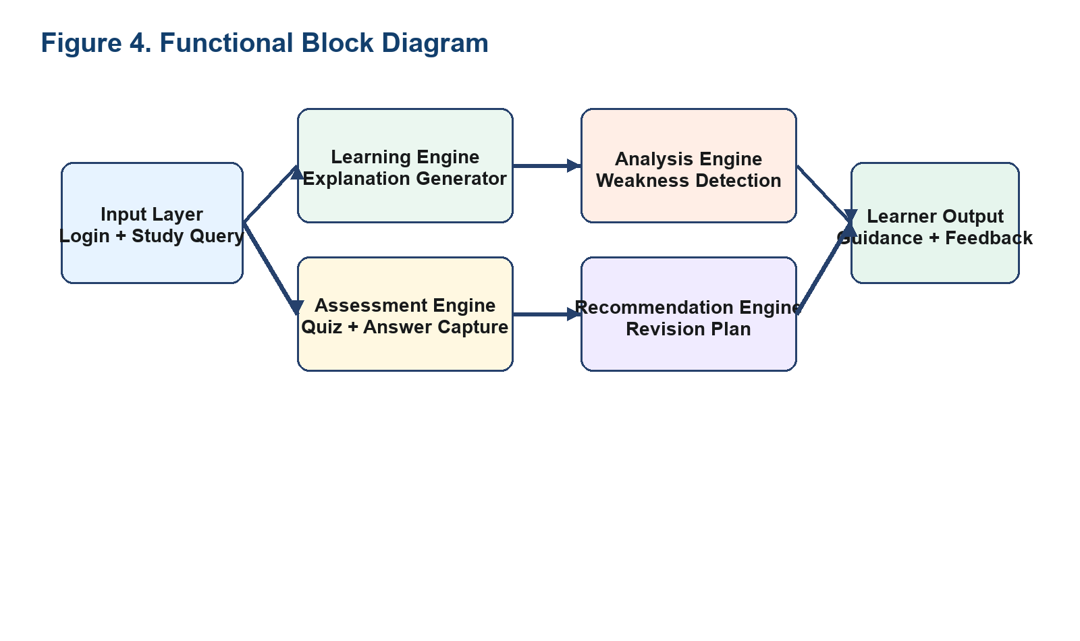
Figure 4. Functional block diagram of EduMind modules.
The architecture diagram shows the data flow from the learner to the frontend, backend, and AI service. The workflow figure explains the pedagogical cycle, while the block diagram presents the main functional modules used to transform a study query into personalized feedback.

9. Implementation
The frontend of EduMind is implemented using React, TypeScript, and Vite. React supports component-based UI composition, TypeScript improves reliability during refactoring, and Vite provides a fast local development workflow [6], [7]. Routing is handled through `react-router-dom`, and session persistence is supported through browser storage concepts aligned with the Web Storage API [8].
The backend is implemented with Python and FastAPI. It exposes endpoints for tutor interaction and connectivity checks, loads environment variables, and forwards suitable prompts to the external Groq-compatible API. CORS middleware is enabled to support communication between the locally hosted frontend and backend [5].
Component | Technology Used | Purpose
Frontend | React + TypeScript + Vite | Builds the study interface and page-level user experience
Routing | React Router | Handles single-page navigation between learning modules
Session Layer | Context + localStorage | Keeps learner state available between interactions
Backend | FastAPI + Python | Processes requests and coordinates AI interaction
External AI | Groq API | Generates dynamic study explanations in AI mode
Deployment for the current prototype is local. The frontend runs through the Vite development server and the backend runs through Uvicorn. This environment is sufficient for functional testing and iterative improvement before a future hosted deployment.

10. Testing and Results
Testing in this prototype focused on functional validation of the end-to-end learner workflow rather than large-scale classroom experimentation. The objective was to confirm that each core path works as expected: sign-in, topic entry, explanation rendering, quiz answering, analysis generation, revision planning, and backend connectivity checks.
Test Case | Method | Expected Outcome | Observed Result
Demo sign-in | Manual UI validation | Learner profile loads successfully | Passed
Tutor start flow | Scenario-based testing | Question triggers explanation and quiz setup | Passed
Quiz completion | Manual answer selection | All questions can be answered and submitted | Passed
Analysis stage | State transition check | Mistakes produce review feedback and revision plan | Passed
Backend health check | API endpoint check | System detects connected or disconnected backend | Passed
API failure handling | Negative-path validation | Errors return clean HTTP failure responses | Passed
The results indicate that the prototype successfully demonstrates the intended adaptive loop. The system is especially effective as a proof of concept for personalized revision guidance. However, the current results should be interpreted as prototype-level validation because the application still relies on demo content in several places and has not yet undergone broad user testing with real cohorts.

11. Impact and Benefits

Social Benefits
EduMind can support students who need more structured, repeated reinforcement than traditional note-based learning offers. By reducing confusion after the first explanation and by pointing learners toward their weak areas, the system can improve confidence and encourage better self-study habits.

Economic Benefits
A browser-based study assistant can reduce dependence on multiple paid tools by combining explanation, practice, and revision support in one platform. For institutions, such systems may later reduce the time spent on repetitive doubt clarification while improving learner preparedness.

Technical Improvement
The project demonstrates a technically meaningful combination of frontend state management, backend API orchestration, and AI-assisted tutoring. Its modular structure also makes it easier to extend into analytics, adaptive content sequencing, and persistent learner history.

12. Future Enhancements
Add real user authentication and learner profiles instead of demo accounts.
Store topic history, quiz attempts, and revision patterns in a database.
Generate adaptive quizzes dynamically based on past errors and subject difficulty.
Include richer analytics such as mastery trends, topic heat maps, and time-based revision alerts.
Support image-based notes, PDF ingestion, voice interaction, and multilingual tutoring.
Deploy the solution to a hosted environment for multi-user access and broader testing.

13. Conclusion
EduMind was developed as a design thinking-driven response to the limitations of static study tools and one-time chatbot interactions. The project identifies a real student need: learning support should not end with an explanation, but continue through assessment, diagnosis, and revision.
The final prototype demonstrates an integrated workflow built with React, TypeScript, FastAPI, and AI service connectivity. Its most important contribution is the structured learning cycle of Learn, Test, Analyze, Adjust, and Re-learn. Although the current system remains a prototype, it provides a credible foundation for a future adaptive learning platform with stronger personalization, analytics, and institutional relevance.

14. References
[1] H. Hariyanto, F. X. D. Kristianingsih, and R. Maharani, "Artificial intelligence in adaptive education: a systematic review of techniques for personalized learning," Discover Education, vol. 4, art. 458, 2025.
[2] L. Fadieieva, "Adaptive learning: a cluster-based literature review (2011-2022)," Educational Technology Quarterly, no. 3, pp. 319-366, 2023. doi: 10.55056/etq.613.
[3] C. Merino-Campos, "The Impact of Artificial Intelligence on Personalized Learning in Higher Education: A Systematic Review," Trends in Higher Education, vol. 4, no. 2, art. 17, 2025. doi: 10.3390/higheredu4020017.
[4] Stanford d.school, "Design Thinking Bootleg," [Online]. Available: https://dschool.stanford.edu/resources/the-bootcamp-bootleg.
[5] FastAPI Documentation, "CORS (Cross-Origin Resource Sharing)," [Online]. Available: https://fastapi.tiangolo.com/tutorial/cors/.
[6] React Documentation, "React Reference Overview," [Online]. Available: https://react.dev/reference/react.
[7] Vite Documentation, "Getting Started," [Online]. Available: https://vite.dev/guide/.
[8] MDN Web Docs, "Web Storage API," [Online]. Available: https://developer.mozilla.org/en-US/docs/Web/API/Web_Storage_API.

