In this project, your task is to predict whether the policyholder will file a claim in the next 6 months or not. The Dataset contains information on policyholders having the attributes like policy tenure, age of the car, age of the car owner, the population density of the city, make and model of the car, power, engine type, etc, and the target variable indicating whether the policyholder files a claim in the next 6 months or not. The data set is a modified data set based on the Car Insurance Claim Prediction competition on Kaggle.

File and Data Field Descriptions

**trainData.csv**- contains 25,000 records of historical data, to be used as training data.

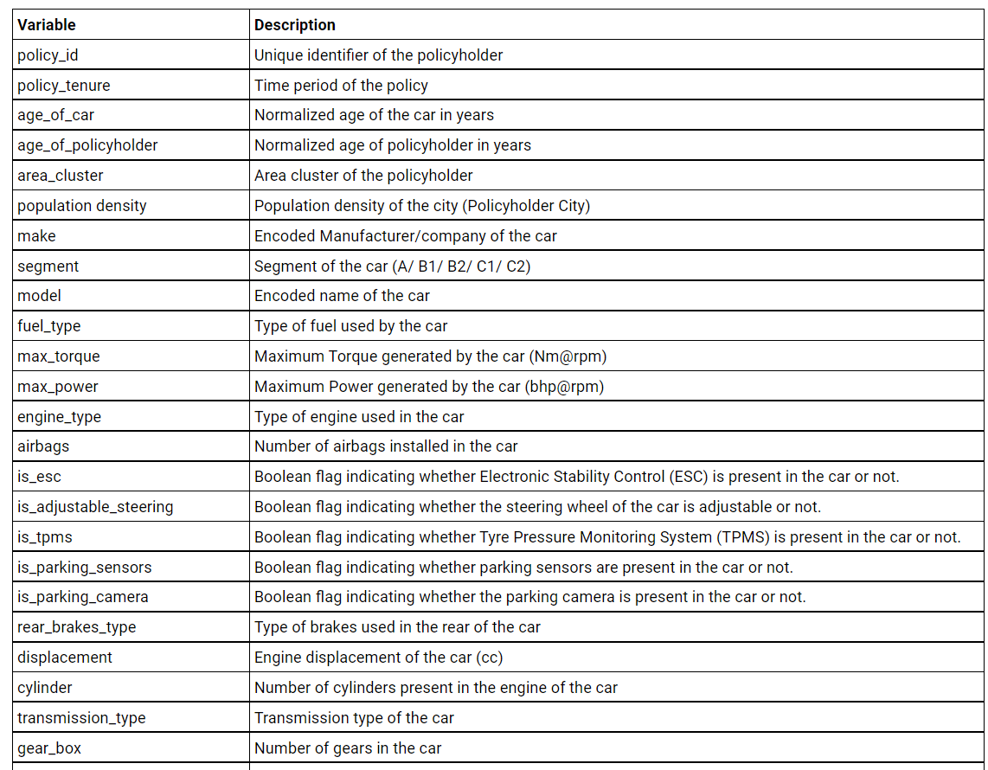

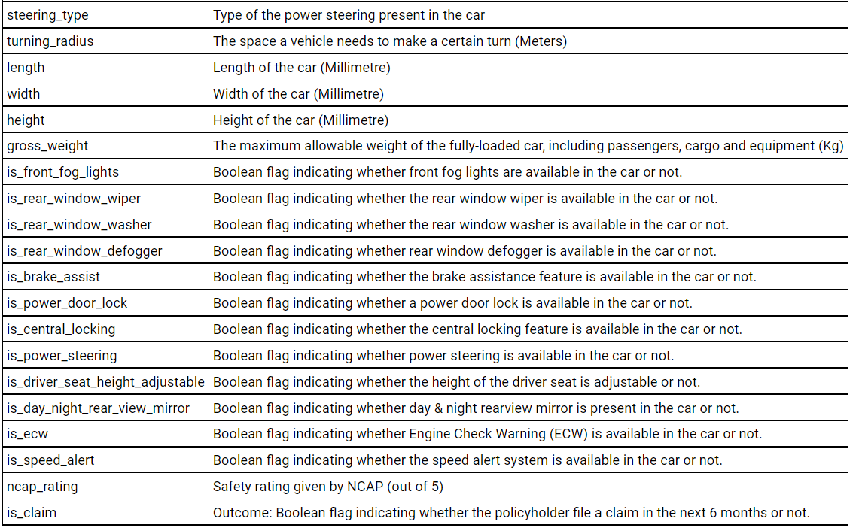 **testDatawithoutTarget.csv-** records of another group of customers with target value missing that to be used as unseen test data. Your task is to predict the value of is_claim for the customer in this set. Export the testData and predict transported value to a csv file.