Practical 10
Part A
Problem 1:- Thread-pool runner: with a fixed pool of 3 (ExecutorService), submit about 10 Runnable tasks that print their id and sleep briefly; shut down and await completion, observing the few threads being reused.

Code:-
ThreadPoolRunner.java
package lab10;
import java.util.concurrent.*;

public class ThreadPoolRunner {
public static void main(String[] args) throws InterruptedException {

ExecutorService pool = Executors.newFixedThreadPool(3);

for (int i = 1; i <= 10; i++) {
int id = i;

pool.submit(() -> {
System.out.println("Task " + id + " running on "
+ Thread.currentThread().getName());

try {
Thread.sleep(500);
} catch (InterruptedException e) {
Thread.currentThread().interrupt();
}
});
}

pool.shutdown();
pool.awaitTermination(1, TimeUnit.MINUTES);

System.out.println("All tasks completed.");
}
}
OUTPUT:- 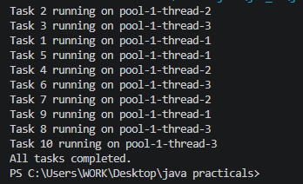

Problem 2:- Producer–consumer: one thread adds numbers to a small shared buffer and another removes them, coordinated with wait()/notify(); produce and consume a fixed number of items in order with none lost.

Code:-
ProducerConsumer.java
package lab10;

class Buffer {
int item;
boolean available = false;

synchronized void produce(int value) throws InterruptedException {
while (available)
wait();

item = value;
available = true;
System.out.println("Produced: " + value);
notifyAll();
}

synchronized int consume() throws InterruptedException {
while (!available)
wait();

int value = item;
available = false;
System.out.println("Consumed: " + value);
notifyAll();
return value;
}
}

public class ProducerConsumer {
public static void main(String[] args) throws InterruptedException {
Buffer b = new Buffer();

Thread producer = new Thread(() -> {
try {
for (int i = 1; i <= 10; i++)
b.produce(i);
} catch (InterruptedException e) {
Thread.currentThread().interrupt();
}
});

Thread consumer = new Thread(() -> {
try {
for (int i = 1; i <= 10; i++)
b.consume();
} catch (InterruptedException e) {
Thread.currentThread().interrupt();
}
});

producer.start();
consumer.start();

producer.join();
consumer.join();

System.out.println("All items processed.");
}
}
OUTPUT 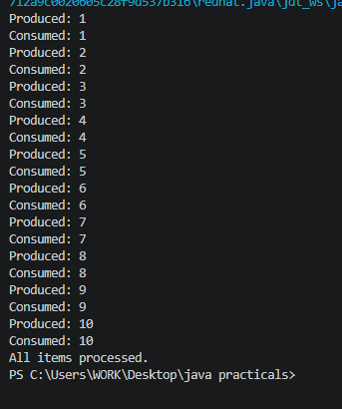

Problem 3:- (For Advanced Learners – home) Reproduce a deadlock between two threads that lock two objects in opposite order, then remove it with a consistent lock order. Choose the scenario yourself.

Code:-
Deadlock.java
package lab10;

class Deadlock {
static Object lock1 = new Object();
static Object lock2 = new Object();

public static void main(String[] args) throws InterruptedException {

Thread t1 = new Thread(() -> {
synchronized (lock1) {
System.out.println("Thread 1 locked lock1");

synchronized (lock2) {
System.out.println("Thread 1 locked lock2");
}
}
});

Thread t2 = new Thread(() -> {
synchronized (lock2) {
System.out.println("Thread 2 locked lock2");

synchronized (lock1) {
System.out.println("Thread 2 locked lock1");
}
}
});

t1.start();
t2.start();

t1.join(1000);
t2.join(1000);

System.out.println("Deadlock example completed (threads may be stuck).");

Thread t3 = new Thread(() -> {
synchronized (lock1) {
synchronized (lock2) {
System.out.println("Thread 3 completed safely");
}
}
});

Thread t4 = new Thread(() -> {
synchronized (lock1) {
synchronized (lock2) {
System.out.println("Thread 4 completed safely");
}
}
});

t3.start();
t4.start();

t3.join();
t4.join();

System.out.println("Fixed example completed.");
}
}

OUTPUT:- 