Practical 12
Part A
Problem 1:- Word frequency: split a paragraph into words, count each in a HashMap, and print the words sorted by frequency (highest first) using a Comparator.

Code:-
package Lab12;

import java.util.*;

public class WordFrequency {
public static void main(String[] args) {

String text = "java is easy java is useful java";

String[] words = text.split(" ");

HashMap<String, Integer> map = new HashMap<>();

for (String word : words) {
if (map.containsKey(word)) {
map.put(word, map.get(word) + 1);
} else {
map.put(word, 1);
}
}

List<String> list = new ArrayList<>(map.keySet());

Collections.sort(list, new Comparator<String>() {
public int compare(String a, String b) {
return map.get(b) - map.get(a);
}
});

for (String word : list) {
System.out.println(word + " : " + map.get(word));
}
}
}
OUTPUT:- 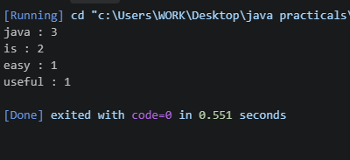

Problem 2:- Unique visitors: from a list of login names with repeats, use a HashSet to count unique
users and a LinkedHashSet to keep first-seen order; print the unique count and the first
three distinct names.
Code:-
import java.util.*;

public class UniqueVisitors {
public static void main(String[] args) {

String[] names = {
"Rahul", "Amit", "Rahul",
"Priya", "Amit", "Neha"
};

HashSet<String> set = new HashSet<>();
LinkedHashSet<String> orderedSet = new LinkedHashSet<>();

for (String name : names) {
set.add(name);
orderedSet.add(name);
}

System.out.println("Unique users: " + set.size());

System.out.println("First three unique users:");

int count = 0;

for (String name : orderedSet) {
if (count == 3) {
break;
}

System.out.println(name);
count++;
}
}
}

OUTPUT 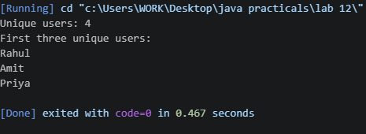

Problem 3:-
Build a leaderboard from player scores held in a Map and print the top-N sorted by score (ties broken by name); choose the data and sorting details.
Code:-
import java.util.*;

public class Leaderboard {
public static void main(String[] args) {

Map<String, Integer> scores = new HashMap<>();

scores.put("Rahul", 90);
scores.put("Amit", 85);
scores.put("Priya", 95);
scores.put("Neha", 90);

List<String> players =
new ArrayList<>(scores.keySet());

Collections.sort(players, new Comparator<String>() {
public int compare(String a, String b) {

if (scores.get(a).equals(scores.get(b))) {
return a.compareTo(b);
}

return scores.get(b) - scores.get(a);
}
});

System.out.println("Top 3 Players:");

for (int i = 0; i < 3; i++) {
String name = players.get(i);

System.out.println(
name + " : " + scores.get(name));
}
}
}

OUTPUT:- 