Practical 13
Part A
Problem 1:- Generic containers: a generic Box<T> with get/set and a Pair<A,B>; use them with different types to show type safety without casts, and write a generic method that returns the first element of any array.
Code:-
class Box<T> {
T value;

void set(T value) {
this.value = value;
}

T get() {
return value;
}
}

class Pair<A, B> {
A first;
B second;

Pair(A first, B second) {
this.first = first;
this.second = second;
}

void display() {
System.out.println(first + " " + second);
}
}

public class GenericDemo {

static <T> T first(T[] array) {
return array[0];
}

public static void main(String[] args) {

Box<Integer> b1 = new Box<>();
b1.set(100);
System.out.println("Box value: " + b1.get());

Box<String> b2 = new Box<>();
b2.set("Java");
System.out.println("Box value: " + b2.get());

Pair<String, Integer> p =
new Pair<>("Rahul", 20);
p.display();

String[] names = {"Amit", "Rahul", "Neha"};
System.out.println("First name: " + first(names));

Integer[] numbers = {10, 20, 30};
System.out.println("First number: " + first(numbers));
}
}

OUTPUT:- 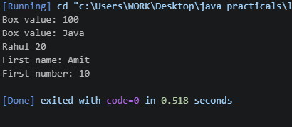

Problem 2:-
Bounded stats: a generic method <N extends Number> double average(N[] values) that
works for Integer[], Double[] and Long[]; note why it refuses non-Number types.

Code:-
public class AverageDemo {

static <N extends Number> double average(N[] values) {
double sum = 0;

for (N value : values) {
sum = sum + value.doubleValue();
}

return sum / values.length;
}

public static void main(String[] args) {

Integer[] a = {10, 20, 30};
Double[] b = {2.5, 3.5, 4.5};
Long[] c = {100L, 200L, 300L};

System.out.println("Integer average: " + average(a));
System.out.println("Double average: " + average(b));
System.out.println("Long average: " + average(c));
}
}

OUTPUT 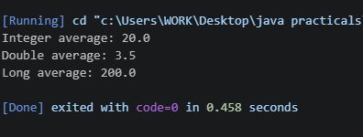

Problem 3:-
Implement a small generic container of your choice (e.g. a stack) backed by an array, reuse it for two different types, and handle the empty case sensibly.
Code:-
class Stack<T> {
T[] arr;
int top = -1;

@SuppressWarnings("unchecked")
Stack(int size) {
arr = (T[]) new Object[size];
}

void push(T value) {
if (top == arr.length - 1) {
System.out.println("Stack is full");
} else {
arr[++top] = value;
}
}

T pop() {
if (top == -1) {
System.out.println("Stack is empty");
return null;
} else {
return arr[top--];
}
}
}

public class GenericStack {
public static void main(String[] args) {

Stack<Integer> s1 = new Stack<>(5);
s1.push(10);
s1.push(20);

System.out.println(s1.pop());

Stack<String> s2 = new Stack<>(5);
s2.push("Java");
s2.push("Python");

System.out.println(s2.pop());
System.out.println(s2.pop());
System.out.println(s2.pop());
}
}

OUTPUT:- 