

**BIRLA VISHVAKARMA MAHAVIDYALAYA**

**ENGINEERING COLLEGE**

**[An Autonomous Institution]**

A

Project Report

On

**Automated Attendance System**

Under the course of

**DESIGN ENGINEERING -3CP08**

B. E., Semester – VI

**(Computer Engineering)**

**Submitted by:**

|  |  |  |
| --- | --- | --- |
| **Sr.** | **Name of student** | **Enrolment No.** |
| 1 | Meet Variya | 180070107061 |
| 2 | Chintan Darji | 180070107005 |
| 3 | Deep Patel | 180070107067 |

**Faculty Guide**

Prof. Kirti J Sharma

Prof. Mosin I Hasan

**Academic year**

(2020-2021)

**CERTIFICATE**

This is to certify that the students namely, **Mr. Meet Variya (180070107061), Mr. Chintan Darji (180070107005), Mr. Deep Patel (180070107067)** of ***B. E. (Computer Engineering) Semester VI*** have successfully completed the course work and related tasks for the course of **Design Engineering 3CP08** during the academic term ending in the month of May 2021.

Date: __________

Place: __________

       Prof. Kirti J Sharma Head of the Department

Prof. Mosin I Hasan

**Table of Contents**

**Page no.**

1. Introduction……………………………………………………..1
2. Literature Review/Secondary Research...……………………....2

* Related Work………………………….…………….…...2
* Processes involved in Face Recognition………………....3

1. Design Considerations for detail design

* Data Flow Diagram……………………………………....5
* E-R Diagram……………………………………………10

1. Designing canvas

* AEIOU………………………………………………….11
* Product Development Canvas…………………………..12

1. Empathy Canvas……………………………………………….13
2. Ideation Canvas………………………………………………..14
3. Implementation/Simulation and Analysis………….……….....15
4. Conclusion……………………………………………….….....25
5. Future scope…………………………………………………....26
6. References………………………………………………….......27

**Introduction**

Nowadays everything is going towards new Era of AI. So, we are changing the whole system of manually work done in any educational institutions as maintaining the attendance is highly important in all the organizations for checking the performance and regularity of employees/students. That's why it has so much importance nowadays and it is a better tool to deal with manual errors. As such we can do much stuff even better than older versions.

The main aim of this project is to develop an accurate, fast and very efficient attendance system. We propose an Automated Attendance System, a web-based application that takes the attendance of the students using face recognition. It is intended to replace the manual model of attendance record keeping in paper records. The call of student and filling attendance in paper is replaced by the interaction of faculty and the attendance system.

The audience of this system will be students, faculties and institute administrator. The Attendance Management System will allow the faculty in charge to maintain a record of attendance of student in their respective classes from a pc. Also, the system will permit the faculty in charge to maintain all the essential details regarding a particular student. The goal is to provide faculty with an easy, portable solution to attendance record maintenance and attendance statistics. Also, there’s no need for specialized hardware.

**Literature Review/ Secondary Research**

**Related Work:**

1) RFID (Radio Frequency Identification)-based Attendance System

A number of works related to Radio Frequency Identification (RFID) based Attendance Systems exist in the literature. Some authors have proposed RFID based system in which students carry a RFID tag type ID card and they need to place that on the card reader to record their attendance. RS232 is used to connect the system to the computer and save the recorded attendance from the database. This system may give rise to the problem of fraudulent access. Unauthorized person may make use of authorized ID card and enter into the organization.

2) Fingerprint based Attendance System

A portable fingerprint device has been developed which can be passed among the students to place their finger on the sensor during the lecture time without the instructor’s intervention. This system guarantees a fool proof method for marking the attendance. The problem with this approach is that passing of the device during the lecture time may distract the attention of the students. Also, it is time consuming.

3) Iris-Recognition Based Attendance System

Iris is another bio-metric that can be used for Attendance Systems. Some authors have proposed Daugman’s algorithm-based Iris recognition system. This system uses iris recognition management system that does capturing the image of iris recognition, extraction, storing and matching. But the difficulty occurs to lay the transmission lines in the places where the topography is bad.

Why Face Recognition?

It is reliable, secure and fast.

**Processes involved in Image Processing: -**

The processes that are involved in image processing are as follows: -

1. Pre-Processing Images

The system captures images of every individual’s face. The images are converted into grey scale as LBPH operates using images in greyscale and the images are stored in a folder. The stored images will be saved with user’s name.

2. Face Detection

When a person appears in front of the camera, the camera detects that a face is present and a frame appears around the face. The entire frame is converted to greyscale as LBPH works only on greyscale images. A scale factor is used to compensate for multiple faces present in front of the camera.

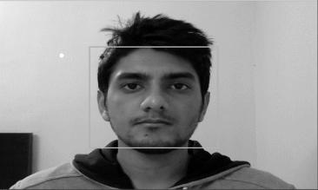

Fig: - Frame around detected face

(Reference:<https://www.ijitee.org/wp-content/uploads/papers/v8i6/F3965048619.pdf> )

3. Feature Extraction

The LBPH algorithm makes use of binary values and stores the data in a file. The binary values are different for each face. The Region of Interest (ROI) are parts of the face from where features are extracted. Information about the gradients in the face is captured. The image of a person’s face is divided cells comprising of 8 pixels. Each pixel present has a gradient and compares itself with its neighbour pixels.

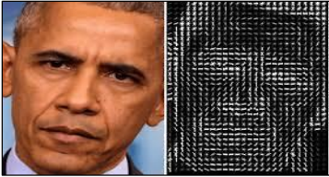

Fig: - Example of features

(Reference:<https://www.ijitee.org/wp-content/uploads/papers/v8i6/F3965048619.pdf> )

4. Face Recognition

In the comparison module, face recognition process is carried out. When a face is detected by the camera it checks the corresponding values of the current visible face with values stored in the file. If the values are a match, then the face is recognized and the name associated with that face is displayed.

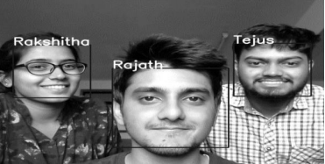

Fig: - Faces recognized

(Reference:<https://www.ijitee.org/wp-content/uploads/papers/v8i6/F3965048619.pdf> )

**Design Considerations for Detail Design**

**1) Data Flow Diagram**

Level 0:  
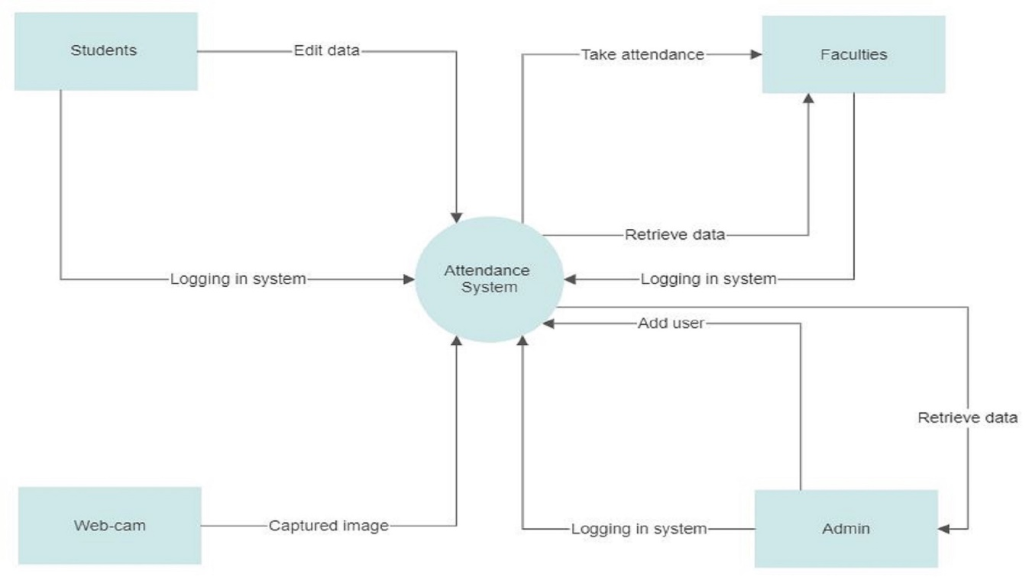

Level 1:

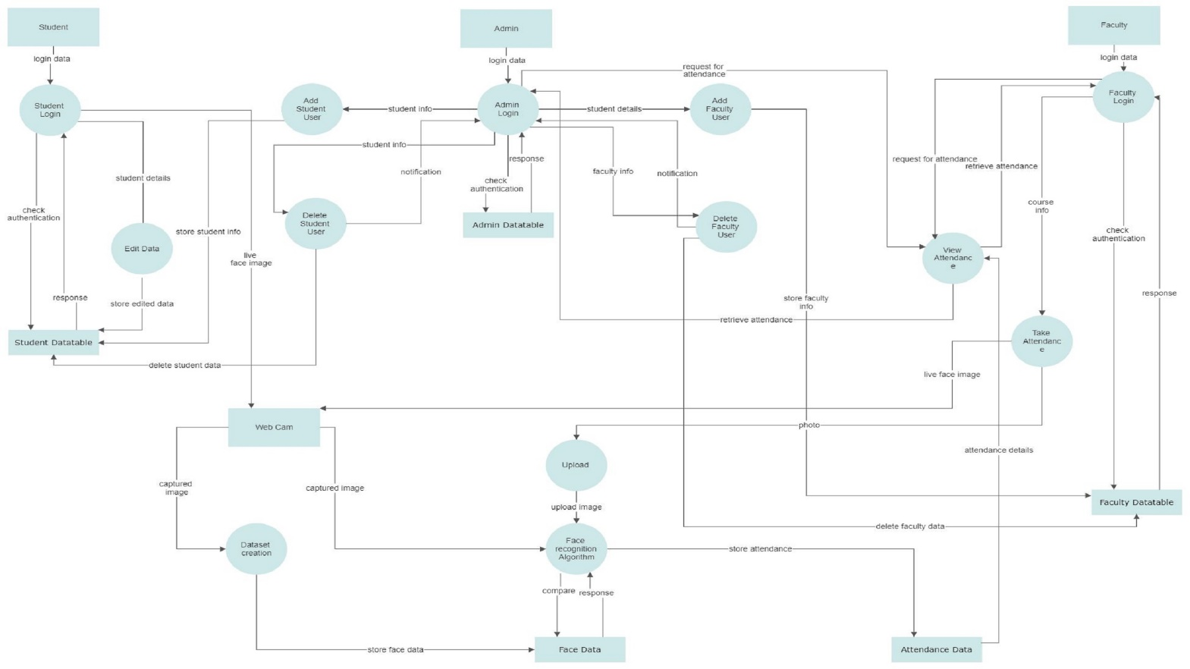

Level 2:

Level 2: (Student)



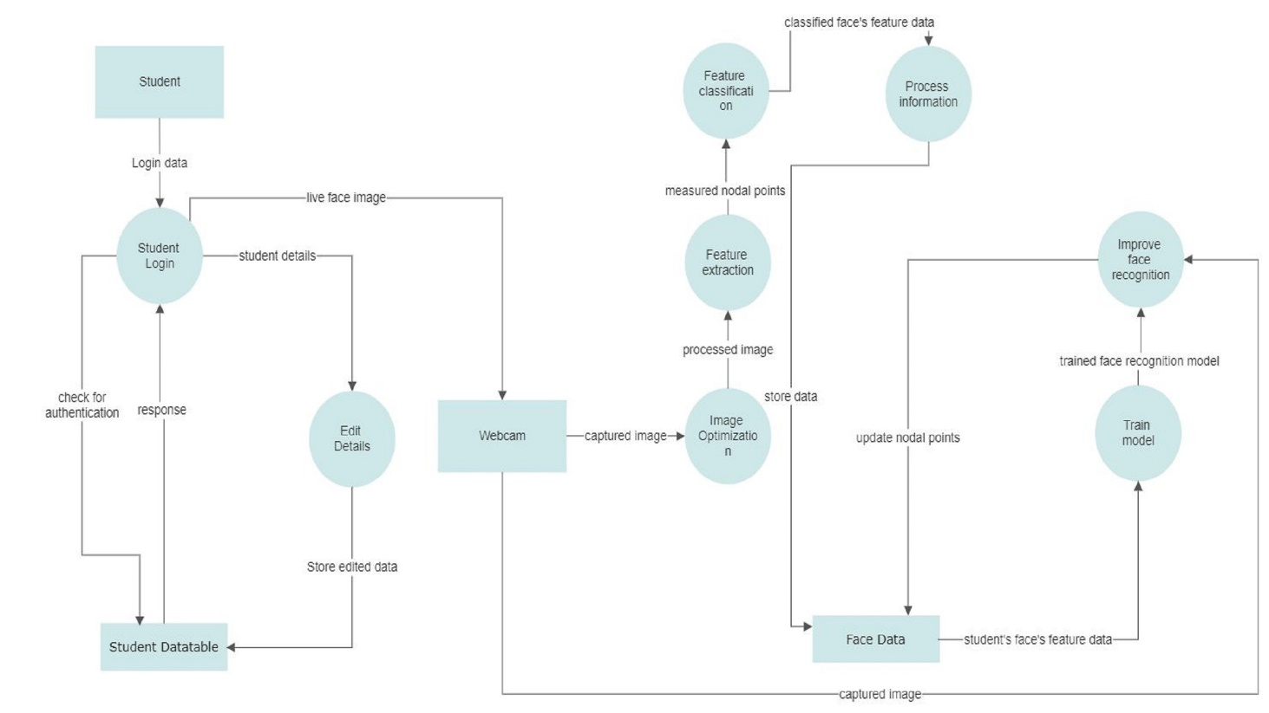

Level 2: (Faculty)

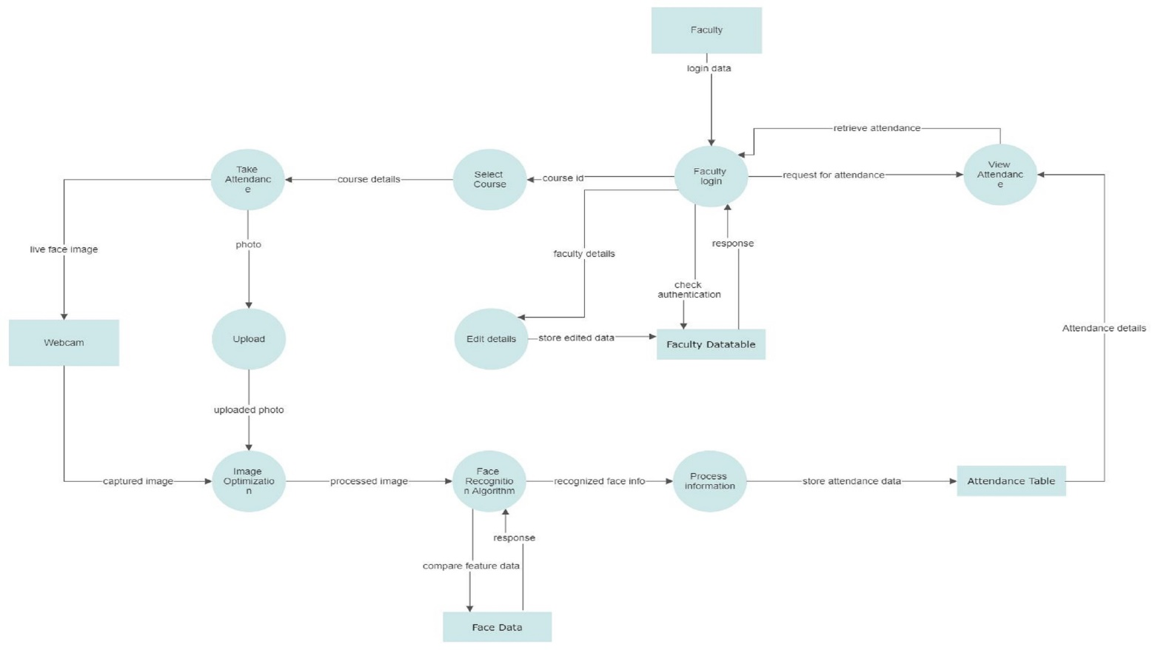

Level 2: (Admin)

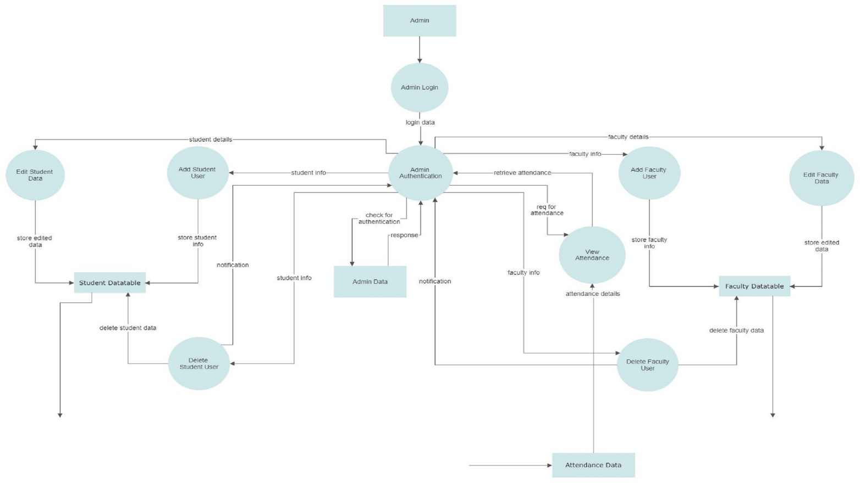

**2) ER Diagram**



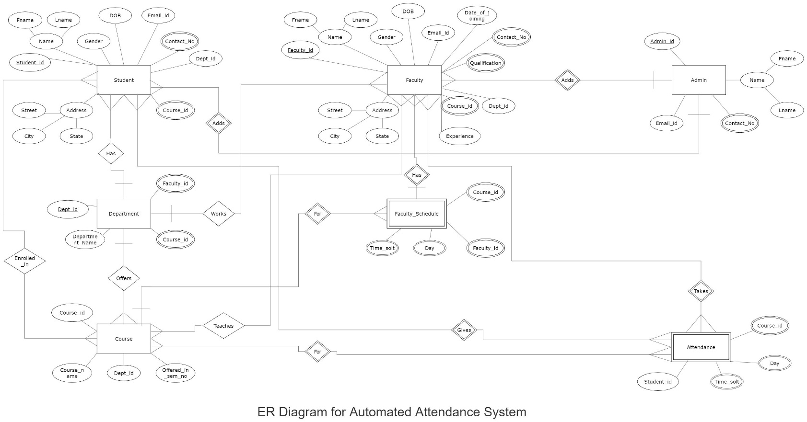

**Designing Canvas**

**1)AEIOU**

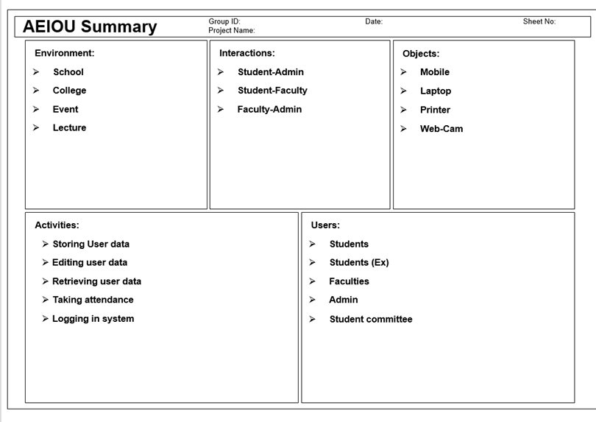

**2) Product Development Canvas**

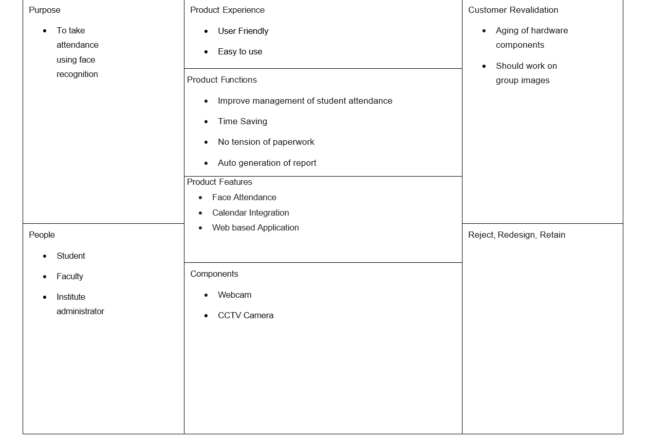

**Empathy Mapping**

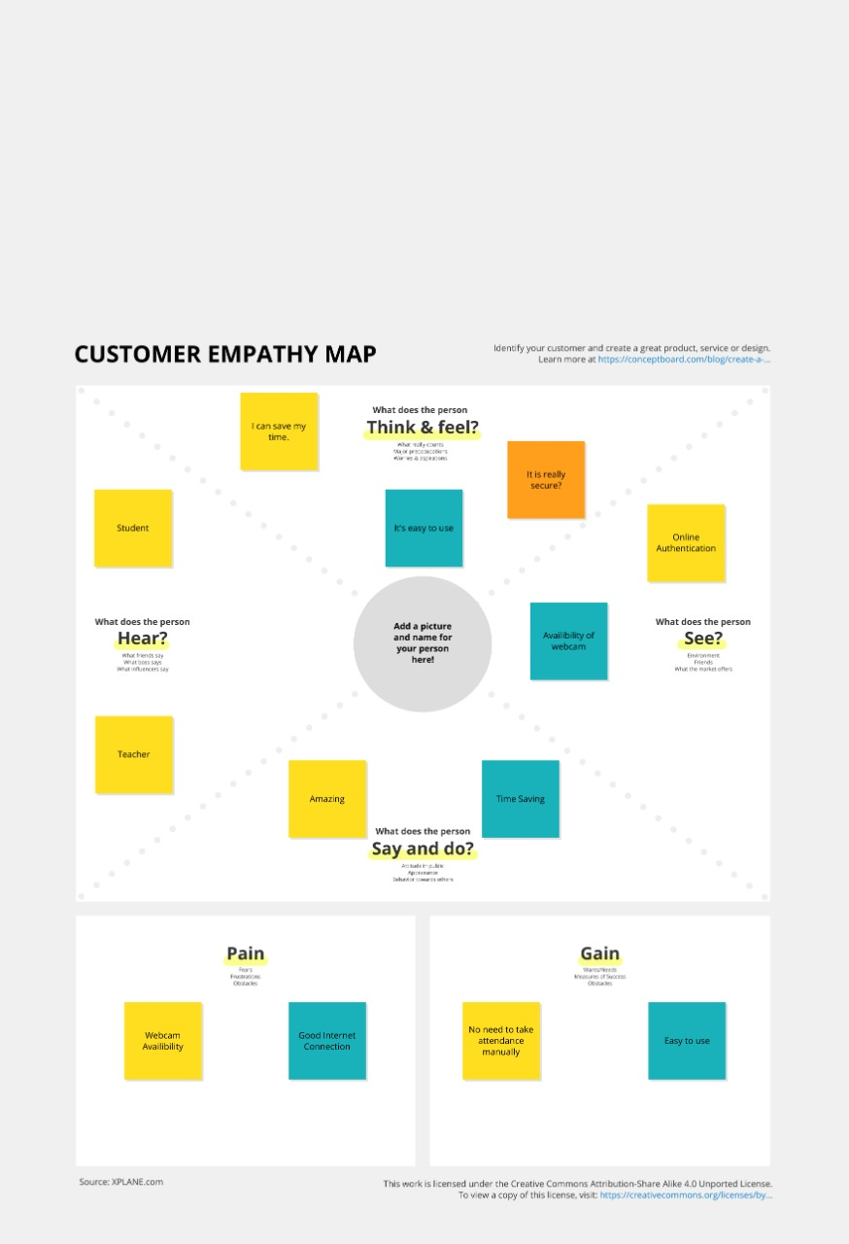

**Ideation Canvas**

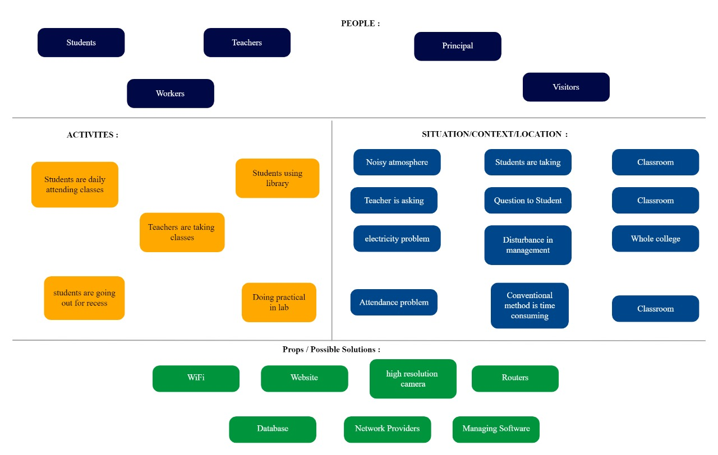

**Implementation/ Simulation and Analysis**

|  |  |
| --- | --- |
| **Technologies Used: -** | Flask(python), HTML, CSS, JavaScript, Bootstrap |
| **Tools: -** | IDE: Pycharm  Database: phpMyAdmin  Web Browser: Google Chrome  Web Server: Apache & flask in-built development server |

**Module Description: -**

The modules of our proposed Automated Attendance System are as follows: -

* Login

The user i.e., student/ faculty/ admin logins into the system using their user id, password and role i.e.; student, faculty or admin.

* Student info management

This module deals with manipulation of student’s data i.e., inserting, viewing, updating or deleting student’s information.

* Faculty info management

This module deals with manipulation of faculty’s data i.e., inserting, viewing, updating or deleting faculty’s information.

* Admin management

It deals with adding a user (student/ faculty) into the system or deleting a user from the system.

* Image capturing

The student’s face image is captured using the webcam in this module. The faculty uses a webcam to take the photo.

* Face detection

Here the faces from the image taken through the web-cam will be detected.

* Face comparison

This module compares the detected face’s data with the face’s data that is stored in the face’s data-table.

* Face recognition

This module recognizes the student from the image if the face’s data is matched.

* Taking attendance

The students whose faces are recognized are marked present and the attendance data is eventually stored by this module.

* View attendance

The faculty or admin will be able to view the attendance of the students for a particular course taken at a particular day and time through this module.

**Database Description: -**

The database of our proposed system is composed of following data-tables: -

* Student Datatable - includes student’s data
* Faculty Datatable - includes faculty’s data
* Admin Datatable - includes admin’s data
* Login Datatable - includes the login credentials i.e.; user name, password and role of the user (i.e., student/faculty/admin)

**User Characteristics: -**

1.Admin: -

The administrator can add as well delete the users i.e., student/faculty from the system. The admin also has the access to user’s (student/faculty) data. He/ She can also view the attendance of the students for a particular course that was taken by a particular faculty at a given day and time. He /She can also change the password. He /She can upload the photos of the students and thus, register their face data into the system.

2.Student: -

The student can modify as well as view their data in the system. They can also change their password.

3.Faculty: -

The faculty can modify as well as view their data in the system. The faculty can take the attendance by enter the course details i.e.; course id and then by clicking on take attendance option the faces will be detected from the web-cam and the face recognition technique will be automatically applied by the system and the recognized faces will be marked present. The faculty can also view the attendance for a particular course taken at a given date and time. He /She can change their password as well.

Here are some of the snapshots of our proposed Automated Attendance System:

Home Page: -

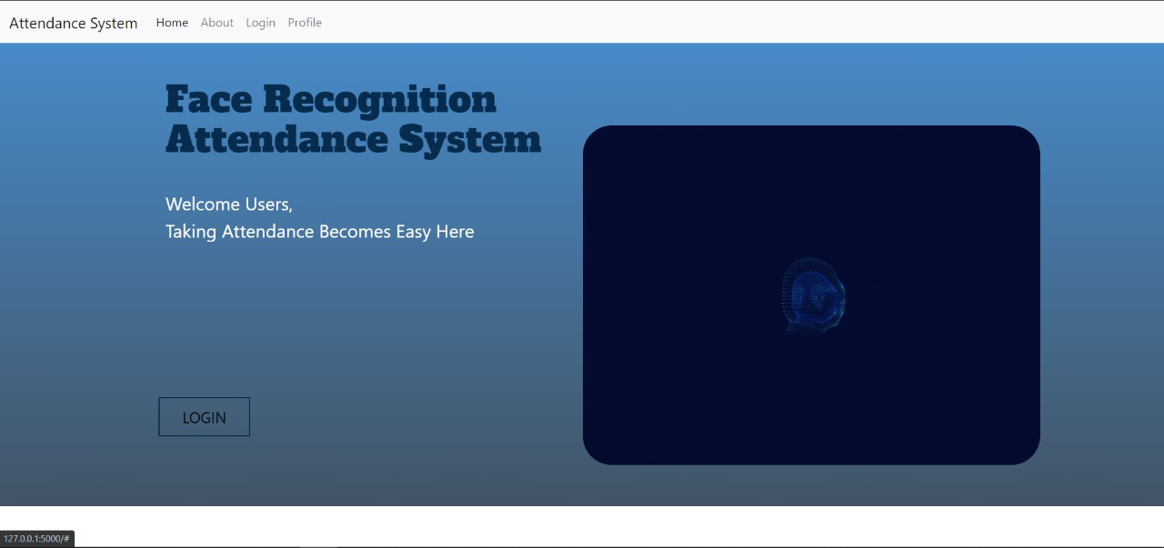

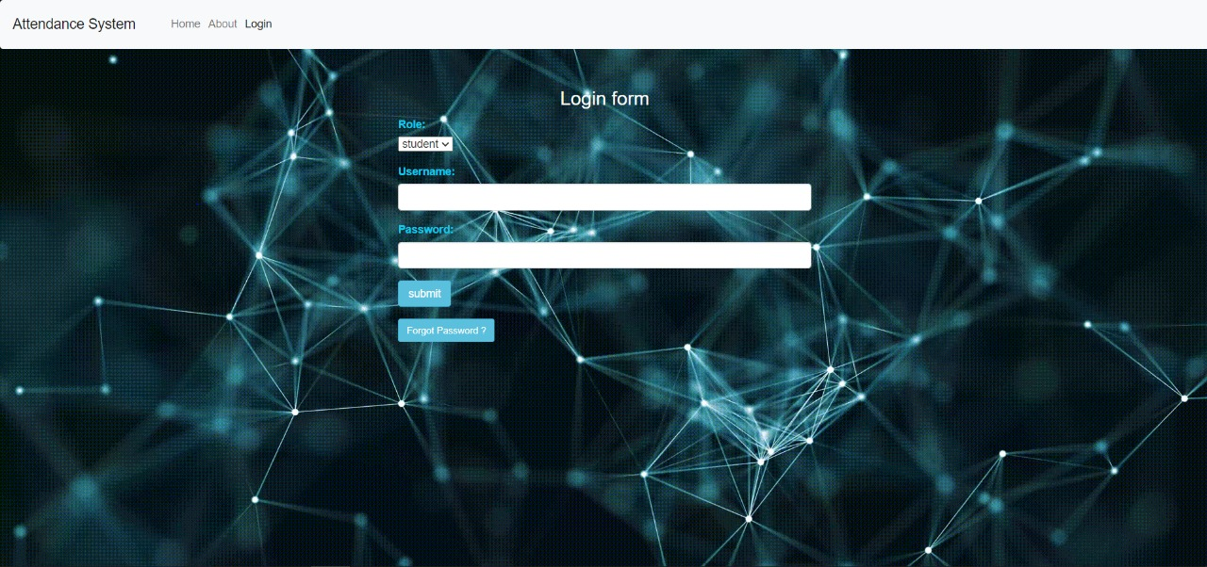Login Page: -

Admin: -

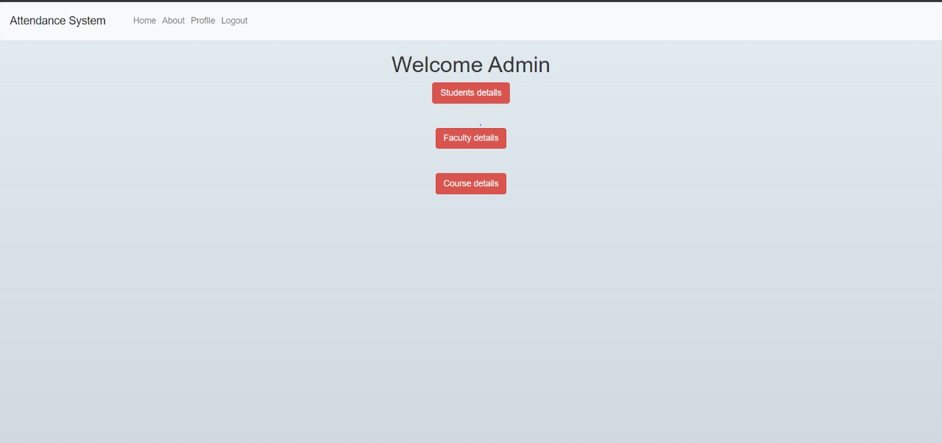

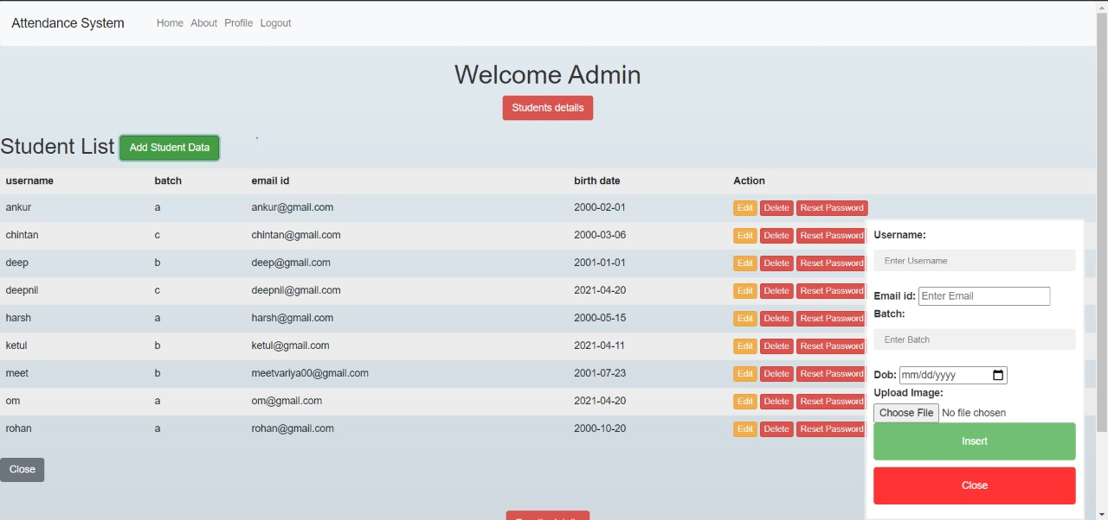

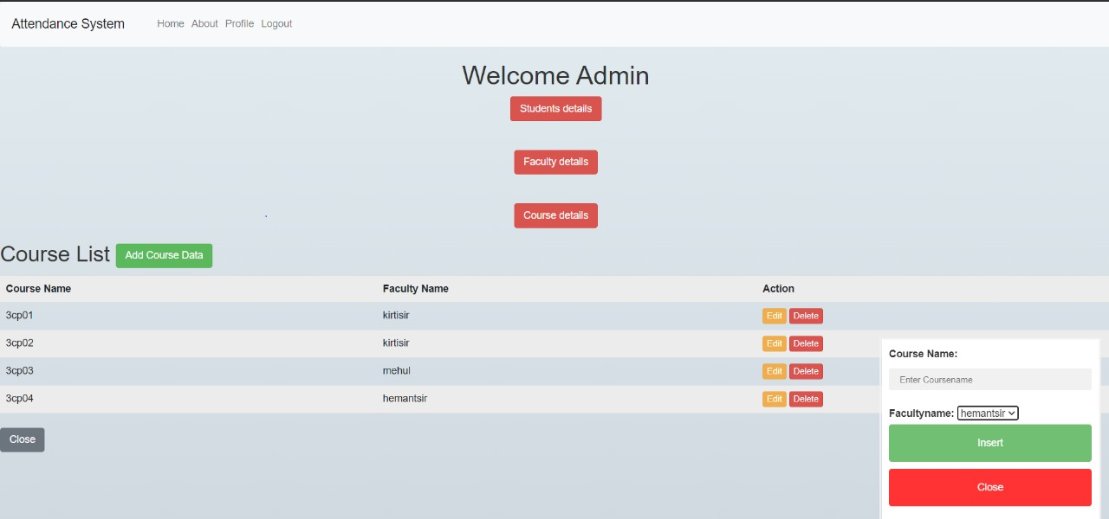

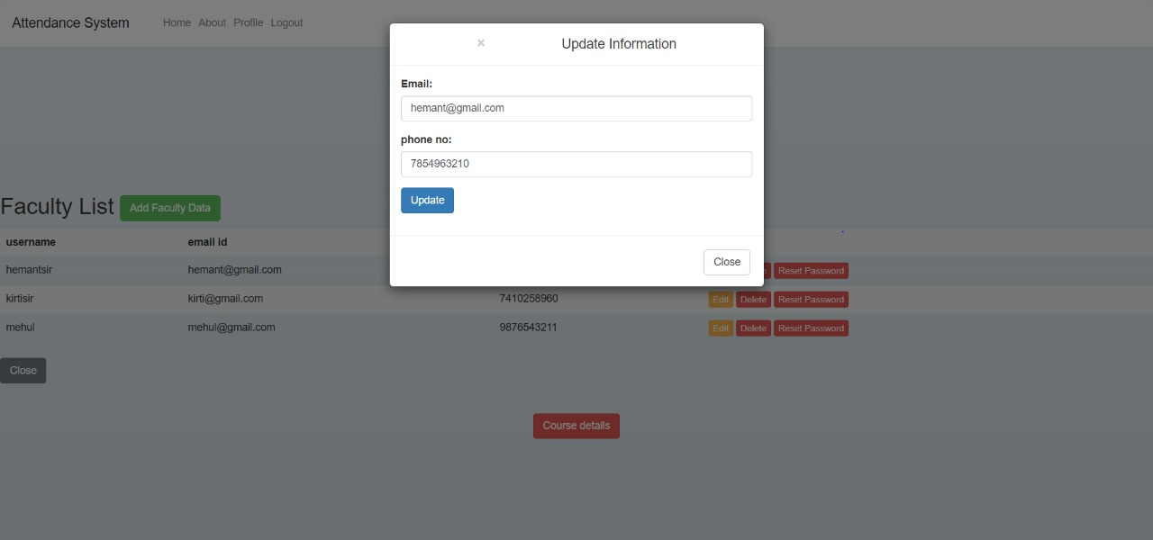

Student: -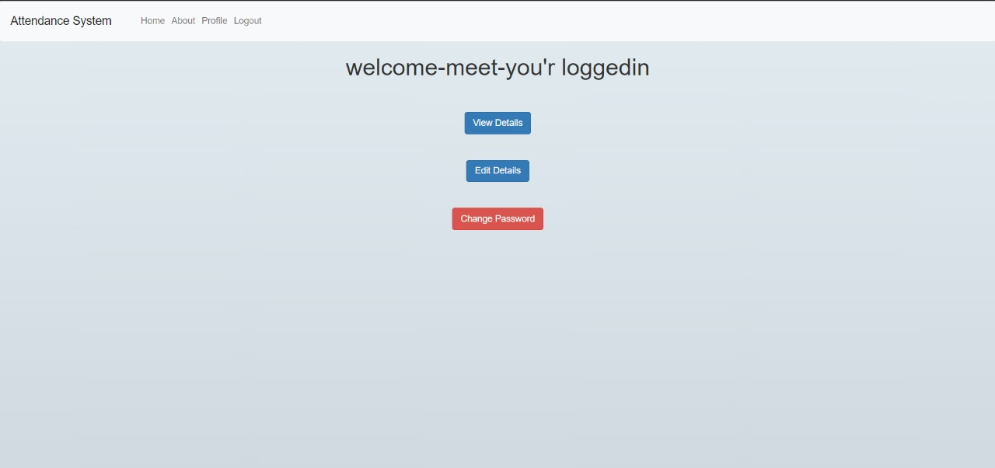

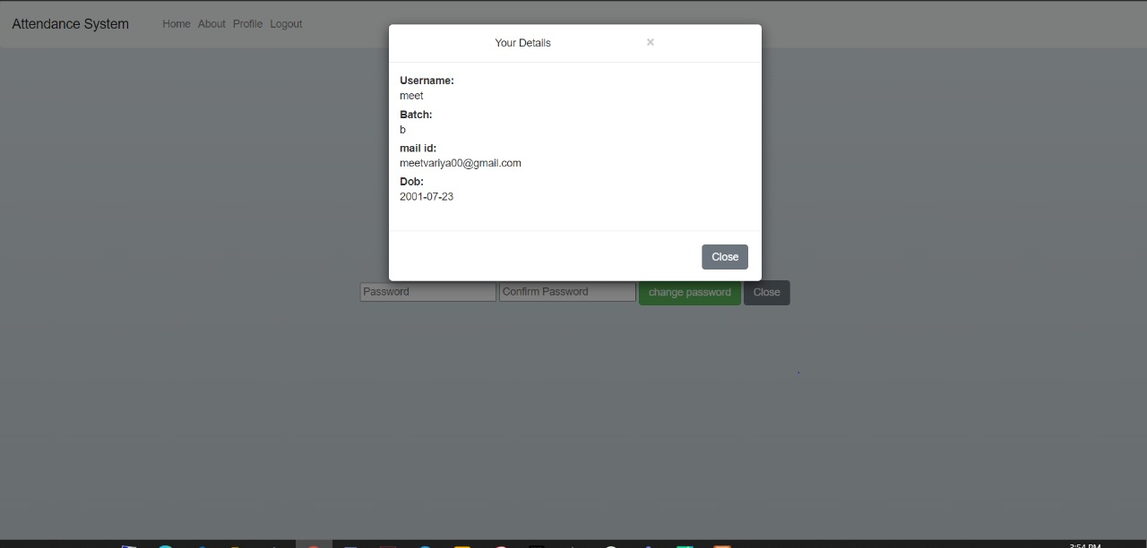

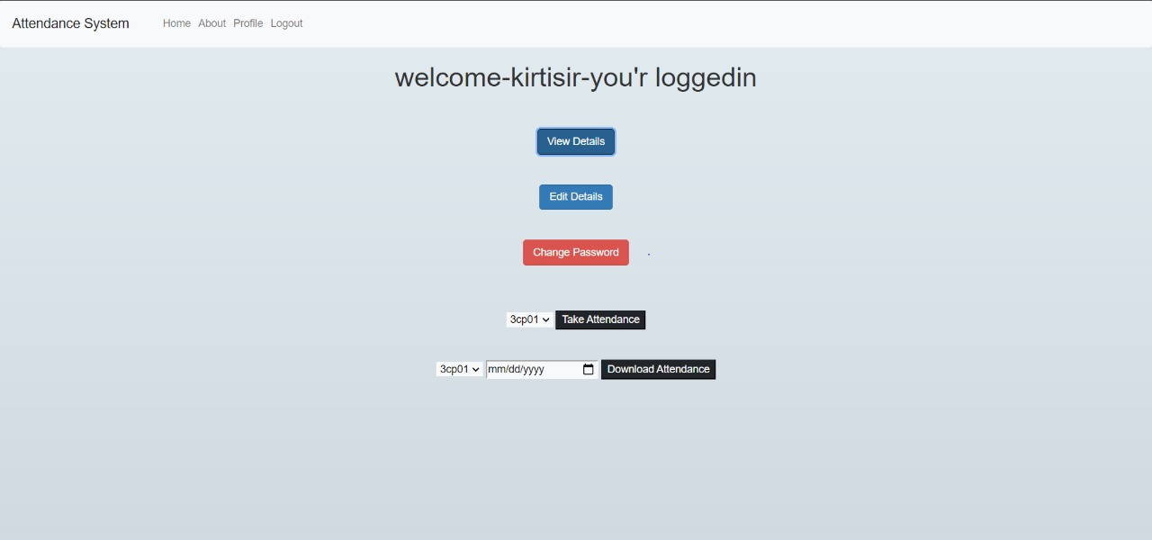Faculty: -

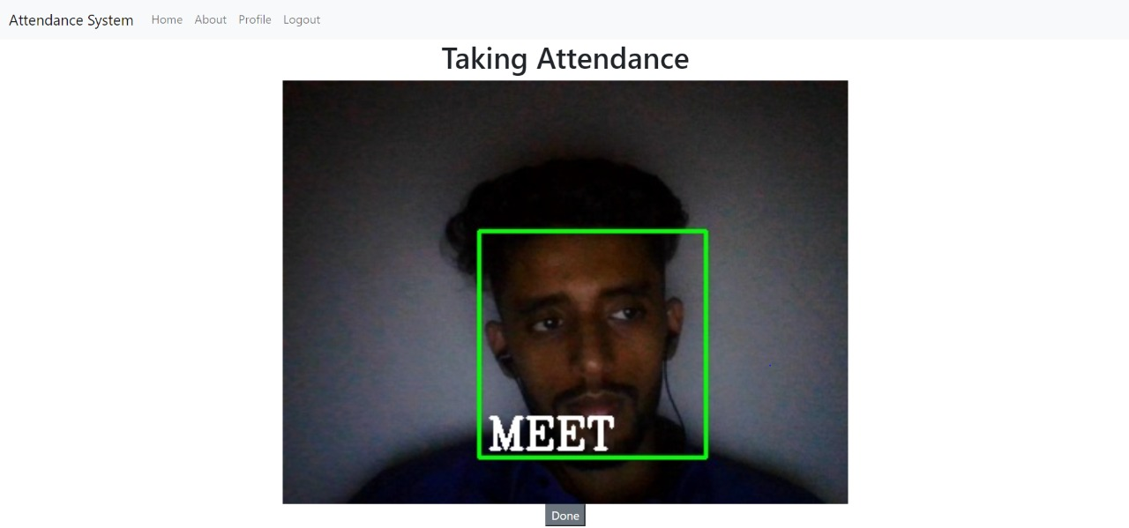

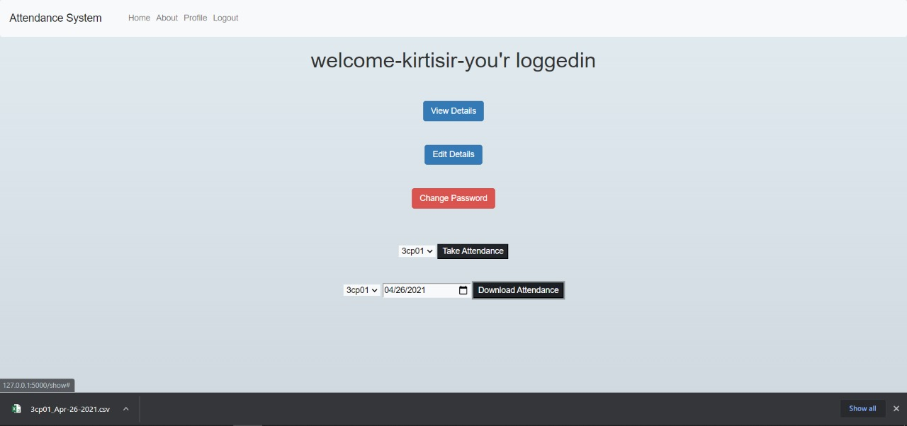

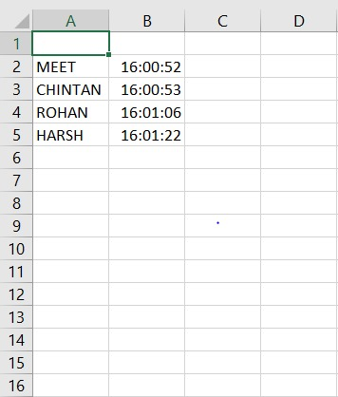

**Note: -**

If in case the user forgets the login password, he/ she must click on the forget password. Then the user just needs to enter their username and email-id in the popup dialog box and click on submit. The login password would be sent on his/ her email-id.

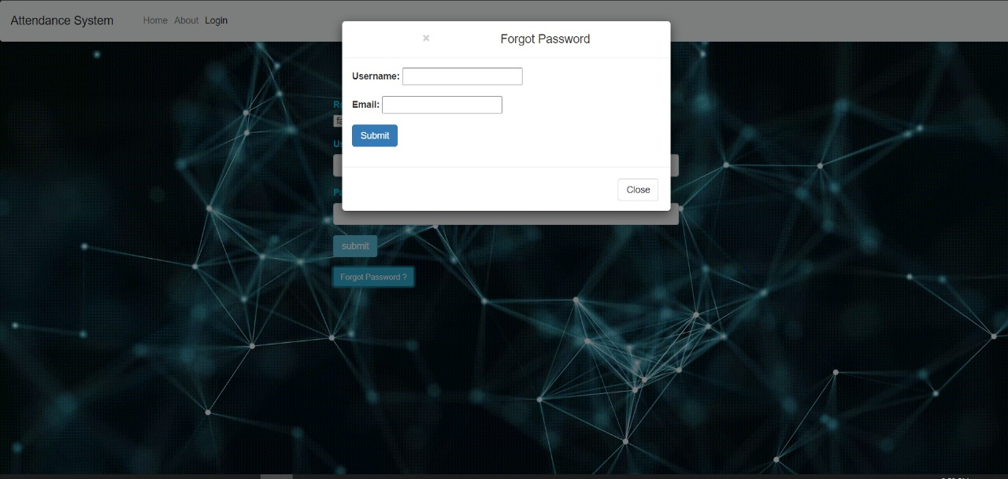

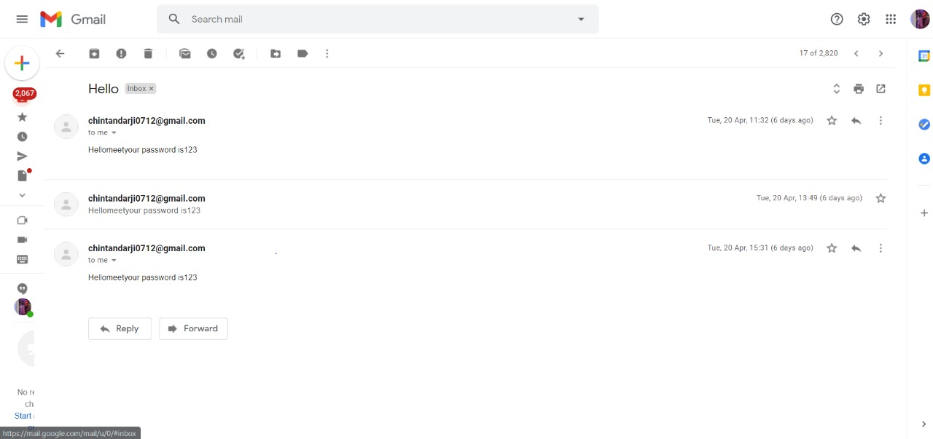

**Conclusion**

Automated Attendance System using face recognition thus proved to be time saving and secured. Using this system, the faculty can get the attendance of whole class throughout the semester within few seconds. In overall, the proposed system gives better result than the existing manual attendance system.

**Future Scopes**

The proposed system can be used in schools and colleges, organizations as well as security-based places. We can enhance security by sending OTP – one time password to both email and mobile for login purpose. We can enhance this project and develop an android app, which will be extremely helpful for students.

**References**

* [F3965048619.pdf (ijitee.org)](https://www.ijitee.org/wp-content/uploads/papers/v8i6/F3965048619.pdf)
* [Automated Class Attendance System based on Face Recognition using PCA Algorithm (semanticscholar.org)](https://pdfs.semanticscholar.org/5263/73d5865210fec4d2c9d4d35d62e5b4e55e81.pdf)
* [IRJET-V4I1286.pdf](https://www.irjet.net/archives/V4/i1/IRJET-V4I1286.pdf)
* [Face Recognition based Attendance System using Machine Learning (ijedr.org)](https://www.ijedr.org/papers/IJEDR1903093.pdf)
* [531.pdf (acadpubl.eu)](https://acadpubl.eu/hub/2018-120-5/5/531.pdf)