Software Requirements Specification
for
Trip Planner
Version 1.0 approved

Prepared by

Yash Dholariya | 18CP019 | yashdholariya90@gmail.com
Jemish Mangukiya | 18CP044 | jemishgm103@gmail.com
Deep Patel | 18CP204 | deeppatel76506@gmail.com
Organization: Birla Vishvakarma Mahavidyalaya
Instructor: Dr Udesang K Jaliya
Khushbu Panchal
Course: Project (4CP31)
Date:
Table of Contents
Table of Contents ii
Revision History ii
1. Introduction 1
1.1 Purpose 1
1.2 Document Conventions 1
1.3 Intended Audience and Reading Suggestions 1
1.4 Product Scope 1
1.5 References 1
2. Overall Description 2
2.1 Product Perspective 2
2.2 Product Functions 2
2.3 User Classes and Characteristics 2
2.4 Operating Environment 2
2.5 Design and Implementation Constraints 2
2.6 User Documentation 2
2.7 Assumptions and Dependencies 3
3. External Interface Requirements 3
3.1 User Interfaces 3
3.2 Hardware Interfaces 3
3.3 Software Interfaces 3
3.4 Communications Interfaces 3
4. System Features 4
4.1 System Feature 1 4
4.2 System Feature 2 (and so on) 4
5. Other Nonfunctional Requirements 4
5.1 Performance Requirements 4
5.2 Safety Requirements 5
5.3 Security Requirements 5
5.4 Software Quality Attributes 5
5.5 Business Rules 5
6. Other Requirements 5
Appendix A: Glossary 5
Appendix B: Analysis Models 5
Appendix C: To Be Determined List 6

Revision History
Name | Date | Reason For Changes | Version
Deep Patel | 23/09/21 | Updated information - System features and business rules | 1.0

Introduction

Purpose
The purpose of this document is to present a detail description of the Trip Planner. It'll explain the purpose and features of the software, the interfaces of the software, what the software will do, the constraints under which it must operate and how the software will react to external stimuli. This document is intended for both the end users and the developers of the software.

Document Conventions
This document will use IEEE format. For clarity, acronyms and technical jargon, deemed uncommon by the author, will be annotated and included in the glossary. The format for headings is as followed: Major headings are in bold 18pt font, and concurrent headings in bold 14pt font. Sections are in the format of x. y, where x and y are real, positive integers.

Intended Audience and Reading Suggestions
This document is intended for: -

Users: - who will use this web application through sign-up and login process.

Developers: - who can improve web application’s capabilities. They can add more features to it for future development.

Project Tester: - who can use this document as a base for their testing strategy as some bugs are easier to find using a requirements document. This way testing becomes more methodically organized.
It is suggested to read the sections sequentially, and refer to the appendices as one progresses, in order to clarify jargon terms and definitions.

Product Scope
The Trip Planner web application will provide up-to-date travel safety and travel cost information, travel recommendations for attractions, hotels and restaurants as well as the translator feature to help users communicate in different languages when travelling to different destinations.

References
- Software engineering A practitioner’s Approach – Roger S Pressman

Overall Description

Product Perspective
The Trip Planner is an independent web-based application and does not depend on any other product or system. The features expressed in this software requirements specification documentation are intended to be fully implemented in version 1.0. The system will be developed in such a way that it will enable easy addition of enhanced features.

Product Functions
The product functions of Trip Planner are as follows: -
- Travel Safety
- Travel Cost
- Translator
- Travel Recommendations
In addition to that, the Trip Planner will provide flexibility and ease of use.

User Classes and Characteristics
2.3.1: Traveler: Anyone who goes through the sign-up and login process and uses the web application for their personal use. Mostly the web application will be used by this class of users. This class of users can use travel safety, travel cost, travel recommendations and translator feature.
2.3.2: Admin: Web application administrator who manages all the users in the system. In addition to that, the admin can also approve or disapprove user details.

Operating Environment
This is a prototype which works in any supported browser. A simple web browser can do the work.

Design and Implementation Constraints
- The time allotted for this project will be limited to the end of this semester.
- Programming is done in Python, HTML, CSS, JavaScript and SQL.
- It is crucial that there is an internet connection for the web application to function since it fetches from the database over the internet.

User Documentation
- The System will provide a hard copy of the user manual.

Assumptions and Dependencies
- The web application will use information collected from the internet.
- User with administrator access should be careful in deleting the users from the system.
- The end users of this web application are assumed to have basic level of computer knowledge.

External Interface Requirements

User Interfaces
GUI along with meaningful frames and buttons.
The system shall be accessible through a web browser.

Hardware Interfaces
Hardware Environment: Intel core i3 - 8th gen and above
System Configuration: RAM 1 GB, HDD-10GB
Operating system: Windows 10/Linux.

Software Interfaces
Front end: HTML/CSS/JavaScript/Bootstrap
Back end: Flask/MySQL

When invalid inputs are given to the modules then the error messages will be popped up to inform the user to enter correct input. When incomplete information is provided by the user and the user tries to submit the form to store the details in the database the system will pop up a message box asking the user to enter all the details required.

Communications Interfaces
APIs will be accessed by a web page using HTTPS.
The web application will provide users with the option of forgot password. The user will just need to enter their email-id and the password corresponding to it will be sent on this given email-id.

System Features

Travel Safety
4.1.1 Description and Priority
This feature will let the users know whether it’s safe to travel to a particular country based on the Covid-19 situation. This feature is of high priority.
4.1.2 Stimulus/Response Sequences
After signing up and logging into the system, the user must switch to the travel safety feature and enter the country name. Based on the Covid-19 situation, the system will tell the user whether it’s safe to travel to that country. In addition to that, the system will also provide brief Covid statistics of that country so that the user can have a better idea.
4.1.3 Functional Requirements
The system will verify whether the input given by the user is correct. If it isn’t, then the error message will be popped up asking user to enter the correct country name.

Travel Cost
4.2.1 Description and Priority
This feature will let the users determine detailed travel cost for travelling to a particular country. This feature is of high priority.
4.2.2 Stimulus/Response Sequences
After signing up and logging into the system, the user must switch to the travel cost feature and enter the country name. The system will provide detailed travel cost to the user for travelling to that country like average daily cost per person, accommodation cost, food cost, local transportation cost and many more. The user can view the output in different currencies like US Dollar, Euro, Pound, Australian Dollar. In addition to that the user can also check the travel cost for different travel style like Budget (Cheap), Mid-range and Luxury (High-end).
4.2.3 Functional Requirements
The system will verify whether the input given by the user is correct. If it isn’t, then the error message will be popped up asking user to enter the correct country name.

Translator
4.3.1 Description and Priority
This feature will let the users communicate in different languages when travelling to different destinations. This feature is of high priority.
4.3.2 Stimulus/Response Sequences
After signing up and logging into the system, the user must switch to the translator feature. In the Text to Speech, user must give input text and the language name. The system will generate an audio which speaks the given input text translated into the given language. Whereas, in Speech to Text, the user must first select a language then start speech recognition. The audio input given by the user will be transcribed and on clicking the submit button, the transcribed audio in the specified language is translated to English.
4.3.3 Functional Requirements
The system will verify whether the input given by the user is correct. If it isn’t, then the error message will be popped up asking user to enter the correct language name.

Travel Recommendations
4.4.1 Description and Priority
This feature will provide users recommendations for attractions, hotels and restaurants based on user’s given preferences. This feature is of high priority.
4.4.2 Stimulus/Response Sequences
After signing up and logging into the system, the user must switch to the recommendations feature. The user must give some travel details like destination, budget and select their preferences. The system will provide recommendations for attractions, hotels and restaurants to the user based on these preferences.
4.4.3 Functional Requirements
The system will verify whether the input given by the user is correct. If it isn’t, then the error message will be popped up asking user to enter the correct destination name.

Other Nonfunctional Requirements

Performance Requirements
- The application should be able to respond to the queries submitted by the user without delay. When a user searches for a tour location, the application should not take much time to return result.
- In every case the response time will less than 1 except for the case where internet connection is being used or the translator feature.

Safety Requirements
System would be protected by a password. One user cannot access other user’s information unless the other user is an admin.

Security Requirements
Security requirements deal with the primary security. The software should be handled only by the administrator and authorized users. Only authorized users can access the system with email-id and password.

Software Quality Attributes
- Availability
The system is available only to registered/authorized users.
- Correctness
The system will provide travel recommendations based on the user’s given preferences.
- Portability
It’s a web-based application built using python flask framework and thus, it’s machine and platform independent. It can be accessed in both mobile and computer platform.
- Reliability
The system will provide up-to-date travel safety information based on the covid-19 situation. In addition to that the system will also provide detailed travel cost information.
- Reusability
The system shall be able to be reused whenever the user wants to plan a trip to any destination. In addition to that the system will also be handy to communicate in different languages throughout their trip using the translator feature.

Business Rules
The system must have 2 user roles defined for accessing and interacting with the system.

Other Requirements
Appendix A: Glossary
DFD: Data Flow Diagram

ERD: Entity Relationship Diagram

SRS: Software Requirement Specification

SQL: Structured Query Language

DB: Databases

RAM: Random Access Memory

OS: Operating System

HTTP: Hyper Text Transfer Protocol
Appendix B: Analysis Models
Data Flow Diagram
Level 0:
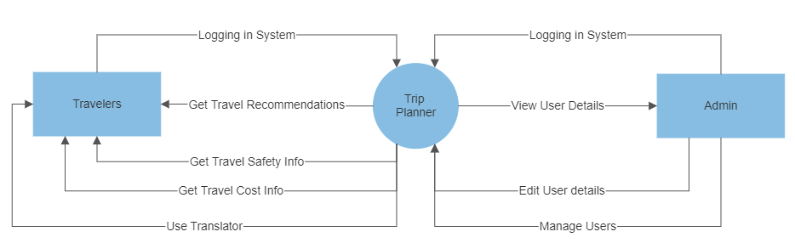

Level 1:
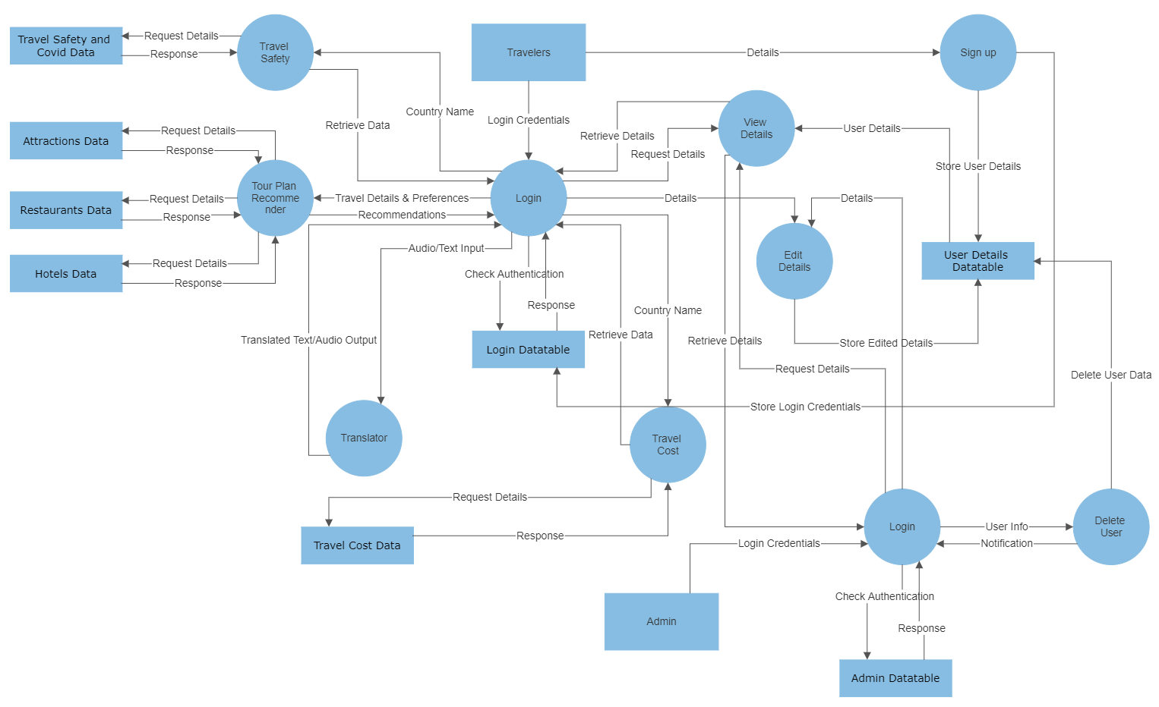

Level 2(Travel Recommendation):
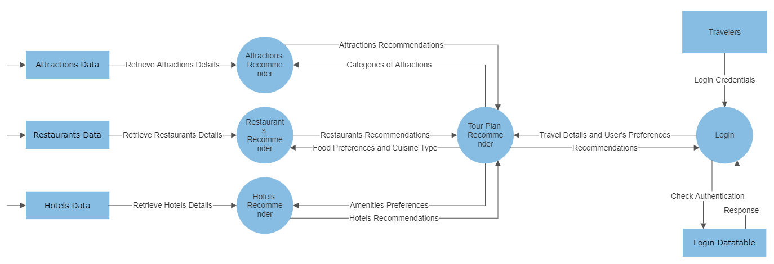

Level 2(Favourites):
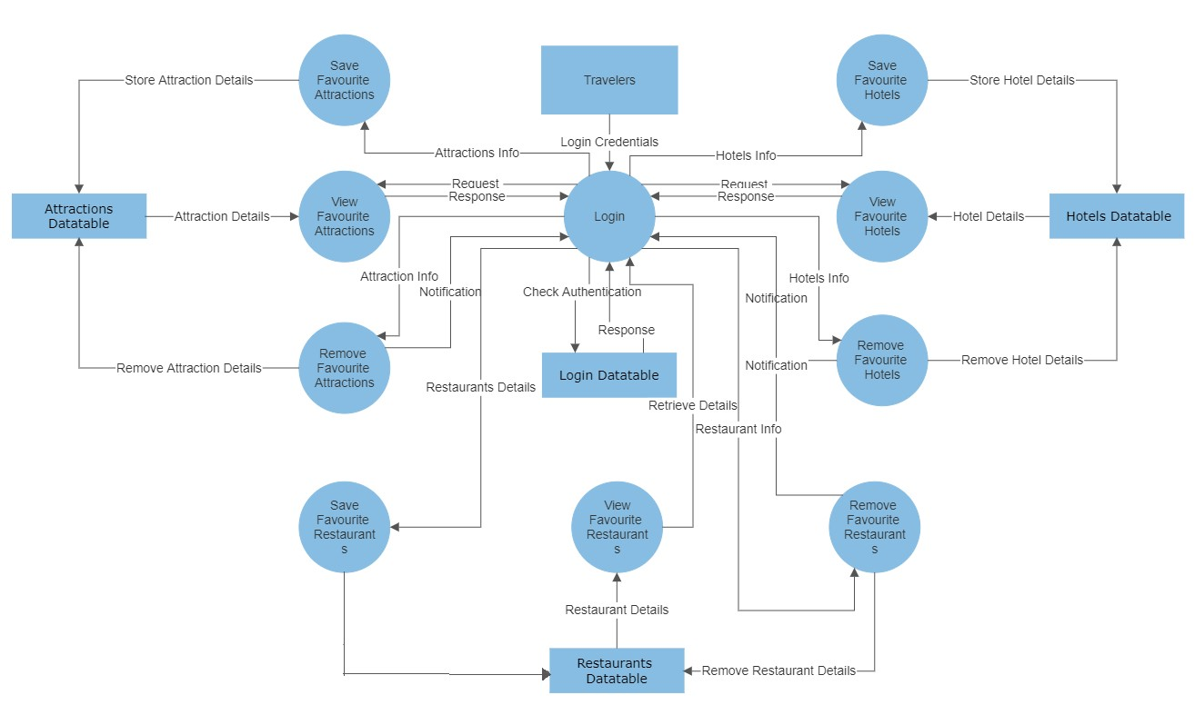

Appendix C: To Be Determined List
<Collect a numbered list of the TBD (to be determined) references that remain in the SRS so they can be tracked to closure.>

