**Assignment**

**Module – 1 (Fundamental)**

1. **What is SDLC?**

The software development life cycle is cost-effective and time -efficient process that development team use to design and build high-quality software.

1. **What is software testing?**

Software testing is a process used to identify the correctness, completeness and quality of developed computer software.

1. **What is agile methodology?**

The Agile methodology is a way to manage a project by breaking it up into several phases. It involves constant collaboration with stakeholders and continuous improvement at every stage. Once the work begins, teams cycle through a process of planning, executing, and evaluating.

1. **What is SRS?**

A software requirements specification (SRS) is a complete description of the behaviour of the system to be developed.

1. **What is oops?**

Object oriented programming is way of writing the programs in organized way object are like a black box where data are hidden**.**

1. **Write Basic Concepts of oops**.
   * + 1. Class
       2. Object
       3. Inheritance
       4. Polymorphism
       5. Encapsulation
       6. Abstraction
2. **What is object?**

Object gives the permission to access functionality of class.

1. **What is class?**

Class is a collection of data member and member function.

1. **What is encapsulation?**

The process wrapping the data in a single unit. To secure the data from outside world.

1. **What is inheritance?**

Making a class from an existing class. Deriving the attributes of some other class.

1. **What is polymorphism?**

One name multiple form.

1. **Draw Use case on Online book shopping.**

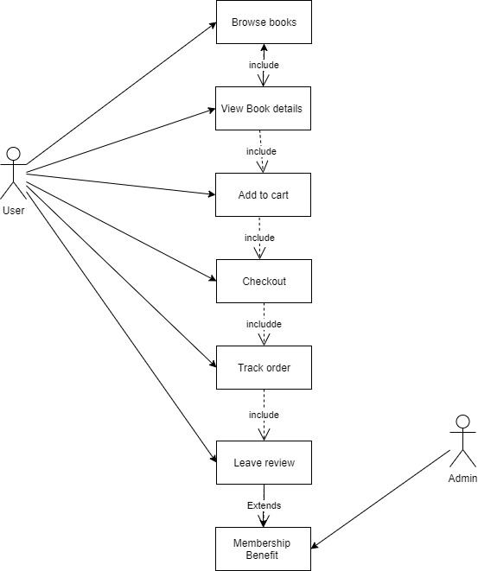

1. **Draw Use case on online bill payment system (Paytm).**

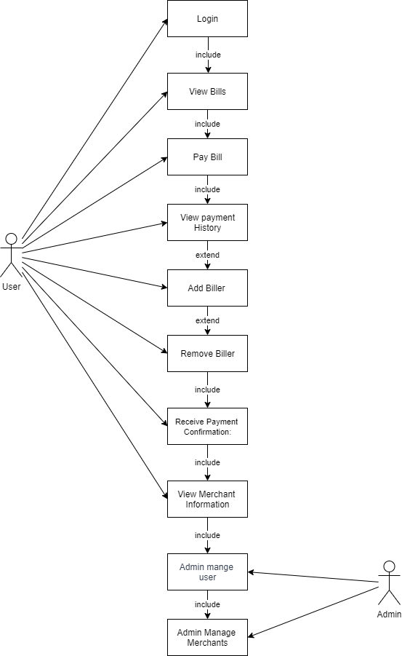

1. **Write SDLC phases with basic introduction.**

* Requirements collection/gathering: Establish customer needs.
* Analysis: Model & specify the requirements - “what”
* Design: Model & specify a solution - “why”
* Implementation: Construct a solution in software
* Testing: Validate solution against requirements
* Maintenance: Repairing defect and adapt the solution to the new requirements.

1. Corrective maintenance: Identifying and repairing defects
2. Adaptive maintenance: Adapting the existing solution to the new platforms.
3. Perfective maintenance: Implementing the new requirements.
4. **Explain Phases of the waterfall model.**

* Requirements collection/gathering: Establish customer needs.
* Analysis: Model & specify the requirements - “what”
* Design: Model & specify a solution - “why”
* Implementation: Construct a solution in software
* Testing: Validate solution against requirements
* Maintenance: Repairing defect and adapt the solution to the new requirements.

1. **Write phases of spiral model.**

* Planning – Determination of objectives, alternatives and constraints
* Risk analysis – analysis of alternatives and identification/ resolution of risks.
* Engineering – Development of the “next level” product.
* Customer Evaluation – Assessment of the results of engineering.

1. **Write agile manifesto principles.**
2. Customer satisfaction through early and continuous software delivery
3. Accommodate changing requirements throughout the development process
4. Frequent delivery of working software
5. Collaboration between the business stakeholders and developers throughout the project
6. Support, trust, and motivate the people involved
7. Enable face-to-face interactions
8. Working software is the primary measure of progress
9. Agile processes to support a consistent development pace
10. Attention to technical detail and design enhances agility
11. Simplicity
12. Self-organizing teams encourage great architectures, requirements, and designs
13. Regular reflections on how to become more effective
14. **Explain working methodology of agile model and also write pros and cons**.

The Agile methodology is a way to manage a project by breaking it up into several phases. It involves constant collaboration with stakeholders and continuous improvement at every stage. Once the work begins, teams cycle through a process of planning, executing, and evaluating.

* Agile Methods break the product into small incremental builds
* These builds are provided in iterations.
* Each iteration typically lasts from about one to three weeks.
* Every iteration involves cross functional teams working simultaneously on various areas like planning, requirements analysis, design, coding, unit testing, and acceptance testing.
* **Pros**
* Is a very realistic approach to software development.
* Promotes teamwork and cross training.
* Functionality can be developed rapidly and demonstrated.
* Resource requirements are minimum.
* Suitable for fixed or changing requirements.
* Little or no planning required.
* Easy to manage.
* Gives flexibility to developers.
* **Cons**
* There is very high individual dependency, since there is minimum documentation generated.
* Transfer of technology to new team members may be quite challenging due to lack of documentation.

1. **Draw use case on Online shopping product using COD.**

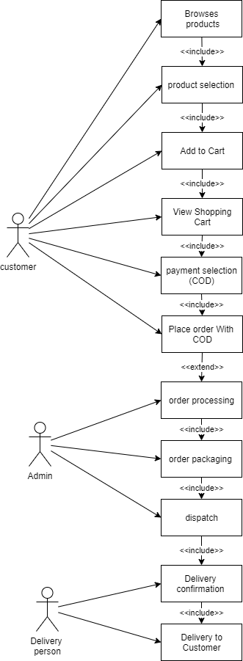

1. **Draw use case on Online shopping product using payment gateway.**

