Experiment No : 11

Aim : Logical Operations

Theory :

Procedure :
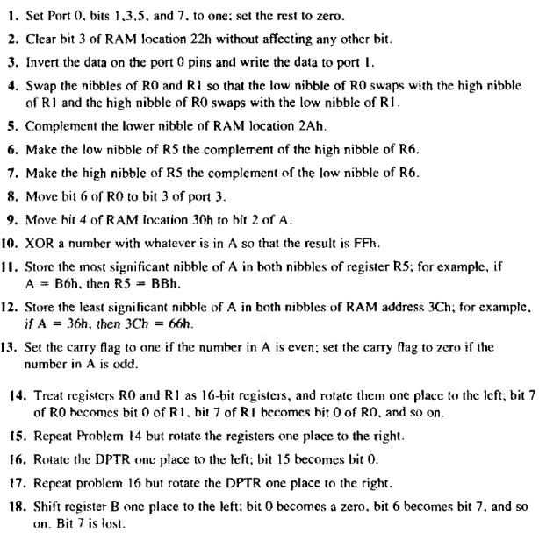
19) Consider two numbers 35H and FFH. Perform the following logical operations on them:
a) AND
b) OR
c) XOR
d) Complement the two numbers
e) Compare the two numbers to check equality
20) Write a code to determine if register A contains the value 99H. If so, make R1=FFH;
otherwise, make R1=0

21) Assume that P1 is an input port connected to a temperature sensor. Write a program to read
the temperature and test it for the value 75. According to the test results, place the temperature
value into the registers indicated by the following.
If T = 75 Then A = 75
If T<75 Then R1 = T
If T>75 Then R2 = T
22) Write a program to continuously monitor P1 for the value 31H. It should get out of the
monitoring only if P1=63H
23) Assume internal RAM locations 40 H- 44H contain the daily temperature for five days as
shown below. Search to see if any of the values equals 65. If value 65 does exist in the table give
its location to R4; otherwise make R4=0.
40H=67
41H= 79
42H= 69
43H = 65 44H =62

Programs :
 | label | Mneumonic | Operation
1) |  | MOV A,#0AAH MOV P0,A | Set A=10101010B  Transfer to P0
2) |  | CLR 13H | Clear bit 3 of RAM location 22h
3) |  | MOV A,P0 CPL A MOV P1,A | Transfer P0 to A Complement A Transfer A to P1
4) |  | MOV A,R0 SWAP A MOV R2,A MOV A,R1 SWAP A MOV R0,A MOV A, R2 MOV R1,A | Get data at A=81h Exchange nibbles ( A=18h) Store at R0  Get data at A=2Ah Exchange nibbles (A=A2h) Exchange between 2 register  Transfer R2 contents into acc Store at R1
5) |  | MOV A,#0Fh XRL 2Ah,A | Get higher nibble Complement higher nibble
6) |  | MOV A,R6 XRL A,#0F0H SWAP A  MOV R1,#05H XCHD A,@R1 | Get data at A=25h Complement higher nibble Exchange nibble  Use R1 as pointer Exchange nibbles
7) |  | MOV A,R5 SWAP A  MOV R0,#06H XCHD A,@R0 XRL A,#0FH SWAP A  MOV R5,A | Get data at A=25h Swap bits  Use R0 as pointer Exchange nibbles Complement lower bit Swap bit  Transfer acc contents into R5
8) |  | MOV 20H,R0 MOV C,06H MOV P3.3,C | Get data at bit address Copy carry flag  Move to 3rd bit
9) |  | MOV 20H,30H MOV C,04H MOV ACC.2,C | Get data at bit address Copy carry flag  Move to 3rd bit
10) |  | MOV R0,A XRL A,#3FH XRL A,R0 | Get data at R0  (A XOR 3FH) Forming N (A XOR N) Result 3Fh
11) |  | ANL A,#0F0H MOV R5,A SWAP A ORL A,R5 MOV R5,A | Mask lower bit  Transfer acc contents into R5 Exchange nibbles  OR operation  Load contents into R5
12) |  | ANL A, #0FH MOV 3CH, #00H ORL A, 3CH | Mask lower bit Send it to 3CH OR operation
 |  | MOV 3CH,A SWAP A ORL A,3CH MOV 3CH,A | Transfer Acc contents to 3CH Xchange upper&lowernibbles OR operation  Finally load content in 3CH
13) |  | MOV R0,A RRC A MOV A,R0 | Get data at R0 Rotate the bits in acc Transfer R0 to acc
14) |  | MOV A, R0 RLC A MOV R0, A MOV A, R1 RLC A MOV R1, A MOV A, R0  MOV 0E0H, C; MOV R0, A | Move R0 contents into acc Rotate acc 1 bit  Transfer acc contents to R0 Move R1 contents into acc Rotate acc 1 bit  Transfer acc contents to R1 Final adjustments  Transfer carry to acc Transfer acc contents into R0
15) |  | MOV A, R0 MOV C, ACC.0 MOV A, R1 RRC A  MOV R1, A MOV A, R0 RRC A MOV R0, A | Move R0 contents into acc Set carry flag  Move R1 contents into acc Rotate acc 1 bit  Move acc contents into R1 Final adjustments  Rotate R1 1 bit  Transfer acc contents to R0
16) | HERE | CLR C MOV A,DPL RLC A  MOV A,DPH RLC A  MOV DPH,A MOV A,DPL RLC A  MOV DPL,A HERE:SJMP HERE | Set carry flag to 0  Load low bytes into acc Rotate bits in A  Load high bytes into acc Rotate bits in A  Transfer acc data to DPH Load low bytes to acc Rotate bits in A  Transfer acc data to DPL
17) | HERE | CLR C MOV A,DPL RRC A  MOV A,DPH RRC A  MOV DPH,A MOV A,DPL RRC A  MOV DPL,A HERE:SJMP HERE | Set carry flag to 0  Load low bytes into acc Rotate bits in A  Load high bytes into acc Rotate bits in A  Transfer acc data to DPH Load low bytes to acc Rotate bits in A  Transfer acc data to DPL
18) |  | MOV A,B RL A  CLR ACC.0 MOV B,A | Clear carry flag Tranfer bits of B to A Set bit 0 to 0  Tranfer bits back to B
19) |  | MOV A,#35H MOV R0,#0FFH ANL A,R0 MOV 20H,A  MOV A,#35H ORL A,R0 MOV 21H,A  MOV A,#35H XRL A,R0 MOV 22H,A  MOV A,#35H CPL A  MOV 23H,A MOV A,#0FFH CPL A  MOV 24H,A  MOV A,#35H  CJNE A,#0FFH,25H | Set A=35H  Set R0 = 0FFH  And Operation Store at 20H  Set A=35  OR Operation Store at 21H  Set A=35  XOR Operation Store at 22H  Set A=35  Complement A Store at 23H Set A = 0FFH  Complement A Store at 24H  Set A=35  Compare equality
20) | NEXT | MOV R1,#0  CJNE A,#99H,NEXT MOV R1,#0FFH | Clear R1  If A≠99, then jump otherwise R1=0FFH
21) | OVER  NEXT EXIT | MOV P1,#0FFH MOV A,P1  CJNE A,#75,OVER SJMP EXIT  JNC NEXT MOV R1,A SJMP EXIT MOV R2,A | Make P1 an input port Read P1 port  Jump if A≠75 A=75  A<75, save A R1 A>75, save A in R2
22) | HERE | MOV P1,#0FFH MOV A,P1  CJNE A,63,HERE | Make P1 an input Get P1  Keep monitoring
23) | BACK  NEXT EXIT | MOV R4,#0 MOV R0,#40H MOV R2,#05 MOV A,#65  CJNE A,@R0,NEXT MOV R4,R0  SJMP EXIT INC R0  DJNZ R2,BACK | R4=0  Load pointer Load counter  A=65, value searched for compare ram data with 65 If 65, save address  Exit  Increment pointer  Keep check until count=0

Conclusion : Logical operations were studied and the code were implemented successfully.

Deepraj Bhosale
181105016

