Experiment No : 1

Aim : Running your first graphics program on ubuntu.

Theory :
libgraph : libgraph is an implementation of the TurboC graphics API (graphics.h) on GNU/Linux using SDL. The library provides easy-to-use 2D graphics interface that can be used for simple prototyping, visualization or studying graphics algorithms.

Installation of libgraph:
1. First, we need to install the build-essentials package to use make, g++ and other compile tools. We can do this with the command

sudo apt-get install build-essential

2. Next we need to install the dependencies of libgraph:

sudo apt-get install libsdl-image1.2 libsdl-image1.2-dev guile-1.8 guile-1.8-dev
libart-2.0-dev libaudiofile-dev libesd0-dev libdirectfb-dev libdirectfb-extra
libfreetype6-dev libxext-dev x11proto-xext-dev libfreetype6 libaa1 libaa1-dev
libslang2-dev libasound2 libasound2-dev

3. Now we need to download libgraph from http://download.savannah.gnu.org/releases/libgraph/libgraph1.0.2.tar.gz and untar the file:

wget http://download.savannah.gnu.org/releases/libgraph/libgraph-1.0.2.tar.gz tar -xf libgraph-1.0.2.tar.gz

You should now have the libgraph folder

4. Before compiling and installing we need to run the configure script in the libgraph folder. So we first give it execution permissions using chmod and then run it. The configure script runs preinstallation checks and sets up the system for installation.

cd libgraph-1.0.2
chmod +x configure
./configure

5. To install we run certain make commands and copy the compiled binaries from /usr/local/lib/ to /usr/lib/tar

sudo make
sudo make install
sudo cp /usr/local/lib/libgraph.* /usr/lib/

Execution :
1. Write a simple graphics program and add a delay to prevent the program from closing immediately.

#include<graphics.h>
int main(){
int gd=DETECT,gm;
initgraph(&gd,&gm,"C:\\TC\\BGI");
circle(100,100,30);
delay(100);
closegraph();
}

2. To compile the program use the following command:

g++ -g filename.cpp -o filename -lgraph

3. To execute the binary produced from compilation run:

./filename

Output :

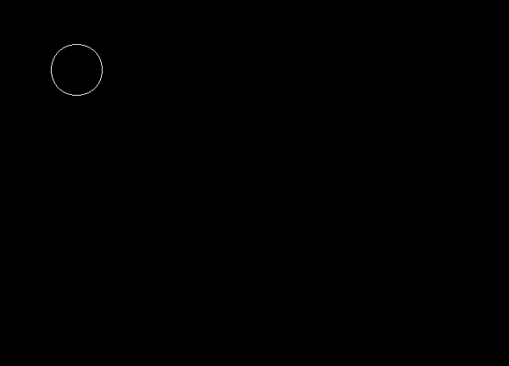
Conclusion : libgraph was installed and example graphics program was compiled and installed.

Deepraj Bhosale
181105016

