Experiment No : 3

Aim : To create a simple animation using functions defined in the libgraph library

Theory :
Animation is a method in which figures are manipulated to appear as moving images. Generally the effect of animation is achieved by a rapid succession of sequential images that minimally differ from each other. In computer animation this is achieved by changing the image every few milliseconds. These changes act like frames.

Code & Output :
#include<graphics.h>
#include<iostream>
using namespace std;
int main()
{
int gd=DETECT,gm;

initgraph(&gd,&gm,NULL);
int r=1;

while (r<=50){

//Mountains
setcolor(BROWN);
line(0,200,1000,200);
line(0,200,125,100);
line(125,100,250,200);
line(250,200,375,100);
line(375,100,500,200);
line(500,200,625,100);
line(625,100,750,200);
setcolor(BROWN);
floodfill(50,190,WHITE);
floodfill(270,190,WHITE);
floodfill(525,190,WHITE);

//Mountain Reflection
line(0,200,125,300);
line(125,300,250,200);
line(250,200,375,300);
line(375,300,500,200);
line(500,200,625,300);
line(625,300,750,200);
floodfill(50,210,WHITE);
floodfill(270,210,WHITE);
floodfill(525,210,WHITE);

//Animated Sun between a mountain
setcolor(RED);
arc(250,200,220,320,r);
arc(250,200,40,140,r);
//floodfill(250,201,WHITE);

//Water
setcolor(BLUE);
line(0,300,1000,300);
floodfill(50,250,BROWN);
floodfill(300,250,BROWN);
floodfill(550,250,BROWN);

//Grass
setcolor(GREEN);
line(0,400,1000,400);
floodfill(50,350,BLUE);

if (r>10){
setcolor(LIGHTCYAN);
line(0,0,1000,0);
line(0,0,0,200);
line(1000,0,1000,200);
line(0,200,1000,200);
line(0,200,125,100);
line(125,100,250,200);
line(250,200,375,100);
line(375,100,500,200);
line(500,200,625,100);
line(625,100,750,200);
floodfill(10,10,GREEN);
}

r+=2;
delay(100);
}
delay(1500);
closegraph();
cout<<"Experiment 3"<<endl;
}
}

Output :
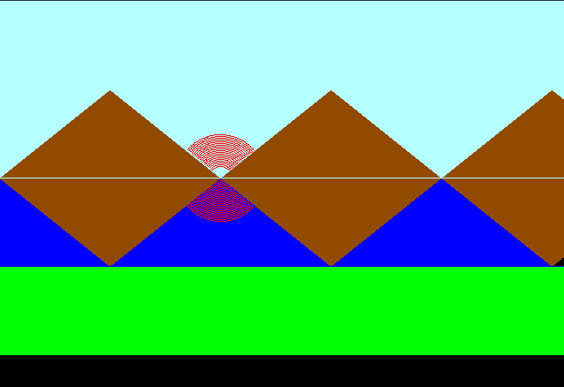

Conclusion : Program to create an animation using libgraph was written and executed successfully

Deepraj Bhosale
181105016

