Experiment No : 9.2

Aim : Interrupts

Procedure :
Interrupts are the events that temporarily suspend the main program, pass the control to the external sources and execute their task. It then passes the control to the main program where it had left off. 8051 has 5 interrupt signals, i.e. INT0, TFO, INT1, TF1, RI/TI. Each interrupt can be enabled or disabled by setting bits of the IE register and the whole interrupt system can be disabled by clearing the EA bit of the same register.
IE (Interrupt Enable) Register
This register is responsible for enabling and disabling the interrupt. EA register is set to one for enabling interrupts and set to 0 for disabling the interrupts.
IP (Interrupt Priority) Register
We can change the priority levels of the interrupts by changing the corresponding bit in the Interrupt
Priority (IP) register
TCON Register
TCON register specifies the type of external interrupt to the microcontroller.
Complete the following 8051 assembly programs in EDSIM
4) Assume that the INT1 pin is connected to a pulse generator.
• write a program in which the falling edge of the pulse will send a high to P1.3, which is connected to an LED (or buzzer).
5) Write a program in which the 8051 reads data from P1 and writes it to P2 continuously while giving a copy of it to the serial COM port to be transferred serially. Assume that XTAL=11.0592. Set the baud rate at 9600.
7) Write a program in which the 8051 gets data from P1 and sends it to P2 continuously while incoming data from the serial port is sent to P0.
• Assume that XTAL=11.0592. Set the baud rata at 9600.
8) Write a program using interrupts to do the following:
• (a) Receive data serially and sent it to P0,
• (b) Have P1 port read data and transmit it serially, and a copy given to P2,
• (c) Make timer 0 generate a square wave of 5kHz frequency on P0.1.
• Assume that XTAL-11,0592. Set the baud rate at 4800.

Code & Output :
4)
ORG 0000H
LJMP MAIN
ORG 0013H
SETB P1.3
MOV R3,#255
BACK: DJNZ R3,BACK
CLR P1.3
RETI
ORG 30H
MAIN:SETB IT1
MOV IE,#10000100B
HERE: SJMP HERE
END
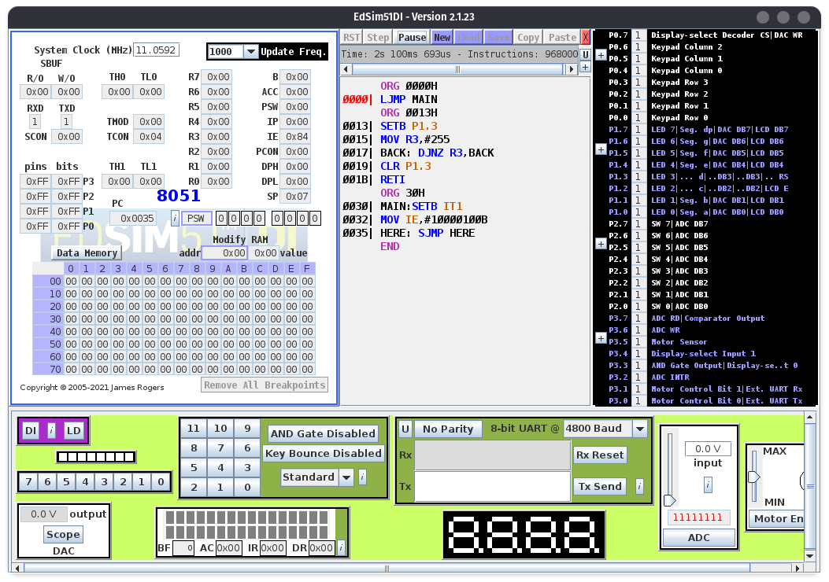

5)
ORG 0000H
LJMP MAIN
ORG 23H
LJMP SERIAL
ORG 30H
MAIN: MOV P1,#0FFH
MOV TMOD,#20H
MOV TH1,#0F6H
MOV SCON,#50H
MOV IE,10010000B
SETB TR1
BACK:MOV A,P1
MOV SBUF,A
MOV P2,A
SJMP BACK
ORG 100H
SERIAL:JB TI,TRANS
MOV A,SBUF
CLR RI
RETI
TRANS:CLR TI
RETI
END
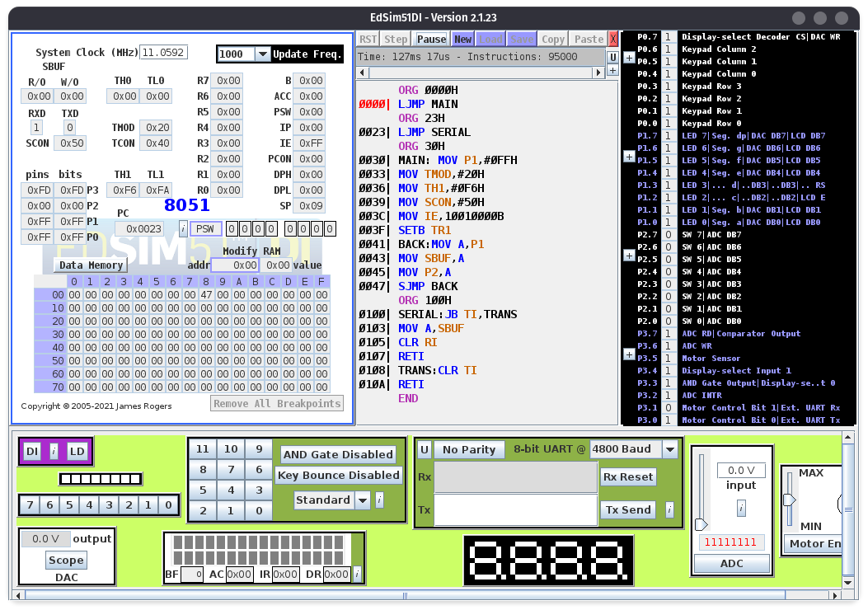

6)
ORG 0000H
LJMP MAIN
ORG 23H
LJMP SERIAL
ORG 30H
MAIN: MOV P1,#0FFH
MOV TMOD,#20H
MOV TH1,#0F6H
MOV SCON,#50H
MOV IE,10010000B
SETB TR1
BACK:MOV A,P1
MOV P2,A
SJMP BACK
ORG 100H
SERIAL:JB TI,TRANS
MOV A,SBUF
CLR RI
RETI
TRANS:CLR TI
RETI
END
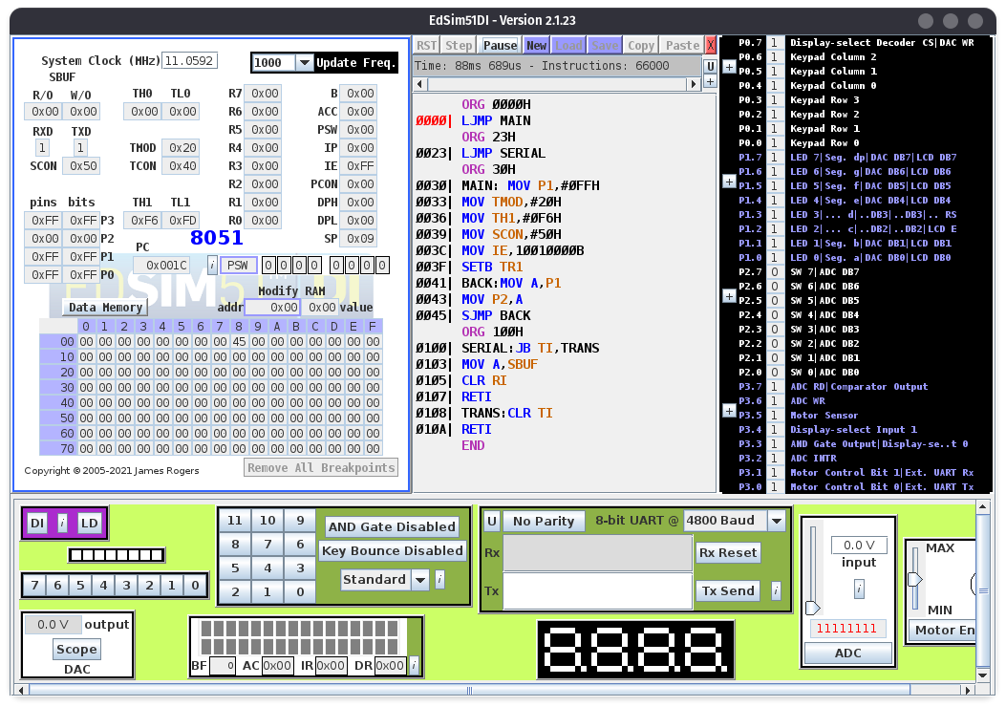
7)
ORG 0000H
LJMP MAIN
ORG 000BH
CPL P0.1
RETI
ORG 23H
LJMP SERIAL
ORG 30H
MAIN: MOV P1,#0FFH
MOV TMOD,#22H
MOV TH1,#0F6H
MOV SCON,#50H
MOV TH0,#-92
MOV IE,10010010B
SETB TR1
SETB TR0
BACK:MOV A,P1
MOV SBUF,A
MOV P2,A
SJMP BACK
ORG 100H
SERIAL:JB TI,TRANS
MOV A,SBUF
MOV P0,A
CLR RI
RETI
TRANS:CLR TI
RETI
END
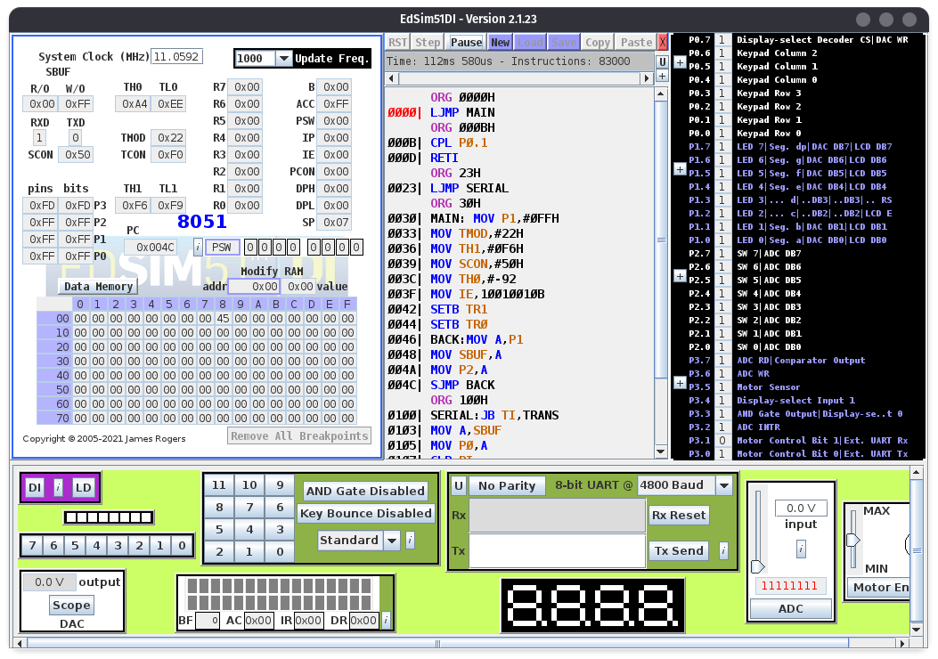

Conclusion : The given 8051 programs to demonstrate interrupts were successfully coded and executed

Deepraj Bhosale
181105016

