PROGRAMMING ASSIGNMENT 2

Experiment No : 1

Aim : To Write a code in C/C++ to implement Hamming Code in Computer Networking.

C++ Program to Implement Hamming Code
#include<iostream>
#include<conio.h>
using namespace std;
int main()
{
int data[10];
int dataatrec[10],c,c1,c2,c3,i;
cout<<"Enter 4 bits of data to be transferred one by one: \n";
cin>>data[0];
cin>>data[1];
cin>>data[2];
cin>>data[4];

//Calculation of even parity
data[6]=data[0]^data[2]^data[4];
data[5]=data[0]^data[1]^data[4];
data[3]=data[0]^data[1]^data[2];

cout<<"\nEncoded data is: \n";
for(i=0;i<7;i++)
cout<<data[i];

cout<<"\n\nEnter received data bits one by one: \n";
for(i=0;i<7;i++)
cin>>dataatrec[i];

c1=dataatrec[6]^dataatrec[4]^dataatrec[2]^dataatrec[0];
c2=dataatrec[5]^dataatrec[4]^dataatrec[1]^dataatrec[0];
c3=dataatrec[3]^dataatrec[2]^dataatrec[1]^dataatrec[0];
c=c3*4+c2*2+c1 ;

if(c==0) {
cout<<"\nNo error while transmission of data: \n";
}
else {
cout<<"\nError on position: "<<c;

cout<<"\nData sent : ";
for(i=0;i<7;i++)
cout<<data[i];

cout<<"\nData received : ";
for(i=0;i<7;i++)
cout<<dataatrec[i];

cout<<"\nCorrect message is: \n";

//if errorneous bit is 0 we complement it else vice versa
if(dataatrec[7-c]==0)
dataatrec[7-c]=1;
else
dataatrec[7-c]=0;
for (i=0;i<7;i++) {
cout<<dataatrec[i];
}
}

return 0;
}

Output :
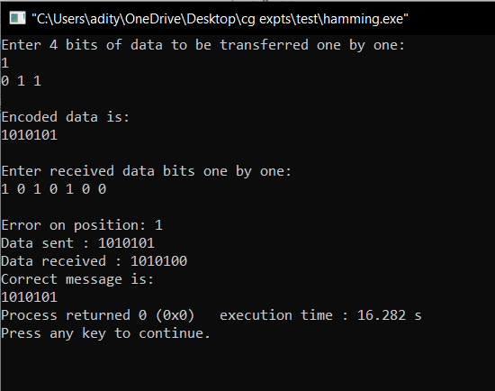

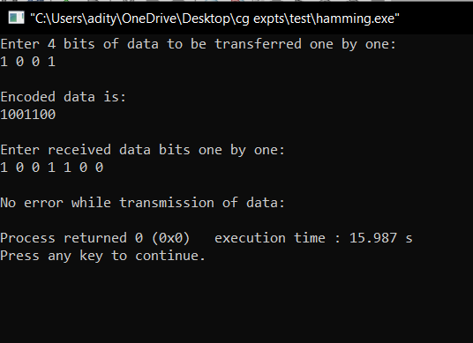

Conclusion : The cpp code for implementing Hamming Code concept was written and executed successfully with o/p.

Experiment Number : 2

Aim : To Write a code in C/C++ to implement Cyclic Redundancy Check (CRC) concept in Computer Networking.

C++ Program to Implement Cyclic Redundancy Code
#include<iostream>
using namespace std;
void division(int temp[],int gen[],int n,int r)
{
for(int i=0;i<n;i++)
{
if (gen[0]==temp[i])
{
for(int j=0,k=i;j<r+1;j++,k++)
if(!(temp[k]^gen[j]))
temp[k]=0;
else
temp[k]=1;}}
}
int main()
{
int n,r,message[50],gen[50],temp[50];
cout<<"At Sender's End "<<endl;
cout<<"Enter the number of message bits : ";
cin>>n;
cout<<"Enter the number of generator bits : ";
cin>>r;
cout<<"Enter the message : ";
for(int i=0;i<n;i++)
cin>>message[i];
cout<<"Enter the generator : ";
for(int i=0;i<r;i++)
cin>>gen[i];
r--;
for(int i=0;i<r;i++)
message[n+i] = 0;
for(int i=0;i<n+r;i++)
temp[i] = message[i];
division(temp,gen,n,r);
cout<<"CRC : ";
for(int i=0;i<r;i++)
{
cout<<temp[n+i]<<" ";
message[n+i] = temp[n+i];
}
cout<<endl<<"Transmitted Message : ";
for(int i=0;i<n+r;i++)
cout<<message[i]<<" ";
cout<<endl<<endl<<"At Receiver's End "<<endl;
cout<<"Enter the received message : ";
for(int i=0;i<n+r;i++)
cin>>message[i];
for(int i=0;i<n+r;i++)
temp[i] = message[i];
division(temp,gen,n,r);
for(int i=0;i<r;i++)
{
if(temp[n+i])
{
cout<<"Error detected in received message.";
return 0;
}}
cout<<endl<<"No error in the Message";
cout<<"\nReceived Message/Original Message : ";
for(int i=0;i<n;i++)
cout<<message[i]<<" ";
return 0;
}

Output :
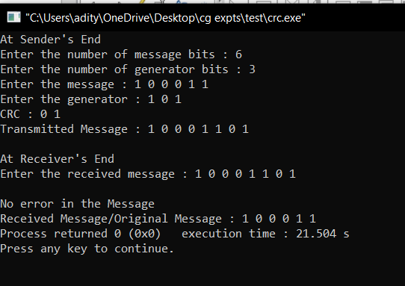

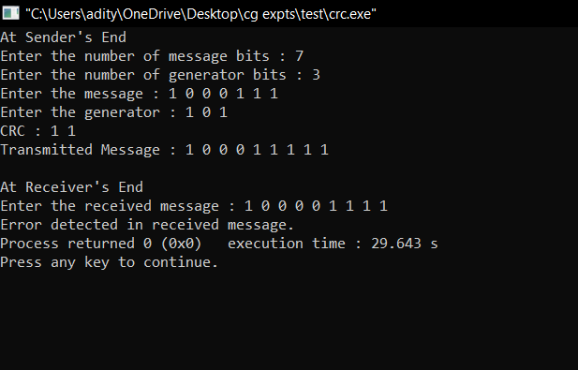

Conclusion : The cpp code for implementing CRC concept was written and executed successfully with o/p.

Deepraj Bhosale
181105016

