Experiment No : 7

Aim : Using Mid-point Ellipse algorithm, draw an animated solar system

Theory :
Ellipses are frequently used component in pictures and graphs, a procedure for generating either full ellipses or arcs is included in many graphics packages. Hence various algorithms for drawing rasterised ellipses have been formulated. One such algorithm is the Mid-Point Ellipse algorithm. This algorithm takes advantage of the symmetry of the ellipse and only computes points for 1 quadrant of the ellipse.

Code & Output :
#include<stdio.h>
#include<graphics.h>

void midPtEllipseAlgo(long x_center,long y_center,long a,long b);

int main(){
int gd=DETECT,gm;
initgraph(&gd,&gm,NULL);

midPtEllipseAlgo(250,230,35,25);
midPtEllipseAlgo(250,230,60,30);
midPtEllipseAlgo(250,230,90,60);
midPtEllipseAlgo(250,230,120,90);
midPtEllipseAlgo(250,230,150,120);
midPtEllipseAlgo(250,230,180,150);
midPtEllipseAlgo(250,230,210,180);
midPtEllipseAlgo(250,230,240,210);

for(int i=0;i<12;i++)
{
//sun
//setfillstyle(SOLID_FILL,YELLOW);
setcolor(YELLOW);
circle(250,230,20);
floodfill(250,230,15);
//mercury
//setfillstyle(SOLID_FILL,RED);
setcolor(RED);
circle(285,230,2);
floodfill(285,230,15);
delay(100);
//venus
//setfillstyle(SOLID_FILL,LIGHTRED);
setcolor(LIGHTRED);
circle(310,230,5);
floodfill(310,230,15);
//earth
//setfillstyle(SOLID_FILL,BLUE);
setcolor(BLUE);
circle(340,230,7);
floodfill(340,230,15);
//mars
//setfillstyle(SOLID_FILL,LIGHTRED);
setcolor(LIGHTRED);
circle(370,230,4);
floodfill(370,230,15);
//jupiter
//setfillstyle(SOLID_FILL,MAGENTA);
setcolor(MAGENTA);
circle(400,230,12);
floodfill(400,230,15);
//SATURN
//setfillstyle(SOLID_FILL,BROWN);
setcolor(BROWN);
circle(430,230,11);
floodfill(430,230,15);
//uranus
//setfillstyle(SOLID_FILL,LIGHTBLUE);
setcolor(LIGHTBLUE);
circle(460,230,9);
floodfill(460,230,15);
//neptune
//setfillstyle(SOLID_FILL,WHITE);
setcolor(WHITE);
circle(490,230,8);
floodfill(490,230,15);
}
getch();
closegraph();
}

void midPtEllipseAlgo(long x_center,long y_center,long a,long b)
{
long x,y,a_sqr,b_sqr, fx,fy, d,tmp1,tmp2;
x=0;
y=b;
a_sqr=a*a;
b_sqr=b*b;
fx=2*b_sqr*x;
fy=2*a_sqr*y;
d=b_sqr-(a_sqr*b)+(a_sqr*0.25);
do
{
putpixel(x_center+x,y_center+y,WHITE);
putpixel(x_center-x,y_center-y,WHITE);
putpixel(x_center+x,y_center-y,WHITE);
putpixel(x_center-x,y_center+y,WHITE);

if(d<0)
{
d=d+fx+b_sqr;
}
else
{
y=y-1;
d=d+fx+-fy+b_sqr;
fy=fy-(2*a_sqr);
}
x=x+1;
fx=fx+(2*b_sqr);
delay(10);

}
while(fx<fy);
tmp1=(x+0.5)*(x+0.5);
tmp2=(y-1)*(y-1);
d=b_sqr*tmp1+a_sqr*tmp2-(a_sqr*b_sqr);
do
{
putpixel(x_center+x,y_center+y,WHITE);
putpixel(x_center-x,y_center-y,WHITE);
putpixel(x_center+x,y_center-y,WHITE);
putpixel(x_center-x,y_center+y,WHITE);

if(d>=0)
d=d-fy+a_sqr;
else

{
x=x+1;
d=d+fx-fy+a_sqr;
fx=fx+(2*b_sqr);
}
y=y-1;
fy=fy-(2*a_sqr);
}
while(y>0);

}

Output :
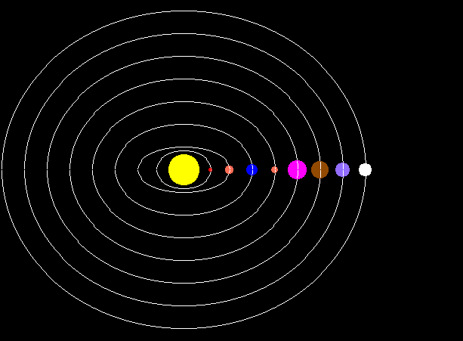

Conclusion : Program to draw a solar system using mid point ellipse algorithm was succesffully written and executed

Deepraj Bhosale
181105016

