Experiment 1

Study of different networking devices and their applications

Repeater
Functioning at Physical Layer. A repeater is an electronic device that receives a signal and re- transmits it at a higher level and/or higher power, or onto the other side of an obstruction,so that the signal can cover longer distances. Repeater have two ports, so it cannot be used to connect more than two devices.

Hub
An Ethernet hub, active hub, network hub, repeater hub, hub or concentrator is a device for connecting multiple twisted pair or fiber optic Ethernet devices together and making them act as a single network segment. Hubs work at the physical layer (layer 1) of the OSI model. The device is a form of multi-port repeater. Repeater hubs also participate in collision detection, forwarding a jam signal to all ports if it detects a collision.

Switch
A network switch or switching hub is a computer networking device that connects network segments.The term commonly refers to a network bridge that processes and routes data at the data link layer (layer 2) of the OSI model. Switches that additionally process data at the network layer (layer 3 and above) are often referred to as Layer 3 switches or multilayer switches.

Bridge
A network bridge connects multiple network segments at the data link layer (Layer 2) of the OSI model. In Ethernet networks, the term bridge formally means a device that behaves according to the IEEE 802.1D standard. A bridge and switch are very much alike; a switch being a bridge with numerous ports. Switch or Layer 2 switch is often used interchangeably with bridge .Bridges can analyze incoming data packets to determine if the bridge is able to send the given packet to another segment of the network.

Router
A router is an electronic device that interconnects two or more computer networks, and selectively interchanges packets of data between them. Each data packet contains address information that a router can use to determine if the source and destination are on the same network, or if the data packet must be transferred from one network to another. Where multiple routers are used in a large collection of interconnected networks, the routers exchange information about target system addresses, so that each router can build up a table showing the preferred paths between any two systems on the interconnected networks.
Gateway
In a communications network, a network node equipped for interfacing with another network that uses different protocols. A gateway may contain devices such as protocol translators, impedance matching de-vices, rate converters, fault isolators, or signal translators as necessary to provide system interoperability. It also requires the establishment of mutually acceptable ad- ministrative procedures between both networks. A protocol translation/mapping gateway interconnects networks with different network protocol technologies by performing the required protocol conversions.

Study of different cabling types and standards for data communications and the procedure for crimping RJ45 connectors used in LAN

Types of network cables

Coaxial Cabling
A coaxial cable has an internal conductor that runs down the middle of the cable. The conductor is surrounded by a layer of insulation which is then surrounded by another carrying conductor shield, which makes this type of cable resistant to external obstruction. This type of cable comes in two types – thin net and thick net. Each type has a maximum transmission speed of
10 Mbps. Coaxial cables were previously used in computer networks, but are now replaced by twisted pair cables. A single-core coaxial cable uses a single central metal(usually copper) conductor, while a multi-core coaxial cable uses multiple thin strands of metal wires.

Twisted-pair Cabling
A twisted-pair cable has four pairs of wires. These wires are twisted almost to each other to reduce crosstalk and external interference. This type of cabling is common in current LANs. Twisted pair cables can be used for telephone and network cables. It comes in two versions: UTP (Unshielded Twisted-Pair) and STP (Shielded Twisted-Pair). The difference between these is that the STP cable has an additional layer of protection to protect the data from external interference.

Fiber Optic Cabling
This type of cable uses optical fibers to transmit data in the form of a light signal. The cables have fiber glass strands surrounded by cladding material. The core is wrapped in cladding;The cladding is wrapped in a buffer, and the buffer is wrapped in a jacket. Fiber optic cables are fully immune to EMI and RFI. This cable can transmit data over long distances at maximum speed. It can transmit 40 km of data at 100Gbps. Fiber optic cables use light to transmit data. It reflects light from one point to another. There are two types of fiber optic cables based on how much light they transmit at a given time; SMF to MMF

Procedure for crimping RJ45 connectors used in LAN

Step 1
Start by stripping off about 2 inches of the plastic jacket off the end of the cable. Be very careful at this point, as to not nick or cut into the wires, which are inside. Doing so could alter the characteristics of your cable, or even worse render is useless. Check the wires, one more time for nicks or cuts. If there are any, just whack the whole end off, and start over.

Step 2
Spread the wires apart, but be sure to hold onto the base of the jacket with your other hand. You do not want the wires to become untwisted down inside the jacket. Category 5 cable must only have 1/2 of an inch of ’untwisted’ wire at the end; otherwise it will be ’out of spec’. At this point, you obviously have a lot more than 1/2 of an inch of un-twisted wire.

Step 3
You have 2 end jacks, which must be installed on your cable. If you are using a pre-made cable, with one of the ends whacked off, you only have one end to install - the crossed over end. Below are two diagrams, which show how you need to arrange the cables for each type of cable end.
Decide at this point which end you are making and examine the associated picture below.
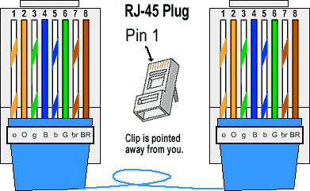

Figure shows how to prepare straight wired connection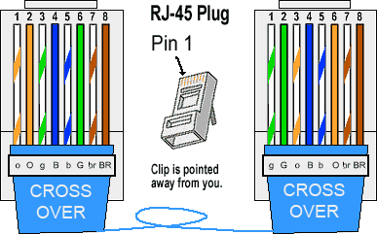

Figure shows how to prepare cross wired connection

Implement different network topologies using packet tracer simulator
Star topology
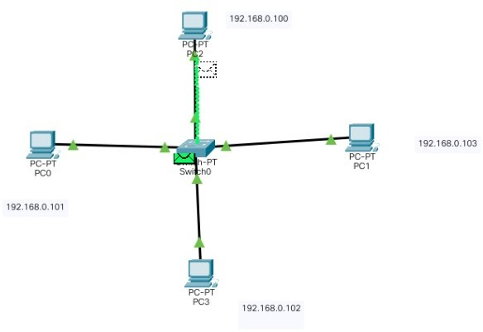
Mesh topology
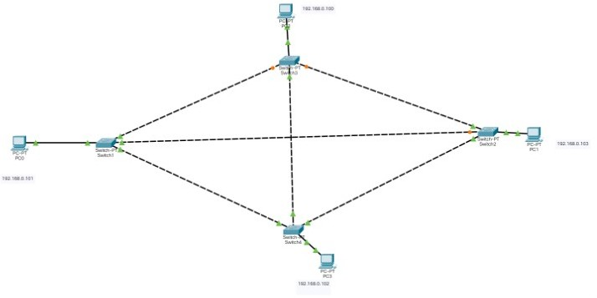

Bus topology
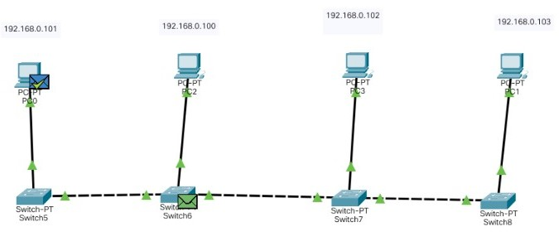
Hybrid topology

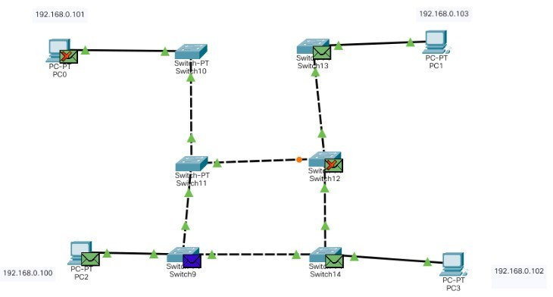

Ring Topology

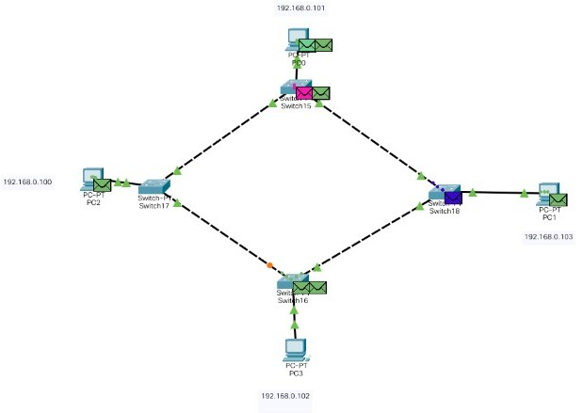

Conclusion
Studied different networking devices and learned about their applications, studied the different cable types and standards for data communication, crimping procedure and implemented different network topologies using packet tracer simulator.

Deepraj Bhosale
181105016

