Experiment No : 1

Aim : To Study the various features of EDSIM51 simulator for 8051 micro controller.

Theory :

- EdSim51 is a software product that simulates the 8051 microcontroller.

- Peripherals can be ignored in EDSim51 unlike other stimulators. Various sections of EDSim consists of:

- The Microcontroller Panel. The Bitfield. Data and Code Memory.

- The Assembly Code Panel.

- The Peripherals. The Logic Diagram. The LED Bank, DAC and the 7-segment Displays. The LCD Module. The Switch Bank and the ADC. The Comparator and the DAC. The Motor. The UART. The Keypad.

Various peripherals provided by EDSim are as follows:
- Analogue-to-Digital Converter(ADC) •
- Comparator •
- UART •
- 4Multiplexed7-segment Displays •
- 4X3Keypad •
- 8 LEDs •
- DC Motor •
- 8 Switches •
- Digital-to-Analogue Converter (DAC)- displayed on oscilloscope.

Write assembly language programs to do the following:

1. Store a hexadecimal number in register A.
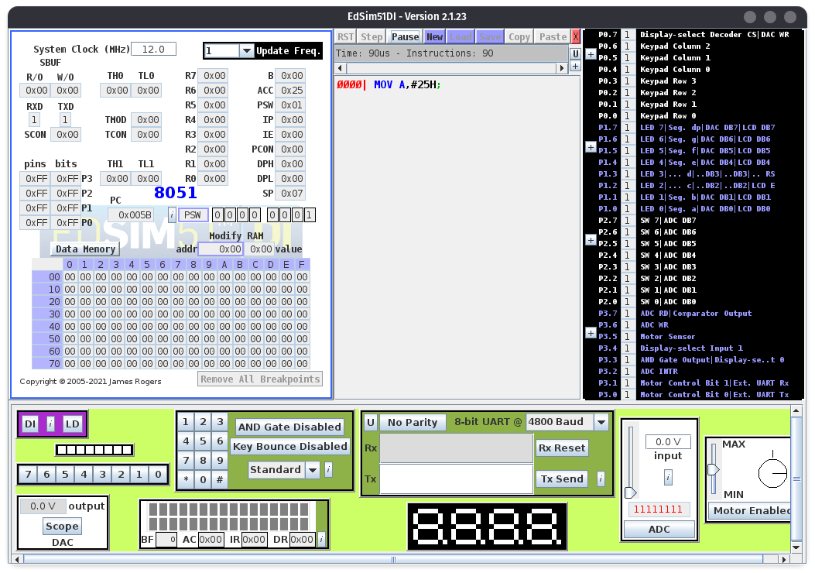
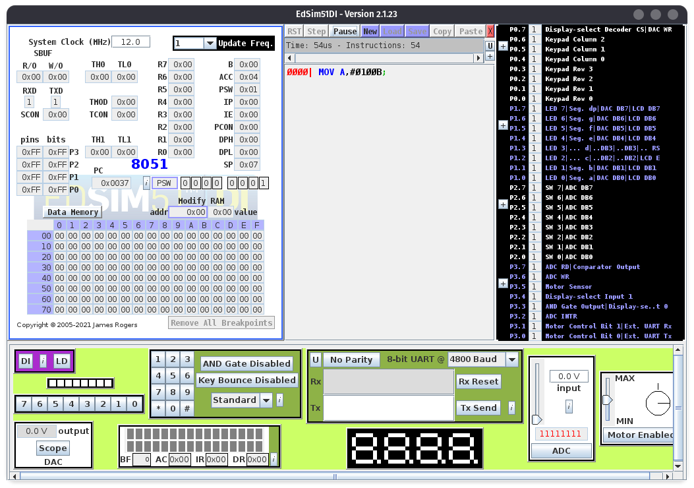
2. Store a binary number in register A.
3. Store a decimal number in register A.
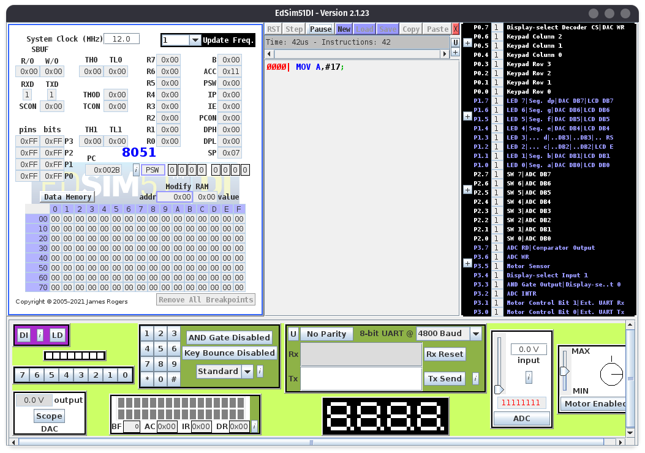
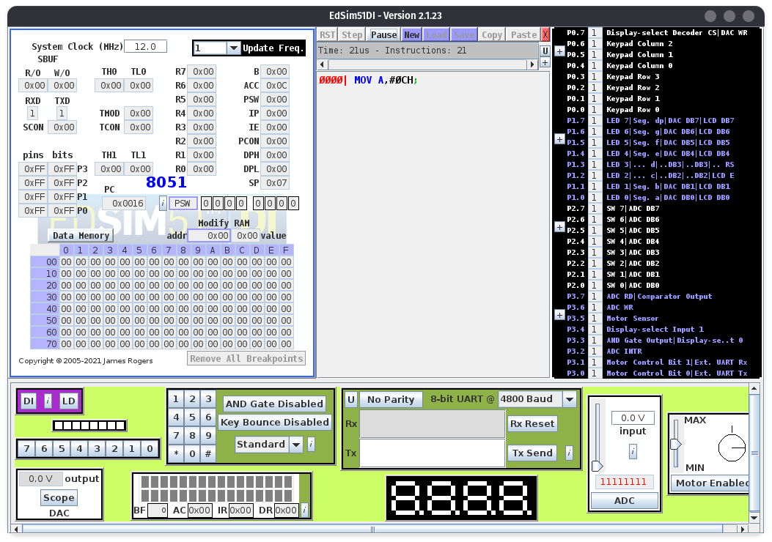
4. Store a hexadecimal number which starts with a letter in register A.
5. Add two unsigned numbers.
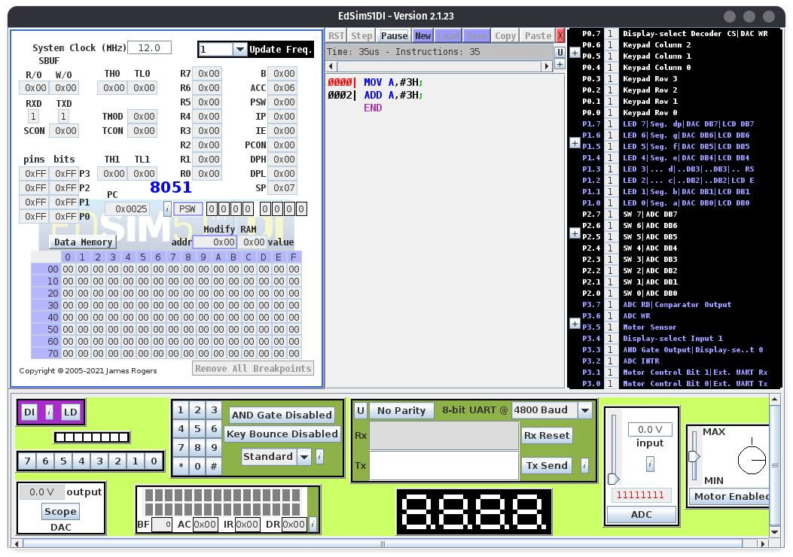
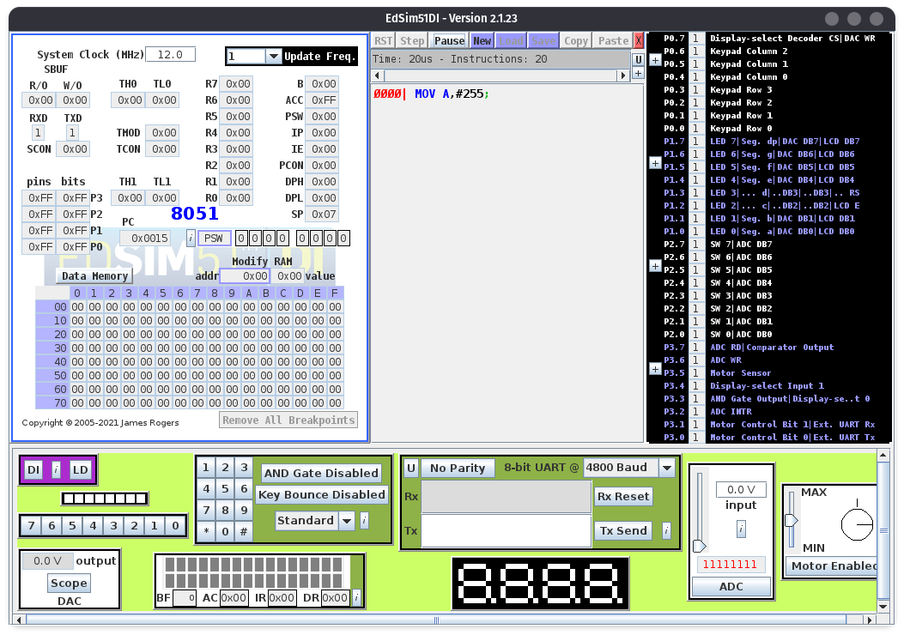
6. What is the largest value you can move into a register? Give an example program

7. What is the use of a pound(#) sign in 8051 programming? Give an example if pound not used.
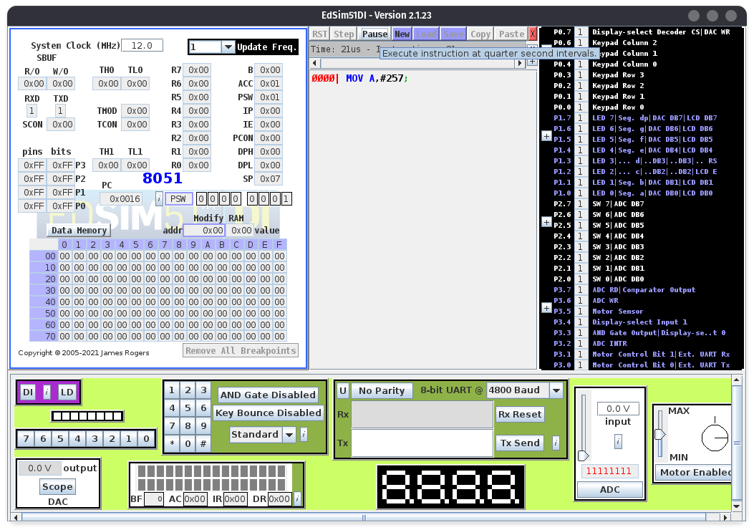
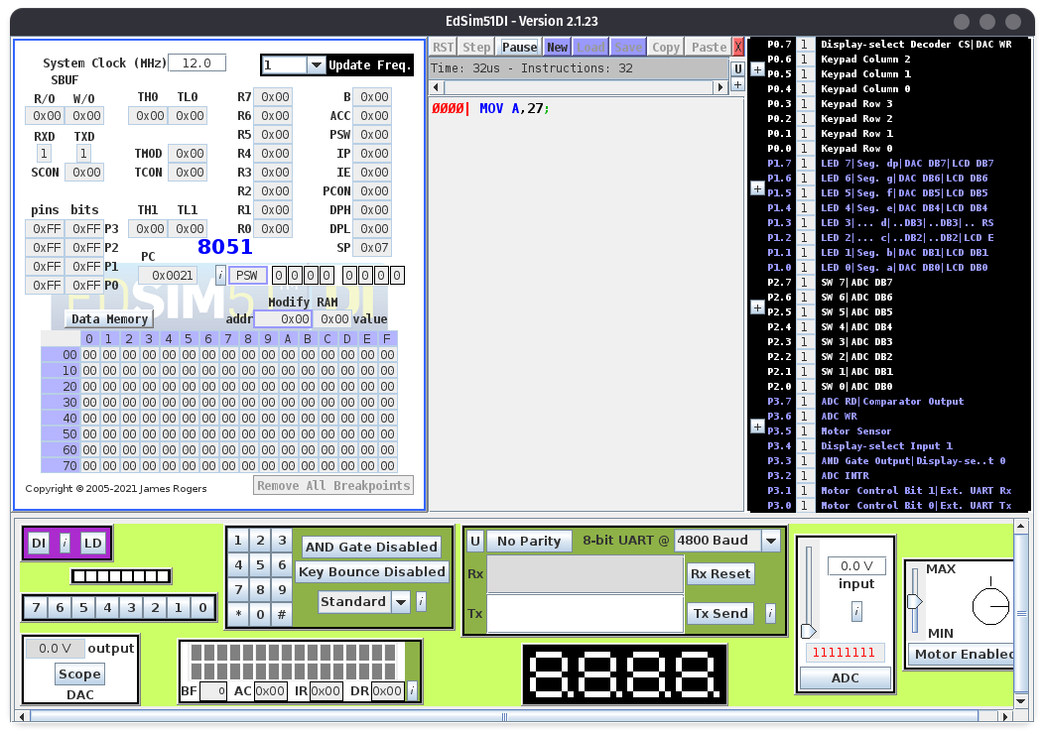
Conclusion : The Experiment to study the various features of EDSIM51 simulator for 8051 microcontroller was completed successfully.

Deepraj Bhosale
181105016

SDTH

