Experiment No : 2

Aim : Interfacing LED Bank and 7 Segment Display

Theory :

There are four 7 segment displays available. The selection of which of the four displays is enabled is done via P3.3 and P3.4 pins. These port pins are applied to a 2-to-4 line decoder, the outputs of which are applied to the base of transistors that enable/disable the displays.

a. P3.3 = 0 & P3.4 =0 → DISPLAY 0 is activated
b. P3.3 = 1 & P3.4 =0 → DISPLAY 1 is activated
c. P3.3 = 0 & P3.4 =1 → DISPLAY 2 is activated
d. P3.3 = 1 & P3.4 =1 → DISPLAY 4 is activated

Only 1 display can be active at a time . The output of any particular display based on the input given to the 8 bits of port 1 (i.e. P0 → P7 ). If any pin has value 1 means the display segment corresponding to it is off and if the value is 0 means the display segment corresponding to it is on.

- Bit address-ability
A type of hardware architecture that supports unique access to individual bytes of data. In this we can access each bit individually and change its value without changing the remaining bits.
- Byte address-ability
Byte addressing refers to hardware architectures which support accessing individual bytes. Such computers are sometimes called byte machines This is in contrast to word-addressable architectures, word machines, that access data in terms of larger units called words. Here changing value affects the entire byte.
- Delay procedure
MOV R1, #10H DJNZ R1, $ In this we move a value into any register we want and then wait until the value becomes 0 and then proceed ahead with the next instruction . The DJNZ instruction decrements the byte indicated by the first operand and, if the resulting value is not zero, branches to the address specified in the second operand. Since the second operand for us is $ it means do decrement and do nothing.

Program :
1. Write the letter A on the LED using bit addressing.
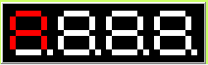
CLR P1.0
CLR P1.1
CLR P1.2
CLR P1.4
CLR P1.5
CLR P1.6

2. Write the letter S on the LED using byte addressing.
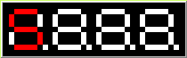
MOV P1, #10010010B

3. Turning one segment of a single LED ON at a time after a delay of 50 counts
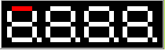
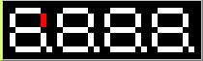
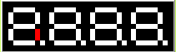
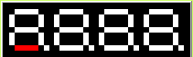
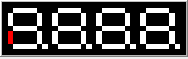
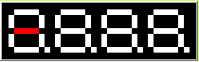
MOV P1,#01111111B
CALL DELAY
MOV P1,#10111111B
CALL DELAY
MOV P1,#11011111B
CALL DELAY
MOV P1,#11101111B
CALL DELAY
MOV P1,#11110111B
CALL DELAY
MOV P1,#11111011B
CALL DELAY
MOVP1,
#11111101B
CALL DELAY
MOV P1,#11111110B
DELAY:
MOVR1,#50
DJNZ R1,$
RET

4. Keep turning ON pairs of the segments of the LED which are opposite to each other one pair at a time

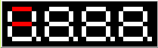
MOV P1,#10111110B
CALL DELAY
MOV P1,#11011101B
CALL DELAY

MOV P1,#10110111B
CALL DELAY
MOV P1,#11101011B
DELAY:
MOV R1,#10

DJNZ R1,$
RET



5. Turing all the 7 segment displays ON one after the other

MOV P1,#10000000B
CALL DELAY
CLR P3.3
MOV P1,#10000000B;

CALL DELAY
MOV P1,#1B;
SETB P3.3
CLR P3.4
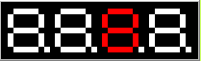
MOV P1,#10000000;
CALL DELAY
CLR P3.3
MOV P1,#10000000;
DELAY:
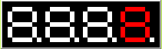
MOV R1,#5
DJNZ R1,$
RET

6. Display your name with one letter after the other on the 7 segment displays.

MOV P1,#11000000B;
CALL DELAY
CLR P3.3
MOV P1,#10000110B;
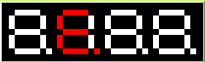
CALL DELAY
SETB P3.3
CLR P3.4
MOV P1,#10000110B;
CALL DELAY

CLR P3.3
MOV P1,#10001100B;

DELAY:

MOV R1,#5
DJNZ R1,$
RET

Conclusion : The Experiment to Interface LED Bank and 7 Segment Display was executed successfully.

Deepraj Bhosale
181105016

