Experiment No : 4

Aim : To Study various 8051 addressing modes.

Theory :

1. Immediate addressing mode

In this Immediate Addressing Mode, the data is provided in the instruction itself. The data is provided immediately after the opcode. These are some examples of Immediate Addressing Mode.

MOV A, #0AFH;
MOV R3, #45H;
MOV DPTR, #FE00H;

In these instructions, the # symbol is used for immediate data. In the last instruction, there is DPTR. The DPTR stands for Data Pointer. Using this, it points the external data memory location. In the first instruction, the immediate data is AFH, but one 0 is added at the beginning. So, when the data is starting with A to F, the data should be preceded by 0.

2. Register addressing mode

In the register addressing mode the source or destination data should be present in a register (R0 to R7). These are some examples of Register Addressing Mode.

MOV A, R5;
MOV R2, #45H;
MOV R0, A;

In 8051, there is no instruction like MOVR5, R7. But we can get the same result by using this instruction MOV R5, 07H, or by using MOV 05H, R7. But these two instructions will work when the selected register bank is RB0. To use another register bank and to get the same effect, we have to add the starting address of that register bank with the register number. For an example, if the RB2 is selected, and we want to access R5, then the address will be (10H + 05H = 15H), so the instruction will look like this MOV 15H, R7. Here 10H is the starting address of Register Bank 2.

3. Direct Addressing Mode
In the Direct Addressing Mode, the source or destination address is specified by using 8-bit data in the instruction. Only the internal data memory can be used in this mode. Here some of the examples of direct Addressing Mode.

MOV 80H, R6;
MOV R2, 45H;
MOV R0, 05H;

The first instruction will send the content of register R6 to port P0 (Address of Port 0 is 80H). The second one is forgetting content from 45H to R2. The third one is used to get data from Register R5 (When register bank RB0 is selected) to register R5.

4. Register indirect addressing Mode

In this mode, the source or destination address is given in the register. By using register indirect addressing mode, the internal or external addresses can be accessed. The R0 and R1 are used for 8-bit addresses, and DPTR is used for 16-bit addresses, no other registers can be used for addressing purposes. Let us see some examples of this mode.

MOV 0E5H, @R0;
MOV @R1, 80H

In the instructions, the @ symbol is used for register indirect addressing. In the first instruction, it is showing that the R0 register is used. If the content of R0 is 40H, then that instruction will take the data which is located at location 40H of the internal RAM. In the second one, if the content of R1 is 30H, then it indicates that the content of port P0 will be stored at location 30H in the internal RAM.

MOVX A, @R1;
MOV @DPTR, A;

In these two instructions, the X in MOVX indicates the external data memory. The external data memory can only be accessed in register indirect mode. In the first instruction if the R0 is holding 40H, then A will get the content of external RAM location40H. And in the second one, the content of A is overwritten in the location pointed by DPTR.

5. Indexed addressing mode

In the indexed addressing mode, the source memory can only be accessed from program memory only. The destination operand is always the register A. These are some examples of Indexed addressing mode.

MOVC A, @A+PC;
MOVC A, @A+DPTR;

The C in MOVC instruction refers to code byte. For the first instruction, let us consider A holds 30H. And the PC value is1125H. The contents of program memory location 1155H (30H + 1125H) are moved to register A.

6. Implied Addressing Mode

In the implied addressing mode, there will be a single operand. These types of instruction can work on specific registers only. These types of instructions are also known as register specific instruction. Here are some examples of Implied Addressing Mode.

RL A;
SWAP A;

These are 1- byte instruction. The first one is used to rotate the A register content to the Left. The second one is used to swap the nibbles in A.

Programs :
1. Place the number 3Bh in internal RAM locations 30h to 32h.

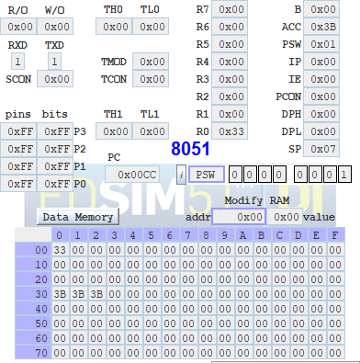
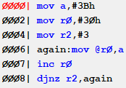

2. Copy the data at internal RAM location 70h to R0 and R3.
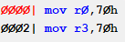
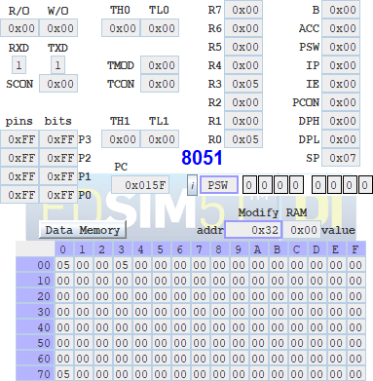
3. Set the SP at the byte address just above the last working register address.
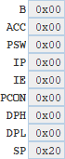

4. Exchange the contents of the SP and the PSW.
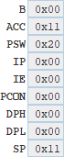
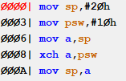

5. Copy the byte at internal RAM address 27h to external RAM address 27h.
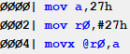
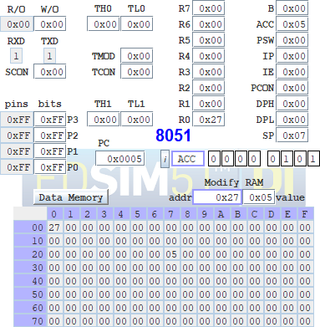
6. Set Timer 1 to A23Dh.
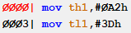
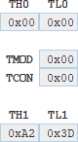
7. Copy the contents of DPTR to registers R0 (DPL) and R1 (DPH).
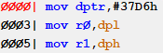
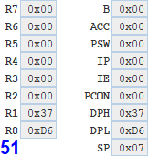

8. Copy the data in external RAM location 0123h to TL0 and the data in external RAM location 0234h to TH0.
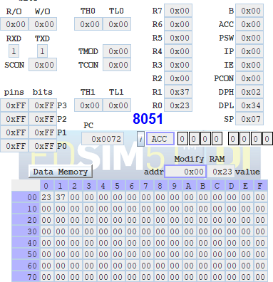
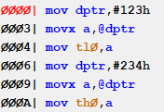

9. Copy the data in internal RAM locations 12h to 15h to internal RAM locations 20h to 23h: Copy 12h to 20h. 13h to 21h, etc.

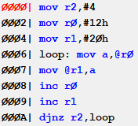
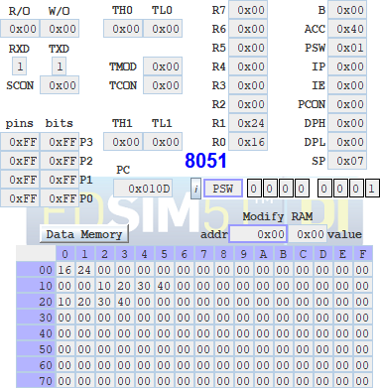

10. Set the SP register to 07h and PUSH the SP register on the stack; predict what number is pushed to address 08h.
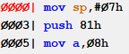
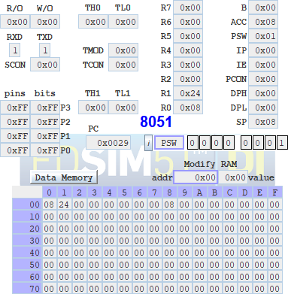

11. Exchange the contents of the B register and external RAM address 02CFh.
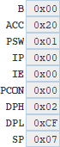
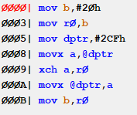

12. Rotate the bytes in registers R0 to R3; copy the data in R0 to R 1, R 1 to R2, R2 to R3, and R3 to R0.

13. Copy the external code byte at address 007Dh to the SP.
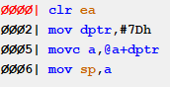
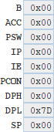
14. Copy the data in register R5 to external RAM address 032Fh.
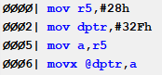
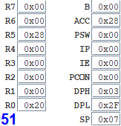
15. Copy the internal code byte at address 0300h to external RAM address 0300h.
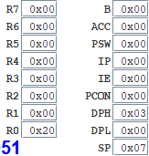
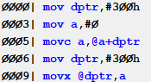

16. Swap the bytes in timer 0; put TL0 in TH0 and TH0 in TL0.
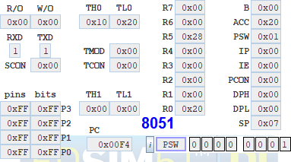
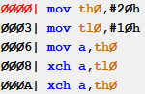

17. Store DPTR in external RAM locations 0123h (DPL) and 02BCH (DPH).
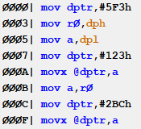
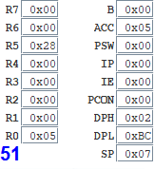

18. Exchange both low nibbles of registers R0 and R1; put the low nibble of R0 in R1, and the low nibble of R1 in R0.
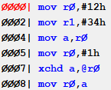
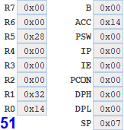

19. Store the contents of RAM location 20h at the address contained in RAM location 08h.
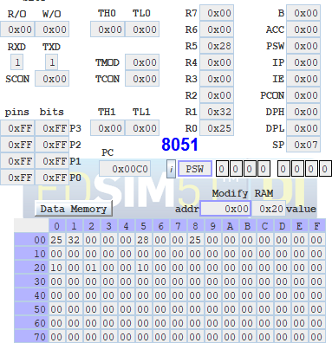
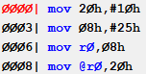

20. Store register A at the internal RAM location address in register A.
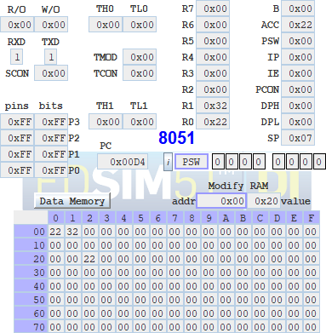
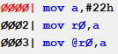

21. Copy program bytes 0100h to 0102h to internal RAM locations 20h to 22h.
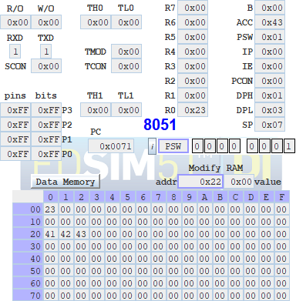
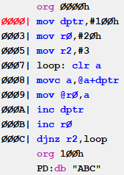

22. PUSH the contents of the B register to TMOD.
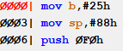
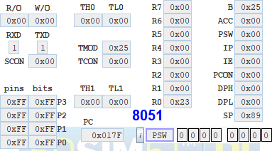
23. Copy the contents of external code memory address 0040h to IE.
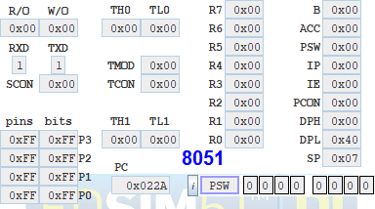
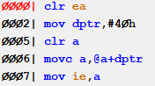

24. Write a program to copy 10 bytes of data stored from 30H to another location staring from 50H.
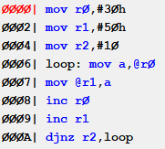
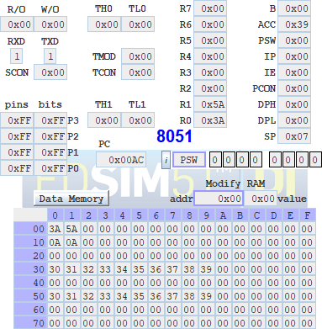

25. Add the BCD numbers found in internal RAM locations 25h, 26h and 27h together and put the result in RAM location 31h(MSB) and 30h(LSB).
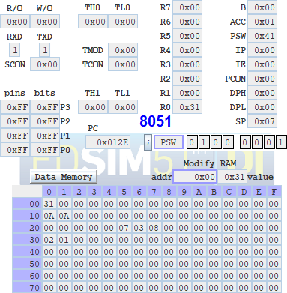
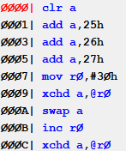

26. Place any number in internal RAM location 3Ch and increment it until the number equals 2Ah. (Use cjne)
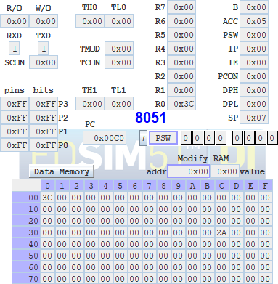
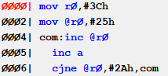

27. Write code to push R0, R1, R3 of bank 0 onto the stack and pop them back into R5, R6, and R7 of bank 3.

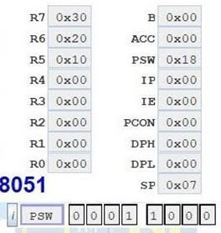
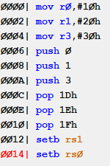

28. Write a program to copy 10 bytes of data starting at ROM address 400H to RAM locations starting at 30H.
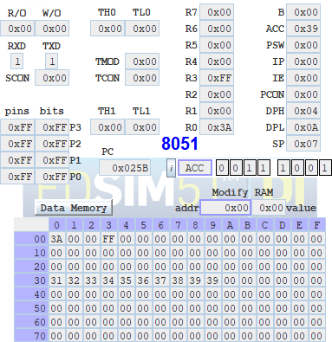
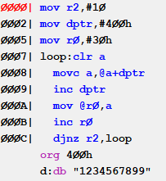

29. Assume that the word INDIA is burned on ROM location starting at 200H and that the program is burned into ROM locations starting at 0. Get this word and store each character in Registers r0-r4.
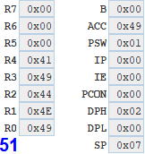
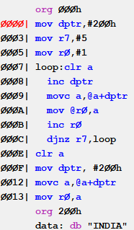

30. Write the same program in question 29 using

a. a counter
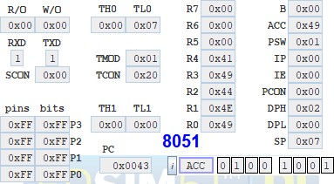
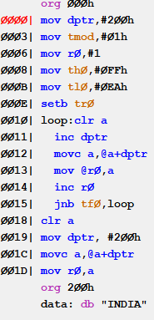
b. using null char at the end of the string
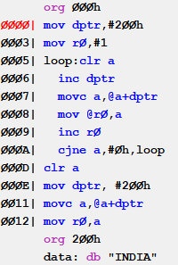
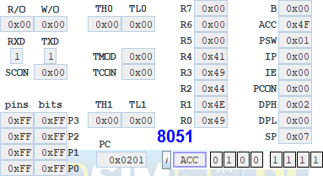

31. Write a program to get the value x from p1 and send x2 to p2 continuously using a look up table for the x2 values.

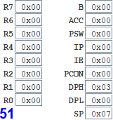
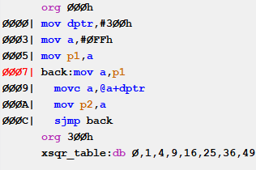

32. Write a program to find y where y= x2 + 2x + 5 and x is between 0 and 9.
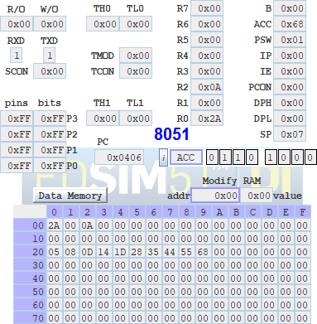
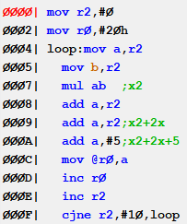

33. Write a program to add the following data and store the result in RAM location 30H. ORG 200H

MYDATA: DB 06,09,02,05,07
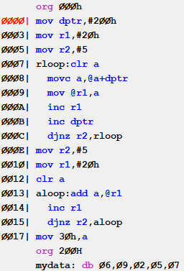
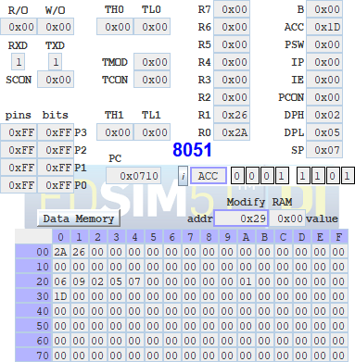

Conclusion :
Programs to study various 8051 Addressing Modes were successfully implemented.

Deepraj Bhosale
181105016

