Experiment No : 5

Aim : To study about Timer Programming .

Procedure:
  - Create a square wave of 50% duty cycle (with equal portions high and low) on the P1.5 bit using timer mode 1 with timer 0 to generate the time delay. Display the output using edsim simulator. Use CPL to transition from hi to lo
  - Modify TL and TH in question 1 to get the largest pulse width possible. Use SETB and CLR to transition from hi,lo
  - Assume that XTAL = 16 MHz. Write A program for timer 0 to create a pulse width of 5 ms on P2.3 in mode 1.
  - Create a square wave (with 75%portion high and 25% portion low) on the P1.5 bit using timer mode 1 with timer 0 to generate the time delay. Display the output using edsim simulator. use CPL to transition from hi to lo
  - Assume XTAL = 11.0592 MHz, generate a square wave of 50% duty cycle on P1.0 using timer 1 in mode 2
  - Assume XTAL = 11.0592 MHz, generate a time delay of 50 counts,200 times, using timer1 mode2. find the total time delay generated

Programs :
- Program 1
MOV TMOD,#01
CLR P0.7
HERE: MOV TL0,#0F2H
MOV TH0,#0FFH
CPL P1.5
ACALL DELAY
SJMP HERE
DELAY: SETB TR0
AGAIN: JNB TF0,AGAIN

CLR TR0 CLR TF0 RET

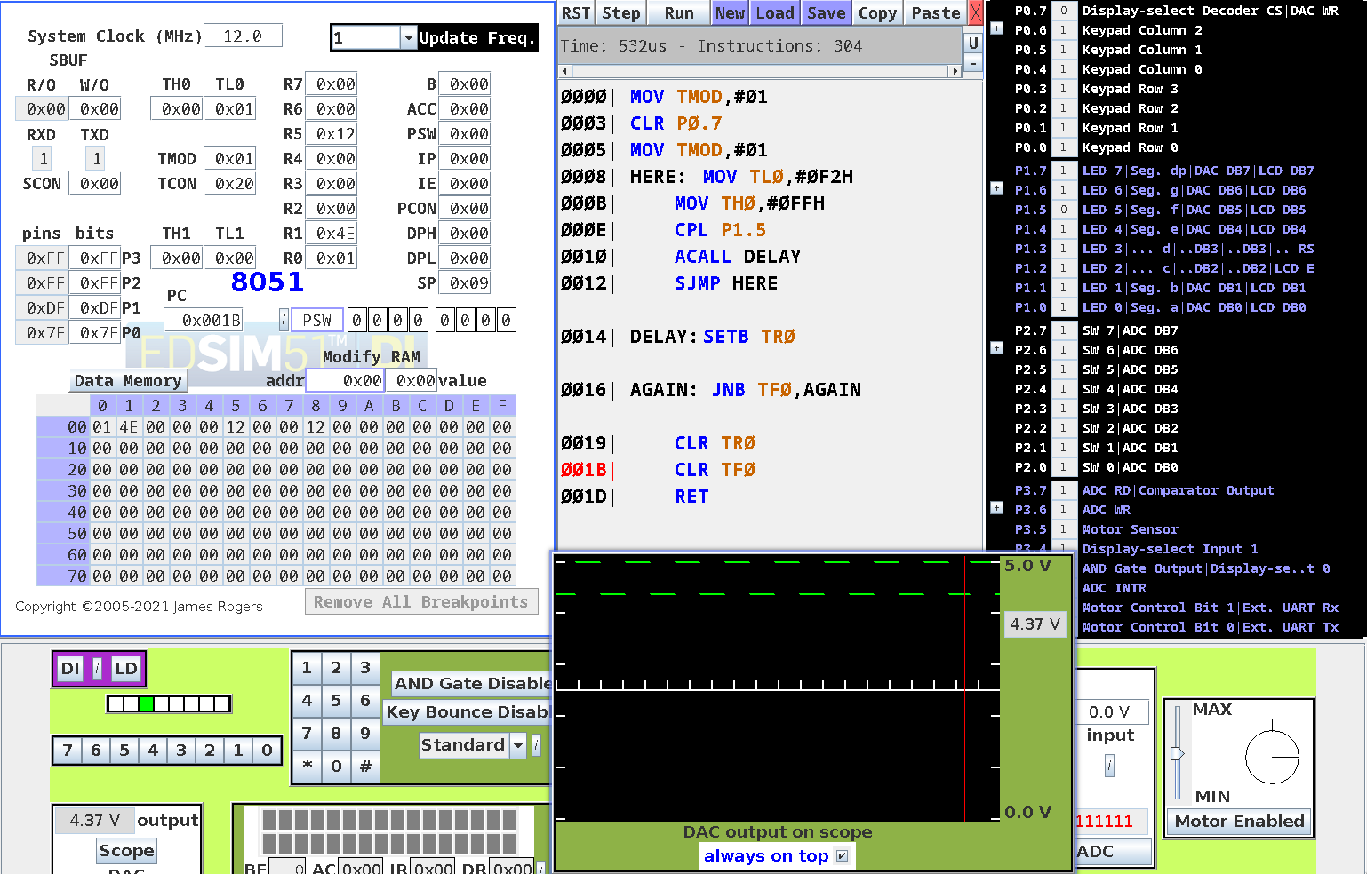
Output :

- Program 2
MOV TMOD,#01
CLR P0.7
HERE: MOV TL0,#0
MOV TH0,#0 ACALL COMPL ACALL DELAY SJMP HERE
DELAY: SETB TR0
AGAIN: JNB TF0,AGAIN
CLR TR0
CLR TF0
RET
COMPL: JB P1.5, ZERO
SETB P1.5
RET
ZERO: CLR P1.5
RET

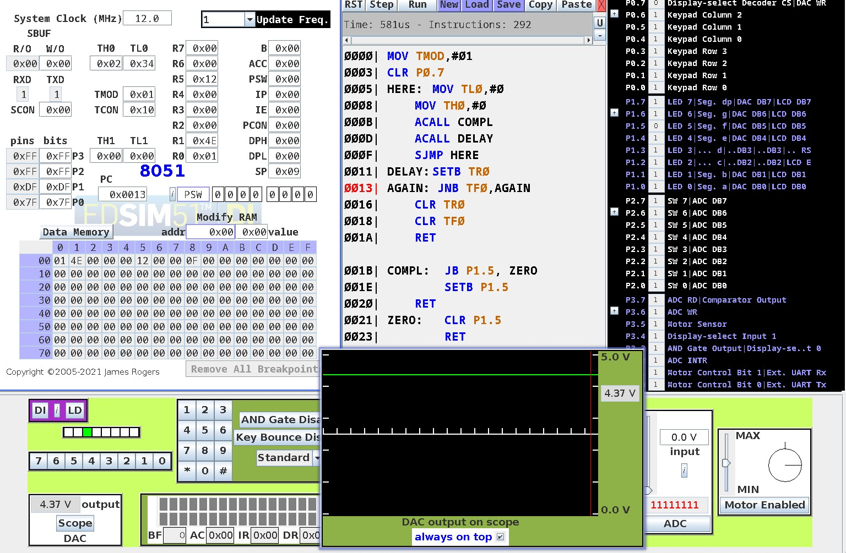
Output :

- Program 3
CLR P2.3
MOV TMOD,#01
CLR P0.7
HERE: MOV TL0,#0F5h
MOV TH0,#0E5h
SETB P2.3
SETB TR0
ACALL AGAIN
JMP HERE
AGAIN: JNB TF0,AGAIN
CLR P2.3
CLR TR0
CLR TF0
RET

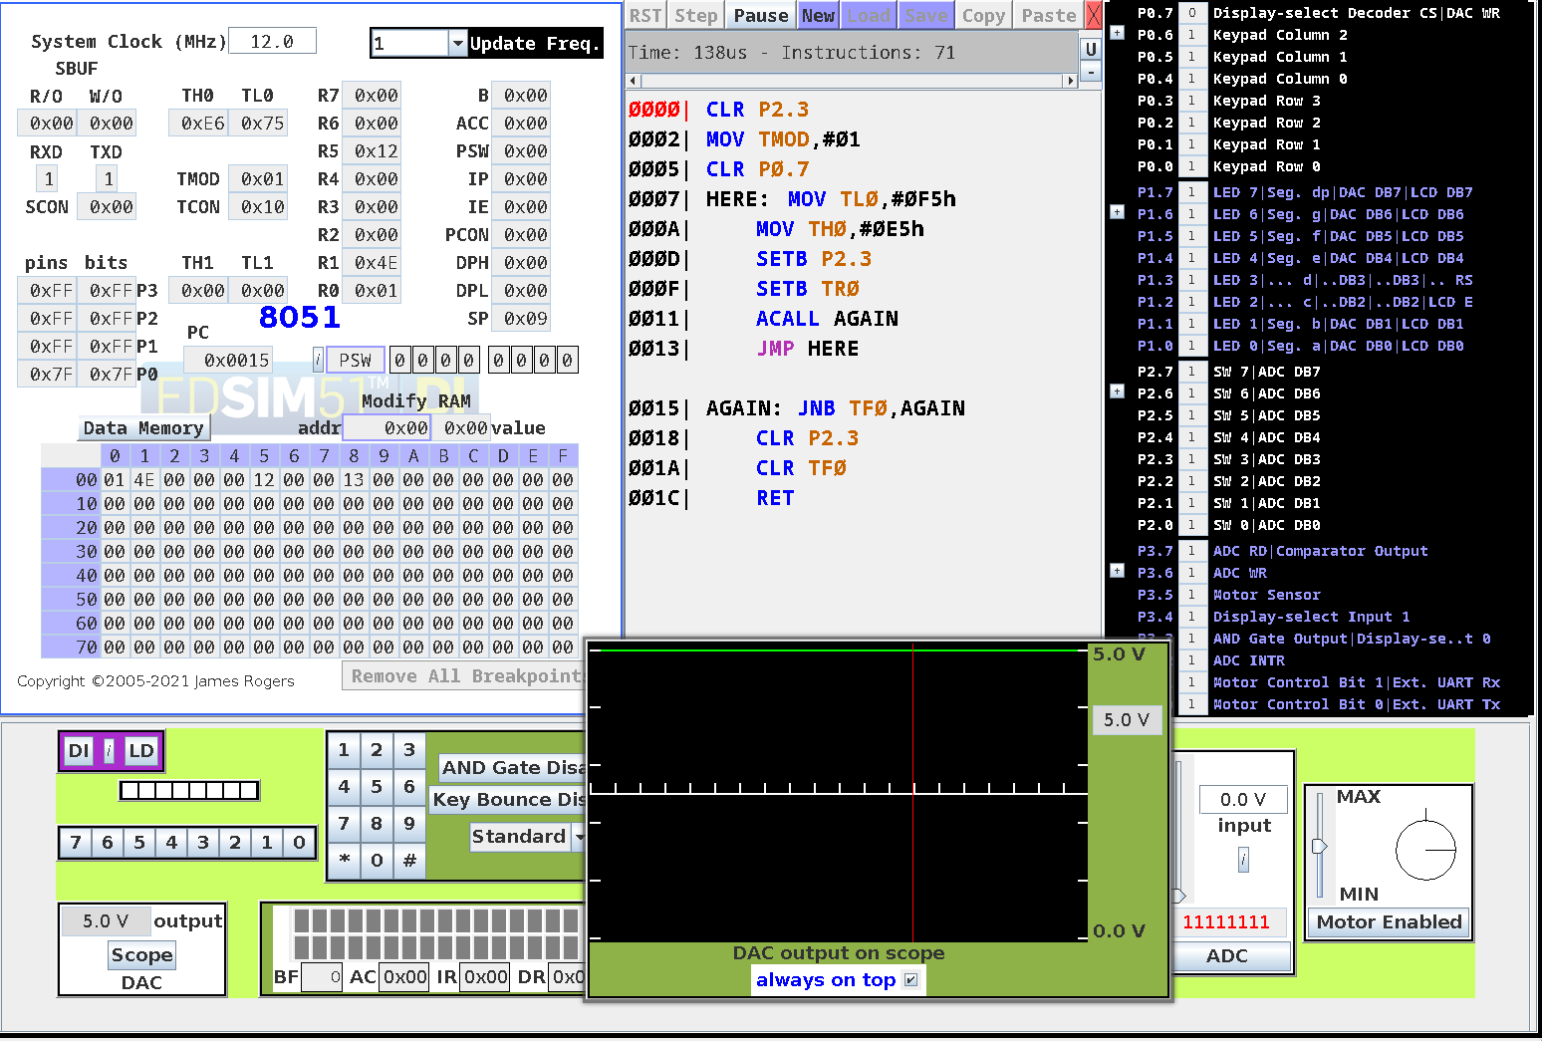
Output :

- Program 4
CLR P1.5
MOV TMOD,#01
CLR P0.7
HERE: ACALL DELAY75
CPL P1.5
ACALL DELAY25
CPL P1.5
JMP HERE

DELAY75:MOV TL0, #0B4h
MOV TH0, #0FFh
SETB TR0
ACALL REPEAT
RET

DELAY25:MOV TL0, #0E6h
MOV TH0, #0FFh
SETB TR0
ACALL REPEAT
RET

REPEAT: JNB TF0, REPEAT
CLR TF0
CLR TR0
RET

Output :
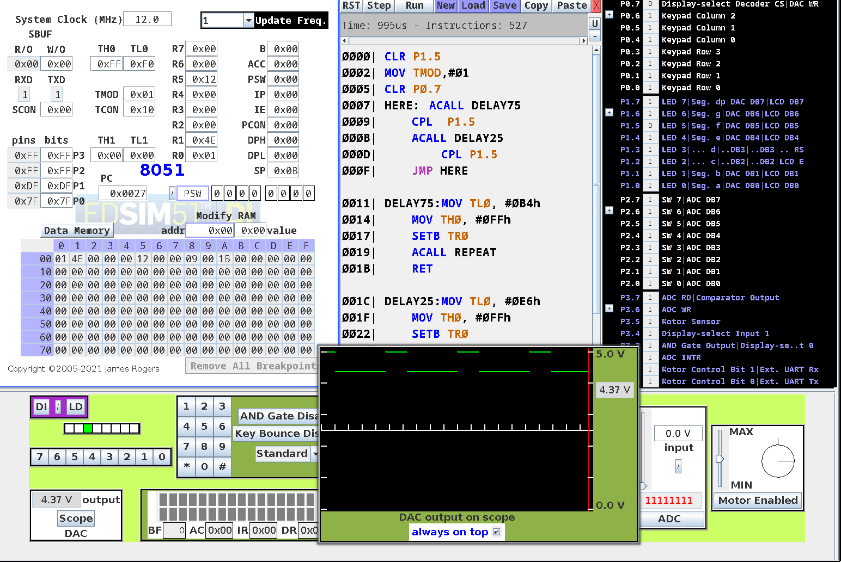

- Program 5
MOV TMOD, #20h
CLR P1.0
CLR P0.7
MOV TH1, #0F0h
MOV TL1, #0F0h
HERE:SETB TR1
CALL DELAY
CPL P1.0
JMP HERE
DELAY: JNB TF1, DELAY
CLR TF1
CLR TR1
RET
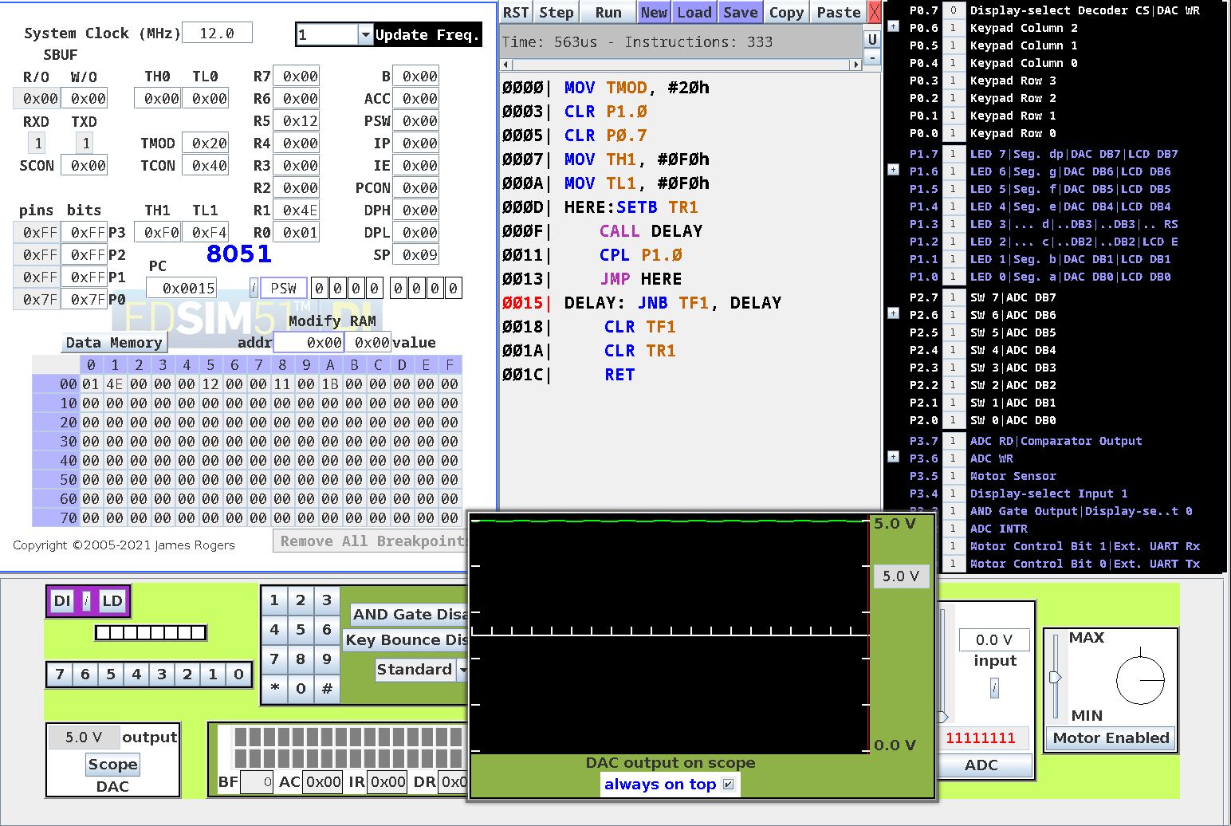
Output :

- Program 6
;Set mode 2 for timer 1
MOV TMOD, #20h
CLR P1.0
; Set intial values for TH and TL
MOV TH1, #0CEh
MOV TL1, #0CEh
; Set number of loops
MOV R2, #200
SETB TR1
;Loop L1 till rollover
L1: JNB TF1, L1
CLR TF1
;loop L1 till R2 becomes 0
DJNZ R2, L1
END

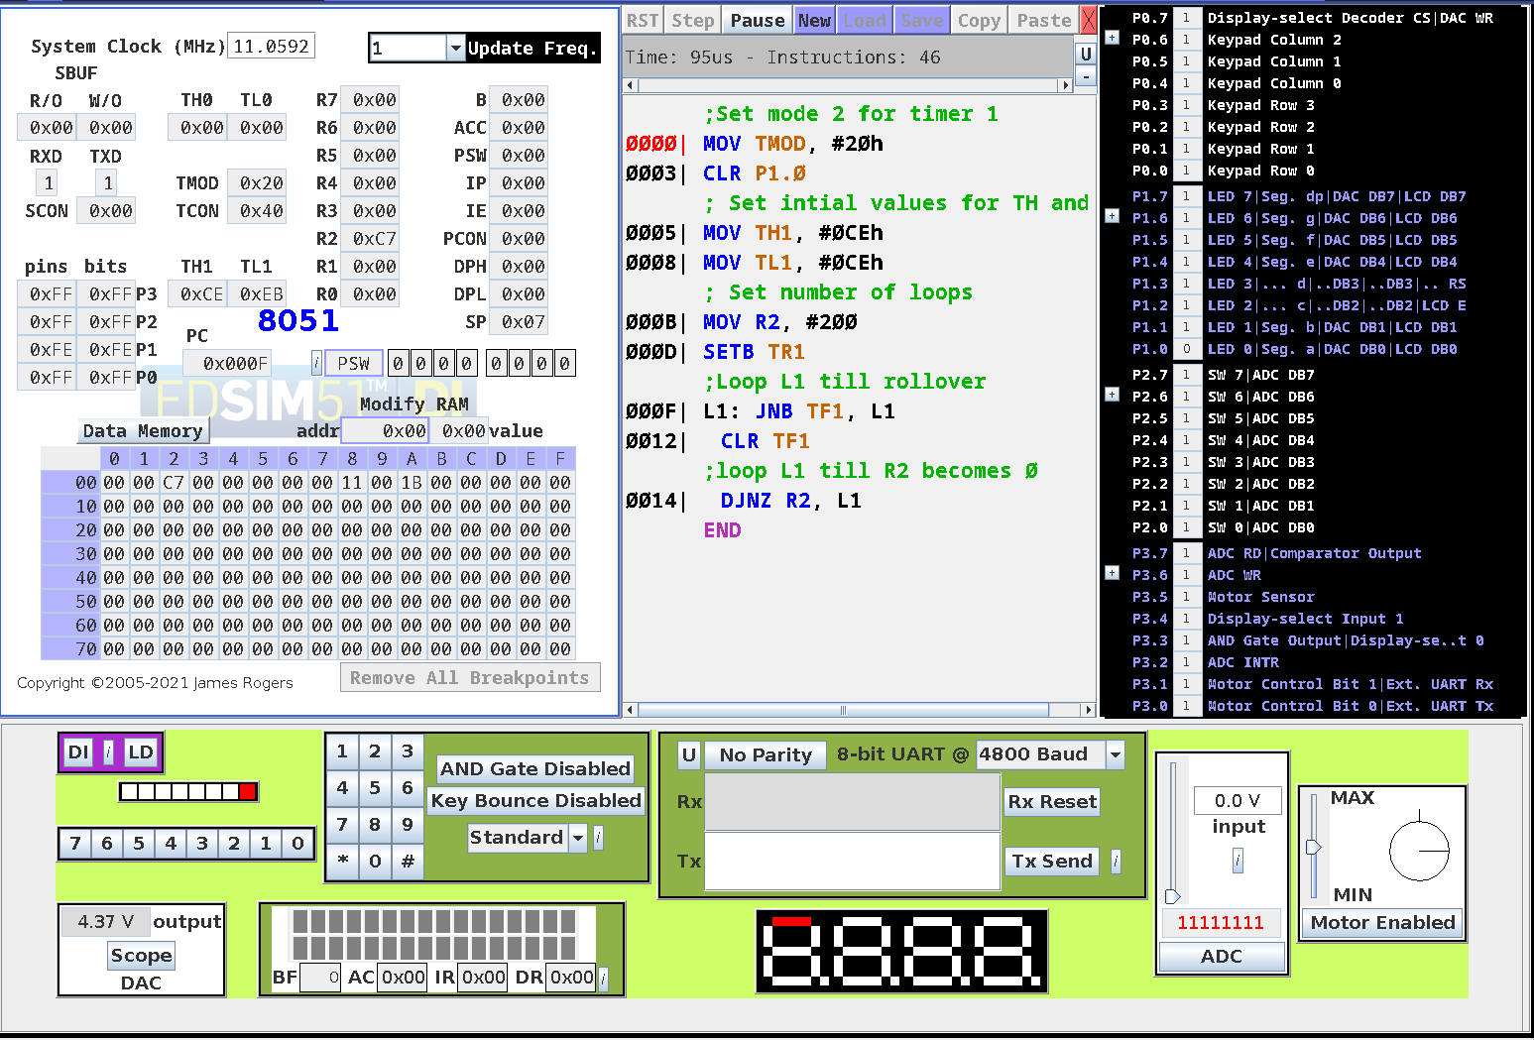
Output :

Total time delay generated:
Let frequency of clock pulse be f and the crystal frequency be C; then;
f = C/12
= 11.0592/12
= 921KHz
Let time for one machine cycle be T; then:
T = 1/f
= 1/921
= 1.085µs
Therefore total time delay(D) generated is
D = 50 ∗ 200 ∗ T
= 10.8ms

Conclusion :
Programs to study Timer were successfully implemented.

Deepraj Bhosale
181105016

