Experiment No : 6

Aim : To interface a keypad with 8051.

Theory :

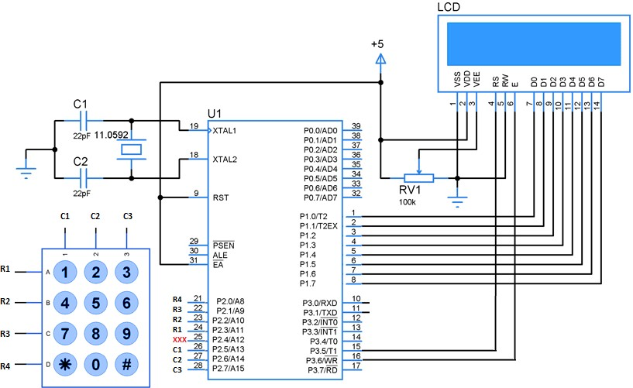

Circuit Connections:
• A 4×3 matrix keypad is interfaced to the microcontroller, which is a 12-key keypad consisting of four rows and three columns.
• The upper pins of port 1, i.e., pin 1.0 to pin 1.3 of the microcontroller are connected to the row lines of the keypad and lower pins (pin 1.4 to pin 1.6) are connected to the column lines.

Circuit Working
◦ Make sure that the all the rows of port 1 high in order to give the signal to microcontroller when any key is pressed.
◦ The working of the keypad goes like this: If any of the keys in row1 of the matrix keypad is pressed, the corresponding column line will give low and similarly if the second key is pressed in row1, then the column line 2 will give low. This process is repeated for all the rows.
◦ When the circuit is powered and any key is pressed, then corresponding pins of the port 1 get enabled.

Complete the following 8051 assembly programs in EDSIM.

1. WAP to use the keypad to store an integer from 0-11 in register R3.
START:
mov r0,#0h

clr p0.0
setb p0.3
call COLSCAN
jb f0,FINISH
clr p0.1
setb p0.0
call COLSCAN
jb f0,FINISH
clr p0.2
setb p0.1
call COLSCAN
jb f0,FINISH
clr p0.3
setb p0.2
call COLSCAN
jb f0,FINISH

jmp START

COLSCAN:
jnb p0.4,KEYFOUND
inc r0
jnb p0.5,KEYFOUND
inc r0
jnb p0.6,KEYFOUND
inc r0
ret

KEYFOUND:
setb f0
ret

FINISH:
mov a,r0
mov r3,a
end

2. WAP to accept two numbers from 0-11 via the keypad, store them in registers and add the numbers and store the result in a register.
;5h+6h=Bh
;Result stored in r7
mov r4,#2 ;counter to loop twice to accept 2 numbers

START:mov p0,#0ffh
clr f0
mov r0,#0h
clr p0.0
setb p0.3
call COLSCAN
jb f0,FINISH
clr p0.1
setb p0.0
call COLSCAN
jb f0,FINISH
clr p0.2
setb p0.1
call COLSCAN
jb f0,FINISH
clr p0.3
setb p0.2
call COLSCAN
jb f0,FINISH

jmp START

COLSCAN:
jnb p0.4,KEYFOUND
inc r0
jnb p0.5,KEYFOUND
inc r0
jnb p0.6,KEYFOUND
inc r0
ret

KEYFOUND: setb f0
ret
FINISH:
add a,r0
djnz r4,START
mov r7,a
end

Conclusion :
Programs to study Timer were successfully implemented.

Deepraj Bhosale
181105016

