Experiment No : 9.1

Aim : Interrupts

Procedure :
Complete the following 8051 assembly programs in EDSIM:
  - Write a program that :
    - continuously gets 8-bit data from a switch which is connected to P2, and sends it to P3 while
    - simultaneously creating a square wave of 200 us period on pin P1.1.
    - Use timer 0 to create the square wave.
    - Assume that XTAL = 11.0592 MHz.
  - Write a program that
    - continuously get 8-bit data from a switch connected to port P2 and sends it to P3 while
    - simultaneously creating a square wave a that has a high portion of 1085 us and a low portion of 15 us on P1.1 .
    - Assume XTAL=11.0592MHz. Use timer 1.
  - Write a program to generate a square wave if 50Hz frequency on pin P1.1. Use an interrupt for timer 0. Assume that XTAL=11.0592 MHz
  - Assume that the INT1 pin is connected to a switch that is normally high. Whenever the switch goes low, it should turn on an LED. The LED is connected to P1.3 and is normally off. When it is turned on it should stay on as long as the switch is pressed low.

Code & Output :

ORG 0000h
LJMP MAIN

; ISR for timer 0
ORG 000Bh
CPL P1.1
RETI

MAIN:
; enable timer interrupt
MOV IE, #82h

;Setup timer
CLR P0.7 ; enable dac
MOV TMOD, #02h
MOV TH0, #A2h ;
MOV TL0, #0B9h

; make p2 input
MOV A, #0FFh
MOV P2, A; Make p2 an input port

;Start timer
SETB TR0

IO:
MOV A, P2
MOV P3, A
JMP IO

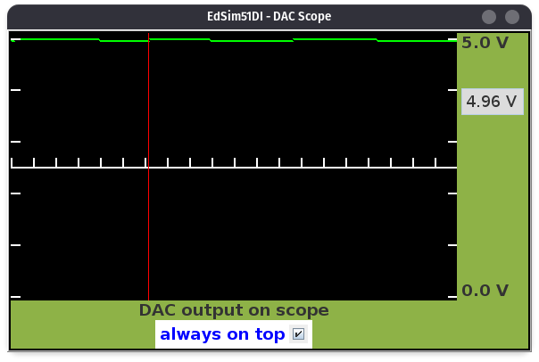

ORG 0000h
LJMP MAIN
; ISR for timer 1
ORG 001Bh
LJMP WAVE
MAIN:
; enable timer interrupt
MOV IE, #82h
;Setup timer
CLR P0.7 ; enable dac
MOV TMOD, #10h
MOV TH1, #0FFh
MOV TL1, #0F1h ;
CLR P1.1
CLR F0; F0=0 means currently wave is low
; make p2 input
MOV A, #0FFh
MOV P2, A; Make p2 an input port
;Start timer
SETB TR1
IO:
MOV A, P2
MOV P3, A
JMP IO
WAVE:
JB F0, MAKELOW
MOV TH1, #0FFh
MOV TL1, #0F1h
SETB P1.1
RETI
MAKELOW:
MOV TH1, #0FCh
MOV TL1, #17h
CLR P1.1
RETI

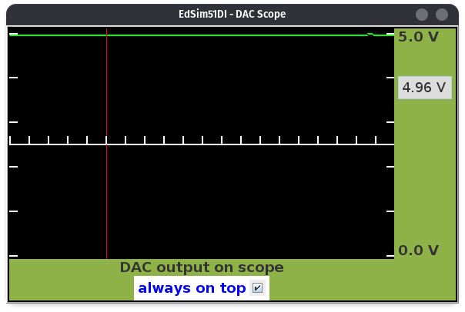

ORG 0
LJMP MAIN
ORG 000BH ;ISR for Timer 0
CPL P1.1
MOV TL0,#00
MOV TH0,#0DCH
RETI
ORG 30H
MAIN:
CLR P0,7; enable DAC
MOV TM0D,#01h ;Timer 0, Mode 1
MOV TL0,#00
MOV TH0,#0DCH
MOV IE,#82H ;enable timer 0 interrupt
SETB TR0
Here:SJMP HERE
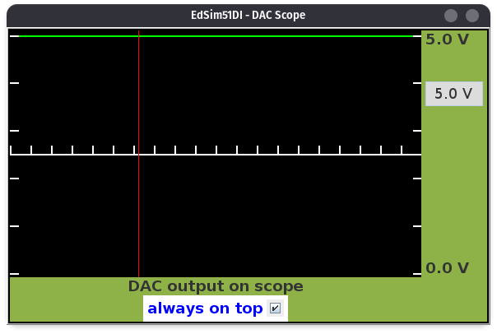

ORG 0000h
LJMP MAIN
;ISR for INT1
ORG 0013h
SETB P1.3 ;Turn on LED
MOV R3, #255
BACK:
DJNZ R3, BACK ;Keep on for fraction of a second
CLR P1.3 ; Turn off LED
RETI
ORG 30H
MAIN:
MOV IE, #10000100B
; Trap till interrupt occurs
HERE:
SJMP HERE

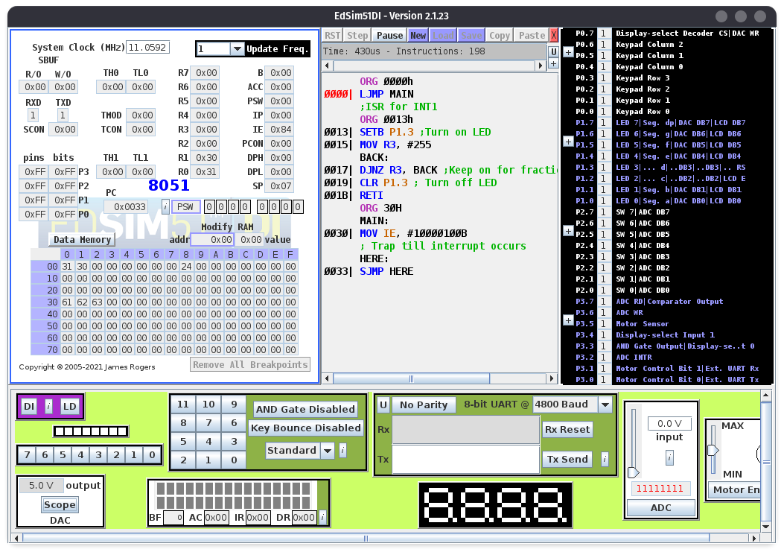

Conclusion : The given 8051 programs to demonstrate interrupts were successfully coded and executed

Deepraj Bhosale
181105016

