Experiment No: 1 Date:
Lab Session 1: Getting Started with Orange

Aim:
Explore the Orange Application
Develop workflows using the Data Mining Tool
Visualize the data using visualization tools

Problem Description:
For the given dataset, perform the following tasks:
Load the dataset
View the data
Filter the data based on rows and columns
Visualize the data using Scatter Plot and Distributions
Widgets Used:
File
Data Table
Select Columns
Select Rows
Data Workflow:
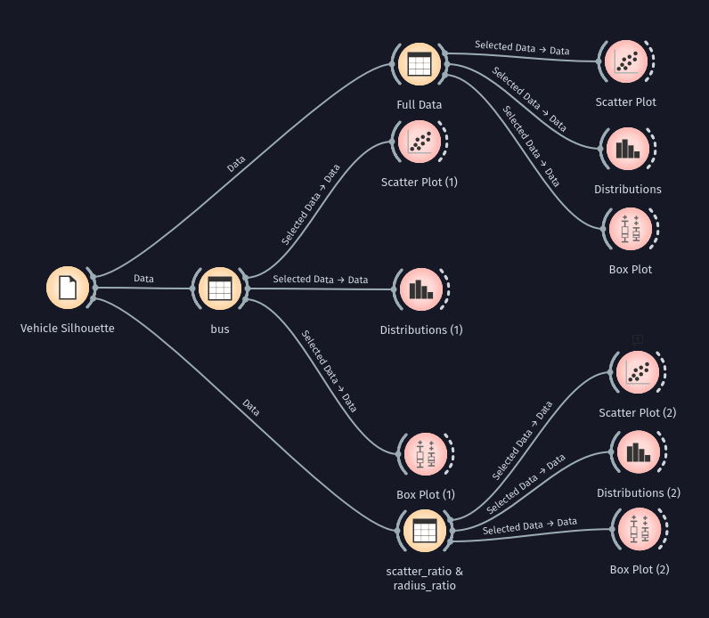

Visualizing the data:
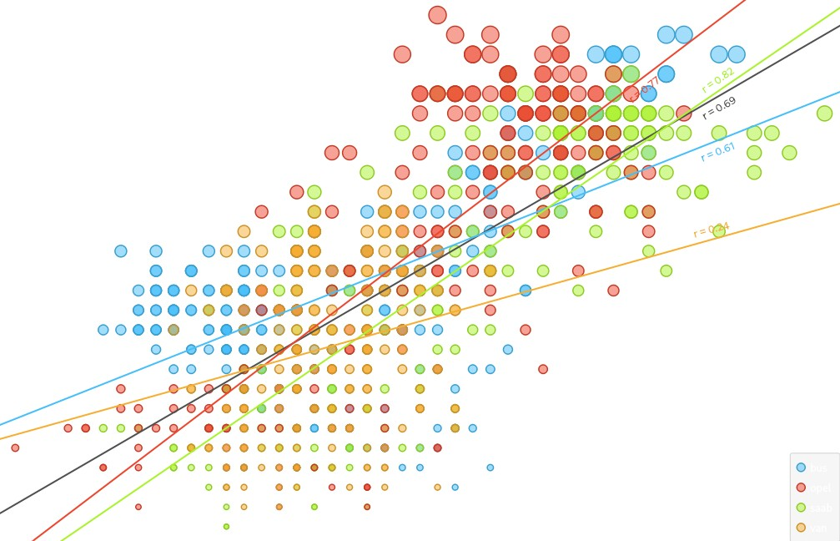  All Data - Scatter Plot | 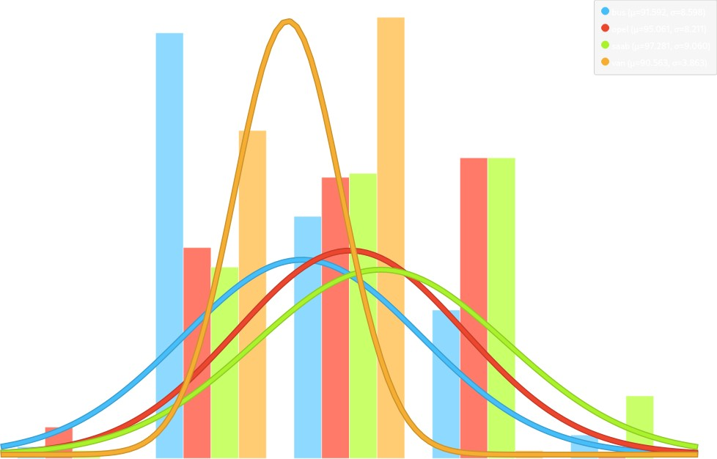  All Data - Distribution
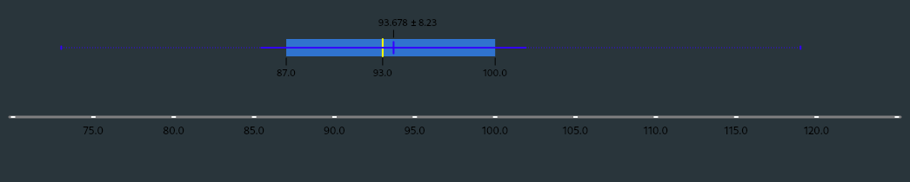  All Data - Box Plot | 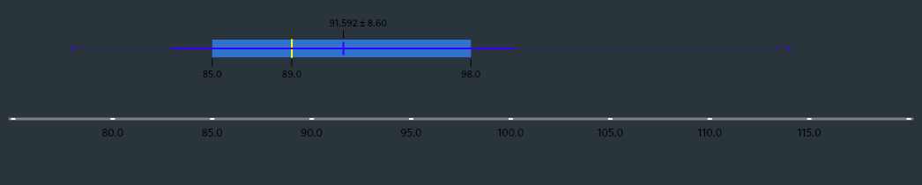  Bus (Rows) - Box Plot
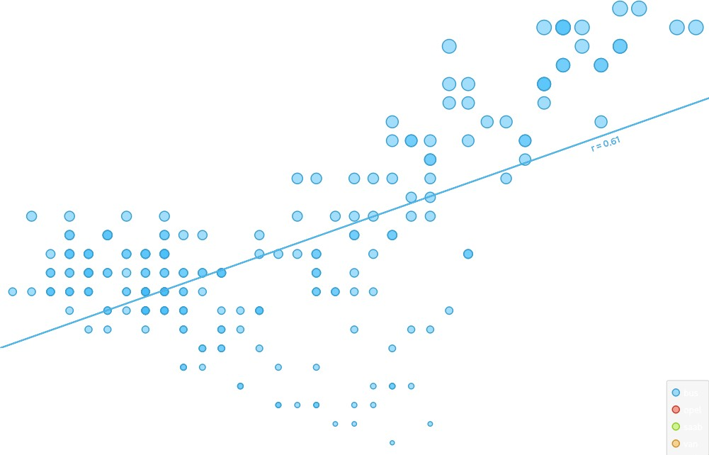  Bus (Rows) - Scatter Plot | 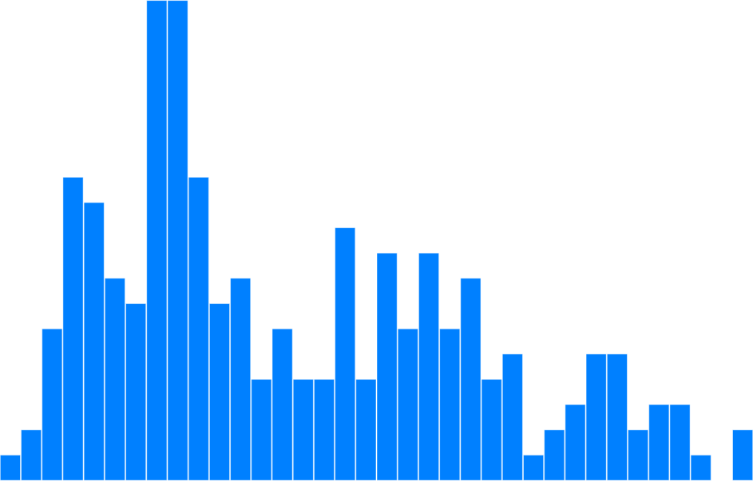  Bus (Rows) - Distribution
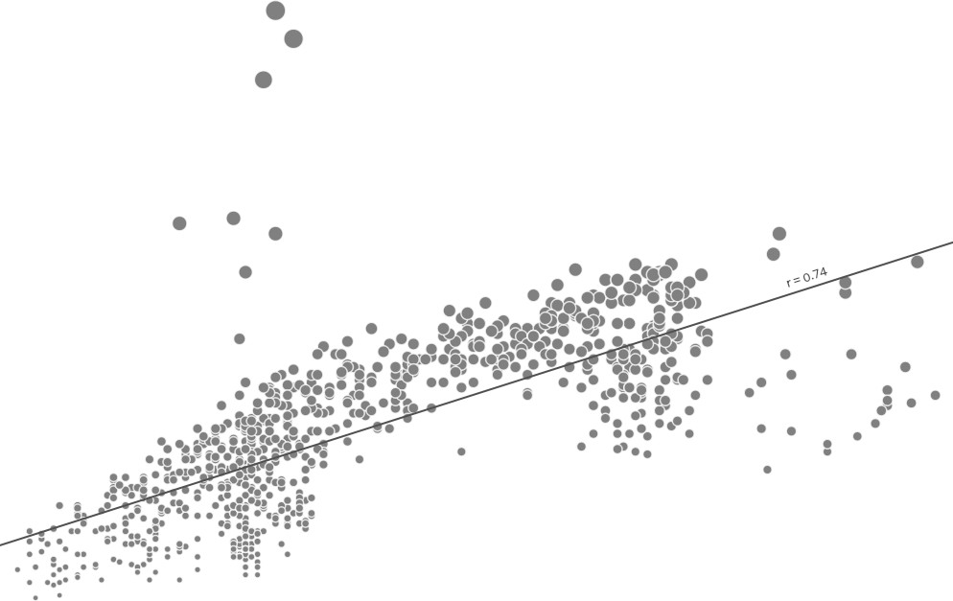  scatter_ratio & radius_ratio (Cols) - Scatter Plot | 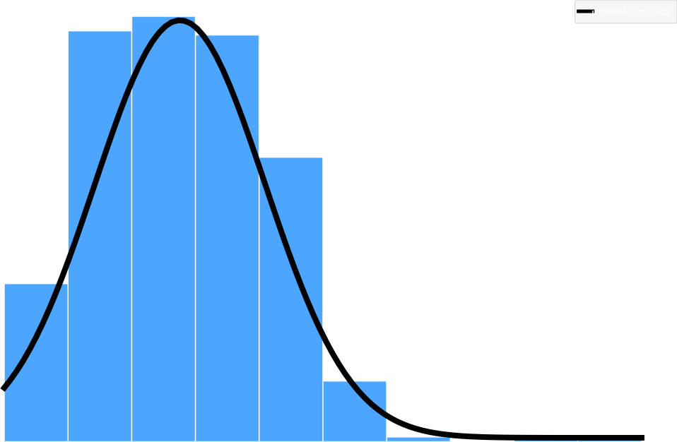  scatter_ratio & radius_ratio (Cols) - Distribution
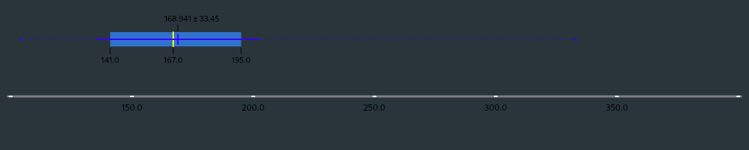
scatter_ratio & radius_ratio (Cols) - Box Plot

Conclusion/Inferences:
For all data:
Scatter Plot: (x - compactness, y - circularity)
1. With the increase of the car's compactness, we observe an increase in the circularity too.
2. Vehicle with the lowest circularity (33) is a saab having compactness 85
3. Vehicle with the highest circularity (59) is an opel having compactness 97
4. Vehicle with the lowest compactness (73) is an opel having circularity 37
5. Vehicle with the highest compactness (119) is an saab having circularity 54
Distribution: (compactness)
1. Majority of vans have compactness ranging between 80 and 100
2. Most buses have compactness in the range 80 and 90
3. Most vans have compactness in the range 90 and 100
4. The same number of opel and saab (77) have compactness in the range 100 and 110
5. There are no vans having compactness less than 80
Box Plot: (compactness)
1. The mean compactness is 93.678 +- 8.23
2. The median compactness is 93
3. The lowest outlier is 73
4. The highest outlier is 119
5. The range of first quantile and third quantile is 87 - 100
For vehicle_class "bus" (Rows):
Scatter Plot: (x - compactness, y - circularity)
1. With the increase of the bus's compactness, we observe an increase in the circularity too.
2. Bus with the lowest circularity (35) has compactness = 98
3. 2 Buses have the highest circularity (58) have compactness 110 and 111.
4. Bus with the lowest compactness (78) has circularity = 43
5. Bus with the highest compactness (114) has circularity = 57
Distribution: (compactness)
1. Most Buses have compactness 85 - 87 (50)
2. Only 2 buses have the highest compactness greater than 112
3. Only 3 buses have the lowest compactness less than 80
4. 29 buses have the second highest compactness 80 - 82
5. 19 buses have the third highest compactness 95 - 97.5
Box Plot: (compactness)
1. The mean compactness is 91.592 +- 8.6
2. The median compactness is 89
3. The lowest outlier is 78
4. The highest outlier is 114
5. The range of first quantile and third quantile is 85 - 98
For scatter_ratio & radius_ratio (Cols):
Scatter Plot: (x - scatter_ratio, y - radius_ratio)
1. With the increase of the vehicle scatter_ratio, we observe an increase in the radius_ratio too.
2. Vehicle with the lowest scatter_ratio (112) has radius_ratio = 115
3. Vehicle with the highest scatter_ratio (265) has radius_ratio = 183
4. vehicle with the lowest radius_ratio (104) has scatter_ratio = 115
5. vehicle with the highest radius_ratio (333) has scatter_ratio = 155
Distribution: (radius_ratio)
1. Most vehicles have radius_ratio in the range 150 - 175
2. No vehicles have radius_ratio in the range 275 - 300
3. Majority of vehicles have radius_ratio in the range 125 - 200
4. Vehicles having radius_ratio < 125 are 76 Vehicles having radius_ratio < 125 are 76 Vehicles having radius_ratio < 125 are 76
5. Vehicles having radius_ratio > 325 is just 1
Box Plot: (radius_ratio)
1. The mean compactness is 168.941 +- 33.45
2. The median compactness is 167
3. The lowest outlier is
4. The highest outlier is
5. The range of first quantile and third quantile is 141 - 195

