Experiment No: 2 Date:
Lab Session 2: Data Pre-processing using Orange

Aim: Perform data cleaning and pre processing on the given dataset

Problem Description: Perform the following on the given dataset
- Impute Missing values
- Discretize continuous values
- Continuize discrete values
- Select relevant attributes
- Select random attributes
Widgets Used:
Preprocess
Data Workflow:
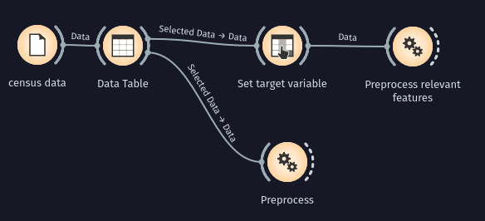

Conclusion: Justify the strategies that you have used to achieve the aim of this experiment.
1) Imputation:
If we impute using most frequent/average value statistically most of the missing values will be filled in with the correct value. This is not true in case the absence of the value means something.
2) Discretisation:
I’ve Discretised using equal width binning and 10 bins. Thus we can still somewhat infer relative size between bins
3) Continuization:
I’ve Continuized categorical variables by setting the most frequent value as base. This would maintain the frequency information in the category.

