Experiment No: 3 Date:
Lab Session 3: K Nearest Neighbour Classifier

Aim: Implement KNN classifier on the following datasets:
a. Iris Dataset
b. Titanic Dataset
c. Placement Dataset

Problem Description: Implement the KNN Classifier and note the following observations for each of the datasets:
a. The need for Data Sampler
b. The impact of k on the performance of the classifier
c. The impact of the splitting ratio on the performance
Widgets Used:
- Data Sampler (Refer Error: Reference source not found)
- Test and Score
- KNN
- Confusion Matrix
- CSV File Import
Data Workflow:
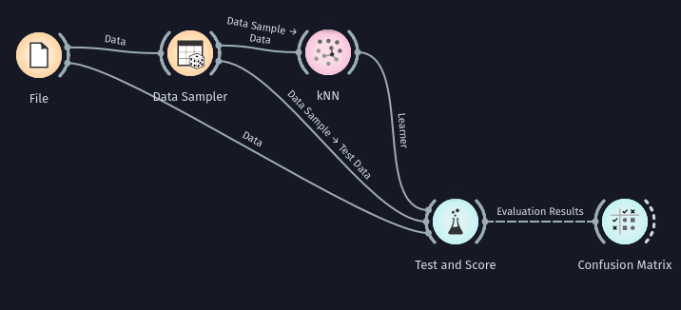

Output:
Iris Dataset: 1) k=3
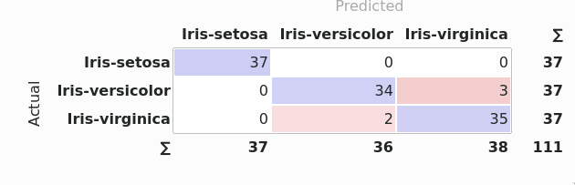
Titanic Dataset: 1) k=3
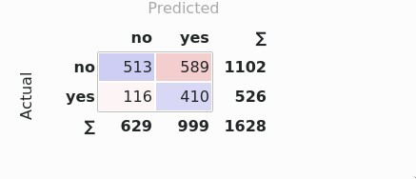
Placement Dataset: 1) k=3
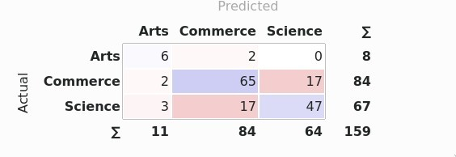

Observations and Conclusion:
- The impact of k is seen as follows on the evaluation metrics:
  - Iris Dataset
 | Accuracy | Precision | Recall | F score
K=3 | 0.955 | 0.955 | 0.955 | 0.955
K=5 | 0.964 | 0.965 | 0.964 | 0.964
K=7 | 0.973 | 0.975 | 0.973 | 0.973
K=11 | 0.991 | 0.991 | 0.991 | 0.991
  - Titanic Dataset
 | Accuracy | Precision | Recall | F score
K=3 | 0.567 | 0.685 | 0.567 | 0.575
K=5 | 0.504 | 0.656 | 0.504 | 0.501
K=7 | 0.353 | 0.566 | 0.353 | 0.255
K=11 | 0.353 | 0.566 | 0.353 | 0.255
  - Placement Dataset
 | Accuracy | Precision | Recall | F score
K=3 | 0.742 | 0.746 | 0.742 | 0.743
K=5 | 0.66 | 0.654 | 0.66 | 0.654
K=7 | 0.616 | 0.605 | 0.616 | 0.607
K=11 | 0.56 | 0.533 | 0.56 | 0.531

- The impact of split ratio for a particular value of k=11
  - Iris Dataset
Split Ratio | Accuracy | Precision | Recall | F score
50-50 | 0.987 | 0.987 | 0.987 | 0.987
60-40 | 0.983 | 0.984 | 0.983 | 0.983
70-30 | 0.978 | 0.979 | 0.978 | 0.978
90-10 | 1.0 | 1.0 | 1.0 | 1.0
  - Titanic Dataset
Split Ratio | Accuracy | Precision | Recall | F score
50-50 | 0.351 | 0.561 | 0.351 | 0.251
60-40 | 0.340 | 0.522 | 0.340 | 0.233
70-30 | 0.344 | 0.537 | 0.344 | 0.240
90-10 | 0.359 | 0.595 | 0.359 | 0.261
  - Placement Dataset
Split Ratio | Accuracy | Precision | Recall | F score
50-50 | 0.561 | 0.533 | 0.561 | 0.538
60-40 | 0.593 | 0.563 | 0.593 | 0.565
70-30 | 0.5 | 0.465 | 0.5 | 0.469
90-10 | 0.476 | 0.433 | 0.476 | 0.433

Conclusion:
- For the iris dataset with 3 target classes, increasing the k value seems to increase the accuracy of the classifier
- For the titanic and placement dataset with 2 and 3 classes respectively, increasing the k value seems to decrease the accuracy of the classifier
- Increasing the sampling ratio seems to decrease the accuracy
- The 90-10 sampling ratio appears to cause an increase in the accuracy as compared to previous ratios possibly due to lack of testing data
- For the placement dataset, increase split ratio seems to increase accuracy intially but for larger splits the accuracy decreases.

