Experiment No: 5 Date:
Lab Session 5: Comparison of Rule Based Classifier, Decision Tree and KNN Classifier

Aim: Compare the performance of Rule Based Classifier, Decision Tree and KNN Classifier on the following datasets:
      - Iris Dataset
      - Titanic Dataset
      - Placement Dataset

Problem Description: Compare the performance of Rule Based Classifier, Decision Tree and KNN Classifier on the following datasets:
      - Iris Dataset
      - Titanic Dataset
      - Placement Dataset
Widgets Used:
- Data Sampler (Refer Error: Reference source not found)
- Test and Score
- Tree
- Tree Viewer
- CN2 Rules
- KNN
- Confusion Matrix
- CSV File Import
Data Workflow:
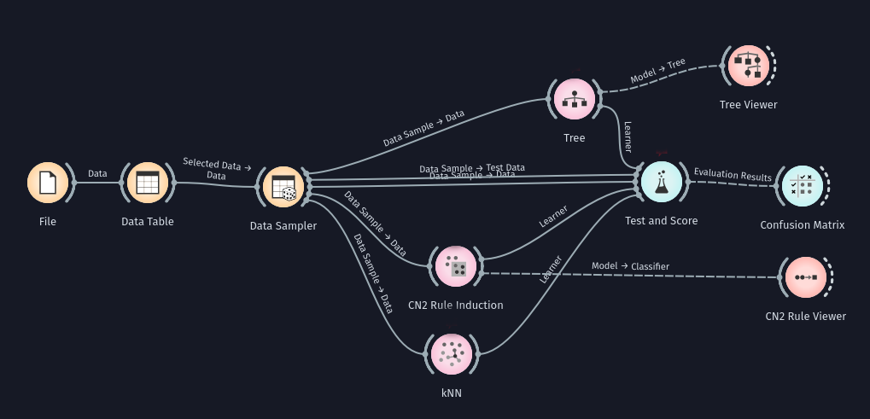

Output:
- Iris Dataset
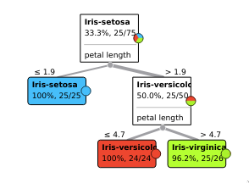

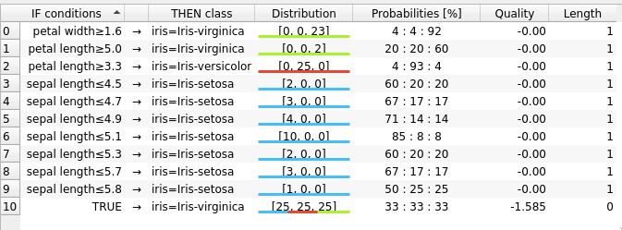

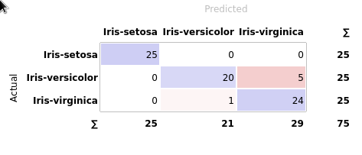

- Titanic Dataset

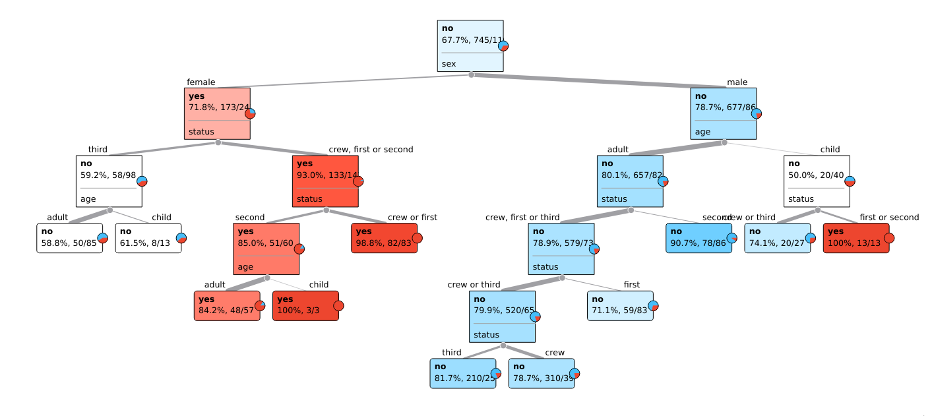

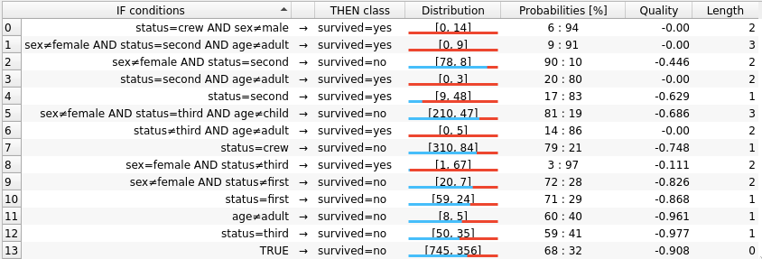

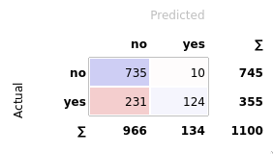

    - Placement Dataset
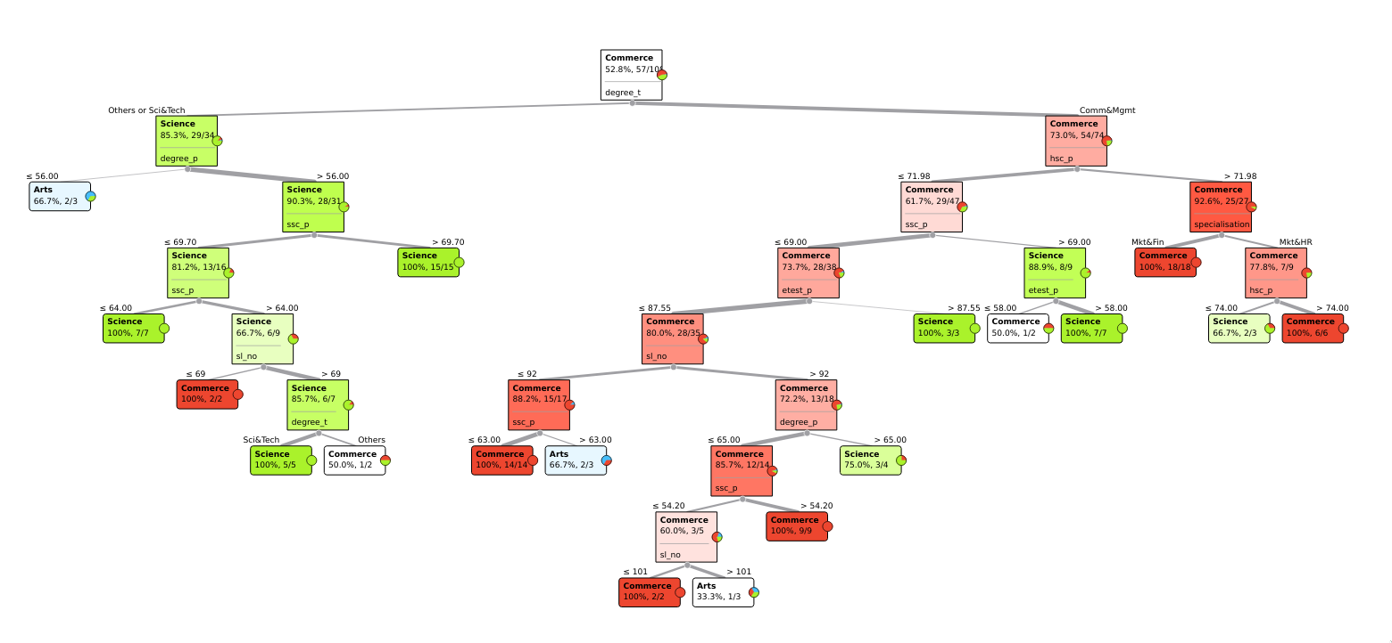

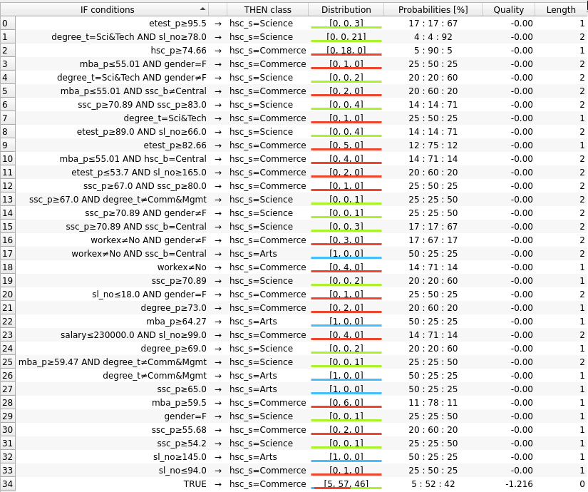

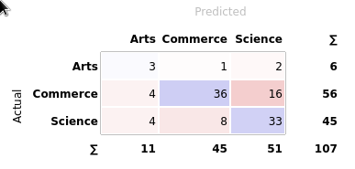

Observations and Conclusion:
- Iris Dataset
Algorithm | Accuracy | Precision | Recall | F Score
Decision Tree | 0.947 | 0.954 | 0.947 | 0.947
KNN | 0.960 | 0.964 | 0.960 | 0.960
Rule Based Classifier | 0.933 | 0.937 | 0.933 | 0.933

- Titanic Dataset
Algorithm | Accuracy | Precision | Recall | F Score
Decision Tree | 0.777 | 0.808 | 0.777 | 0.741
KNN | 0.777 | 0.808 | 0.777 | 0.741
Rule Based Classifier | 0.781 | 0.811 | 0.781 | 0.747

- Placement Dataset
Algorithm | Accuracy | Precision | Recall | F Score
Decision Tree | 0.710 | 0.729 | 0.710 | 0.719
KNN | 0.467 | 0.436 | 0.467 | 0.450
Rule Based Classifier | 0.785 | 0.768 | 0.785 | 0.774

