Experiment No: 5 Date: 26.10.2021
Aim: Write a Python program to read an image from a file system and perform the bit plane slicing of the image and write it back with a different name.

Algorithm:
- Read the image and store it in a container to perform operations on it.
- Convert this image into grayscale image
- Input a value for which bit position you want to display the image
- Get the RGB value of the pixel
- Now convert the decimal value to binary and extract the value at the position earlier inputted.
- Save the new RGB value in the pixel
- Repeat step 4 - 6 for each pixel of the image
- Choose a directory to store the new image
- Store the sliced image into the selected directory

Program:
Python Code:
def show_image(self):
file_filter = 'Image File (*.jpg *.png)'
fname = QtWidgets.QFileDialog.getOpenFileName(parent=self.centralwidget,
caption='Select an Image',
directory="/run/media/deeprajb/HDD/Important Photos/Wallpapers",
filter=file_filter)
self.img = cv2.imread(fname[0], cv2.IMREAD_GRAYSCALE)
self.img1 = QtGui.QImage(self.img.data, self.img.shape[1], self.img.shape[0], QtGui.QImage.Format_Grayscale8)
self.imageinput.setPixmap(QtGui.QPixmap.fromImage(self.img1))

def DecimalToBinary(self,num,width):
bnr = bin(num).replace('0b','')
x = bnr[::-1]
while len(x) < width:
x += '0'
bnr = x[::-1]
return bnr
def bit_to_img(self,array,bitselect):
img_con=[]
for i in array:
img_con.append(i[bitselect])
return img_con

def bit_plane_slicing(self):
(row, col) = self.img.shape[0:2]
lst = []
for i in range(row):
for j in range(col):
lst.append(np.binary_repr(self.img[i][j] ,width=8))
new_img=(np.array([int(i[7-self.comboBox.currentIndex()]) for i in lst],dtype = np.uint8) * (2**(self.comboBox.currentIndex()))).reshape(self.img.shape[0],self.img.shape[1])
cv2.imwrite('bps_output.jpg',new_img)
self.imageoutput.setPixmap(QtGui.Qpixmap("bps_output.jpg"))

Output:
Python GUI Output:
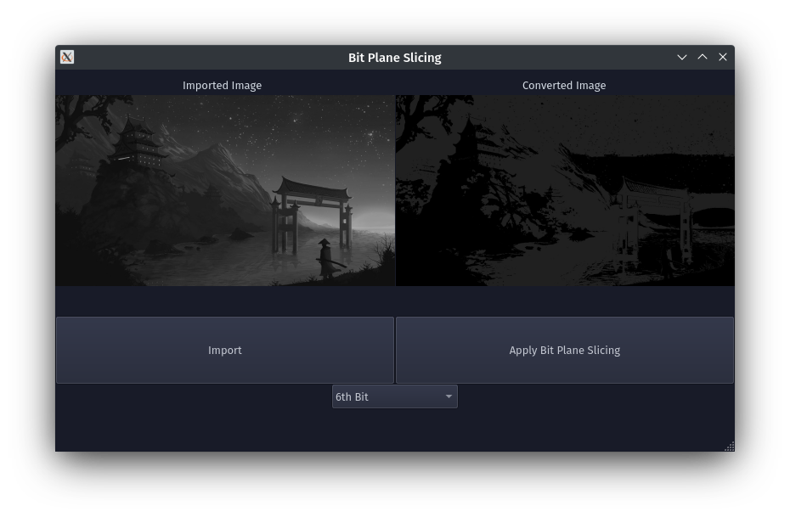

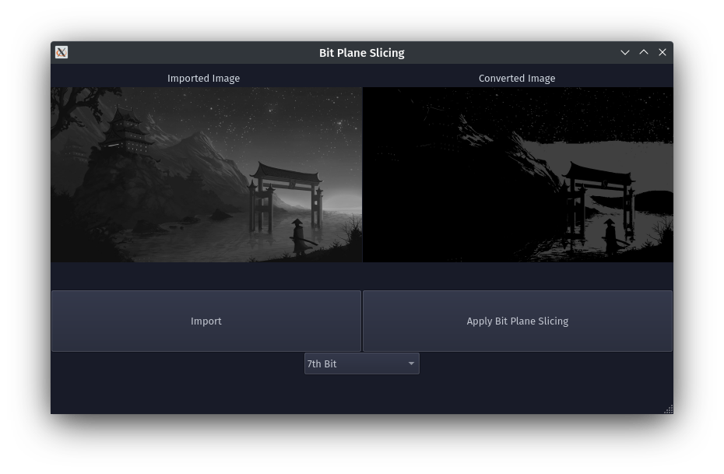

Conclusion: Program to read an image and perform bit plane slicing on it was written and executed successfully.

