Experiment No: 6 Date: 02.11.2021
Aim: Write a Java program to read an image from a file system and perform contrast stretching of the image and write it back with a different name.

Theory: Contrast stretching (often called normalization) is a simple image enhancement technique that attempts to improve the contrast in an image by `stretching' the range of intensity values it contains to span a desired range of values, e.g. the the full range of pixel values that the image type concerned allows. It differs from the more sophisticated histogram equalization in that it can only apply a linear scaling function to the image pixel values. As a result the 'enhancement' is less harsh. There are 2 types :
- Linear Transform : it stretches the Image in full range from 0 to 2^B - 1. The formula used to stretch the pixel is given by Sk = [ ( 2^B - 1 ) ( Rk - Rmin ) ] / ( Rmin - Rmax ) and the transformation function graph is given by :
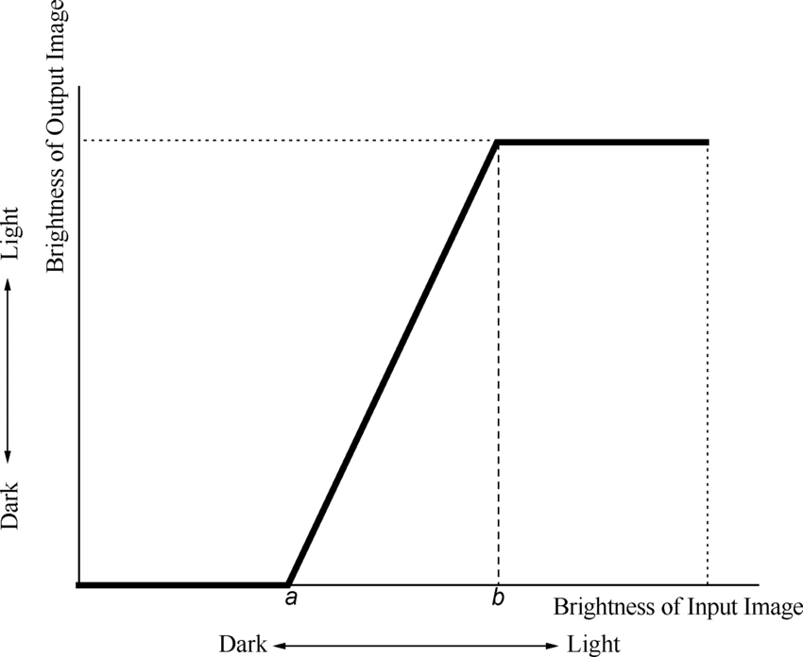

- Limited Linear Transform : In this only a limited range is stretched . The range is specified by the user in which the image needs to be stretched and is generally represented by R1 ( lower limit ) and R2 ( upper limit ). The S1 and S2 values are also specified by the user . There can be 2 types in this too : One in which the values outside the range are left as it is and the other in which if the pixel is less than or equal to the lower limit it is substituted by the S1 value and if the pixel is greater than or equal to upper limit it is replaced by the S2 value. The formula to calculate the stretched image is given by :
S2 = S1 + { [ ( S2 - S1 ) ( R - R1 ) ] / ( R2 - R1 ) }
The transformation function is given by :

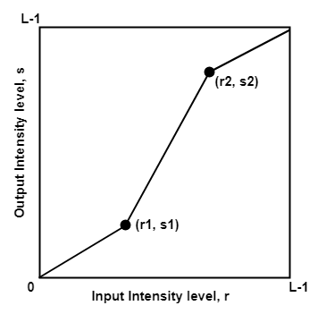
ALGORITHM :
- Read the image and store it in a container to perform operations on it.
- Convert this image into grayscale image
- Input the values of R1, R2, S1 and S2
- Get the RGB value of the pixel
- Now calculate a new value of the pixel based on the type ( linear / limited linear ) using formulas given in above theory .
- Save the new RGB value in the pixel
- Repeat step 4 - 6 for each pixel of the image
- Choose a directory to store the new image
- Store the sliced image into the selected directory

Program:
Python Code:
def show_image(self):
file_filter = 'Image File (*.jpg *.png)'
fname = QtWidgets.QFileDialog.getOpenFileName(parent=self.centralwidget,
caption='Select an Image',
directory="/run/media/deeprajb/HDD/Important Photos/Wallpapers",
filter=file_filter)
self.img = cv2.imread(fname[0], cv2.IMREAD_GRAYSCALE)
self.img1 = QtGui.QImage(self.img.data, self.img.shape[1], self.img.shape[0], QtGui.QImage.Format_Grayscale8)
self.imageinput.setPixmap(QtGui.Qpixmap.fromImage(self.img1))

def contrast_stretching(self):
(row, col) = self.img.shape[0:2]
min_range = self.lowerbound.value()
max_range = self.upperbound.value()
cso = self.img.copy()
smin=0
smax=255
for i in range(0,row-1):
for j in range(0,col-1):
if self.img[i,j] <= min_range:
cso[i,j] = smin
elif self.img[i,j] >= max_range:
cso[i,j] = smax
else:
cso[i,j] = smin + (((smax-smin)*(self.img[i,j]-min_range))/(max_range-min_range))
cv2.imwrite('cs_output.jpg',cso)
self.imageoutput.setPixmap(QtGui.QPixmap("cs_output.jpg"))

Output:
Python GUI Output:
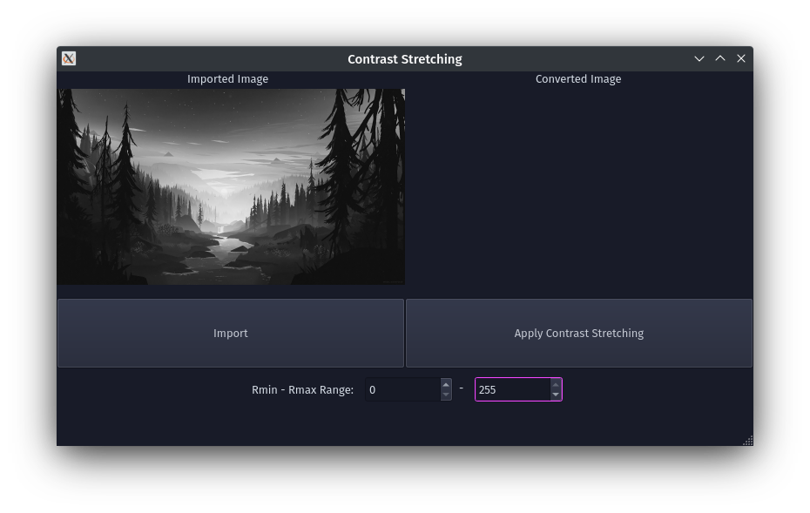
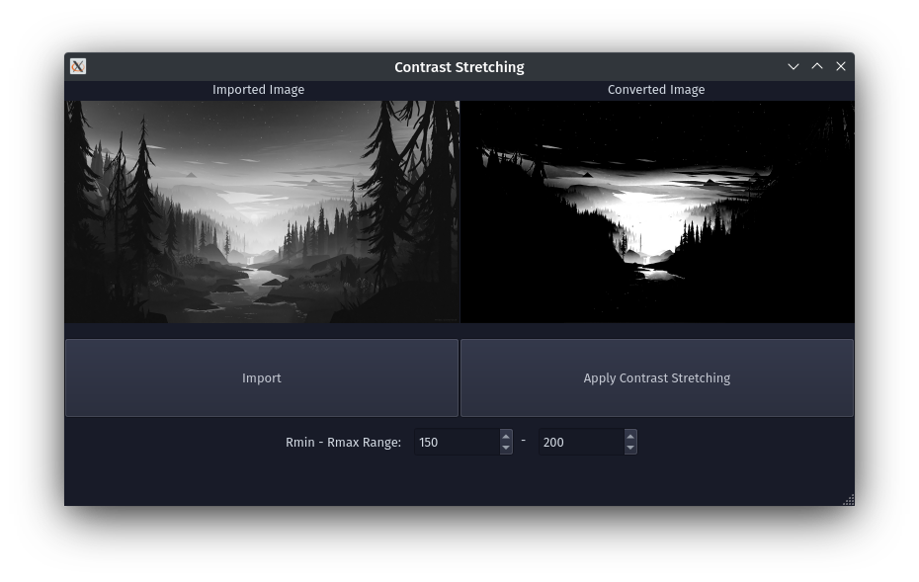
Conclusion: Program to read an image and perform contrast stretching on it was written and executed successfully.

