Experiment No: 3a Date:
Aim: Develop a static webpage for an online bookstore

Theory:

CSS Selectors
A CSS selector is the part of a CSS ruleset that actually selects the content you want to style. The major types of CSS selectors are:

Element Type Selector:
Also referred to simply as a “type selector,” this selector must match one or more HTML elements of the same name. Thus, a selector of nav would match all HTML nav elements, and a selector of ¡ul¿ would match all HTML unordered lists, or ¡ul¿ elements.

Class Selector:
The class selector is the most useful of all CSS selectors. It’s declared with a dot preceding a string of one or more characters. Just as is the case with an ID selector, this string of characters is defined by the developer. The class selector also matches all elements on the page that have their class attribute set to the same value as the class, minus the dot.

ID Selector:
An ID selector is declared using a hash, or pound symbol (#) preceding a string of characters. The string of characters is defined by the developer. This selector matches any HTML element that has an ID attribute with the same value as that of the selector, but minus the hash symbol.

CSS Box shadow
The box-shadow CSS property adds shadow effects around an element’s frame. You can set multiple effects separated by commas. A box shadow is described by X and Y offsets relative to the element, blur and spread radius, and color.

Output:

Homepage:
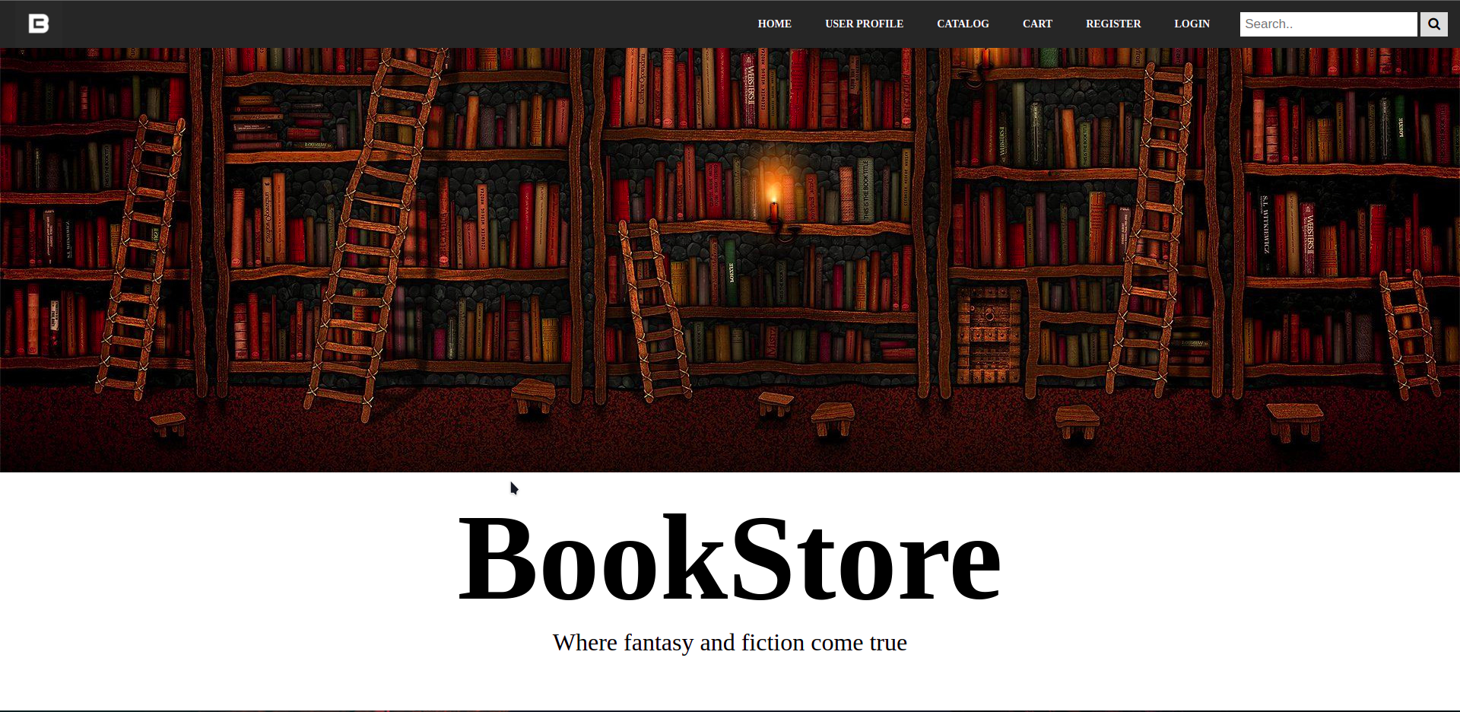
Catalog Page:
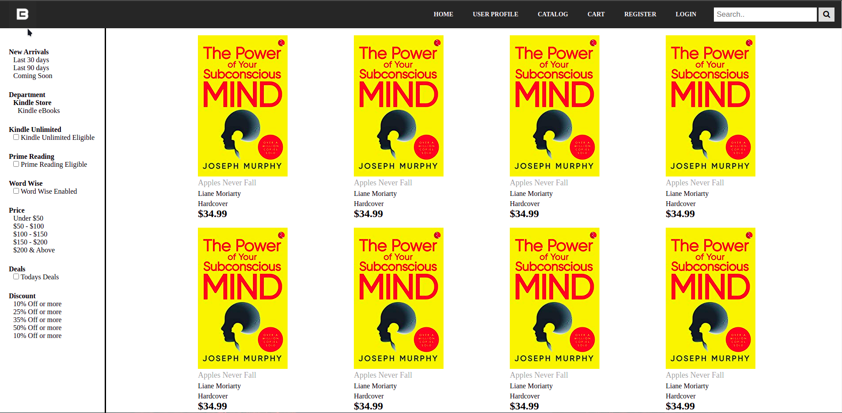

User Profile Page:

Shopping Cart:
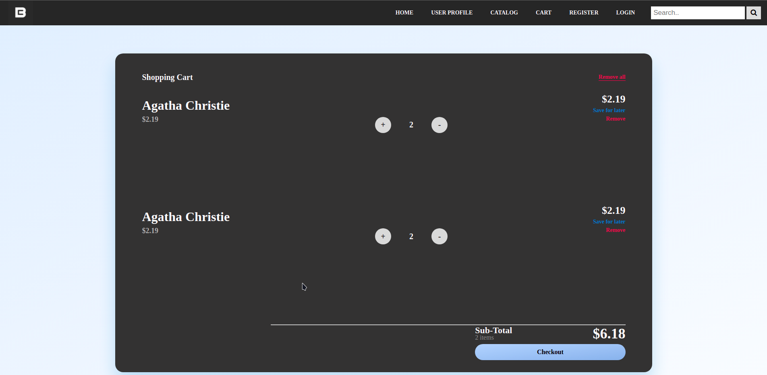

Login Page:
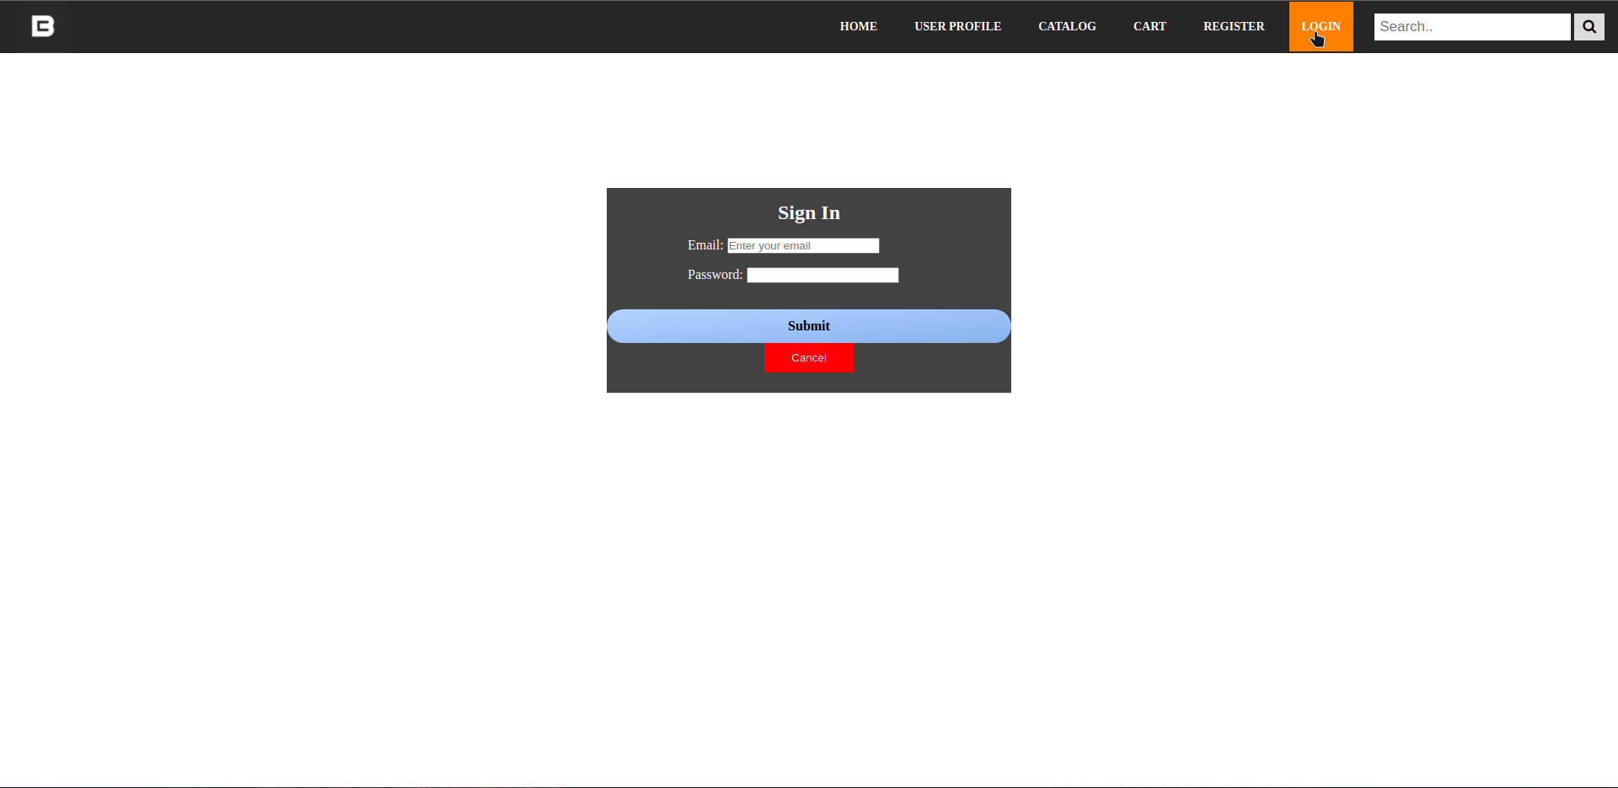
Register Page:
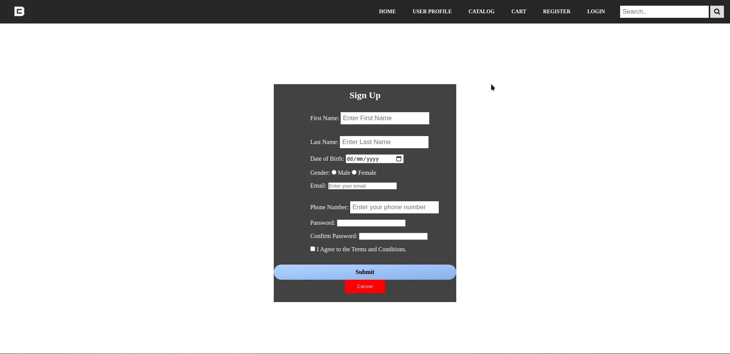
Conclusion: A static webpage for an online bookstore was successfully developed.

