Experiment No: 3b Date:
Aim: To compare and contrast css grid and flexbox

Theory:

CSS Grid
CSS Grid Layout (aka “Grid” or “CSS Grid”), is a two-dimensional grid-based layout system that, compared layout system of the past, completely changes the way we design user interfaces. The CSS Grid Layout Module offers a grid-based layout system, with rows and columns, making it easier to design web pages without having to use floats and
positioning.

To get started you have to define a container element as a grid with display: grid, set the column and row sizes with grid-template-columns and grid-template-rows, and then place its child elements into the grid with grid-column and grid-row. Similarly to flexbox, the source order of the grid items doesn’t matter. Your CSS can place them in any order,
which makes it easy to rearrange your grid with media queries.

CSS Flexbox
The Flexible box(aka Flexbox) Layout module aims at providing a more efficient way to lay out, align and distribute space among items in a container, even when their size is unknown and/or dynamic (thus the word “flex”). The main idea behind the flex layout is to give the container the ability to alter its items’ width/height (and order) to best fill the available space (mostly to accommodate to all kind of display devices and screen sizes). A flex container expands items to fill available free space or shrinks them to prevent overflow.

To define a parent container to be a flex conatainer we use the display:flex; property.
The direction of flex (i.e. orientation) can be specified to be any one of:
• row (default): left to right
• row-reverse: right to left
• column: same as row but top to bottom
• column-reverse: same as row-reverse but bottom to top

Output:
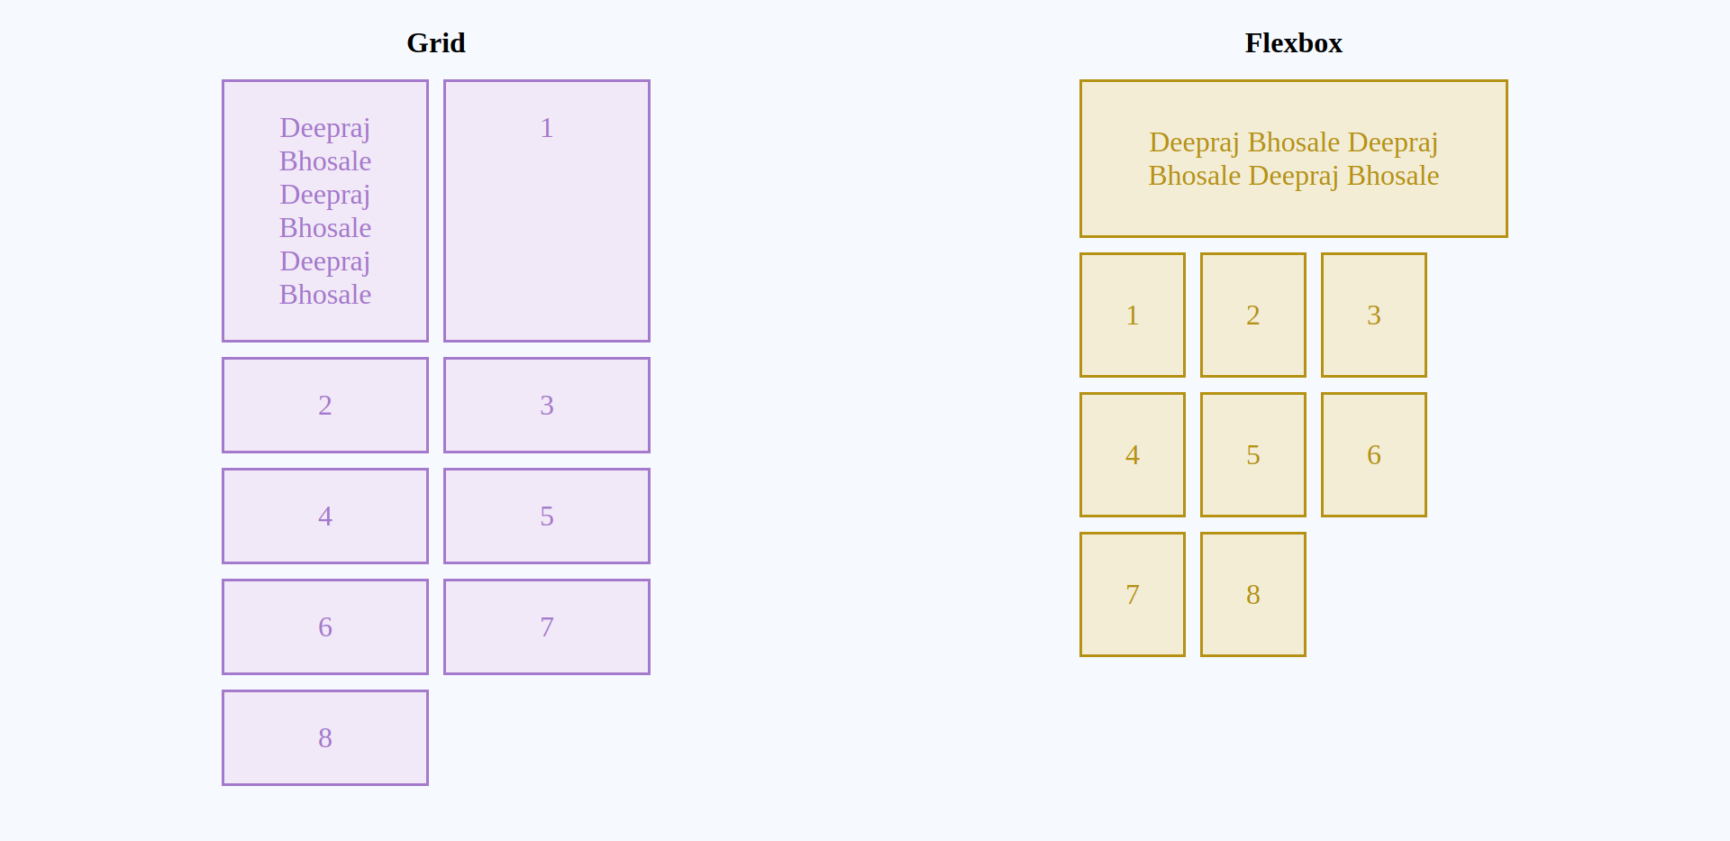

Findings:
- Flexbox is one-dimensional, while CSS Grid is two-dimensional.
- Grid allows more fine customisation
- Flexbox layout is most appropriate to the components of an application, and smallscale layouts, while the Grid layout is intended for larger scale layouts.
- Flexbox requires less time to learn and is less complex than grid

Conclusion: CSS Grid and Flexbox were successfully compared

