Experiment No: 4a Date:
Aim: Use Javascript to design a calculator that can perform operations sum, product, difference
and quotient.

Theory:

The eval function
eval() is a function property of the global object.
The argument of the eval() function is a string. If the string represents an expression, eval() evaluates the expression. If the argument represents one or more JavaScript statements, eval() evaluates the statements.
If you construct an arithmetic expression as a string, you can use eval() to evaluate it at a later time. For example, suppose you have a variable x. You can postpone evaluation of an expression involving x by assigning the string value of the expression, say ”3 * x + 2”,to a variable, and then calling eval() at a later point in your script.

HTML events
An HTML event can be something the browser does, or something a user does.
Here are some examples of HTML events:
• An HTML web page has finished loading
• An HTML input field was changed
• An HTML button was clicked
Often, when events happen, you may want to do something.
JavaScript lets you execute code when events are detected.
HTML allows event handler attributes, with JavaScript code, to be added to HTML elements.
Common HTML events include:
• onchange: An HTML element has been changed
• onclick: The user clicks an HTML element
• onmouseover: The user moves the mouse over an HTML element
• onmouseout: The user moves the mouse away from an HTML element
• onkeydown: The user pushes a keyboard key
• onload: The browser has finished loading the page

Code:
let display = document.getElementById('display');

let buttons = Array.from(document.getElementsByClassName('button'));

buttons.map( button => {
button.addEventListener('click', (e) => {
switch(e.target.innerText){
case 'C':
display.innerText = '';
break;
case '=':
try{
display.innerText = eval(display.innerText);
} catch {
display.innerText = "Error"
}
break;
case '←':
if (display.innerText){
display.innerText = display.innerText.slice(0, -1);
}
break;
default:
display.innerText += e.target.innerText;
}
});
});

Output:
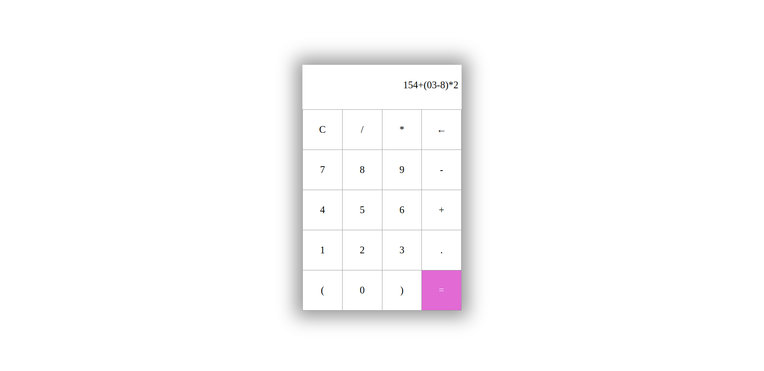
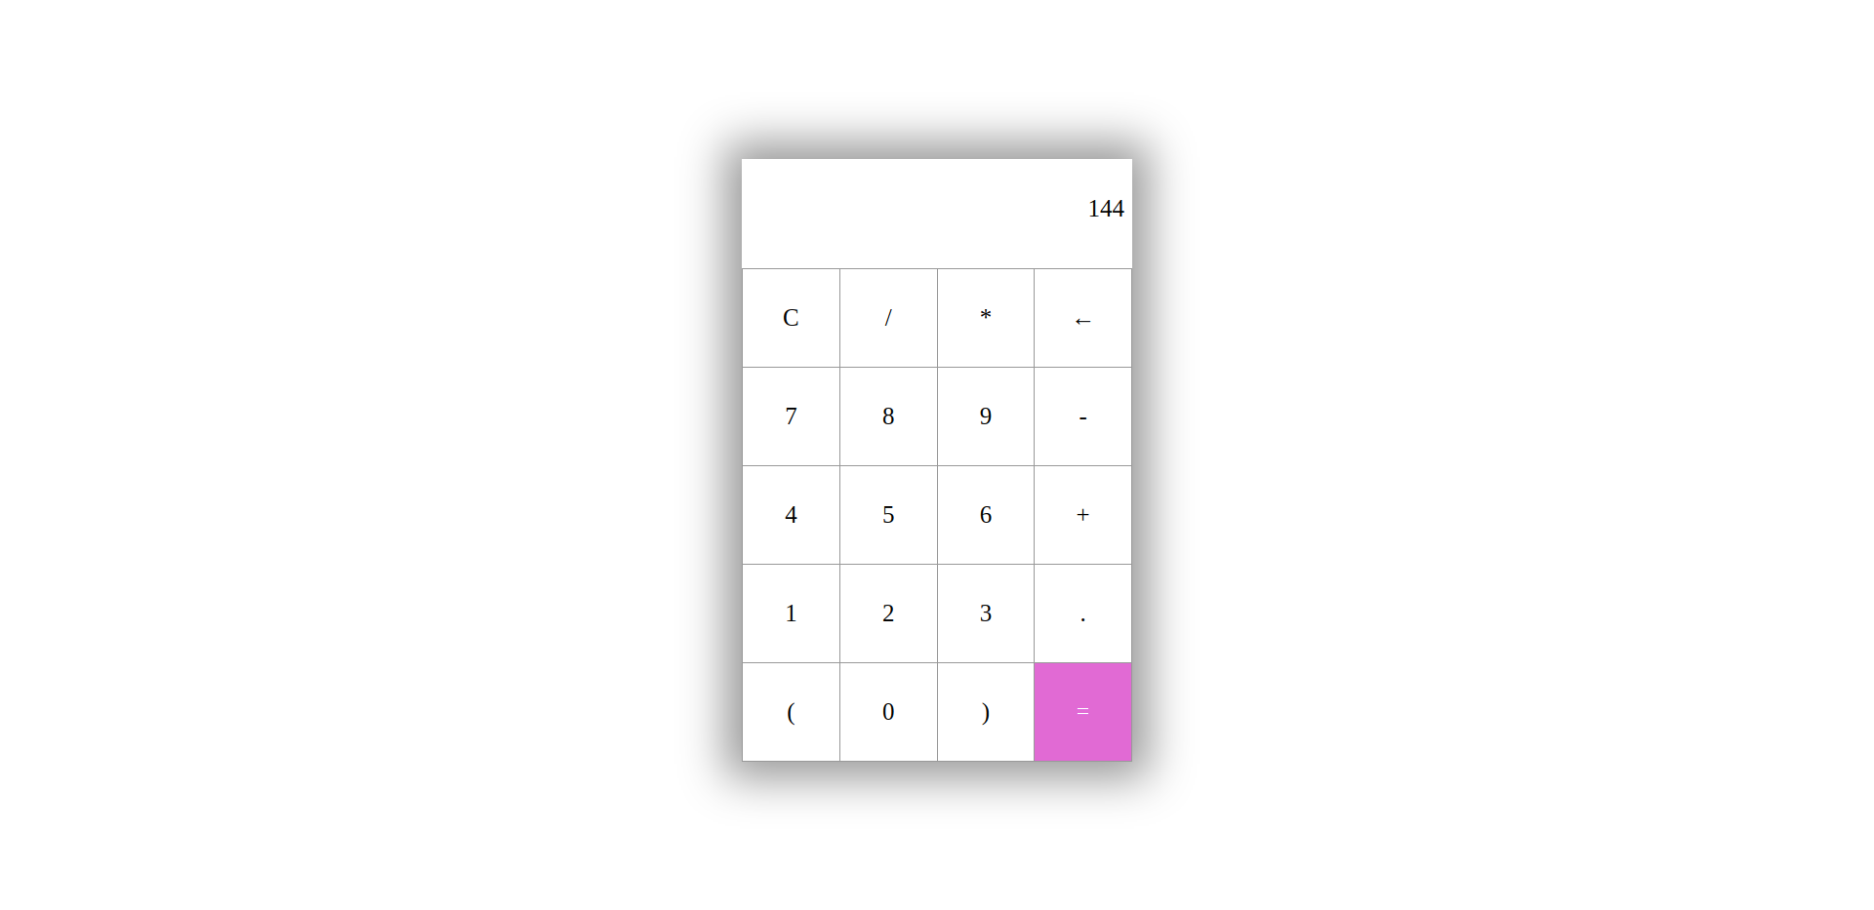

Conclusion: A Calculator that can perform operations sum, product, difference and quotient was success-
fully designed and implemented

