Experiment No: 4b Date:
Aim: Write a Javascript program to calculate squares and cubes from the numbers from 0 to n
and output the html tags that display the values in tabular format.

Theory:
The getElementByID method
The getElementByID() method returns the element that has the ID attribute with the specified value.
This method is one of the most common methods in the HTML DOM, and is used almost every time you want to manipulate, or get info from, an element on your document.
Returns null if no elements with the specified ID exists.
An ID should be unique within a page. However, if more than one element with the specified ID exists, the getElementByID() method returns the first element in the source code.

The innerHTML attribute
When a node in the DOM is selected using JS, we can modify the contents of that node by using the innerHTML attribute, it allows us to read and set the child nodes of the selected node

Code:
function getN(){
let n=document.getElementById("ip-box").value;
return parseInt(n)
}
function createTable(){
let n=getN();
console.log(n)
var tableStructure;
if (isNaN(n)){
tableStructure="Invalid input."
}
else{
tableStructure="<center><table id=result-table><tr><th>n</th><th>n^2</th><th>n^3</th></tr>"
console.log(n);
for(let i=0;i<n;i++){
let newRow="<tr><td>"+i+"</td>"+"<td>"+i**2+"</td>"+"<td>"+i**3+"</td></tr>"
tableStructure+=newRow;
}
tableStructure+="</table></center>"
}
document.getElementById("result-container").innerHTML=tableStructure;
}

Output:
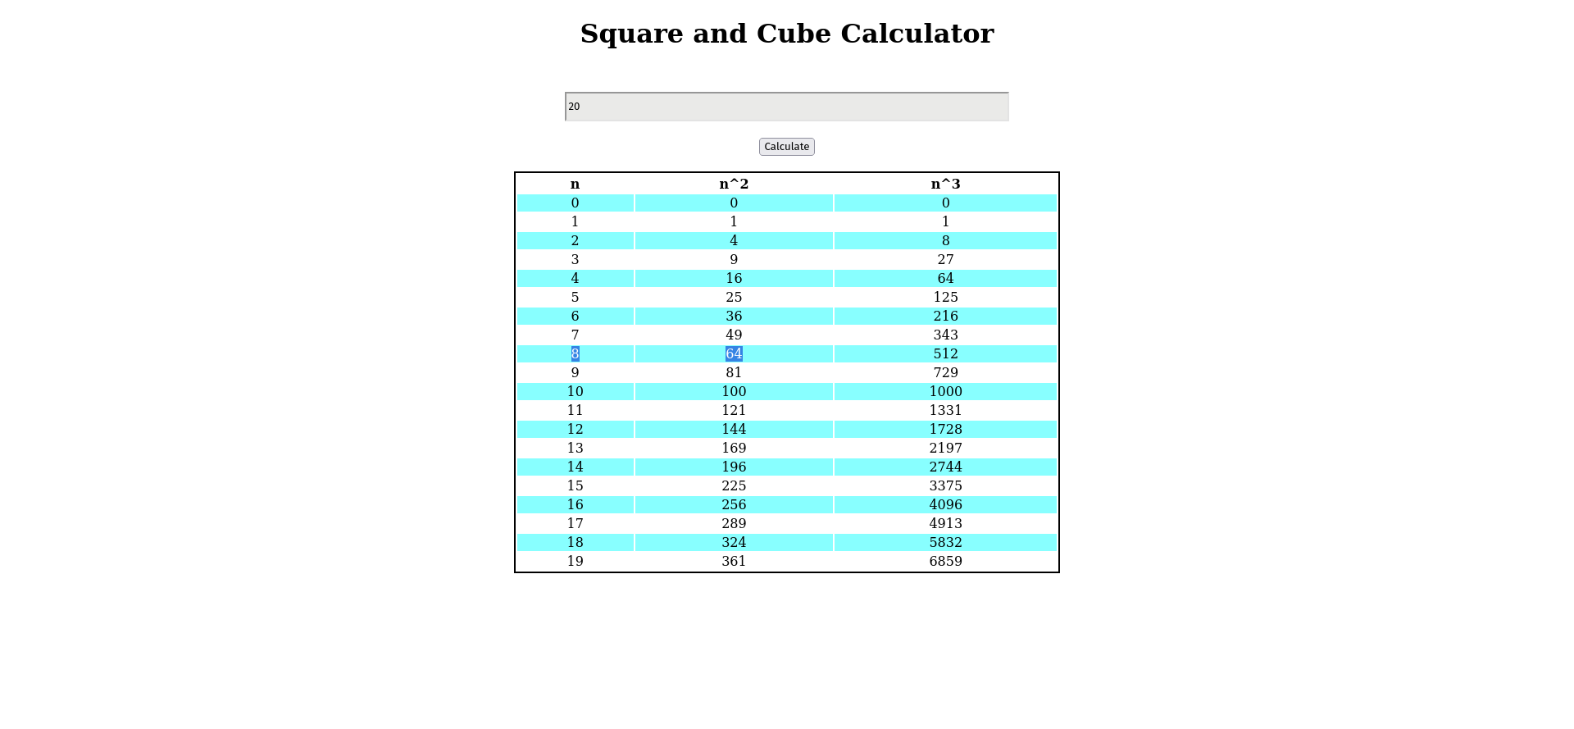

Conclusion: A Javascript program to calculate squares and cubes from the numbers from 0 to n and output the html tags that display the values in tabular format was successfully written and executed

